A Project Synopsis
on

“Student Attendance Management System”

IN
COMPUTER SCIENCE AND ENGINEERING BY
• Mr. Ritesh Pratap Shinde (Roll No.161 ,S Y CSE-A)
• Mr. Vallbh Parashram Shinde (Roll No.163 ,S Y CSE-A)
• Mr. Arun Dattatray Tipugade (Roll No.165 ,S Y CSE-A)
• Mr. Omkar Tanaji Tipugade (Roll No.166 ,S Y CSE-A)

Under the guidance of
<Prof.Rohit Raut >
Assistant Professor

Department of Computer Science and Engineering
Dr. D.Y. Patil Pratishthan's College of Engineering,
Kalamba Ring Road, Salokhenagar Kolhapur-416007

STUDENT ATTENDANCES MANAGEMENT SYSTEM

Introduction-
Student attendance management is an important aspect of educational institutions. Accurate and timely recording of attendance is crucial for monitoring student performance and ensuring that students are meeting the requirements of their courses. To facilitate this process, a student attendance management system can be implemented, which can automate the attendance recording process and provide real-time attendance reports for teachers and administrators.
The goal of this mini-project is to develop a student attendance management system that can efficiently manage student attendance data. The system will allow teachers to take attendance for their classes and store the data in a database. The attendance records will be accessible to authorized personnel, including teachers, school administrators, and parents. The system will also generate reports on attendance data for each student, which can be used to track their attendance and monitor their progress throughout the academic year.
Literature Survey/Review Of Existing System-
1) "Managing Student Attendance: Successful Strategies for Reducing Truancy" by Ken Reid - This book provides practical strategies for addressing truancy and promoting attendance in schools.
2) "Attendance Management: A Comprehensive Guide to Designing, Implementing, and Evaluating Programs to Improve School Attendance" by Michael A. Gottfried - This book offers a comprehensive guide to designing, implementing, and evaluating attendance management programs in schools.
Problem Specification/Proposed System-
The problem with taking student attendance in a book is that it can be time-consuming and prone to errors. Writing down the names of each student and marking their attendance manually can be tedious and can take up valuable instructional time. Moreover, there is a risk of making mistakes, such as marking a student as absent when they are present, or vice versa.
Additionally, using a book to take attendance makes it difficult to keep track of attendance data over time, as the book can become disorganized or lost. It also does not allow for easy sharing of attendance information with other teachers or administrators who may need it.
Therefore, it is recommended to use a digital system for taking student attendance, which can streamline the process, reduce errors, and provide more useful data.
Unique solutions-
- Mark attendance properly and store in file
- Generate report
- Counting attendance automatically
Hardware and Software Requirements-
1)Windows-10/11
2)Intel Core i3 Processor.
3) 256 GB-SSD.
4) 4 GB RAM.

DFD:-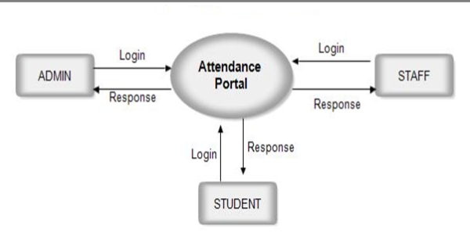

FLOW CHART:-
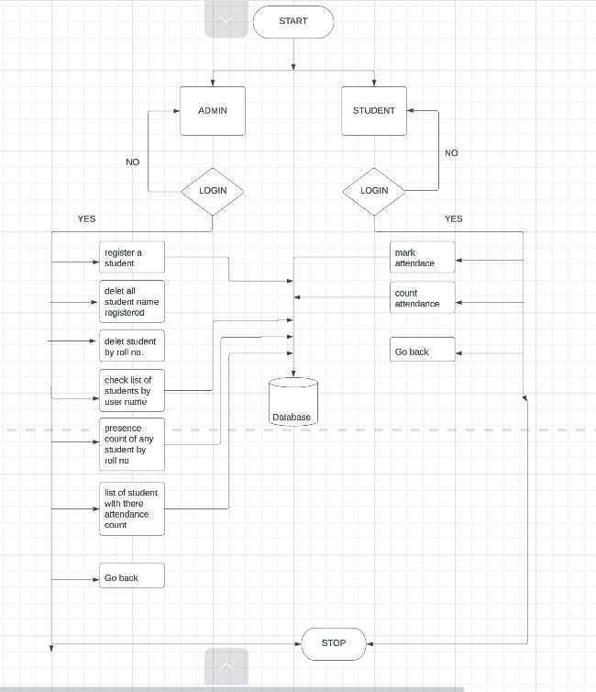

Algorithm –
Step1:- Start .
Step2:- First login admin
Step 3:- Check whether the credentials is valid or not If valid then display menu of admin login
Step 4:- Register students , fill all data
Step 5:- Provide all students , there username and passwords
Step 6:- login student
Step 7:- Check whether the student credentials is valid or not If valid then display menu of student login
Step 8:- Student is able to mark there attendace.

REFERENCE:-
1) Ken Reid
2) Michael A. Gottfried
WWW.Google.Com

