Python Assignment

1. Grade Checker
This program takes marks as input and determines the grade using if-else conditions based on predefined ranges.
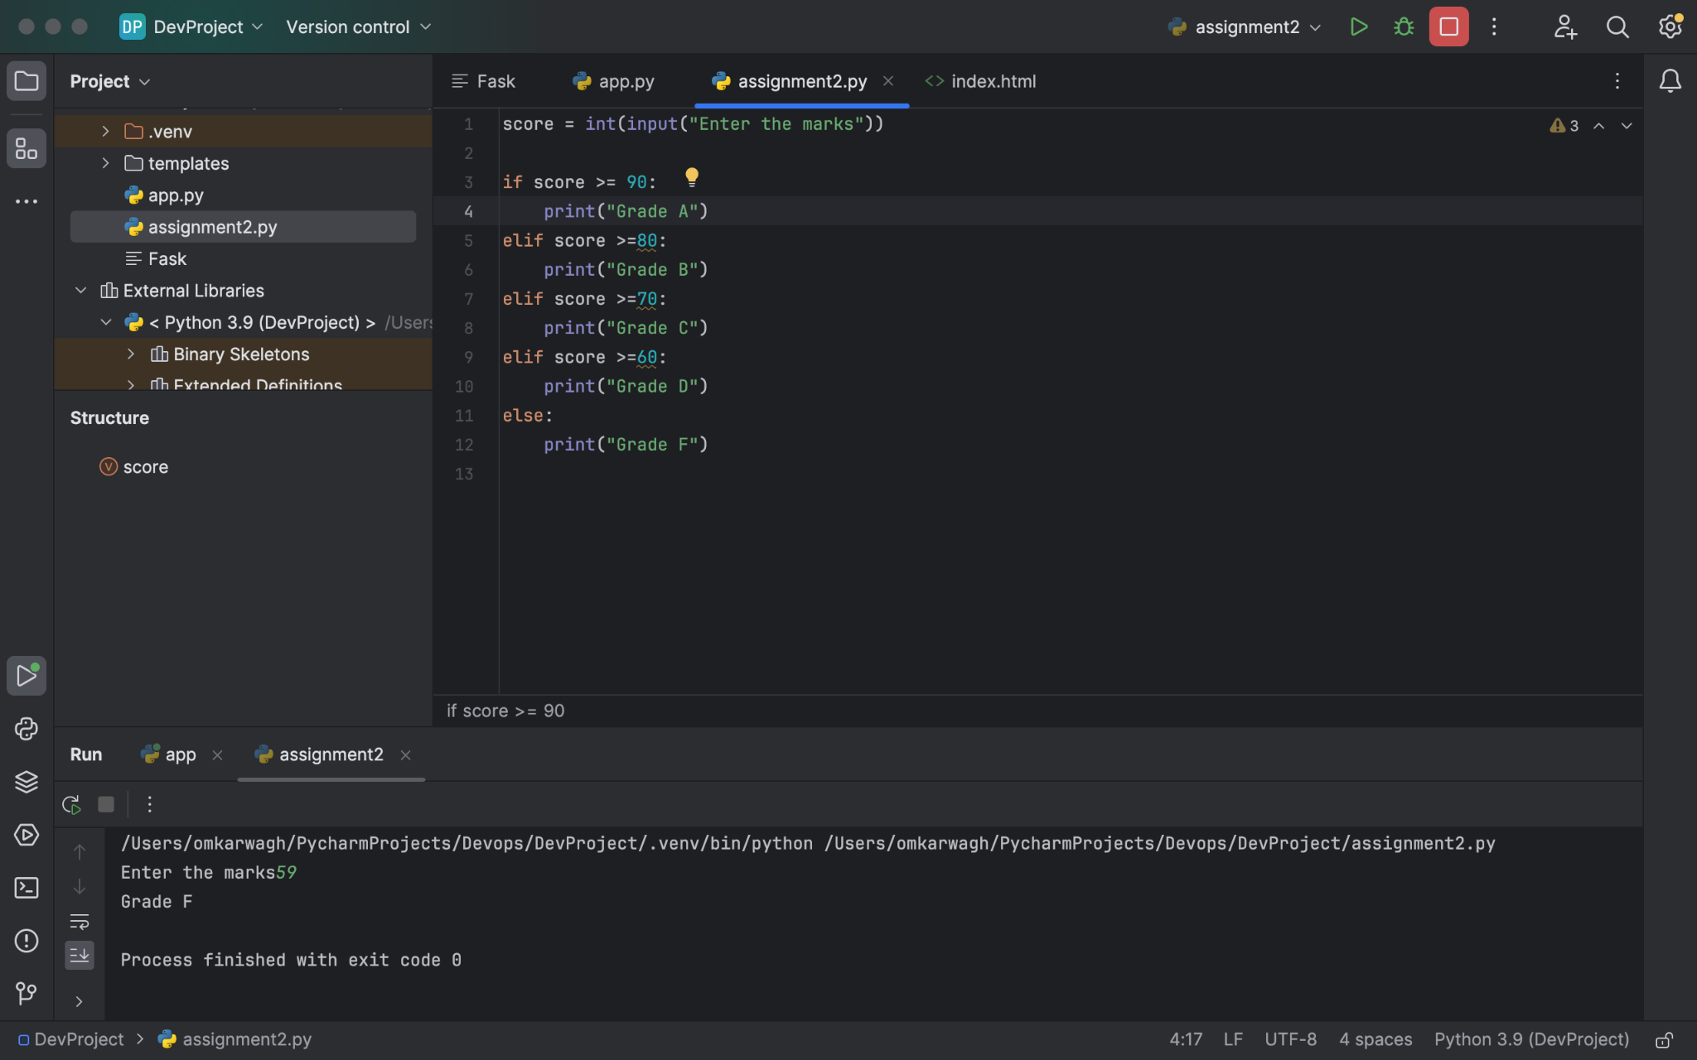

2. Student Grades Dictionary (Program Code)
This program uses a Python dictionary to store student names and grades and provides options to add, update, and display students.
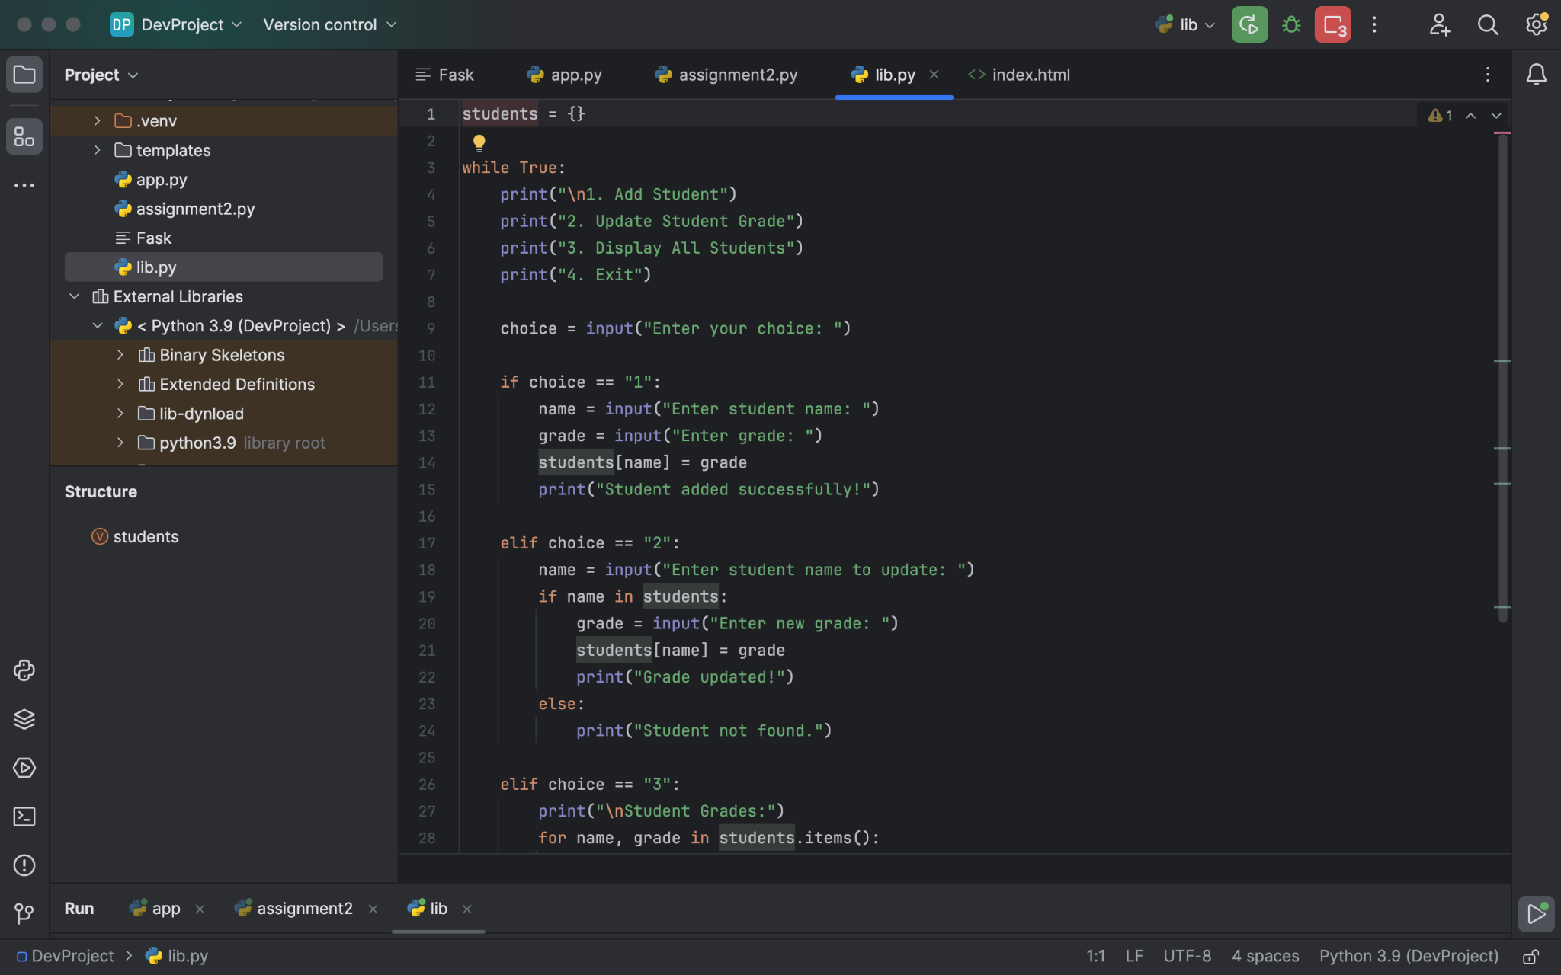

3. Student Grades Dictionary (Program Output)
The output shows how students are added and displayed from the dictionary using menu options.
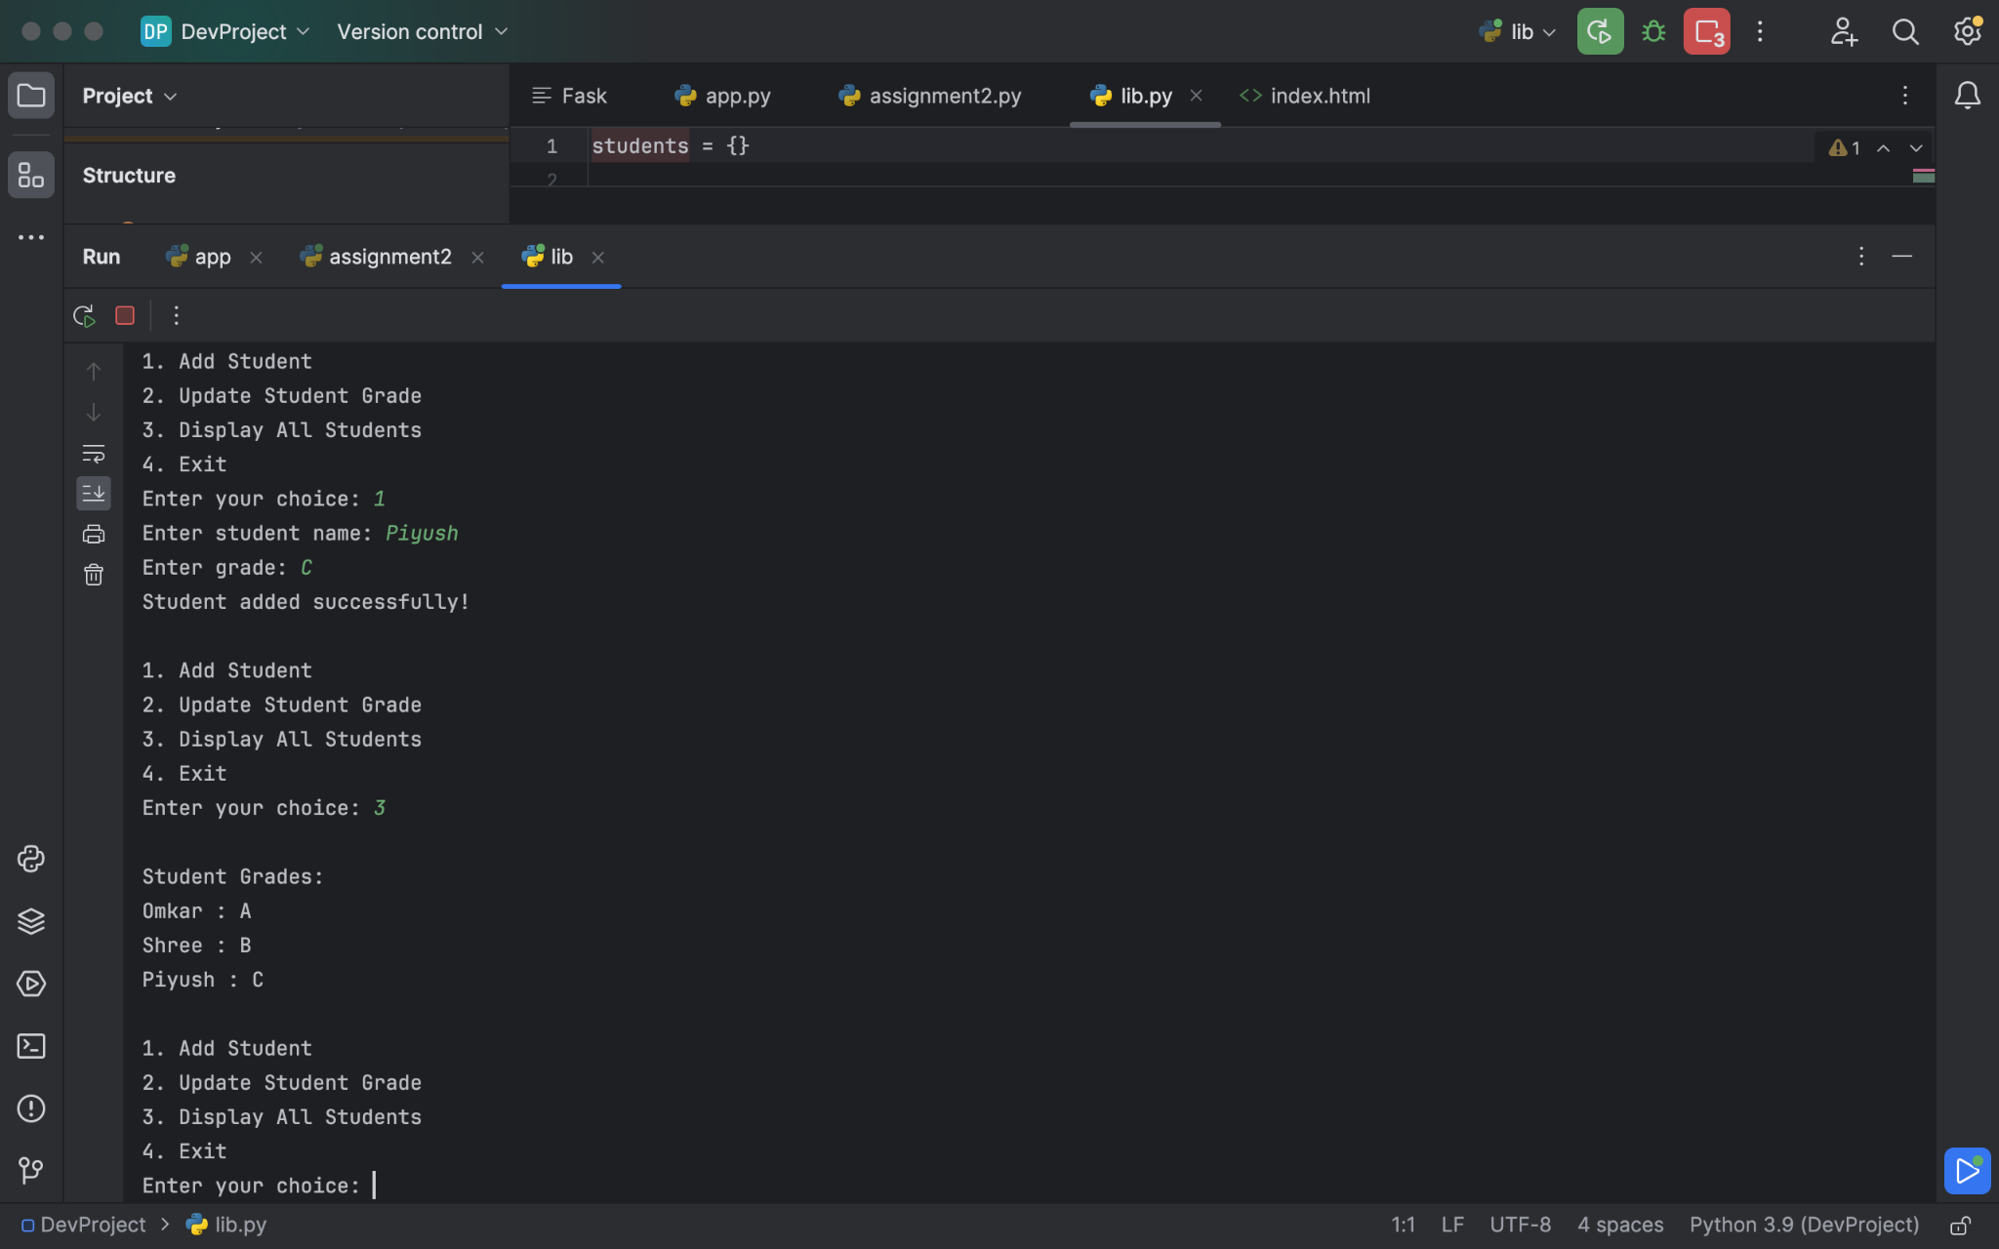

4. Write and Read from File
This program writes text into a file and then reads the content from the file and prints it to the console.
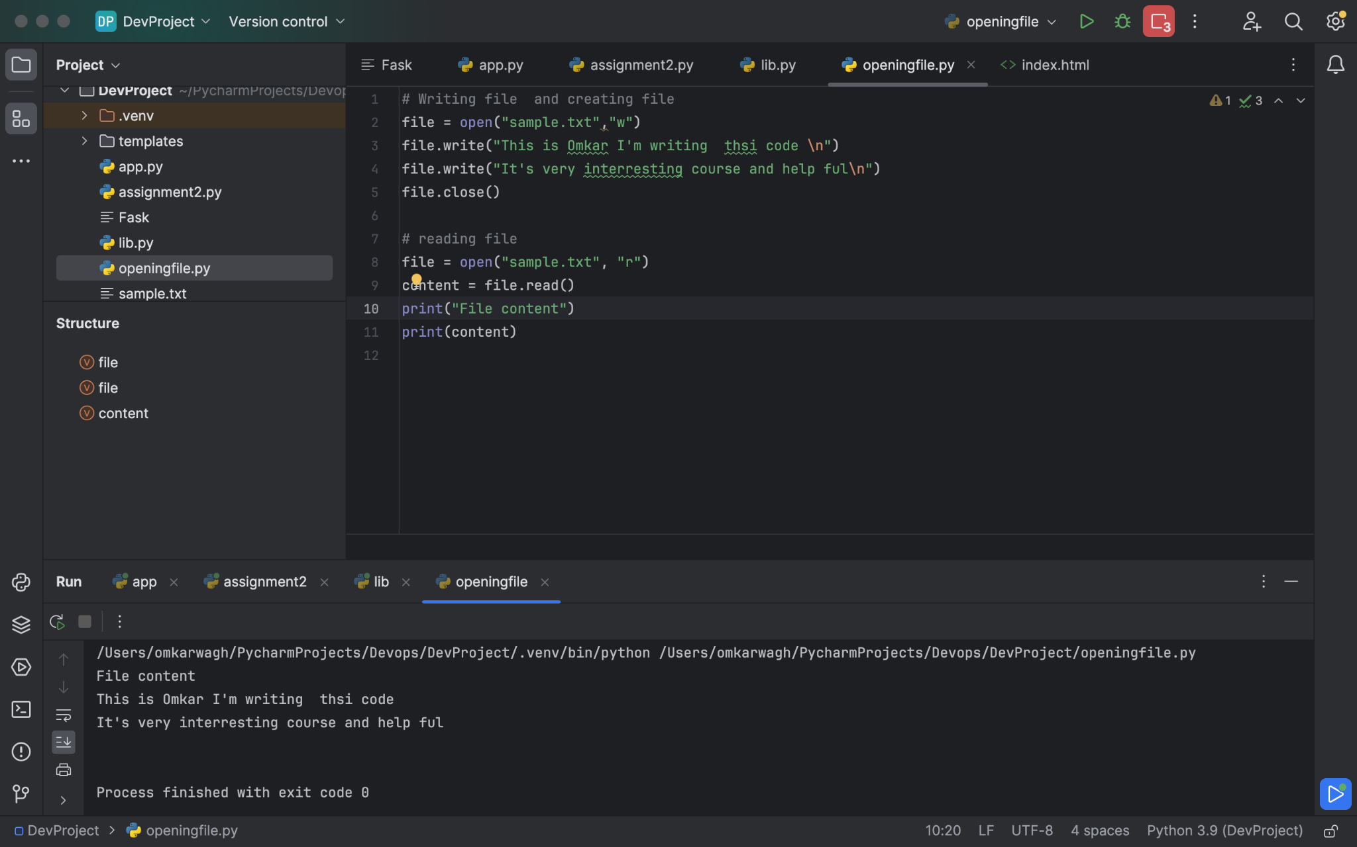

GitHub Repository
https://github.com/OmkarWagh2003/linux-basics-assignment

