Linux Basics Assignment
Name: Omkar Wagh

Task 1 – Creating and Renaming Files
Commands:
mkdir test_dir
cd test_dir
touch example.txt
mv example.txt renamed_example.txt
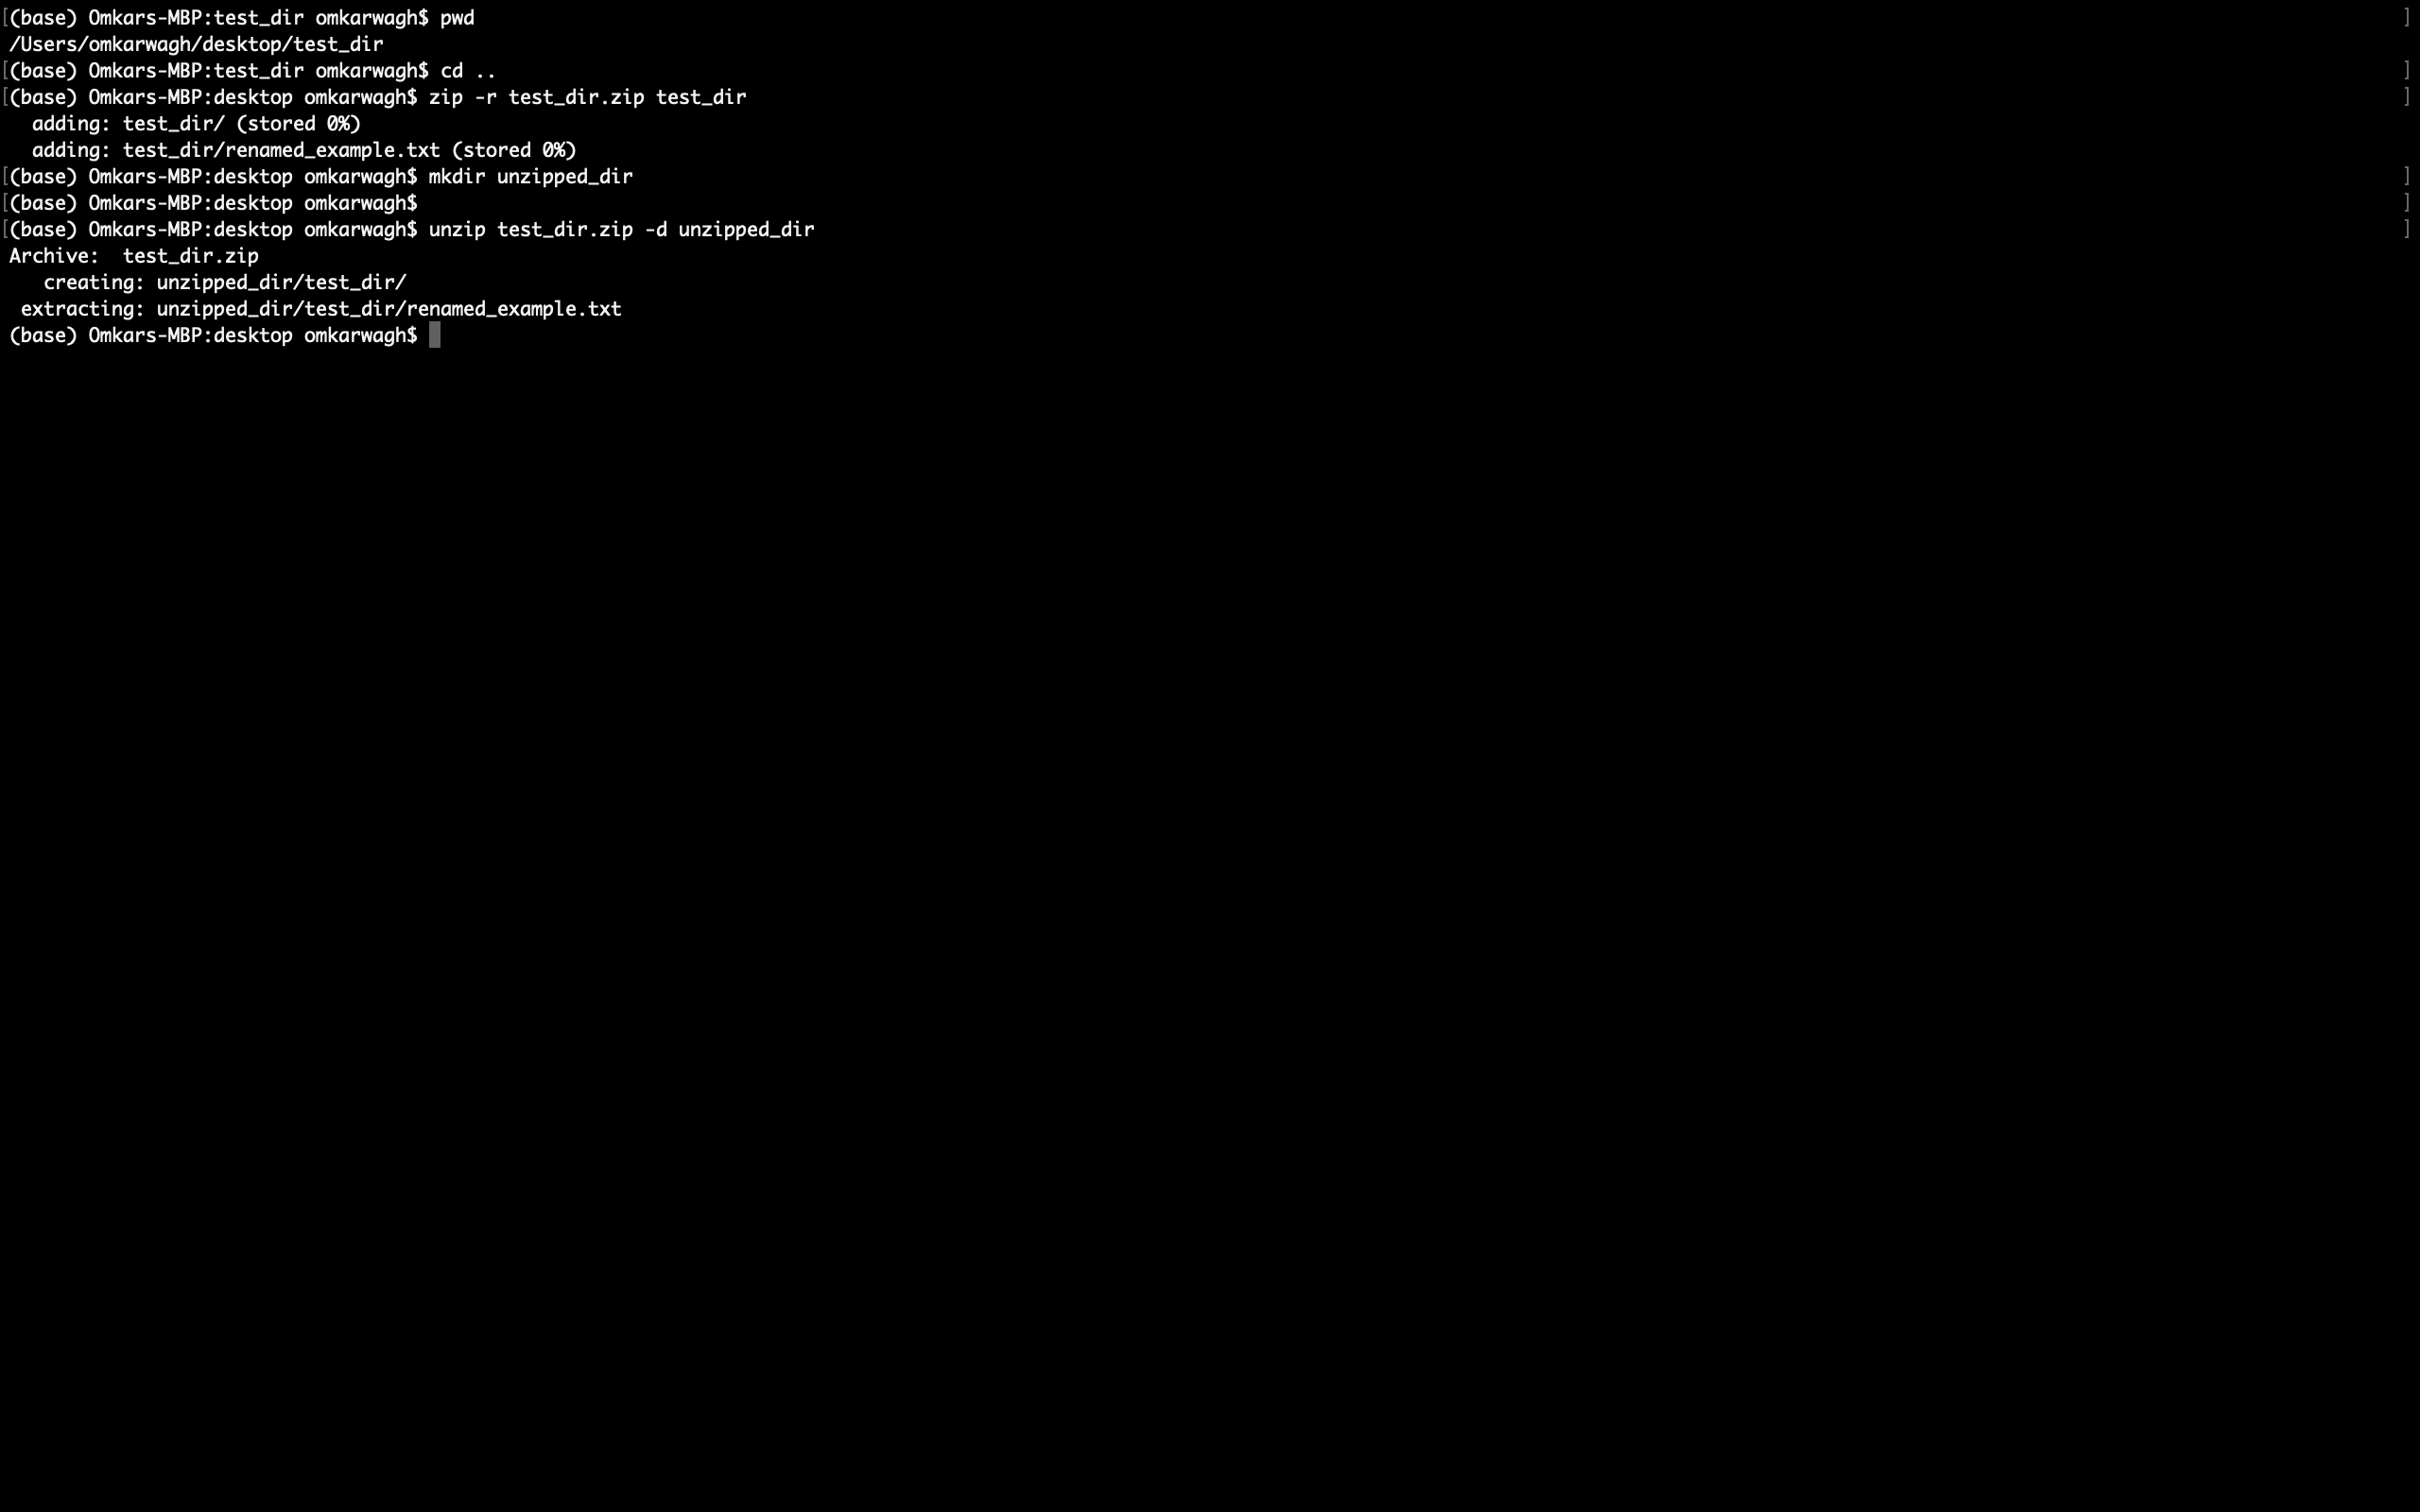
Explanation:
Creates a directory, enters it, creates a file and renames it.

Task 2 – Viewing File Contents (cat)
Commands:
cat /etc/passwd
Explanation:
Displays the full contents of the passwd file.
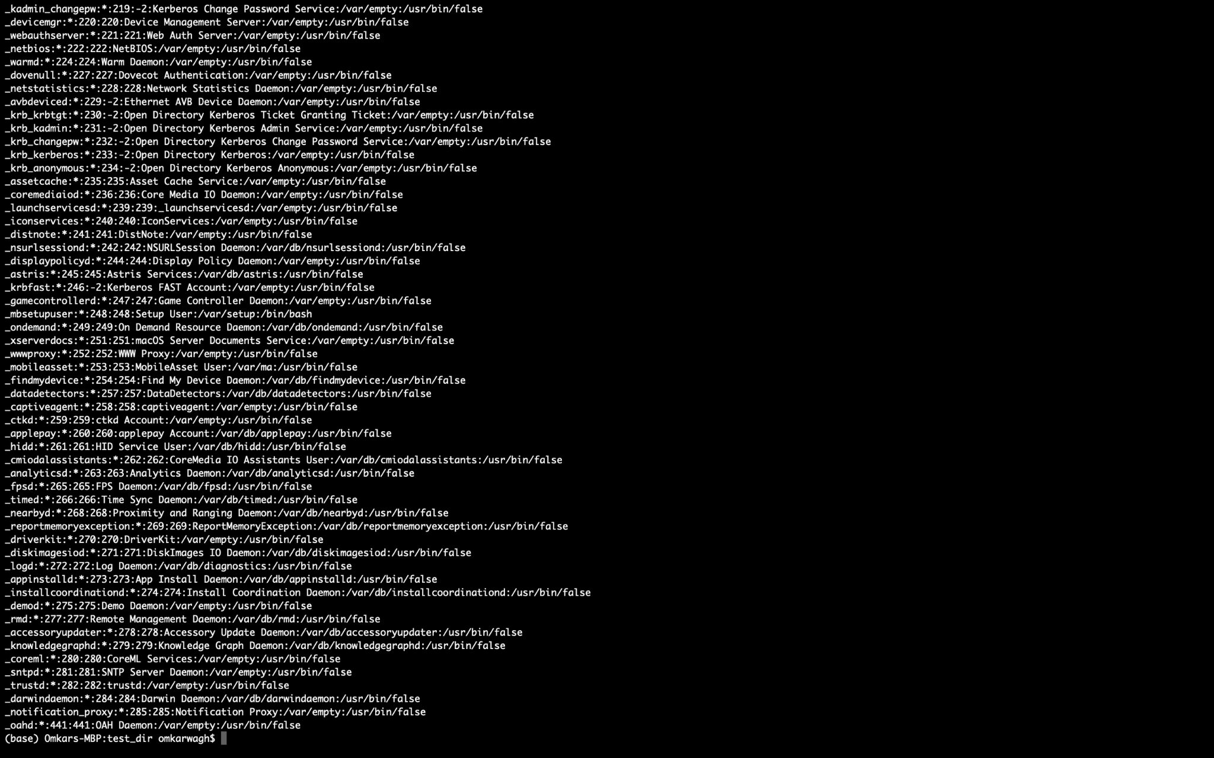

Task 2 – Viewing File Contents (head)
Commands:
head -n 5 /etc/passwd
Explanation:
Displays the first 5 lines of the passwd file.


Task 2 – Viewing File Contents (tail)
Commands:
tail -n 5 /etc/passwd
Explanation:
Displays the last 5 lines of the passwd file.


Task 3 – Searching Pattern
Commands:
grep "root" /etc/passwd
Explanation:
Searches for the word root inside the passwd file.


Task 4 – Zipping and Unzipping
Commands:
zip -r test_dir.zip test_dir
mkdir unzipped_dir
unzip test_dir.zip -d unzipped_dir
Explanation:
Compresses the directory and extracts it.
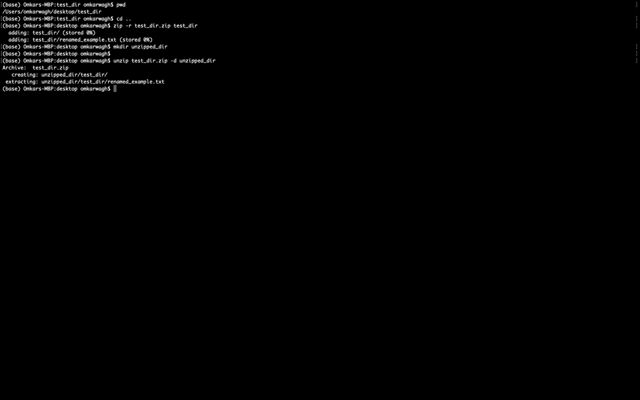

Task 5 – Downloading File
Commands:
wget https://example.com/sample.txt
Explanation:
Downloads a file from the internet.
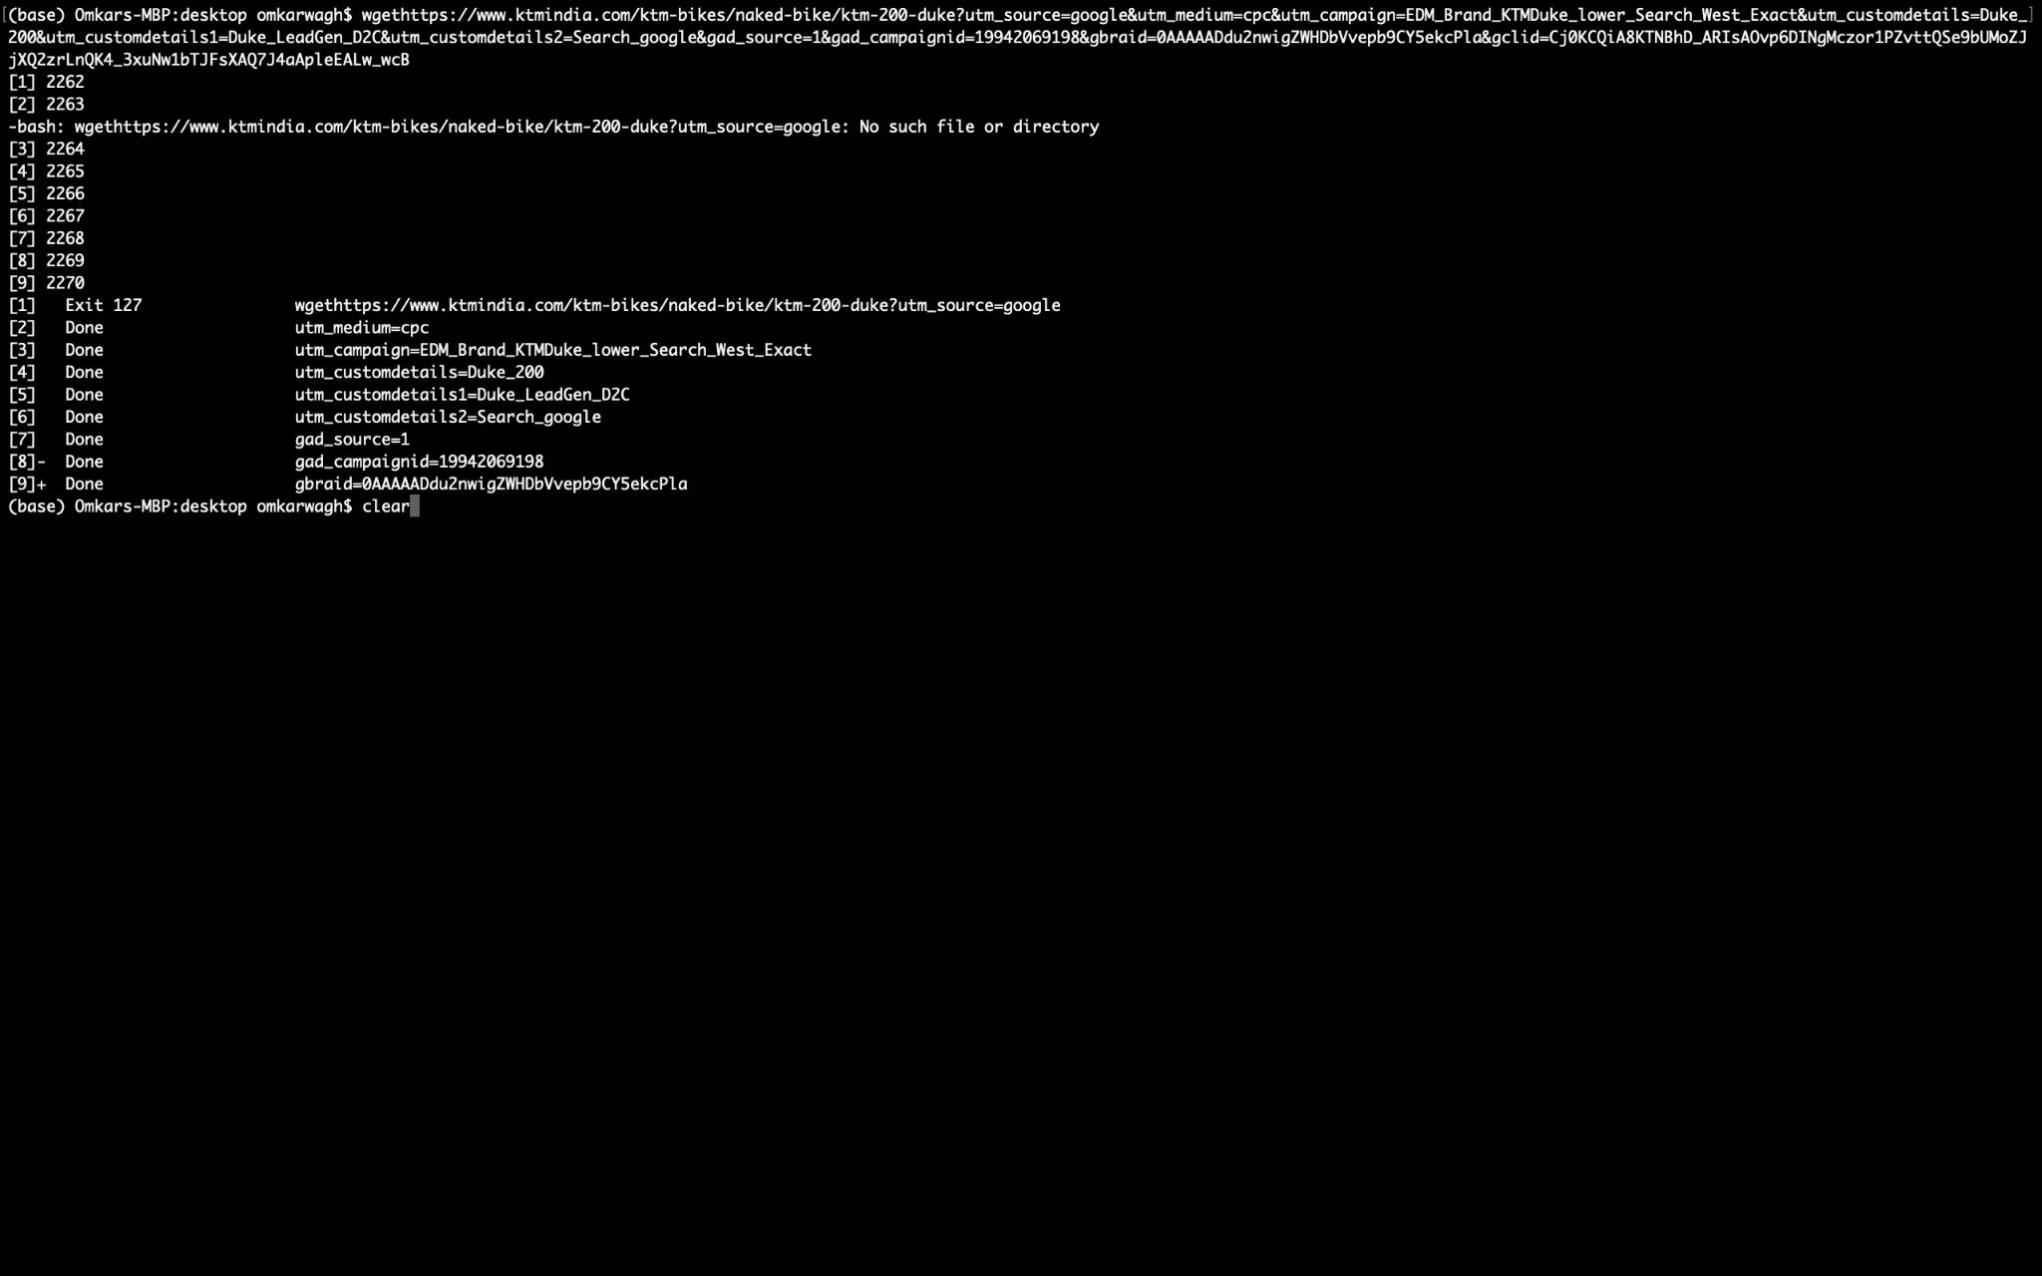

Task 6 – Changing Permissions
Commands:
touch secure.txt
chmod 444 secure.txt
Explanation:
Creates a file and changes permissions to read only.
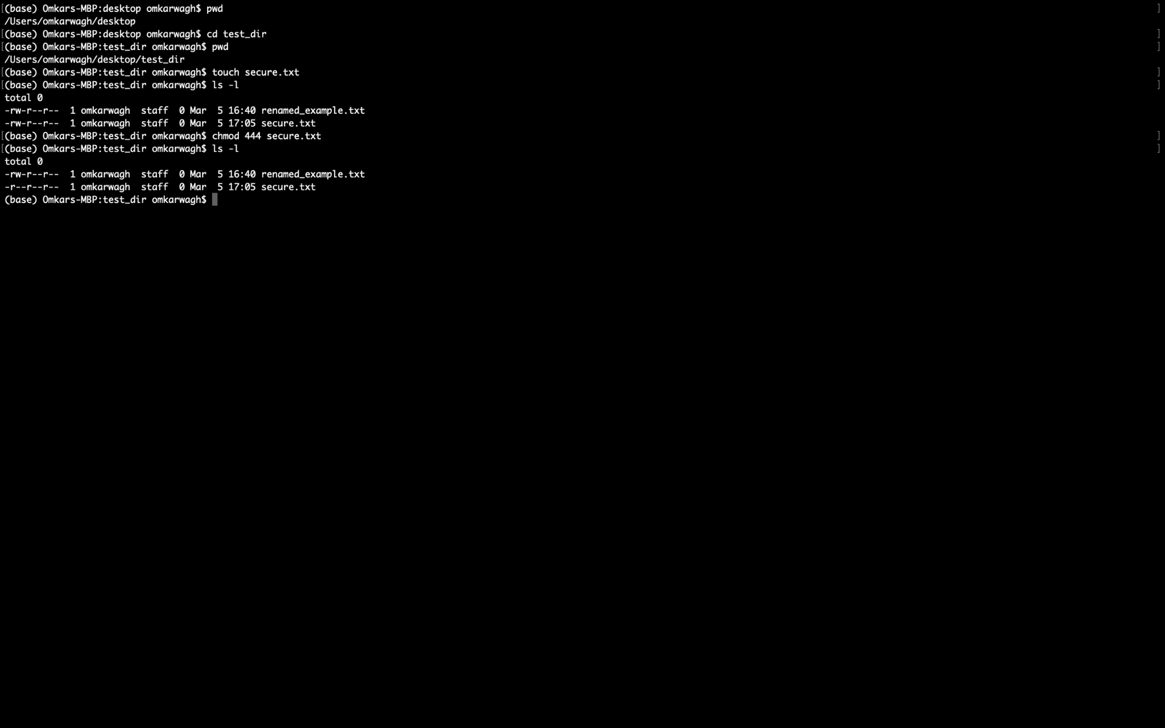

Task 7 – Environment Variable
Commands:
export MY_VAR="Hello, Linux this is Omkar"
echo $MY_VAR
Explanation:
Creates an environment variable and prints it.


