NPC – UNIT 4 ASSIGNMENT
Configure DHCP and Set Up a Network Using Cisco Packet Tracer
Student Name | Omkar Shejwal
PRN | 2125UCSM1041
Subject / Module | Network Protocols and Communication (NPC) - Unit 4
Project Title | DHCP Configuration and Network Setup
Software / Tools | Cisco Packet Tracer 9.0.1 (Windows/Kali)
GitHub Repository | Configure-DHCP-and-Set-Up-a-Network-Using-Cisco-Packet-Tracer
GitHub Link | https://github.com/OmkarShinde148/Configure-DHCP-and-Set-Up-a-Network-Using-Cisco-Packet-Tracer

1. Aim
To create a small LAN in Cisco Packet Tracer, configure a server with a static IPv4 address, enable the DHCP service, assign IP configuration automatically to client PCs, and verify end-to-end network connectivity using the ICMP ping command.
2. Network Topology
The topology contains three PCs (PC0, PC1, PC2), one Cisco 2960-24TT Switch (Switch0), and one Generic Server (Server0). Each end device is connected to the switch using Copper Straight-Through Ethernet cables.
Figure 1: Network topology with PC0, PC1, PC2, Server0, and Switch0.
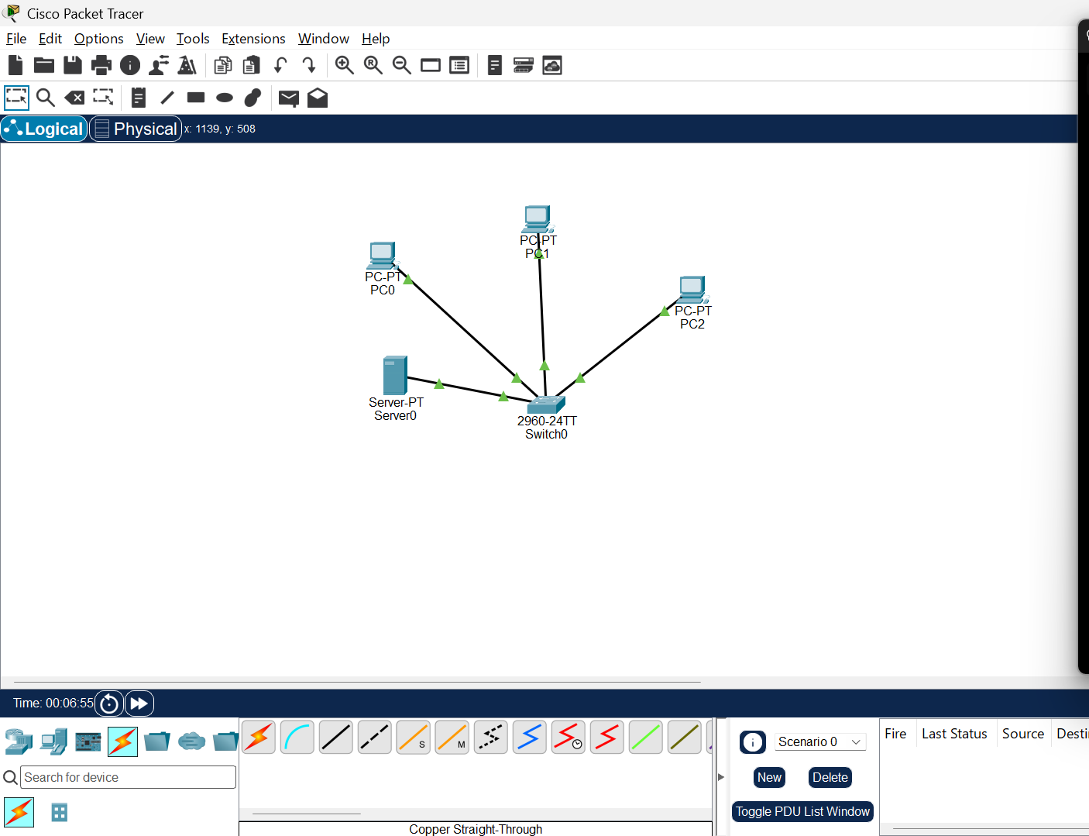
3. IP Addressing and DHCP Configuration
Server0 was configured with a static IPv4 address so that clients can communicate with it reliably. The DHCP service was enabled and a pool named NPC_POOL was configured.
Device / Setting | Configured Value
Server0 IPv4 address | 192.168.1.2
Subnet mask | 255.255.255.0
DHCP pool name | NPC_POOL
DHCP pool start address | 192.168.1.10
DHCP pool subnet mask | 255.255.255.0
Maximum number of users | 50
Default gateway / DNS | 0.0.0.0 (Local LAN)
Figure 2: Server0 static IP configuration.
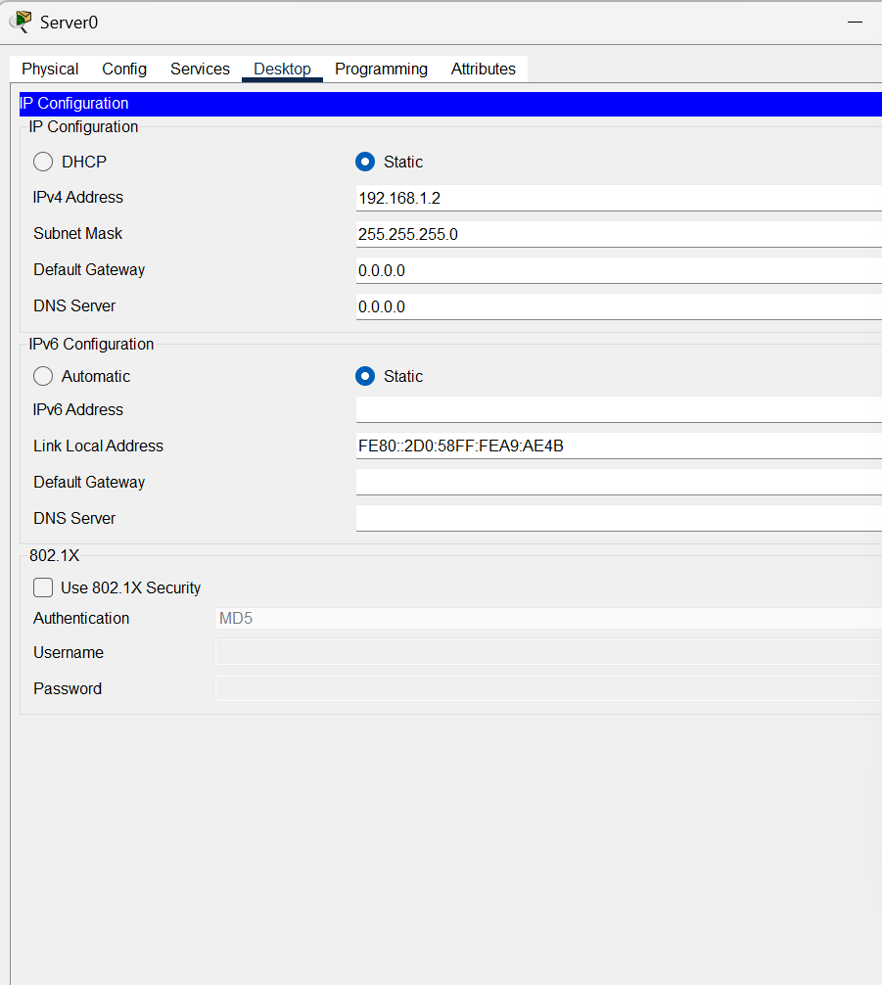
4. DHCP Service Setup
In Server0, Services > DHCP was opened. The DHCP service was switched On, and the NPC_POOL entry was configured with the start IP address 192.168.1.10 and subnet mask 255.255.255.0.
Figure 3: DHCP service and NPC_POOL settings.
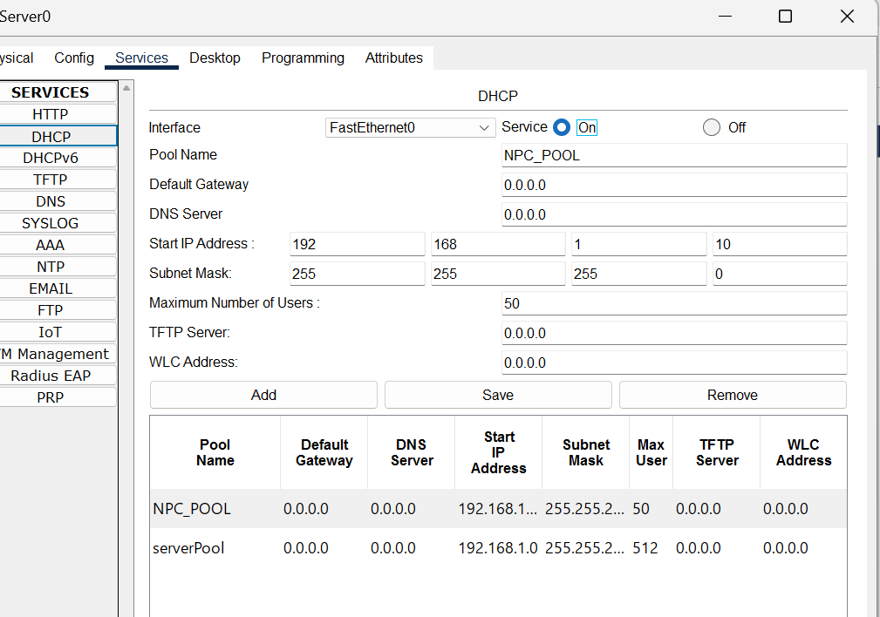
5. Automatic IP Configuration on PCs
On each PC, Desktop > IP Configuration was opened and DHCP was selected. The screenshots show successful DHCP requests (DHCP request successful) and the dynamic IPv4 addresses received by the PCs.
Figure 4: PC0 IP configuration (DHCP successful; IPv4 address: 192.168.1.1).
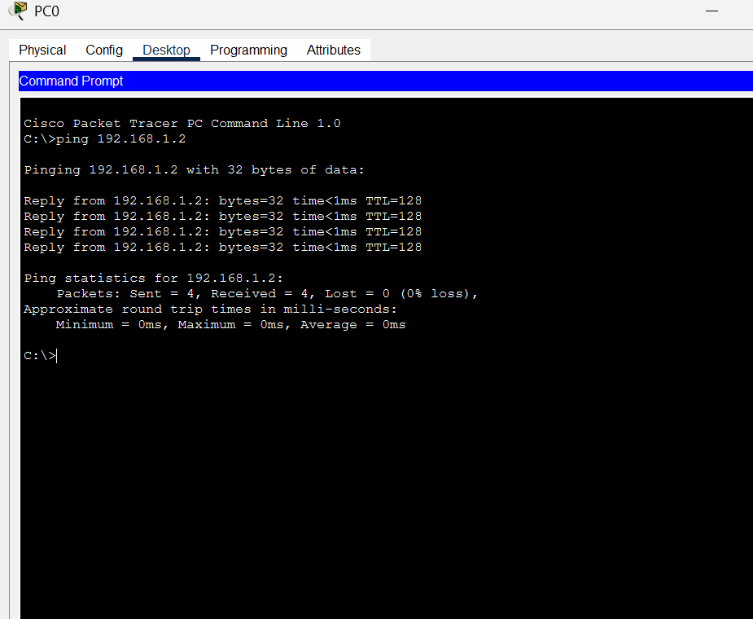
Figure 5: PC1 IP configuration (DHCP successful; IPv4 address: 192.168.1.3).
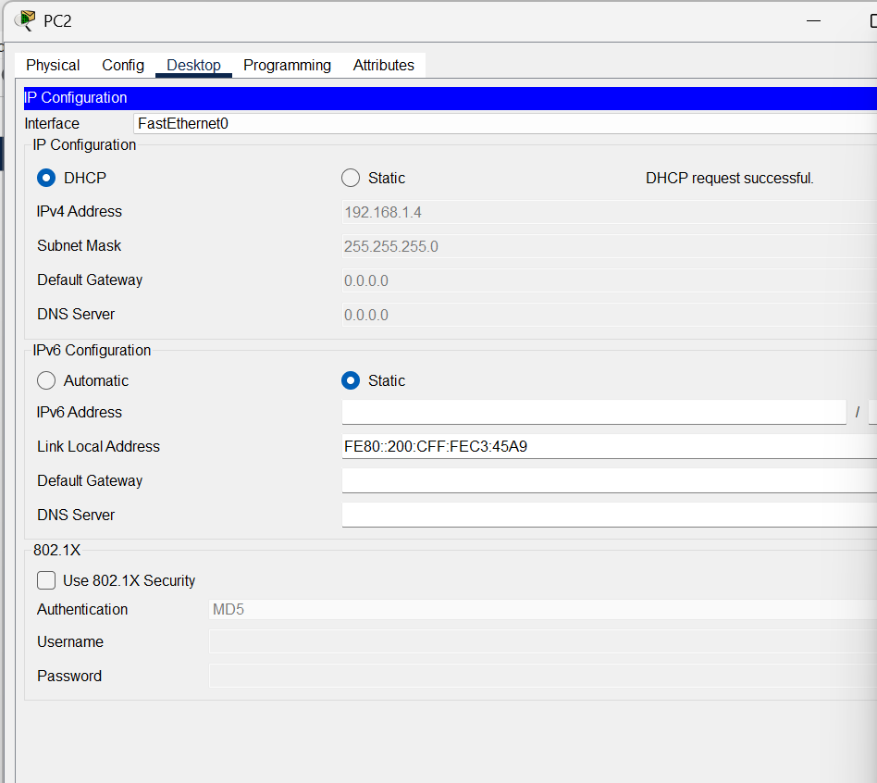
Figure 6: PC2 IP configuration (DHCP successful; IPv4 address: 192.168.1.4).
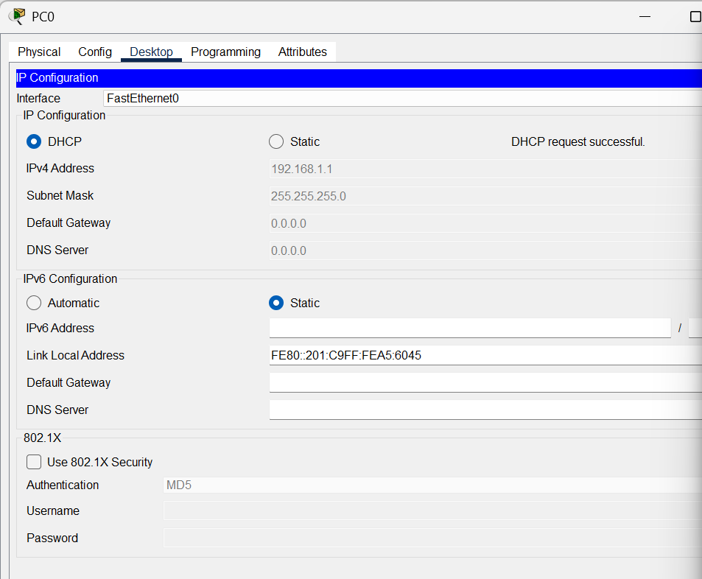
6. Connectivity Testing
Network connectivity was verified from PC0 using the ICMP ping command in the Command Prompt. The ping tests to Server0 (192.168.1.2), PC1 (192.168.1.3), and PC2 (192.168.1.4) all returned replies with 4 packets sent, 4 received, and 0% packet loss.
Figure 7: Successful ping tests from PC0 to Server0, PC1, and PC2.
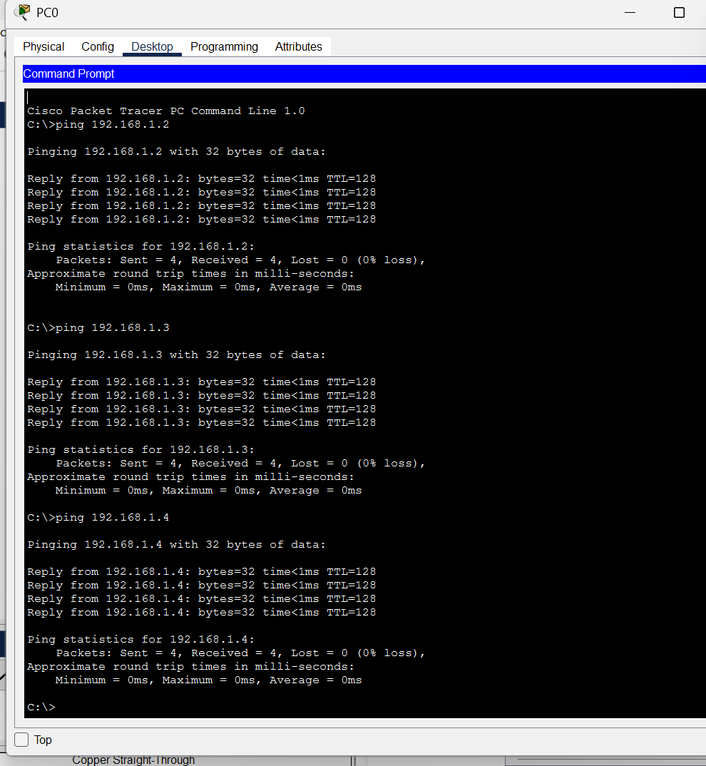
7. Results and Conclusion
The LAN topology was created successfully in Cisco Packet Tracer. Server0 was assigned a static IP address, the DHCP service was enabled, and the client PCs received IPv4 configuration automatically. Ping tests confirmed flawless connectivity between PC0, Server0, PC1, and PC2 with 0% packet loss.
8. Submission Evidence Checklist
✓ Cisco Packet Tracer Project File: NPC_Unit4_DHCP_Assignment.pkt
✓ Project Documentation Report: NPC_Unit4_DHCP_Assignment_Report.pdf & .docx
✓ Complete Topology & Configuration Screenshots in screenshots/ folder
✓ GitHub Repository: https://github.com/OmkarShinde148/Configure-DHCP-and-Set-Up-a-Network-Using-Cisco-Packet-Tracer

