AWS MULTI-BRANCH NETWORK (MBN)
Architecture, Configuration, Connectivity Tests & Evidence
AWS Region: Asia Pacific (Mumbai) — ap-south-1
Document status: Implementation record based on supplied screenshots and conversation-confirmed test results

1. Executive summary
The MBN project builds a centralized application network connected to branch VPCs using an AWS Transit Gateway. The Application VPC hosts an Apache HTTP web application on a private EC2 instance. The Pune and Mumbai branch EC2 instances have successfully accessed the application over HTTP, according to the project owner. Branch-to-branch communication is intended to be isolated using dedicated Transit Gateway route tables; this document records that design intent separately from the tests that are explicitly evidenced.
The document includes the original screenshots extracted from the supplied Doc1.docx as evidence. Some console screenshots are small/low-resolution, so exact values are only transcribed where readable or confirmed in the project history. Resource status can change after the screenshots were captured.

2. Project objectives
- Connect separate branch VPCs to a central Application VPC through AWS Transit Gateway.
- Host a centralized web application in the Application VPC and access it privately from branch networks.
- Keep branch-to-branch communication blocked by design while allowing branch-to-application communication.
- Provide outbound internet egress for private application resources through an Internet Gateway and NAT Gateway path, for package downloads.
- Record the implementation and testing evidence for future troubleshooting and portfolio documentation.

3. High-level architecture
Logical traffic flow: Pune EC2 / Mumbai EC2 → branch VPC route table → central Transit Gateway → Application attachment → Application VPC route table → Application EC2 (10.10.11.94), TCP port 80. Return traffic follows the corresponding Application VPC route table and Transit Gateway route-table routes back to the source branch.
Internet egress flow for private application instances: Application private subnet → MBN-Private-RT default route (0.0.0.0/0) → NAT Gateway in MBN-App-Public-AZ1 → public subnet route table → MBN-Application-IGW → internet. The NAT/IGW setup is described as configured in the conversation; this file does not contain a dedicated successful internet-download output screenshot.

4. VPC and subnet inventory
Network / VPC | CIDR / subnet | Purpose / notes
MBN-Application-VPC | 10.10.0.0/16 | Central application workload network
Application private subnet AZ1 | 10.10.11.0/24 | Application EC2 private IP 10.10.11.94
Application private subnet AZ2 | 10.10.12.0/24 | Second application private subnet
Application TGW attachment subnet | 10.10.255.0/28 | Transit Gateway VPC attachment subnet
MBN-Branch1-Pune-VPC | 10.1.0.0/16 | Pune branch network
Pune workload subnet | 10.1.1.0/24 | Pune workload subnet recorded in project history
Pune TGW attachment subnet | 10.1.255.0/28 | Transit Gateway VPC attachment subnet
MBN-Branch2-Mumbai-VPC | 10.2.0.0/16 | Mumbai branch network
MBN-Mumbai-Workload-Subnet | 10.2.1.0/24 | Mumbai EC2 private IP 10.2.1.193
Mumbai TGW attachment subnet | 10.2.255.0/28 | Attachment screenshot shows AZ ap-south-1a
MBN-Branch3-Delhi-VPC | 10.3.0.0/16 | Delhi branch network; workload connectivity not tested in this record
Delhi TGW attachment subnet | 10.3.255.0/28 | Transit Gateway VPC attachment subnet
MBN-App-Public-AZ1 | 10.10.1.0/24 | Public subnet for NAT Gateway path; recorded as created in project conversation

5. Transit Gateway and route-table design
Transit Gateway: MBN-Central-TGW (ID shown in screenshots: tgw-04c5da43d5d5bf3e4). VPC attachments shown in the supplied screenshots are Available, with the Application attachment associated to the central/application-side route table and the Mumbai attachment associated with MBN-Mumbai-TGW-RT.
Route-table names recorded from the console: MBN-Central-TGW, MBN-Pune-TGW-RT, MBN-Mumbai-TGW-RT, MBN-Delhi-TGW-RT, and MBN-Branch-TGW-RT. The screenshot route table MBN-Central-TGW contains active static routes for 10.1.0.0/16 (Pune attachment), 10.2.0.0/16 (Mumbai attachment), 10.3.0.0/16 (Delhi attachment), and 10.10.0.0/16 (Application attachment).
The branch-specific route-table design has each branch route table route 10.10.0.0/16 to the Application attachment. The intent is to avoid branch-to-branch routes in branch-associated Transit Gateway route tables. Verify that the currently associated route tables have no route to the other branch CIDRs before claiming complete isolation; a successful application test alone does not prove isolation.

6. Application server and web hosting
Application EC2 private IP: 10.10.11.94. The web application was hosted using Apache HTTP Server (httpd) on Amazon Linux, with a sample HTML page identifying the Multi-Branch Network project. The project owner reported successful HTTP tests from both Pune and Mumbai branch EC2 instances.

6.1 Apache commands used
sudo dnf install httpd -y
sudo systemctl enable --now httpd
sudo systemctl is-active httpd
curl http://localhost
curl -I http://10.10.11.94

6.2 HTTP security-group access
Application security group: MBN-App-SG. The documented intended inbound rules for HTTP are TCP port 80 from Pune 10.1.0.0/16 and Mumbai 10.2.0.0/16. Restricting the source to private branch CIDRs avoids exposing the web server publicly. The screenshots provided include the Mumbai security-group rules and network settings, but not a clear screenshot of the final HTTP inbound rules; retain the console as the source of truth.

7. NAT Gateway and internet egress
The project conversation records attachment of MBN-Application-IGW, creation of MBN-App-Public-AZ1 (10.10.1.0/24), creation/configuration of MBN-App-Public-RT with 0.0.0.0/0 targeting the Internet Gateway, and a public NAT Gateway named MBN-App-NAT-AZ1. The Application private route table MBN-Private-RT should keep the specific routes for 10.1.0.0/16, 10.2.0.0/16, and 10.3.0.0/16 via the Transit Gateway, while using 0.0.0.0/0 via the NAT Gateway for general internet egress.
Cost and security note: NAT Gateway has hourly and data-processing charges. Review the current state and billing after testing; remove it if no longer required. Do not associate the public route table with the private application subnets.

8. Security controls
- Security groups are stateful; permitted response traffic is automatically allowed.
- Network ACLs are stateless; inbound and outbound rules must allow both request and return traffic.
- The provided NACL screenshots show rule 100 allowing all IPv4 traffic from/to 0.0.0.0/0 followed by the default * deny rule. This is permissive and should be tightened to the required traffic after validating connectivity.
- Avoid SSH ingress from 0.0.0.0/0; restrict administrative access to a trusted IP or use AWS Systems Manager where configured.
- Use the branch-specific TGW route tables to enforce intended routing separation, and verify there are no alternate routes that enable branch-to-branch paths.

9. Verification and test results
Test | Result recorded | Evidence / limitation
Pune EC2 ↔ Application EC2 ICMP | Successful in both directions | Conversation-confirmed; original screenshots include ping output on pages 4–6.
Mumbai EC2 → Application EC2 ICMP | Initially timed out during troubleshooting; later connectivity reported established | Conversation-confirmed latest state is connectivity established; screenshot bundle includes older failure and success snapshots.
Pune EC2 → Application HTTP | Successful | Project owner explicitly confirmed branch test successful.
Mumbai EC2 → Application HTTP | Successful | Project owner explicitly confirmed branch test successful.
Branch-to-branch communication isolation | Intended, not fully evidenced by the provided screenshots | Need explicit tests in both directions and confirm no route path to peer branch; ping failure alone is not proof if SG/NACL blocks it.
Delhi workload connectivity | Not tested | No Delhi workload EC2 test evidence in this bundle.
NAT internet download | Configured in conversation; no final curl/dnf success output in uploaded file | Run a fresh test if documenting internet egress as verified.

10. Troubleshooting history
During Mumbai connectivity troubleshooting, the following checks were performed: Mumbai EC2 route lookup showed destination 10.10.11.94 via local gateway 10.2.1.1 using interface ens5 and source IP 10.2.1.193; the gateway neighbor entry was REACHABLE; firewalld on the Mumbai EC2 was reported inactive; inbound and outbound NACL screenshots showed allow-all rule 100; MBN-Mumbai-TGW-Attachment was Available and associated to MBN-Mumbai-TGW-RT; and tcpdump on the Application EC2 initially showed no ICMP requests while ping timed out. Later, the project owner reported connectivity established and proceeded to host the application. These observations are historical snapshots and should not be interpreted as the current state if configuration has since changed.

11. Evidence appendix — original screenshots
The following images were extracted from the user-provided Doc1.docx and included as proof. Captions identify their sequence in the source document; where console text is too small to read reliably, the image is retained as visual evidence without guessing exact values.
Evidence 1 — VPC overview / selected VPC details (source document page 1).
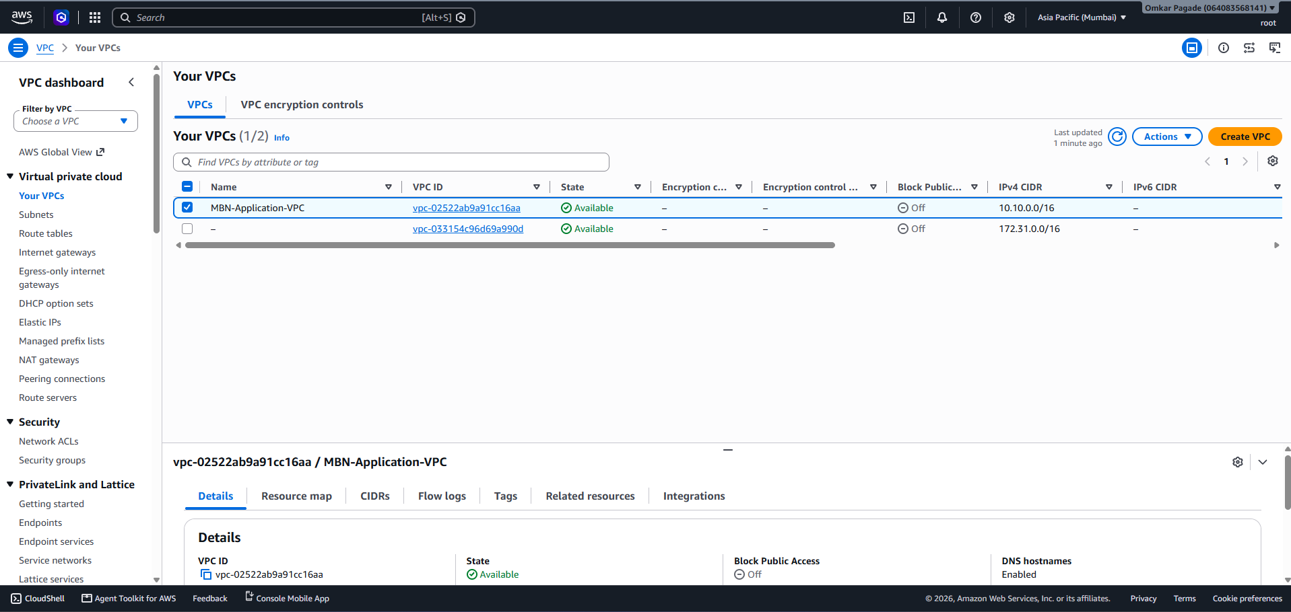
Evidence 2 — Subnet listing and subnet details (source document page 1).
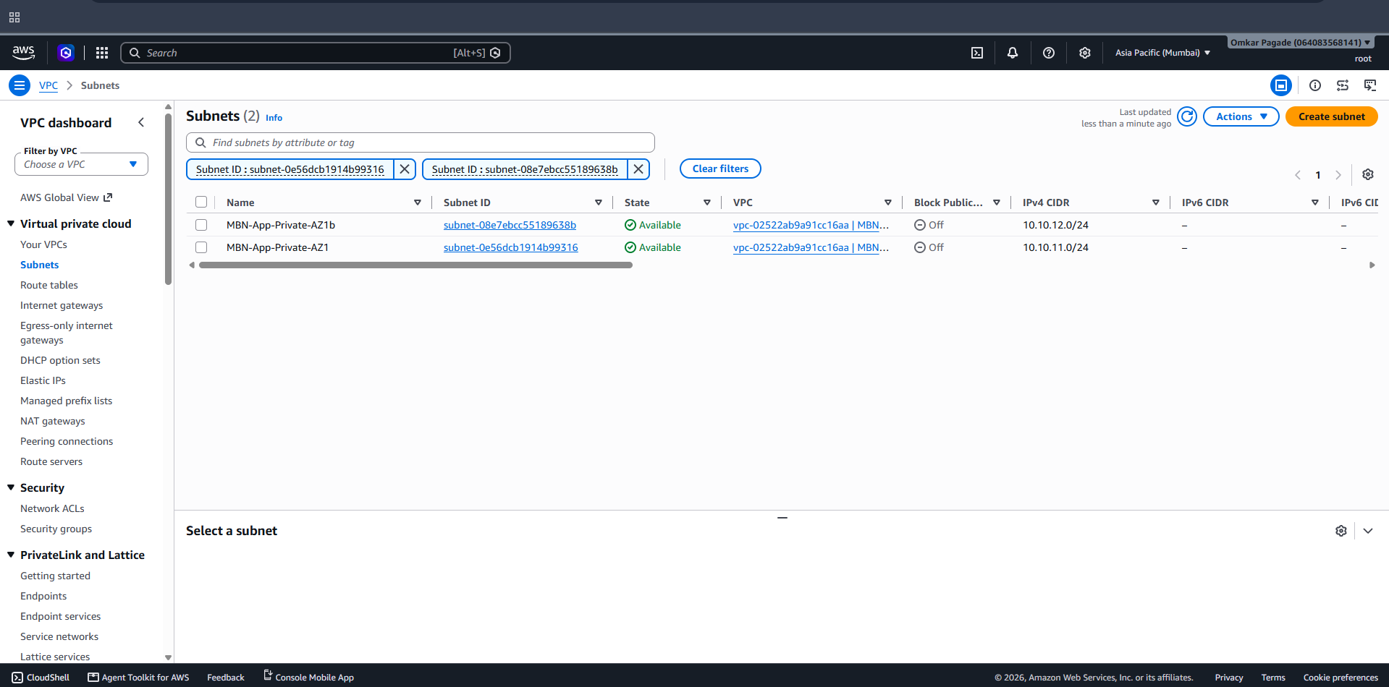
Evidence 3 — VPC inventory (source document page 2).
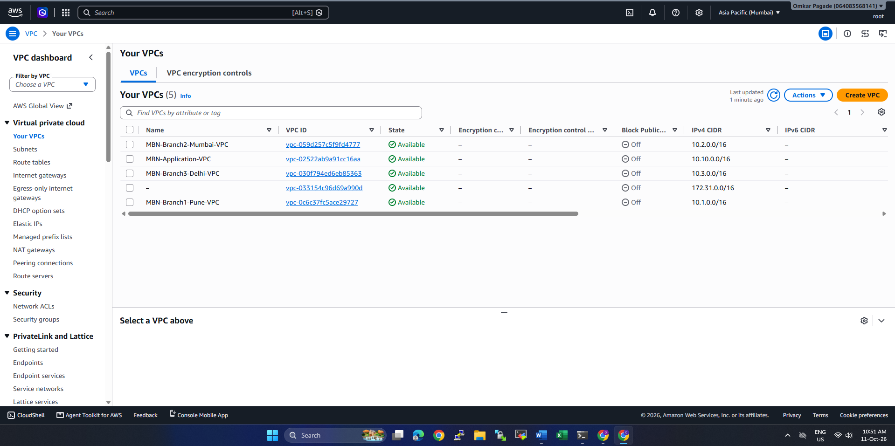
Evidence 4 — Subnet inventory / subnet creation evidence (source document page 2).
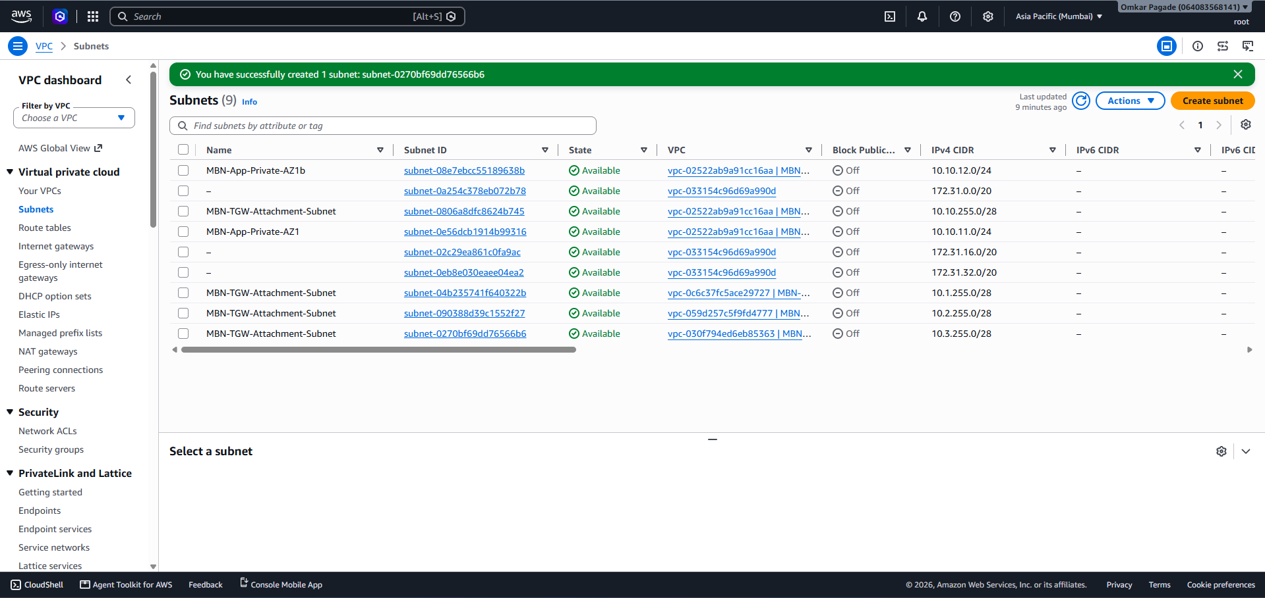
Evidence 5 — Transit Gateway inventory (source document page 3).
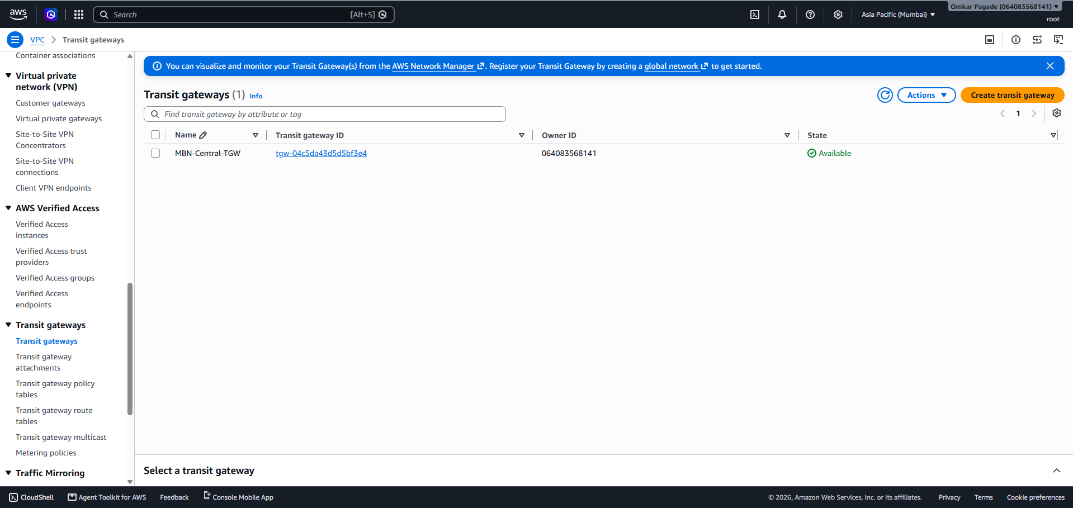
Evidence 6 — EC2 instance inventory and selected instance details (source document page 3).
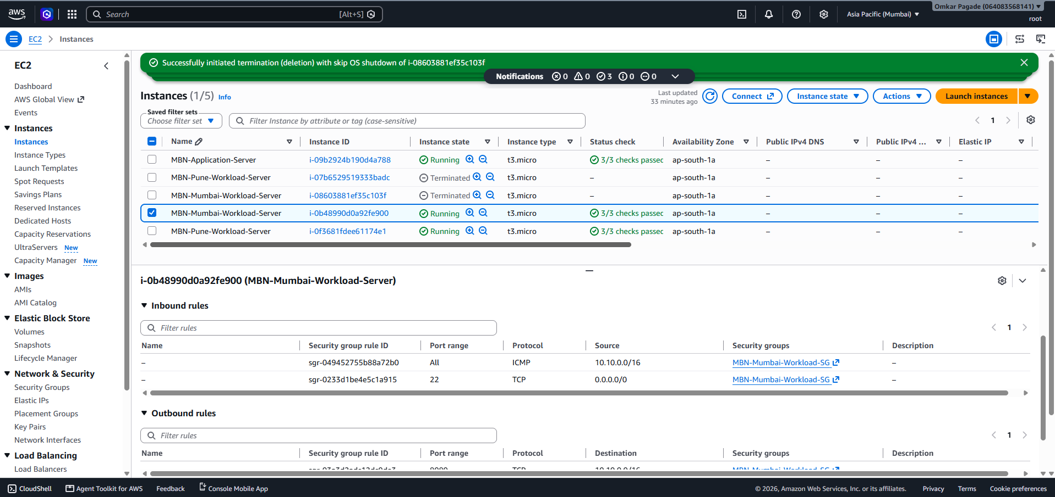
Evidence 7 — Transit Gateway route-table inventory (source document page 4).
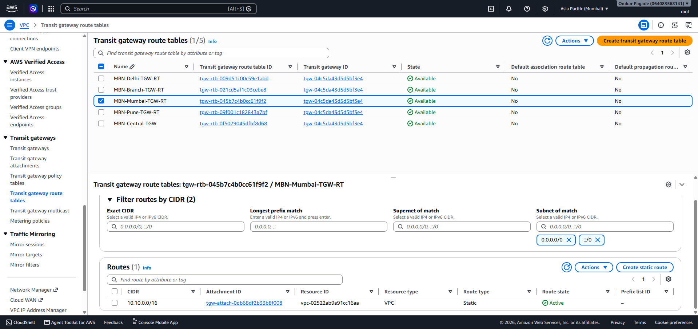
Evidence 8 — Pune EC2 ping test output (source document page 4).
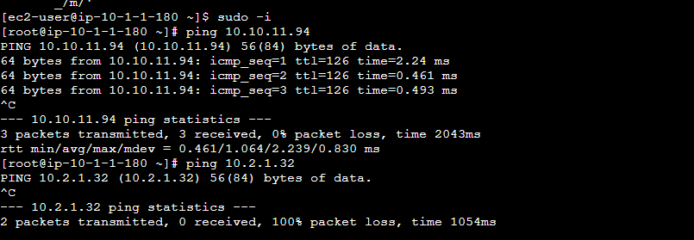
Evidence 9 — Application EC2 ping test output (source document page 4).
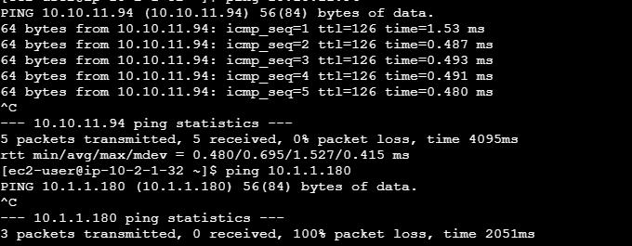
Evidence 10 — Application EC2 connectivity test output (source document page 5).
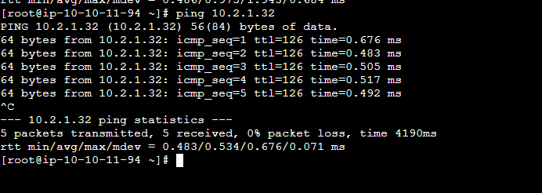
Evidence 11 — Branch-to-branch ping test output (source document page 5).
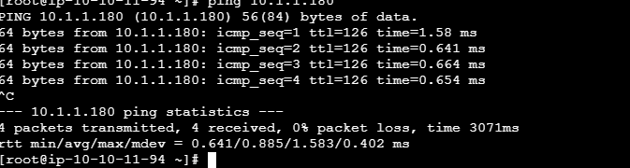
Evidence 12 — Additional branch connectivity test output (source document page 5).
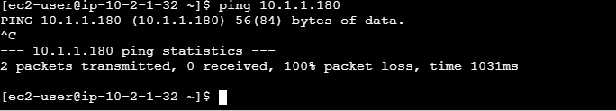
Evidence 13 — Additional terminal output from network testing (source document page 6).
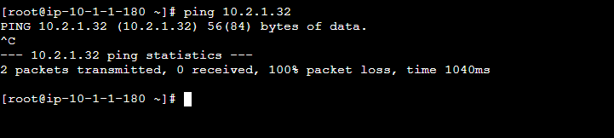
Evidence 14 — Additional terminal output / configuration evidence (source document page 6).
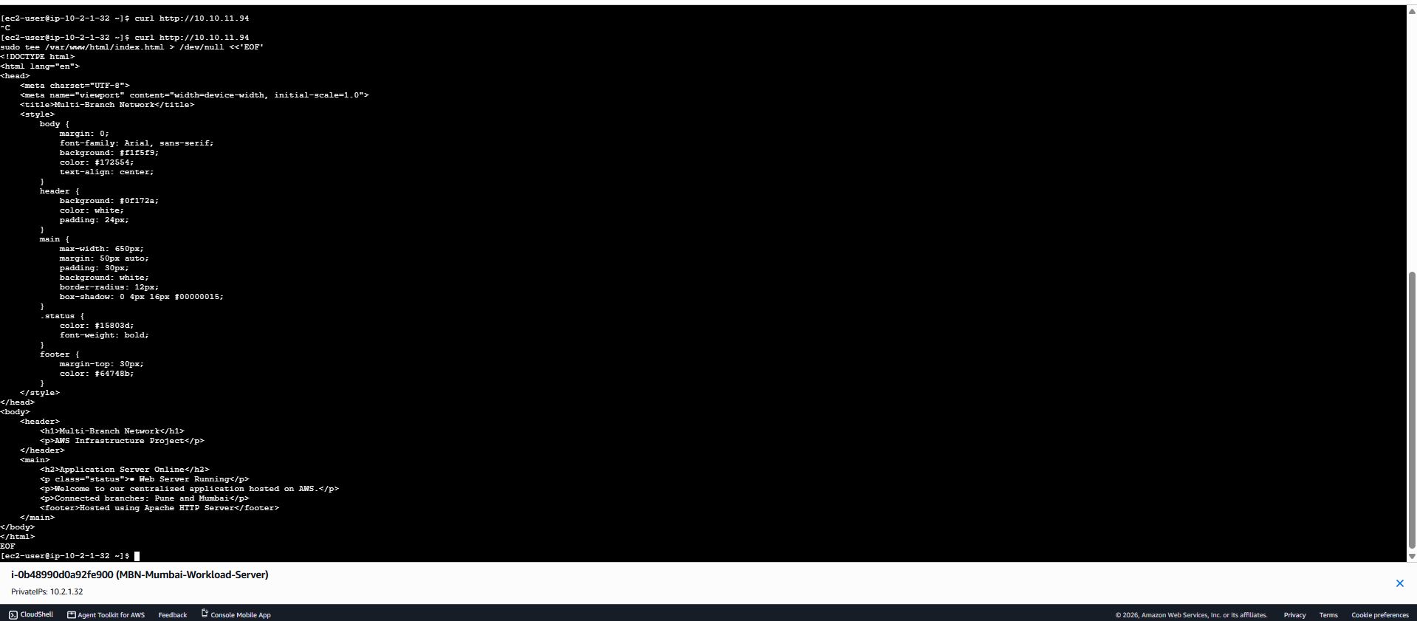
Evidence 15 — Additional terminal output / configuration evidence (source document page 6).
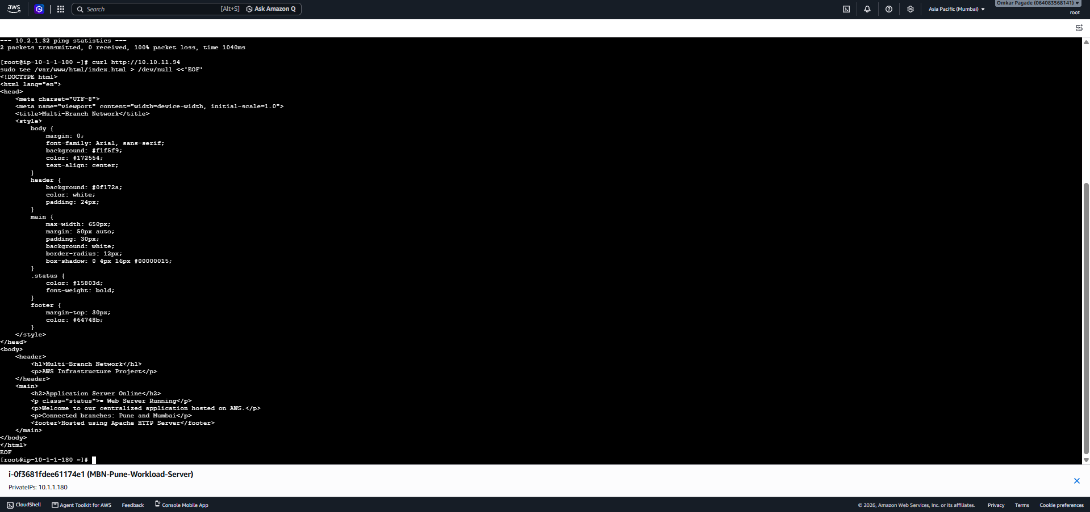

12. Recommended next actions
- Run explicit HTTP tests from Pune and Mumbai again and capture the terminal output with timestamps.
- Test branch isolation in both directions using routing evidence as well as traffic tests; record SG/NACL rules so a blocked ping is not mistaken for route isolation.
- Confirm Delhi routes and connectivity only if/when a Delhi workload is created.
- Tighten NACLs from allow-all to least-privilege rules after validating required traffic.
- Verify NAT Gateway egress with curl and package download, then review cost and remove the NAT Gateway if it is not required.
- Consider monitoring, backups, and multi-AZ/high-availability design before calling the setup production-ready.

13. Conclusion
The MBN project has achieved its core learning milestone: a centralized web application in the Application VPC is accessible from Pune and Mumbai through the Transit Gateway-based network. The supplied screenshots document the VPCs, subnets, Transit Gateway, route tables, EC2 inventory and ping tests. Branch isolation is a stated design goal but should be described as fully validated only after explicit peer-branch tests and route-table review are captured. This document is an implementation record, not an AWS audit or guarantee of production readiness.

