Disaster Recovery Runbook
Manual recovery of the Apache web application from Mumbai to Singapore
Primary Region: Mumbai (ap-south-1) | DR Region: Singapore (ap-southeast-1)

1. Purpose
This runbook describes the manual recovery procedure for the project's static Apache web application. It is intended for a controlled learning exercise. Automatic failover, automated DNS changes, database restoration, and application-data replication are not configured in the current project.

2. Recovery objectives
Objective | Target / current status
RTO | Provisional target: restore the demo website within 60 minutes of declaring the primary unavailable. Actual RTO: not measured.
RPO — AMI-based app recovery | Recover the application files from the latest available copied AMI. Actual time gap between failure and AMI creation/copy must be recorded during a test.
RPO — S3 objects | Recover a retained previous object version. A time-based RPO has not been established.
RPO — AWS Backup | A completed EC2 image recovery point exists with 7-day retention selected. Restore validation is pending.
These are project targets, not guaranteed service levels. Record timestamps during the next exercise before claiming actual RTO/RPO.

3. Scope and assumptions
- Primary Region: Mumbai (ap-south-1).
- Recovery Region: Singapore (ap-southeast-1).
- Primary EC2: DR-primary-app-AZ1 (instance ID recorded as i-01d8da29a0cc81dea).
- Recovery EC2: DR-Singapore-Recovery-App-01.
- Recovery AMI: DR-Recovery-App-AMI-v1; it was confirmed Available in Singapore.
- Both instances are normally stopped between learning sessions to reduce compute charges.
- The recovery webpage was previously tested in a browser and updated to identify the DR environment.
- A new public IPv4 address may be assigned after an instance is stopped and started unless an Elastic IP is configured.

4. Trigger and authorization
This runbook is initiated by a human operator after observing that the primary application is unavailable or after a planned recovery test. CloudWatch alarms and automated failover triggers are not configured in this project. Confirm that the exercise is authorized and that the primary outage is real or intentionally simulated before changing traffic.

5. Manual recovery procedure
- Record the incident/test start time in UTC and local time, the symptom, and the person conducting the test.
- Open the AWS EC2 console and select Singapore (ap-southeast-1).
- Confirm that DR-Recovery-App-AMI-v1 is present and shows Available. If it is missing or not Available, stop and investigate before proceeding.
- Open EC2 → Instances and inspect DR-Singapore-Recovery-App-01. If it is Stopped, start it. If it does not exist, launch a new instance from DR-Recovery-App-AMI-v1 using DR-Singapore-VPC, DR-Singapore-Public-AZ1, and DR-Singapore-App-SG. Do not create a duplicate if the existing recovery instance is usable.
- Wait for the instance state to become Running and for EC2 status checks to pass. If checks fail, capture the error and troubleshoot before proceeding.
- Retrieve the current Public IPv4 address from the instance details. Do not reuse a previously recorded dynamic IP without verifying it.
- Confirm inbound security group rules allow HTTP on port 80 for the intended test audience and SSH only from an approved source IP. Do not open SSH to 0.0.0.0/0.
- Connect to the instance using the authorized SSH key if service checks are required. Never share or upload the private key.
- Run `sudo systemctl is-active httpd` and `curl -I http://localhost`. Expected service state is `active`; expected HTTP response is 200 OK.
- Open `http://CURRENT_PUBLIC_IP` in a browser and verify the page identifies `Environment: DISASTER RECOVERY` and `Region: ap-southeast-1 (Singapore)`.
- Record the successful browser verification time. Calculate measured RTO as recovery validation completion time minus the recorded incident/test start time.
- If this is a real service recovery, communicate the recovery endpoint to authorized stakeholders and perform any traffic/DNS change through the separately approved process. Automatic DNS failover is not part of this project.
- When testing is complete and the recovery instance is no longer needed, stop it (do not terminate it). Verify the instance state is Stopped.

6. S3 object-version recovery
- Open the project S3 bucket in Mumbai (ap-south-1). Keep Block Public Access enabled.
- Open the test object `dr-test.txt` and enable Show versions.
- Identify the version ID corresponding to the older test content and download that version.
- Open the downloaded file and confirm the expected previous content. Do not permanently delete versions.
- Record the test time, object key, version ID (avoid including sensitive data), and outcome.

7. AWS Backup recovery point
- Open AWS Backup in Mumbai (ap-south-1) → Vaults → Default.
- Confirm the EC2 image recovery point exists and status is Completed. The project screenshot showed one recovery point for DR-primary-app-AZ1, backup type Image.
- Do not delete the recovery point. A restore-from-AWS-Backup test has not yet been performed.
- If a restore test is planned, review the restore configuration and costs first; launch the restored resource only during an approved test window.

8. Rollback / return to primary
Return to Mumbai only after the primary application has been repaired and verified, data consistency has been assessed, and the owner authorizes the switch. Because this project has no automated traffic routing and no database replication, do not assume that DNS or application data will synchronize automatically. Record the chosen endpoint and the exact time of any manual change. Avoid running conflicting writable copies if future project extensions add stateful data.

9. Troubleshooting
Symptom | Checks / action
Recovery instance does not start | Confirm AMI Available, quota/instance capacity, subnet/VPC selection, and launch events; capture errors.
EC2 status checks fail | Review system/instance status checks and instance screenshot; do not declare recovery successful until checks pass.
SSH fails | Verify current public IP, key pair, username for Amazon Linux, route table, security group source CIDR, and that the private key is locally available.
Website does not load | Check httpd service, `curl -I http://localhost`, inbound TCP 80 rule, public IPv4 assignment, public route to IGW, and NACLs.
AMI missing in Singapore | Confirm console region is ap-southeast-1 and AMI filter is Owned by me; verify copy completed.
S3 older version unavailable | Confirm versioning is enabled, Show versions is on, and the expected version has not expired or been permanently deleted.

10. Test record template
Field | Value to record during each exercise
Test / incident ID | ____________________________
Start time (UTC) | ____________________________
Start time (local) | ____________________________
Primary failure symptom | ____________________________
Recovery instance start time | ____________________________
HTTP 200 / browser validation time | ____________________________
Measured RTO | ____________________________
Latest recoverable AMI timestamp | ____________________________
Measured RPO / data gap | ____________________________
Result and observations | ____________________________
Operator / reviewer | ____________________________

11. Safety and cost checklist
- Do not terminate instances as part of this runbook; stop them when not needed.
- Remember that EBS volumes, AMI snapshots, and AWS Backup recovery points can continue to incur storage charges.
- Check the current public IPv4 address after start; dynamic addresses can change.
- Keep S3 private and never put SSH private keys in documentation or GitHub.
- Review billing before launching additional resources or testing restores.
- Do not report automatic failover as implemented.

12. Evidence references
The supplied file screenshotforreference.docx contains console screenshots of EC2 instances, AMIs, VPC/subnet/route-table views, S3, AWS Backup jobs, and the Default vault recovery point. The project owner should retain that original evidence file with this runbook. For a formal exercise, add timestamped screenshots of the actual recovery test and measured timings.

Selected console evidence 1
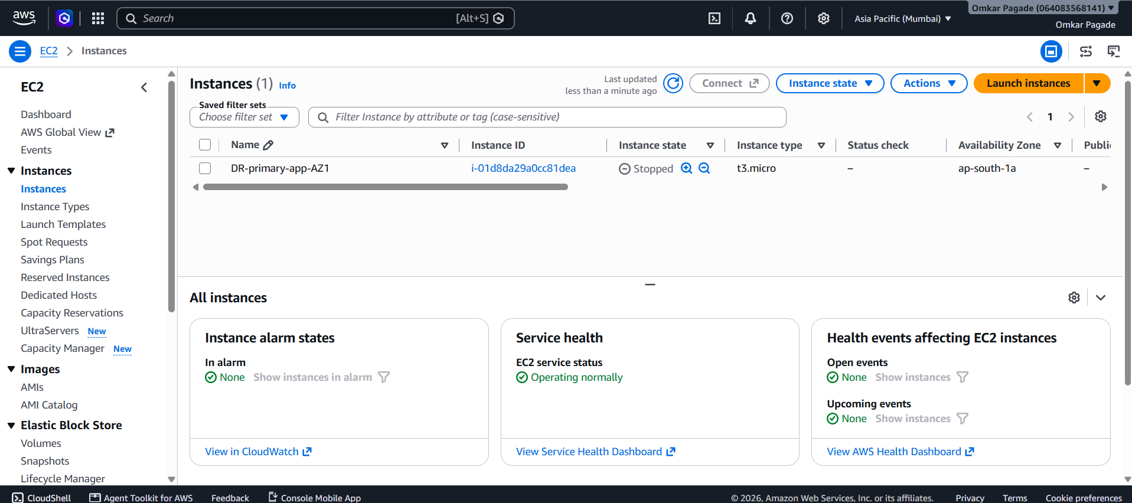
Selected image extracted from screenshotforreference.docx.

Selected console evidence 2
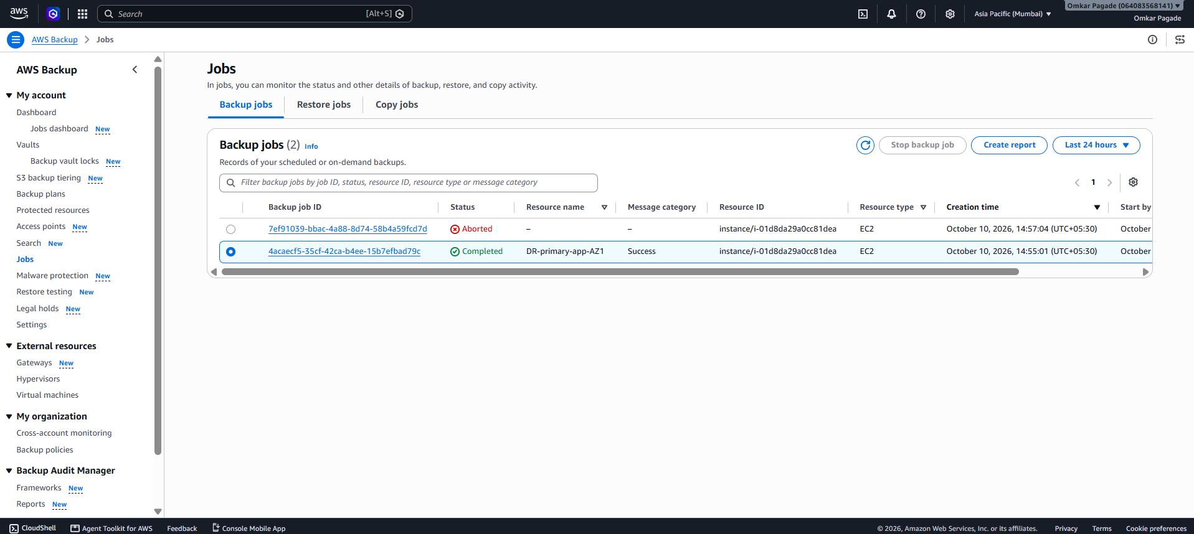
Selected image extracted from screenshotforreference.docx.

Selected console evidence 3
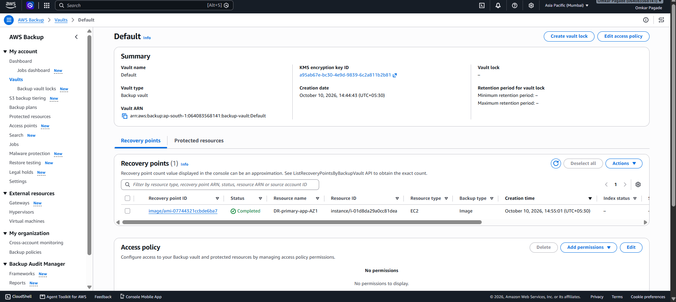
Selected image extracted from screenshotforreference.docx.

