AWS SERVERLESS MONITORING APPLICATION
Project Documentation & GitHub Portfolio Guide
Technologies demonstrated: Amazon S3 • Amazon CloudFront • AWS Lambda • Amazon DynamoDB
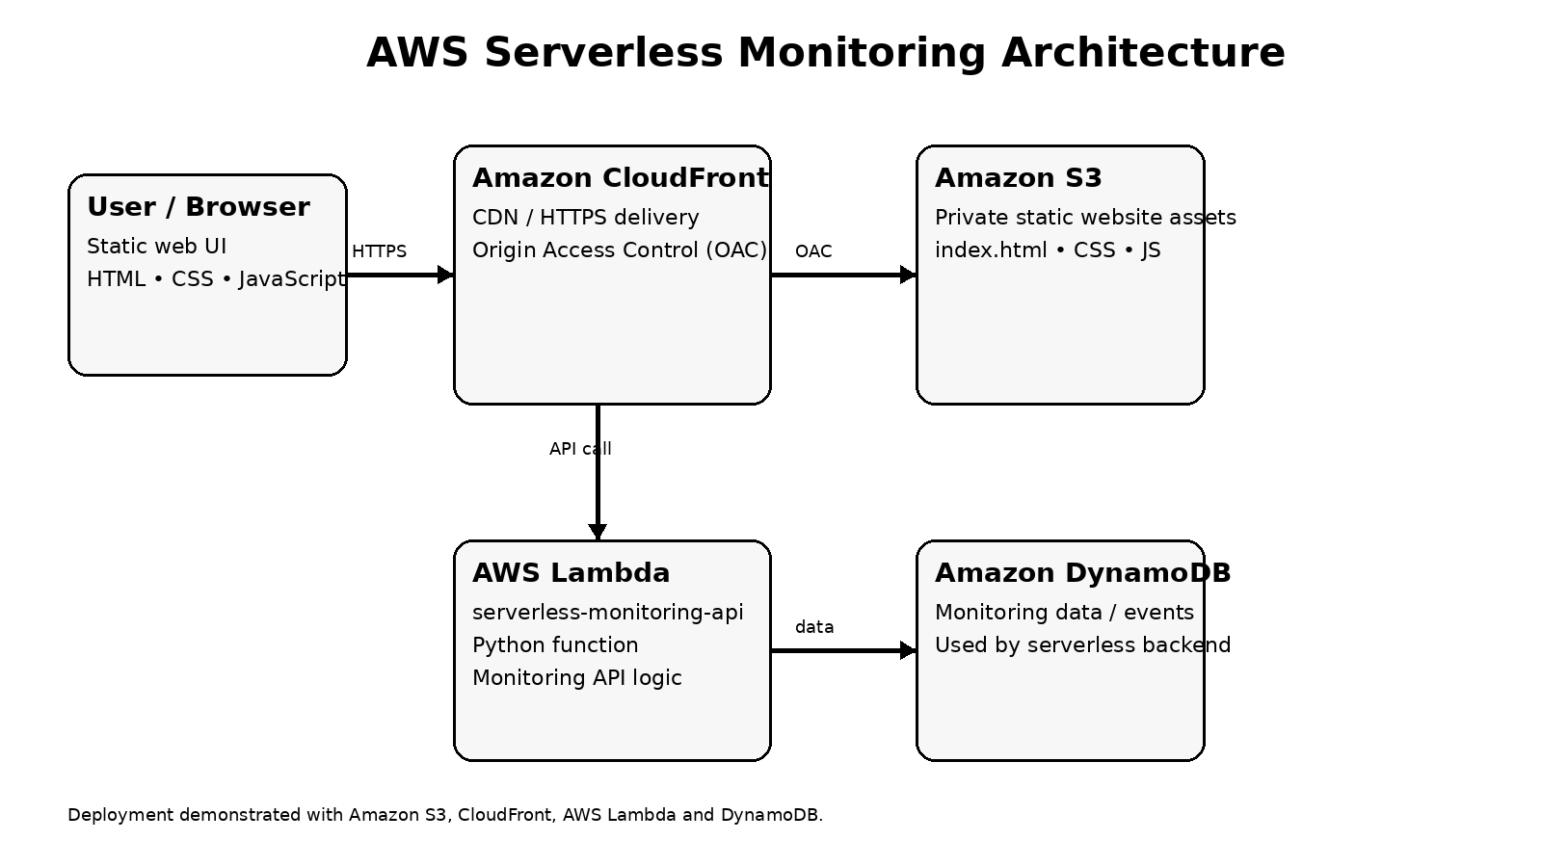
Figure 1 — High-level architecture reconstructed from the project screenshots and workflow.

1. Project Overview
This project demonstrates a serverless web application hosted using AWS managed services. The frontend is stored in Amazon S3 and delivered through Amazon CloudFront. CloudFront is configured to access the S3 origin using Origin Access Control (OAC), keeping the origin protected. An AWS Lambda function named serverless-monitoring-api provides serverless backend/API logic. DynamoDB is used with the backend for monitoring-related data in the implemented workflow.

2. Project Objectives
- Host a static web frontend without managing web servers.
- Deliver frontend content globally through Amazon CloudFront.
- Protect the S3 origin using CloudFront Origin Access Control (OAC).
- Implement backend logic using AWS Lambda without provisioning servers.
- Use DynamoDB as the serverless data layer for the monitoring workflow.
- Create an architecture that can be extended with monitoring, alerts, authentication and additional AWS services.

3. AWS Services Used
Service | Role | Implementation Evidence
Amazon S3 | Stores static frontend files | Screenshots on pages 1–3
Amazon CloudFront | CDN and secure delivery of S3 content | Screenshots on pages 3–5
Origin Access Control (OAC) | Restricts direct origin access and lets CloudFront access S3 | CloudFront origin configuration shown on page 4
AWS Lambda | Runs serverless backend/API logic | Lambda console and test/code screenshots on pages 5–6
Amazon DynamoDB | Serverless data store used by the monitoring backend workflow | Used in the implemented project workflow

4. Implementation Walkthrough

4.1 Create the S3 bucket
The screenshots show creation of an S3 bucket and configuration of the bucket's access settings. The bucket is used to hold the static frontend assets.

4.2 Upload frontend files
The S3 object view shows frontend files uploaded to the bucket. These files form the static web interface.

4.3 Configure CloudFront
A CloudFront distribution is configured with the S3 bucket as its origin. The screenshots show the distribution configuration and origin settings.

4.4 Configure Origin Access Control
The CloudFront origin configuration uses OAC so the distribution can securely access the S3 origin rather than relying on a public S3 website endpoint.

4.5 Create the Lambda backend
The project includes a Python Lambda function named serverless-monitoring-api. The Lambda console and test interface are shown in the final screenshots.

4.6 Connect the serverless data layer
The implemented workflow uses DynamoDB for monitoring-related data. This keeps the application serverless and removes the need for a traditional database server.

5. Request / Data Flow
- User opens the application URL in a browser.
- CloudFront receives the request and serves the frontend content.
- CloudFront retrieves the static files from the protected S3 origin using OAC when required.
- The frontend invokes the serverless backend/API functionality.
- AWS Lambda executes the Python backend logic.
- The backend reads or writes monitoring data through DynamoDB as required by the application workflow.
- The Lambda response is returned to the frontend and displayed to the user.

6. Security Design
- S3 should not be treated as a public web server when CloudFront OAC is being used.
- CloudFront OAC provides controlled access from the distribution to the S3 origin.
- Lambda execution should use an IAM role with least-privilege permissions.
- DynamoDB permissions should be limited to the tables and operations required by the Lambda function.
- Secrets, access keys and sensitive configuration must never be committed to GitHub.

7. Availability, Scalability and Cost
The architecture uses managed/serverless services, so there is no traditional web server to patch or maintain. CloudFront can distribute static content at the edge, Lambda runs backend code on demand, and DynamoDB provides a managed NoSQL data layer. Actual cost depends on traffic, requests, data transfer, Lambda execution, CloudFront usage, and DynamoDB usage.

8. Testing & Validation
- Verify the S3 bucket contains the expected frontend files.
- Open the CloudFront distribution URL and confirm the frontend loads.
- Confirm CloudFront can access the S3 origin through OAC.
- Invoke/test the Lambda function and verify the expected response.
- Verify DynamoDB operations used by the monitoring workflow.
- Check CloudWatch logs when troubleshooting Lambda execution.

9. Troubleshooting Notes
CloudFront returns 403: Check S3 bucket policy/OAC relationship, CloudFront origin configuration, object path and distribution deployment status.
Frontend does not load: Check that the requested object exists in S3 and that CloudFront is pointing to the correct origin.
Lambda returns 500: Check CloudWatch logs, IAM permissions, environment/configuration values, request payload and DynamoDB data types.
DynamoDB data-type error: Validate the data types sent by the Lambda function. DynamoDB numeric values must use supported DynamoDB number handling rather than unsupported floating-point representations.

10. Project Limitations / Future Enhancements
- Add Amazon API Gateway for a formal HTTPS API layer if the application requires a public API endpoint.
- Add Amazon CloudWatch dashboards and alarms for operational monitoring.
- Add SNS notifications for critical monitoring events.
- Add authentication and authorization if the monitoring dashboard will be exposed to users.
- Add infrastructure-as-code using Terraform or AWS CloudFormation for repeatable deployment.
- Add CI/CD using GitHub Actions for automated S3, CloudFront and Lambda deployments.
- Add automated tests and structured application logging.
- Add backup/retention strategy for DynamoDB and other persistent data where required.

11. GitHub Repository Structure
serverless-monitoring/
├── frontend/
│ ├── index.html
│ ├── style.css
│ └── script.js
├── lambda/
│ └── serverless-monitoring-api.py
├── architecture/
│ └── aws-serverless-architecture.png
├── docs/
│ └── AWS_Serverless_Monitoring_Project_Documentation.docx
├── README.md
└── .gitignore

12. Portfolio / LinkedIn Description
Built an AWS serverless monitoring application using Amazon S3, CloudFront, AWS Lambda and DynamoDB. The static frontend is securely delivered through CloudFront with Origin Access Control (OAC), while Lambda provides backend logic and DynamoDB supports the monitoring data workflow. This project demonstrates serverless architecture, secure object delivery, managed compute, NoSQL data storage and cloud troubleshooting.

13. Evidence from the Uploaded Project Record
The uploaded six-page project record is screenshot-based and contains no machine-readable text. The screenshots show S3 bucket creation/configuration and uploaded objects on pages 1–3, CloudFront origin/distribution configuration on pages 3–5, and AWS Lambda creation/testing on pages 5–6. fileciteturn0file0L2-L7

14. Recommended GitHub README
A ready-to-use README is provided as a separate README.md file generated with this documentation package.

