PROJECT DOCUMENTATION

AWS Secure VPC — Private Application Network with Zero Public Servers
AWS Networking • Cloud Security • Multi-AZ Application Delivery

Project owner | Omkar Pagade
Region | Asia Pacific (Mumbai) — ap-south-1
VPC CIDR | 10.0.0.0/16
Status | Core deployment and reported connectivity/security tests completed; HTTPS, VPC endpoints, and Flow Logs are optional enhancements unless separately enabled

1. Executive Summary
This project implements a three-tier AWS network in which the public entry point is an internet-facing Application Load Balancer (ALB), while the application EC2 instances and Amazon RDS MySQL database remain in private subnets without public IPv4 exposure. The VPC spans two Availability Zones, separates public, application, and database subnets, and uses route tables and security groups to control traffic.
Administration of the Amazon Linux 2023 instances is performed through AWS Systems Manager Session Manager, avoiding the need to expose SSH. The ALB forwards HTTP requests to two Apache web servers. The application security group permits web traffic from the ALB security group, and the RDS security group permits MySQL traffic from the application security group.

2. Why This Use Case Matters
- Reduce attack surface: application and database instances do not need public IP addresses or public inbound management ports.
- Layered network controls: separate subnets, route tables, and security groups isolate the internet-facing tier from application and database tiers.
- High availability foundation: the ALB is mapped to two Availability Zones and can route requests to two registered application targets. Application resilience depends on both targets remaining healthy.
- Safer administration: Session Manager uses IAM authorization and the SSM Agent rather than requiring inbound SSH from an administrator's IP.
- Controlled data access: RDS is configured as private and accepts MySQL connections from the application security group, not arbitrary internet sources.
- Practical operations learning: the build demonstrates routing, target health checks, private connectivity, managed database access, and cost-aware resource management.

3. Architecture Overview
Logical architecture (the actual deployed resources should be cross-checked against the AWS console before production use):
Internet users
|
| HTTP :80 (current lab listener; HTTPS is a recommended enhancement)
v
Internet-facing Application Load Balancer
Public-AZ-A (10.0.1.0/24) + Public-AZ-B (10.0.2.0/24)
|
| ALB security group -> application security group, TCP :80
v
Private application tier (no public IPv4 addresses)
+-- Omkar-Private-App-AZ-A | 10.0.11.0/24 | Amazon Linux 2023 + Apache
+-- Omkar-Private-App-AZ-B | 10.0.12.0/24 | Amazon Linux 2023 + Apache
|
| Application security group -> RDS security group, TCP :3306
v
Private Amazon RDS for MySQL
+-- Private-DB-AZ-A | 10.0.21.0/24
+-- Private-DB-AZ-B | 10.0.22.0/24
Private application outbound traffic (when needed):
Private-App-RT -> NAT Gateway in Public-AZ-A -> Internet Gateway -> Internet
Administration:
Authorized administrator -> AWS Systems Manager Session Manager -> private EC2
(no inbound SSH rule / no EC2 public IP required)
Note: the current lab listener was tested over HTTP port 80. For a production deployment, use HTTPS with an ACM certificate, redirect HTTP to HTTPS, and review authentication, application secrets, patching, WAF needs, logging, backup, and recovery requirements.

4. Network Address Plan
Subnet name | CIDR | Tier | Purpose
Public-AZ-A | 10.0.1.0/24 | Public | ALB
Public-AZ-B | 10.0.2.0/24 | Public | ALB
Private-App-AZ-A | 10.0.11.0/24 | Private | EC2 application server A
Private-App-AZ-B | 10.0.12.0/24 | Private | EC2 application server B
Private-DB-AZ-A | 10.0.21.0/24 | Private | RDS subnet group
Private-DB-AZ-B | 10.0.22.0/24 | Private | RDS subnet group

The VPC CIDR is 10.0.0.0/16. Each /24 subnet contains 256 IPv4 addresses, with five IPv4 addresses reserved by AWS per subnet. Confirm the actual Availability Zone IDs/names selected in the account; AZ suffixes can map differently between accounts.

5. Resource Inventory
Resource | Name / identifier | Configuration | Purpose
VPC | Omkar-Secure-VPC | 10.0.0.0/16 | Isolated network boundary
Internet Gateway | Omkar-Secure-IGW | — | Internet route target for public subnets
Public route table | Omkar-Public-RT | 0.0.0.0/0 -> IGW; local VPC route | Associated with both public subnets
Application route table | Omkar-Private-App-RT | 0.0.0.0/0 -> NAT Gateway; local VPC route | Associated with both private application subnets
Database route table | Omkar-Private-DB-RT | Local VPC route only | Associated with both private database subnets
NAT Gateway | Omkar-NAT-AZ-A | Public-AZ-A | Outbound internet for private application tier
ALB | Omkar-Public-ALB | Internet-facing; HTTP :80 in lab | Entry point for web requests
Target group | Omkar-App-TG | HTTP :80; health path / | Contains both private EC2 targets
EC2 | Omkar-Private-App-AZ-A / AZ-B | Amazon Linux 2023 + Apache | Private application tier
RDS | omkar-private-mysql | MySQL :3306; private | Managed relational database
DB subnet group | omkar-private-db-subnet-group | Private-DB-AZ-A and AZ-B | Subnets available to RDS
IAM role | Omkar-EC2-SSM-Role | AmazonSSMManagedInstanceCore | Allows EC2 SSM Agent to communicate with Systems Manager
ALB security group | Omkar-ALB-SG | Inbound HTTP :80 from internet for lab; outbound to app :80 | Controls entry-point traffic
App security group | Omkar-Private-App-SG | Inbound HTTP :80 from Omkar-ALB-SG | Prevents direct public HTTP access to EC2
RDS security group | Omkar-RDS-SG | Inbound MySQL :3306 from Omkar-Private-App-SG | Restricts database access to application tier

6. Routing Design
Route table | Subnet associations | Expected routes | Design reason
Omkar-Public-RT | Public-AZ-A, Public-AZ-B | 10.0.0.0/16 -> local; 0.0.0.0/0 -> Omkar-Secure-IGW | Allows internet-facing ALB subnets to use the IGW; public IPv4 and security rules are still required for internet reachability.
Omkar-Private-App-RT | Private-App-AZ-A, Private-App-AZ-B | 10.0.0.0/16 -> local; 0.0.0.0/0 -> Omkar-NAT-AZ-A | Allows private application servers to initiate outbound internet connections without assigning public IPv4 addresses.
Omkar-Private-DB-RT | Private-DB-AZ-A, Private-DB-AZ-B | 10.0.0.0/16 -> local only | Database tier has no default route to IGW or NAT Gateway.

Design trade-off: a single NAT Gateway is cheaper than deploying one per AZ but creates an AZ dependency and can incur cross-AZ data-transfer costs. For production resilience, consider one NAT Gateway per AZ or use appropriate VPC endpoints for supported AWS services. VPC endpoints were not assumed to be deployed in this project.

7. Traffic Flow
- User to application: internet client -> ALB DNS name -> ALB listener on HTTP :80 -> target group Omkar-App-TG -> healthy private EC2 target on HTTP :80.
- Application to database: private EC2 -> RDS private endpoint on TCP :3306; Omkar-RDS-SG allows inbound MySQL only from Omkar-Private-App-SG.
- Administration: authorized IAM principal -> Systems Manager Session Manager -> SSM Agent on EC2. No inbound SSH rule is required.
- Private outbound traffic: application subnet -> Omkar-Private-App-RT -> NAT Gateway in Public-AZ-A -> Internet Gateway -> external destination, when needed.
- Database routing: RDS subnets use Omkar-Private-DB-RT with only the VPC local route; RDS public accessibility is disabled.

8. Security Controls
Control | Implemented configuration / intended rule | Security benefit
No public app IPs | Both EC2 application instances have no public IPv4 address (verified by user). | Prevents direct public addressing of application servers.
ALB security group | Omkar-ALB-SG accepts HTTP :80 from the internet for lab testing; outbound traffic to targets is permitted. | Creates a single controlled web entry point.
Application security group | Omkar-Private-App-SG inbound HTTP :80 source is Omkar-ALB-SG; no inbound SSH rule. | Only the load balancer can initiate web traffic to the instances.
RDS security group | Omkar-RDS-SG inbound MySQL :3306 source is Omkar-Private-App-SG. | Restricts database access to the application tier.
RDS private access | Publicly accessible set to No; RDS is in the DB subnet group. | Avoids a public database endpoint.
Database routes | Omkar-Private-DB-RT has only the local VPC route. | No direct default route from database subnets to IGW or NAT.
Session Manager | EC2 role Omkar-EC2-SSM-Role includes AmazonSSMManagedInstanceCore. | Enables managed access without public SSH.
IAM least privilege | The EC2 role allows SSM agent operations; administrator identities still need permission to start sessions. | Separates instance permissions from human operator permissions.
Secrets | Database password is not included in this document or repository. | Avoids publishing credentials.

9. Implementation Procedure (Reproducible Summary)
- Create Omkar-Secure-VPC with CIDR 10.0.0.0/16 in ap-south-1.
- Create the six /24 subnets listed in Section 4 across two distinct Availability Zones.
- Create and attach Omkar-Secure-IGW. Create Omkar-Public-RT, add the default route to the IGW, and associate both public subnets.
- Create Omkar-Private-App-RT and associate both private application subnets. Create Omkar-Private-DB-RT and associate both database subnets.
- Create Omkar-NAT-AZ-A in Public-AZ-A, allocate an Elastic IP, wait for Available, and route the application route table's 0.0.0.0/0 to the NAT Gateway.
- Create Omkar-EC2-SSM-Role with AmazonSSMManagedInstanceCore.
- Launch two Amazon Linux 2023 EC2 instances in the two private application subnets with public IP assignment disabled, the SSM role attached, and Omkar-Private-App-SG attached.
- Use Session Manager to install Apache (httpd), enable/start the service, create a different test page on each instance, and verify with curl http://localhost.
- Create Omkar-ALB-SG and Omkar-Private-App-SG with the source-restricted rules described in Section 8.
- Create target group Omkar-App-TG using HTTP :80 and health check path /. Register both EC2 instances.
- Create internet-facing Omkar-Public-ALB across both public subnets, associate Omkar-ALB-SG, and forward the HTTP :80 listener to Omkar-App-TG.
- Create DB subnet group omkar-private-db-subnet-group with both private database subnets.
- Create private RDS MySQL instance omkar-private-mysql with public accessibility disabled and Omkar-RDS-SG allowing TCP :3306 from Omkar-Private-App-SG.
- Test ALB DNS access, target health, TCP reachability to RDS port 3306, and database login/SQL queries from a private EC2 instance.

10. Validation and Test Results
Test | Expected result | Reported result
Session Manager connection to EC2 | Terminal opens without SSH/public IP | Successful
Apache local test | curl http://localhost returns page content | Successful on both application servers
ALB DNS test | Page served through ALB | Successful
ALB target health | Both EC2 targets Healthy | Both reported healthy
EC2 to RDS TCP :3306 | TCP connection succeeds | Ncat connected to private IP 10.0.22.174:3306
Database authentication and SQL | MySQL login and test queries succeed | Reported successful
Security audit | No EC2 public IP; RDS private; security group sources restricted; DB route local only | All 5 checklist items reported verified

These results are based on the user's reported console checks and command output; they were not independently queried from the AWS account. Keep screenshots or fresh console exports with the repository as evidence, after redacting account IDs, public addresses where unnecessary, and all secrets.

11. Cost Considerations
No fixed project cost is stated because AWS pricing depends on region, instance class, hours running, storage, data transfer, NAT usage, ALB capacity, backup retention, and account-specific Free Tier or promotional eligibility. Check AWS Billing and Cost Management -> Bills and Cost Explorer for actual charges.
Cost driver | Why it can cost money | Cost-control approach
Two EC2 instances | Compute hours and EBS volumes | Stop instances when not in use; EBS storage may still be billed.
NAT Gateway | Hourly charge plus data processing; may charge while EC2 is stopped | Delete when not needed, or compare supported VPC endpoints for AWS service traffic. Record configuration before deletion.
Application Load Balancer | Load balancer hours and capacity-unit usage | Delete for long idle periods if you can recreate it; stopped EC2 does not stop ALB charges.
RDS MySQL | DB instance hours, storage, backups, I/O depending on configuration | Use a small eligible dev class, monitor storage/backups, and stop when not needed; stopped DB instances may restart automatically after seven days.
Elastic IP | May incur charges depending on allocation and association state | Release unused Elastic IPs after deleting dependent NAT resources.
CloudWatch / Flow Logs | Metrics, log ingestion, retention and queries can incur charges | Use only needed logs, set retention, and review usage.
Data transfer | Cross-AZ traffic and internet data transfer can incur charges | Avoid unnecessary cross-AZ traffic; evaluate production resilience versus cost.

Suggested lab shutdown decision: first save the architecture, subnet/route/security-group details, target group and ALB settings, RDS configuration, and evidence screenshots. Then choose either (a) keep the environment active for demonstrations and accept ongoing charges, or (b) delete billable resources in a planned order and rebuild later. Stopping EC2 alone is not a complete cost shutdown.

12. Limitations and Recommended Enhancements
- Enable HTTPS using AWS Certificate Manager and configure an HTTP-to-HTTPS redirect. The current test listener uses HTTP.
- Consider AWS WAF, application authentication, secure secrets management, patch management, and tighter administrator IAM permissions for production.
- The NAT Gateway is in one AZ. Production designs may use one per AZ for resilience, or use appropriate VPC endpoints to reduce NAT dependency.
- RDS subnet group spans two AZs, but that alone does not mean the database deployment is Multi-AZ. Confirm the DB deployment setting; Multi-AZ has additional cost.
- Add VPC Flow Logs with a deliberate retention period if network-level investigation is required.
- Use automated backups and test restore procedures; define RTO and RPO if this system has business continuity requirements.
- Use infrastructure as code (CloudFormation or Terraform) to make the environment repeatable.
- Use an actual application with health endpoints and database integration instead of static test pages for an end-to-end demo.

13. Suggested Interview Talking Points
- Why are public and private subnets separate, and what makes a subnet public?
- Why does an ALB require subnets in at least two Availability Zones, and how is that different from having two healthy targets?
- How does a security-group reference restrict EC2 inbound traffic to the ALB?
- Why can EC2 connect to RDS even though RDS has no internet route?
- What is the difference between a NAT Gateway and an Internet Gateway?
- Why can a NAT Gateway still incur charges when EC2 is stopped?
- How does Session Manager work, and what IAM permissions are needed on the instance versus the administrator?
- What is the difference between a DB subnet group spanning two AZs and a Multi-AZ RDS deployment?
- How would you enable HTTPS, logging, backups, and production-grade high availability?

14. Evidence Screenshots
The following screenshots were carried over from the source document supplied with the project. They show console evidence for the VPC resource map, EC2 instances, Session Manager, RDS and DB subnet group, and test web pages. Before public publication, review each screenshot for account IDs, ARNs, public IP addresses, endpoints, or other identifiers you do not want to share.
Evidence image 1 — AWS resource map / VPC network layout.
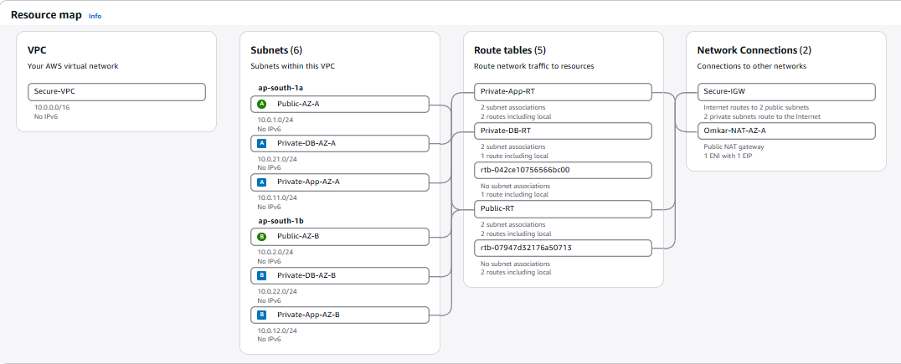
Evidence image 2 — VPC console overview.
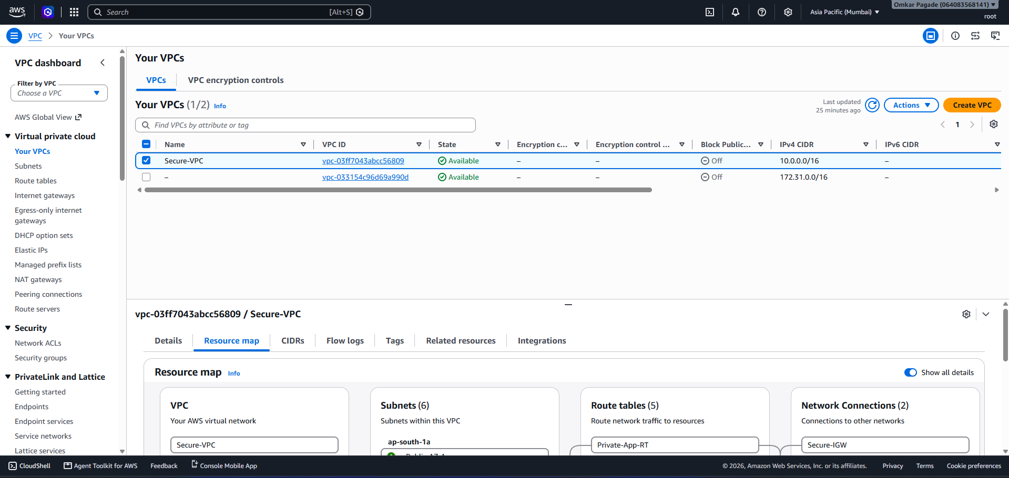
Evidence image 3 — EC2 instances in the project.
Evidence image 4 — Systems Manager Session Manager console.
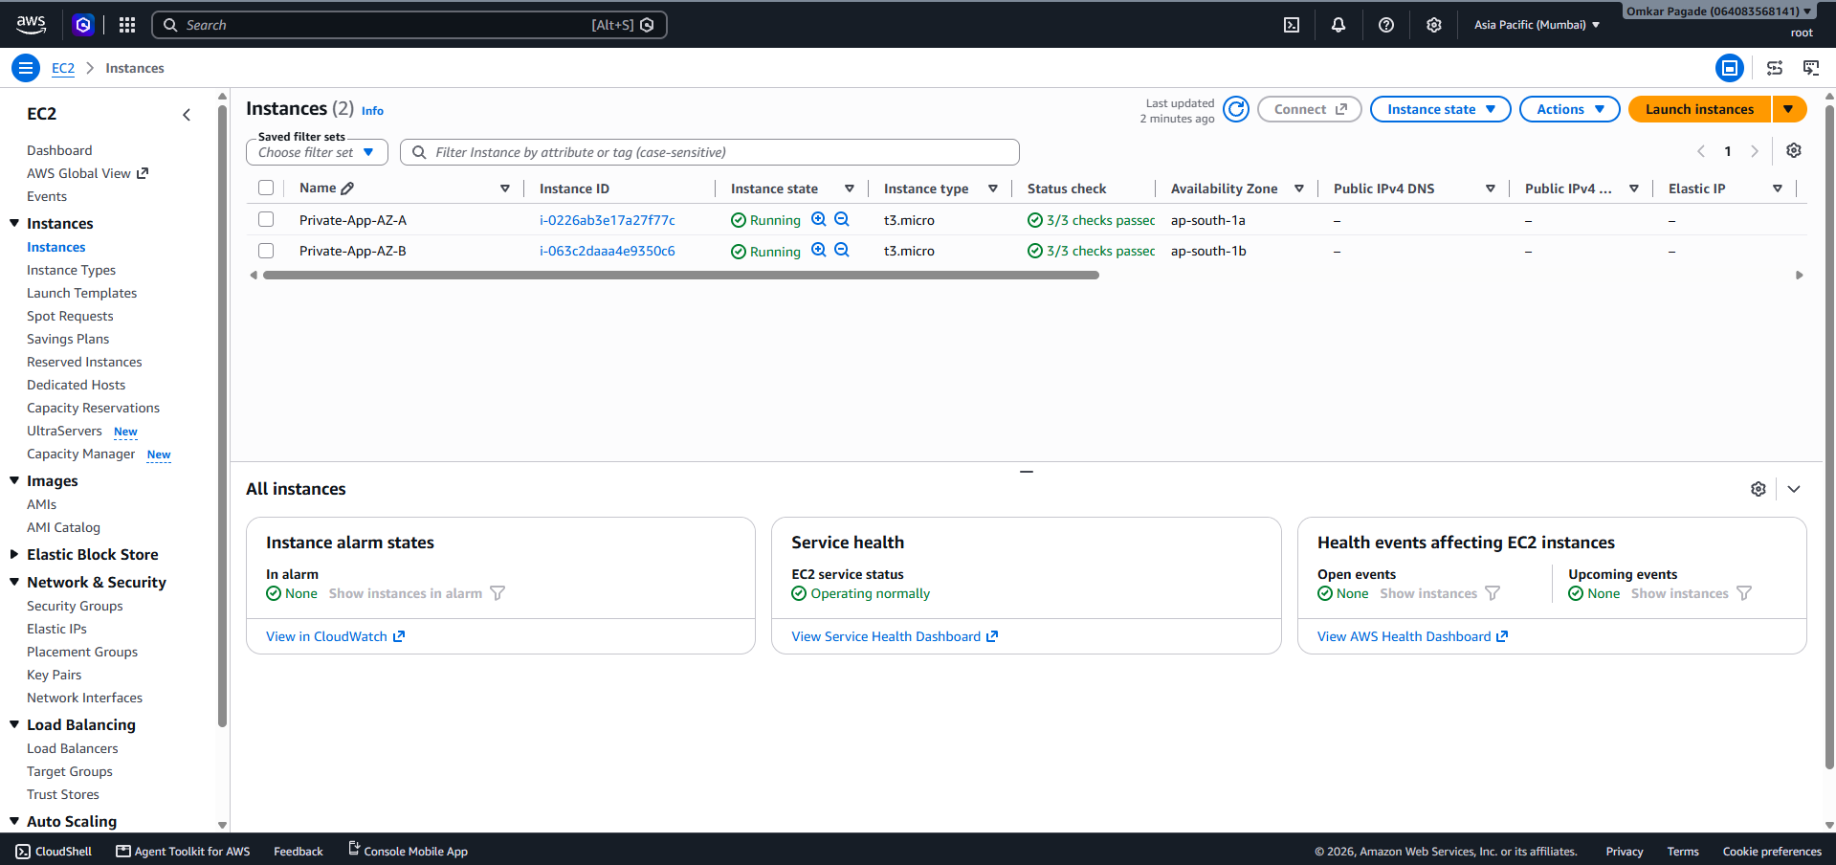
Evidence image 5 — RDS database and subnet group overview.
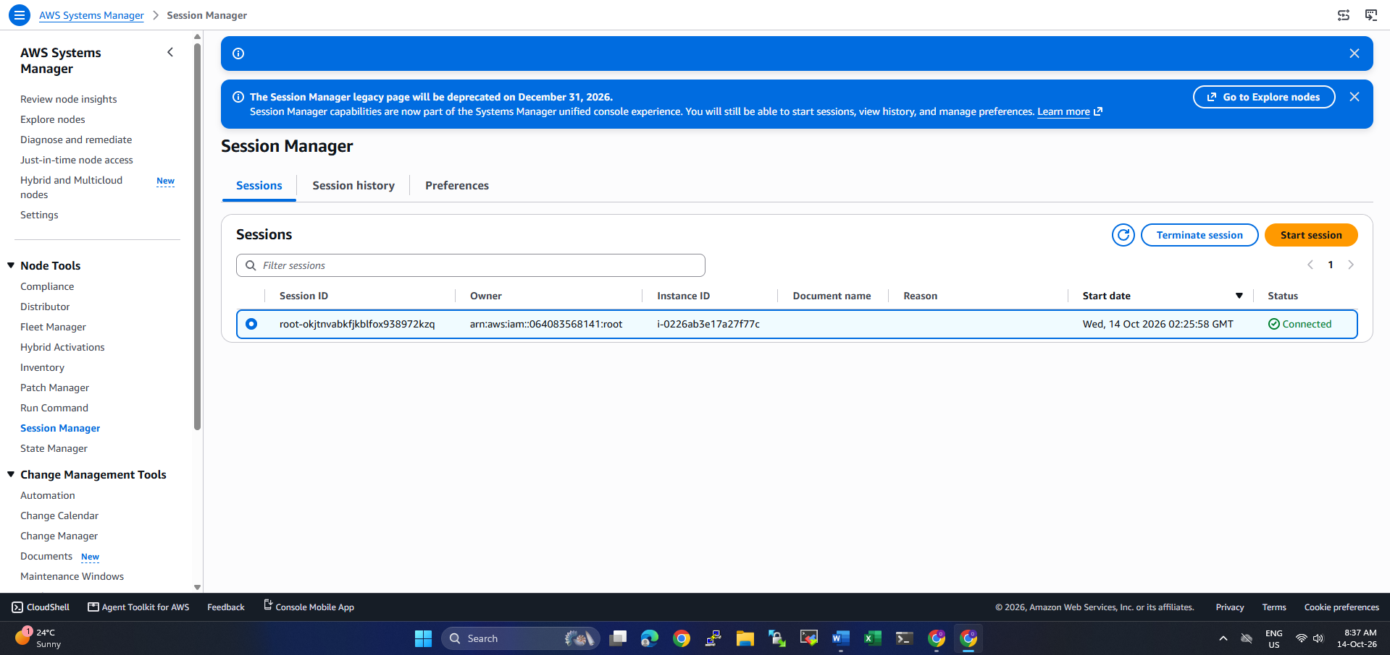
Evidence image 6 — RDS subnet group configuration.
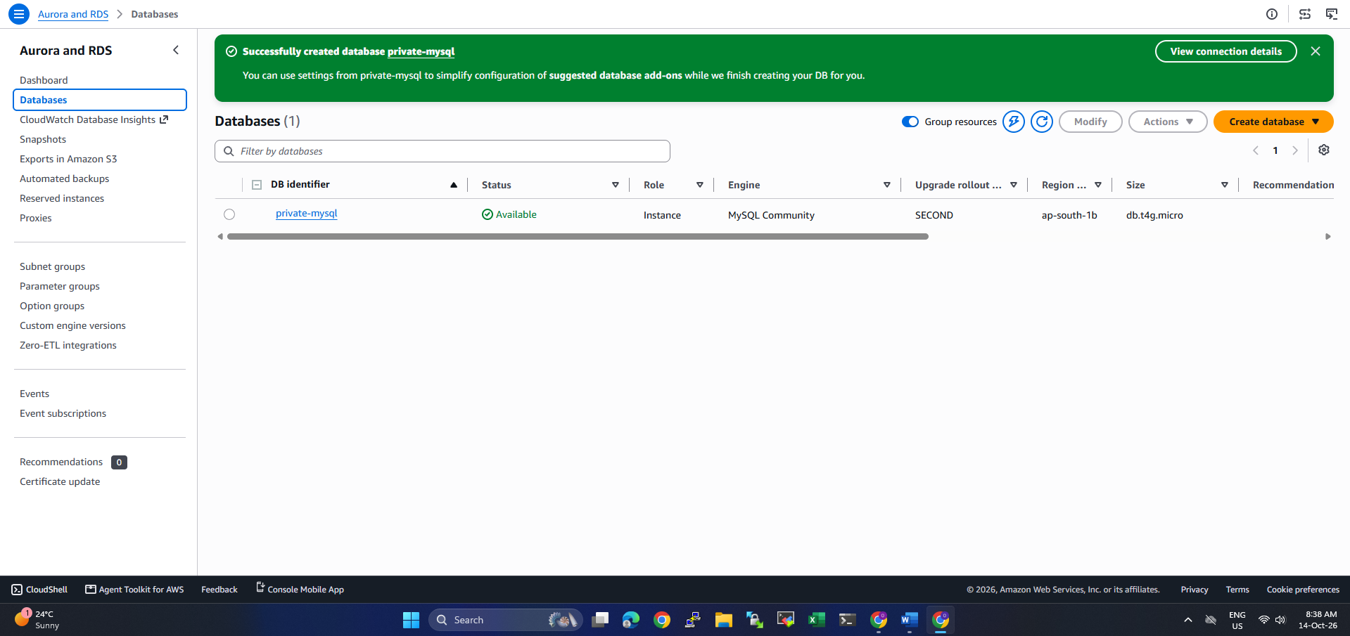
Evidence image 7 — Session Manager / terminal test evidence.
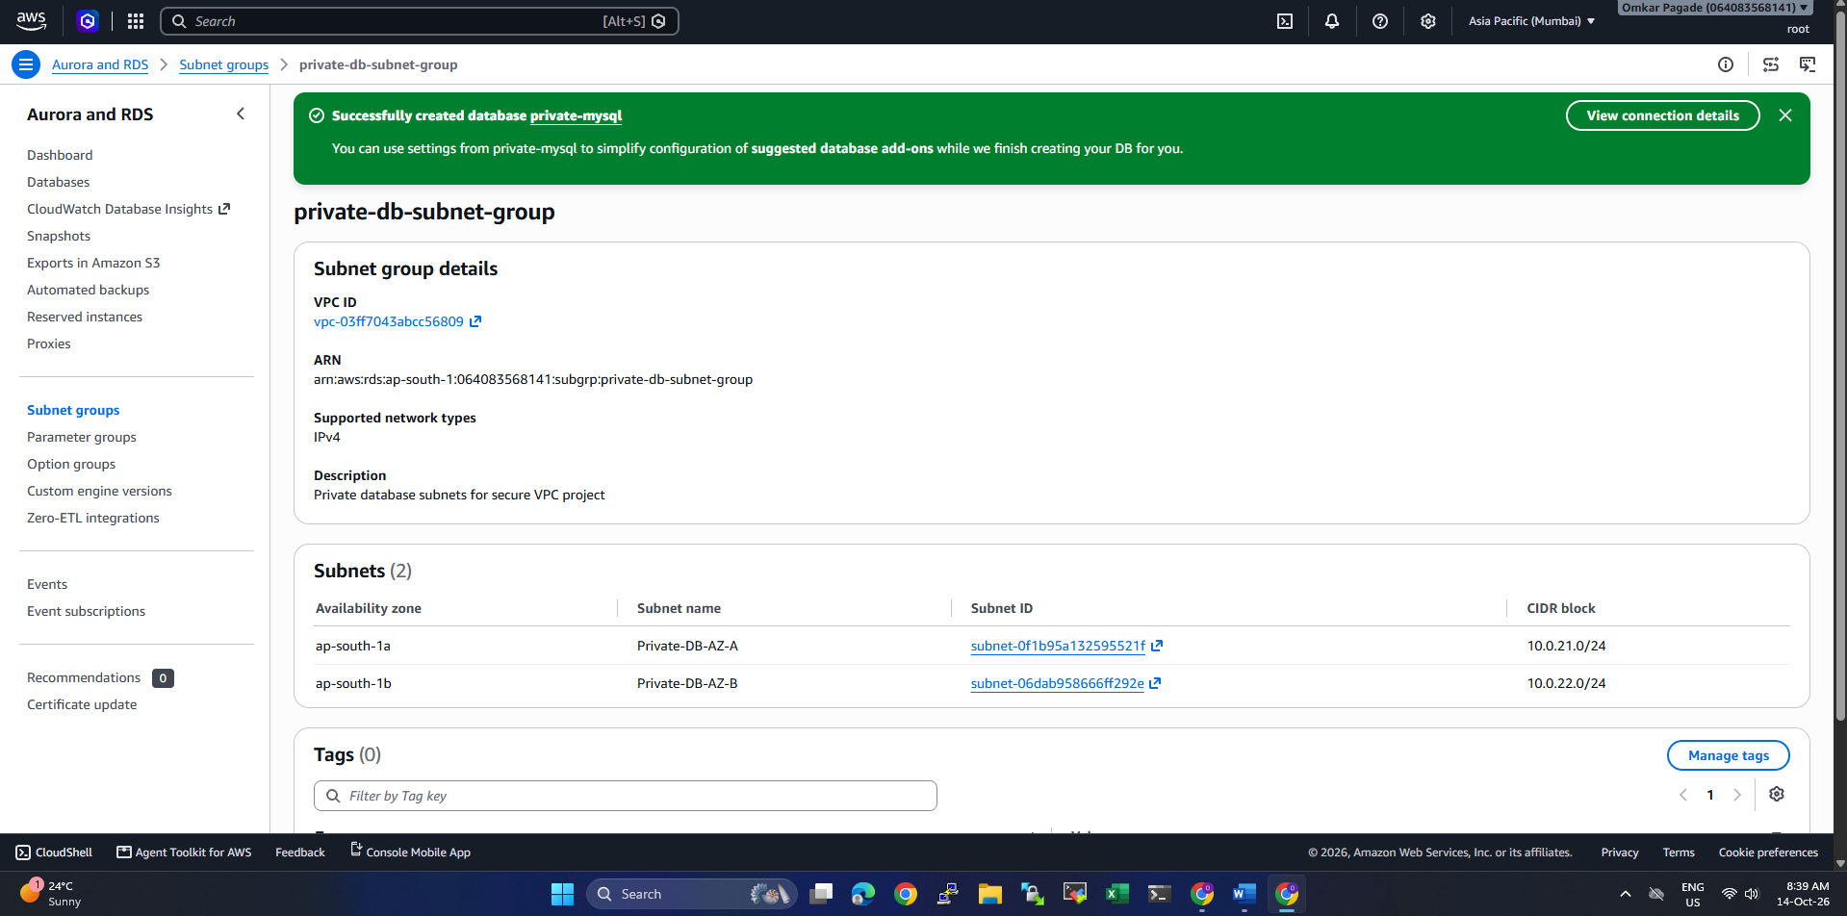
Evidence image 8 — Private Application Server AZ-A test page.
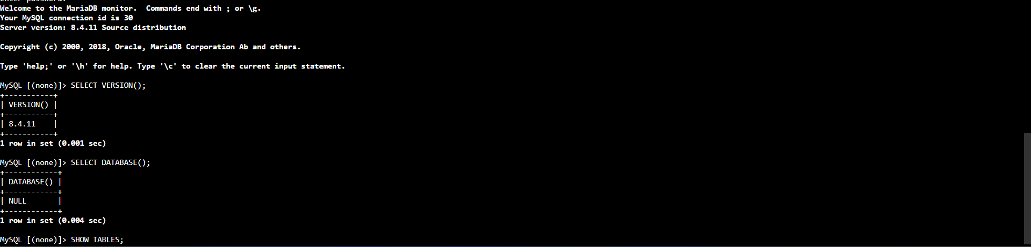
Evidence image 9 — Private Application Server AZ-B test page.
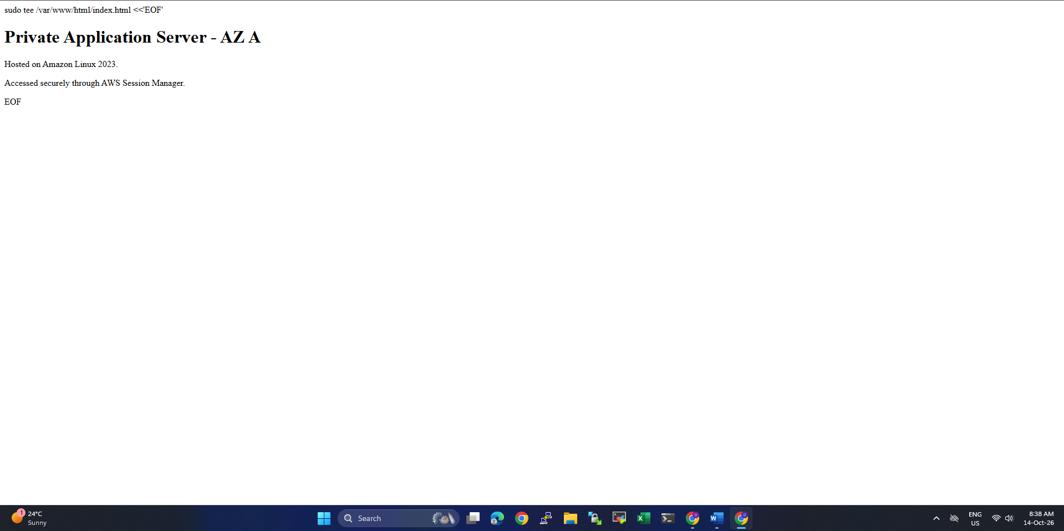
Evidence image 10 — Additional source screenshot evidence.
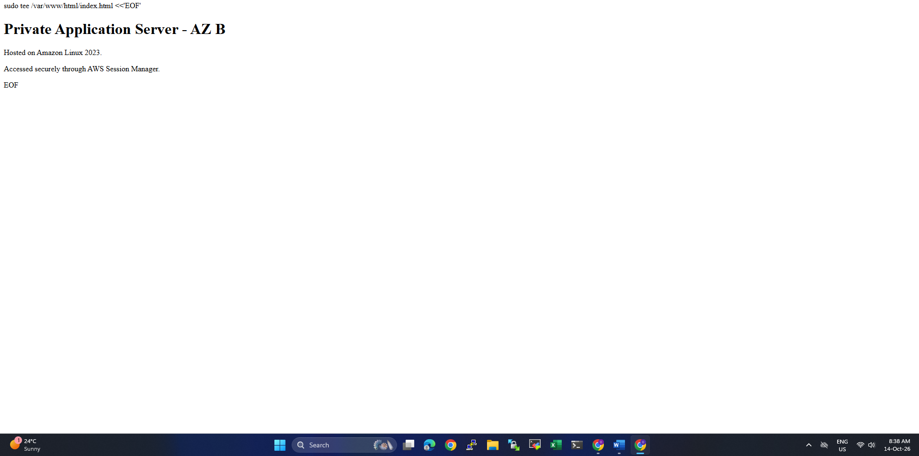

15. Conclusion
The project demonstrates a practical secure AWS network: the ALB is the public entry point, application EC2 instances are private across two AZs, and RDS is private behind security-group and route-table controls. The user-reported tests confirm that ALB access, target health, Session Manager administration, and application-to-database connectivity worked during validation. Before presenting it as production-ready, add HTTPS, confirm the RDS availability mode, consider AZ-resilient NAT or VPC endpoints, review backups/logging, and document the actual AWS bill.

