Software Requirements Specification

**for**

**DOODLE CLASSROOM**

**Version 1.0 approved**

**Prepared by Project Team 06**

|  |  |
| --- | --- |
| **Name** | **PRN** |
| HARSHADA PATIL (PL) | 230340320035 |
| OMKAR SUTAR | 230340320065 |
| ROHIT PAWAR | 230340520078 |
| JASWANT SINGH | 230340520038 |
| ABHISHEK NAIK | 230340320004 |
| RAHUL RAJ | 230340520070 |

**Centre for Development of Advanced Computing**

Raintree Marg, Near Bharati Vidyapeeth, Opp. Kharghar Railway Station, Sector 7,

CBD Belapur, Navi Mumbai - 400 614 - Maharashtra (India) Phone: +91-22-27565303

Fax: +91-22-2756-0004

**Date Created:16/08/2023**

# Table of Contents

Table of Contents ii

Revision History iii

1. Introduction 5
   1. Purpose 5
   2. Intended Audience and Reading Suggestions 5
   3. Product Scope 5-6
   4. References 6
2. Overall Description 7
   1. Product Perspective 7
   2. Product Functions 7
   3. User Classes and Characteristics 7
   4. Operating Environment 9
   5. Design and Implementation Constraints 9
   6. User Documentation 10
   7. Assumptions and Dependencies 10
3. External Interface Requirements 11
   1. User Interfaces 11
   2. Hardware Interfaces 12
   3. Software Interfaces 12
   4. Communications Interfaces 12
4. System Features 13
5. Overview of project modules 15
   1. Admin Module 15
   2. Teacher Module 15
   3. Student Module 16
6. ER-Diagram 17-18
7. UML Diagrams 19-32
8. Other Nonfunctional Requirements 33
   1. Performance Requirements 33
   2. Safety Requirements 33
   3. Security Requirements 33
   4. Software Quality Attributes 33
   5. Business Rules 33
9. Features 34

# Revision History

|  |  |  |  |
| --- | --- | --- | --- |
| **Name** | **Date** | **Reason For Changes** | **Version** |
|  |  |  |  |
|  |  |  |  |

# Introduction

## Purpose

This document outlines the software requirements for the " DOODLE CLASSROOM" platform, which is an intermediary website connecting Institute/Teacher with their students offering easy communication and services. This SRS document covers the initial release (Version 1.0) of Doodle Classroom platform.

The scope of the Doodle Classroom platform covered by this SRS includes both the customer- facing and vendor-facing functionalities. This document provides a comprehensive overview of the key features, interactions, and technical specifications required to develop and deploy the Doodle platform.

## Intended Audience and Reading Suggestions

This Software Requirements Specification (SRS) is intended for a diverse audience that includes developers, testers and users. Each of these reader types will find valuable insights within the document to suit their specific roles and responsibilities in the development and deployment of the Doodle platform.

Developers will find detailed technical requirements, use cases, and functional specifications in the SRS. They can refer to the functional and non-functional requirements sections to understand the scope of the project and the features to be implemented.

Users, both Institute Admin and Staff, can refer to the sections related to user registration, authentication, and interaction.

Testers can use the SRS to develop test cases and scenarios. They should focus on the functional requirements and the expected behavior of the platform's features.

## Product Scope

Doodle aims to empower both Institute and Students in the Institute. The objective of this project is to develop a web-based application that serves as a comprehensive Learning Management System. The proposed platform aims to provide educators and students with a user- friendly and efficient virtual classroom environment for managing and facilitating academic activities.

Benefits, Objectives, and Goals:

1. User Roles and Authentication: The system will support multiple user roles, including teachers, students, and Institute administrators.
2. Each user will have a unique login to access their respective dashboards.
3. Academic Group Creation and Management: Educators should be able to create Groups and organize course materials details, assignments submission details, and announcements within them.
4. Teachers will add the students to the group.
5. Communication and Announcements: The platform should enable seamless communication between teachers and students. Teachers can post announcements, send messages, and conduct discussions within the classroom.
6. User-Friendly Interface: The platform should have an intuitive and responsive design to ensure smooth navigation and easy access to all features.

## References

* + - https://edu.google.com/workspace-for-education/classroom

# Overall Description

## Product Perspective

The described project is an educational platform that aims to facilitate efficient communication, collaboration, and academic management between teachers, students, and institute administrators. The platform's primary goal is to enhance the teaching and learning experience by providing various tools and features tailored to the needs of different user roles.

Context and Origin:

The project's context lies in addressing the challenges posed by this evolving educational paradigm.

It seeks to bridge the gap between physical classrooms and virtual learning environments, providing a comprehensive platform that accommodates various stakeholders' needs. The context is also influenced by the need for efficient communication and organization, especially in cases where physical interactions are limited, such as during the COVID-19 pandemic.

## Product Functions

The following is a high-level summary of the major functions that the platform must perform:

## User Classes and Characteristics

The following user classes are anticipated to use the product:

1. User Role Management:
   * The system allows administrators to define and manage user roles (teachers, students, administrators).
   * Administrators can assign specific privileges and access levels to each user role.
2. User Authentication and Login
   * Users are required to authenticate using unique login credentials (username and password).
   * The system verifies user credentials and grants access based on the assigned role.
3. Dashboard and Profile Management:
   * Each user is presented with a personalized dashboard upon login, displaying relevant information and navigation options.
   * Users can update their profiles, including personal details and profile pictures.
4. Group Creation and Management:
   * Teachers can create academic groups for specific courses or subjects.
   * Teachers have the ability to add students to these groups and manage group membership.
5. Course Materials Organization:
   * Teachers can upload course materials such as lecture notes, presentations, and readings.
   * Materials are organized within the respective academic groups for easy access by students.
6. Assignment Submission and Grading:
   * Teachers can create assignments, set due dates, and specify submission requirements.
   * Students can submit their assignments through the platform, and teachers can review and grade submissions.
7. Announcements and Communication:
   * Teachers can post announcements, updates, and important information within academic groups.
   * Students receive notifications about new announcements and can engage in discussions with teachers and peers.
8. Messaging and Discussion Forums:
   * Users can send private messages to other users, facilitating one-on-one communication.
   * Discussion forums allow group members to engage in topic-based conversations and seek help from peers.

## Operating Environment

To ensure optimal performance and functionality, the platform must coexist harmoniously with the following elements:

Hardware Platform:

* + - The platform is designed to be accessible via web browsers on desktop computers, laptops, tablets, and smartphones.
    - It should function smoothly on devices with varying processing power, memory, and display capabilities.

Operating Systems:

* + - The platform is intended to be compatible with a range of modern operating systems, including:
    - Windows, mac OS, Linux distributions, Android, IOS.

Web Browsers:

* + - The platform should be accessible and perform optimally on widely used web browsers, such as: Google Chrome, Mozilla Firefox, Microsoft Edge, Apple Safari.

Software Components:

* + - Web server software (e.g., Apache, Nginx)
    - Database management system (MySQL)
    - Backend technologies (Node JS)
    - Frontend technologies (ReactJS)

Network Connectivity:

* + - The platform requires a stable internet connection for users to access its features and functionalities.
    - It should be designed to handle varying levels of network speeds and connectivity.

## Design and Implementation Constraints

The following constraints need to be considered during the development process: Technology Stack:

* + - The development team is required to use specified programming languages, frameworks,

and technologies to ensure compatibility and maintainability.

Operating System Compatibility:

* + - The platform must be designed to run on multiple operating systems and web browsers, ensuring broad accessibility.

Concurrent Users:

* + - The platform should be able to handle a significant number of concurrent users without compromising performance.

## User Documentation

The user documentation, nestled within the Help menu, acts as a go-to guide for our project. It's a treasure trove of details about every module and feature. If users have questions, they can find step- by-step instructions here on how to use the application. This documentation is the comprehensive report of our project, covering everything from its purpose, functionalities, and user roles to the software and hardware it requires, along with the environment it operates in.

## Assumptions and Dependencies

Assumptions:

* + - Third-Party Services: The project assumes seamless integration with some third-party services. It is assumed that the APIs provided by these services will function as expected.
    - Regulatory Compliance: To achieve regulatory compliance, the platform's development and operations team should work closely with legal experts familiar with education and technology regulations in the regions where the platform will be used. Regular audits and reviews should be conducted to ensure ongoing compliance and adapt to changes in regulations.
    - Hardware Compatibility: It is assumed that the hardware diversity of users, including devices and operating systems, will not hinder the functionality and accessibility of the platform.

Dependencies:

* + - API Integrations: The project is dependent on successful integration with external services. Any changes or disruptions to these APIs can impact the platform's core functionality.
    - Software Frameworks: The project relies on specific software frameworks and components for its development. Any changes or issues with these frameworks can influence the project's timeline and functionality.

Other:

* + - A functional email service is required for notifications to be sent to the customer.

# External Interface Requirements

## User Interfaces

This section outlines the logical characteristics and components of each interface.

1. Teacher and Student Registration and Login:
   * Interface Elements: Input fields for username, password, and buttons for login.
   * Purpose: Allows users to securely create accounts and access the platform.
2. Student Profile Creation:
   * Interface Elements: Input fields for username, password, and buttons for login
   * Purpose: Allows knowing the Personal details to the Student.
3. Administrator Panel:
   * Interface Elements: Backend dashboard with functionalities for user management, Student and Teacher verification, dispute resolution, and content moderation.
   * Purpose: Allows administrators to manage the platform's operation and ensure smooth functionality.

## Hardware Interfaces

These interfaces encompass both logical and physical characteristics, ensuring compatibility and efficient communication between the software and hardware components.

1. Supported Device Types:
   * The platform supports a range of device types, including desktop computers, laptops, tablets, and smartphones.
   * The user interfaces are designed to be responsive, adapting to different screen sizes and orientations.
2. Internet Connectivity:
   * The platform requires an internet connection to operate, as data processing and communication occur over the internet.
   * The platform interacts with network interfaces to send and receive data packets.
3. Browser Compatibility:
   * The user interfaces are accessed through web browsers, and compatibility is ensured with popular browsers such as Google Chrome, Mozilla Firefox, Microsoft Edge, and Apple Safari.
   * The platform adheres to web standards to ensure consistent functionality across different browsers.

## Software Interfaces

These software interfaces encompass connections with external services and databases.

* + 1. Database Interface:
       - The platform interfaces with a relational database management system (RDBMS) such as MySQL to store user account information, vendor profiles, service details, and communication history. Data items include user profiles, service offerings, inquiries, messages, and payment records. The purpose of this interface is to securely store and retrieve user-related information and service data.
    2. Student and Teacher Verification:
       - The platform interfaces with an admin verification tool within the platform.
       - Data items include vendor registration details, verification documents, and verification outcomes.
       - The purpose of this interface is to facilitate the admin's verification process for Users registration.

## Communications Interfaces

These interfaces encompass both user-facing and internal communication mechanisms.

* + 1. Web Browser Interface:
       - The primary user interface of the platform is accessible through standard web browsers (e.g., Chrome, Firefox, Safari). Users and vendors interact with the platform's features, including registration, login, dashboard access, service requests.
    2. Email Communication:
       - The purpose of this interface is to send invoices to customers via email.

# System Features

* User Role Management:

Description: This feature enables administrators to define user roles (teachers, students, administrators) and assign specific permissions and access levels to each role.

Priority: High

* Authentication and Authorization:

Description: Users log in using secure credentials. Role-based access control ensures that users can access only the features and data relevant to their roles.

Priority: High

* Dashboard Customization:

Description: Personalized dashboards for each user role, displaying relevant information such as course schedules, assignments, announcements, and messages.

Priority: Medium

* Group Creation and Membership:

Description: Teachers can create academic groups for courses. They can manage group membership and invite students to join.

Priority: High

* Assignment Creation and Grading:

Description: Teachers can create assignments, set due dates, and specify submission requirements. Students can submit assignments digitally, and teachers can review.

Priority: High

* Announcement and Discussion System:

Description: Teachers can post announcements within academic groups. Discussion forums allow group members to engage in topic-based conversations.

Priority: Medium

* Responsive Design:

Description: Ensures that the user interface adapts seamlessly to different screen sizes and devices, providing a consistent user experience.

Priority: High

* Data Security and Privacy Controls:

Description: Ensures data security through encryption and privacy controls, complying with regulations to protect user data.

Priority: High

* Content Moderation:

Description: Implements mechanisms to prevent and address inappropriate content or behavior, promoting a safe online environment.

Priority: Medium

* Regulatory Compliance Modules:

Description: Implements features to ensure compliance with relevant regulations, demonstrating a commitment to legal and ethical standards.

Priority: High

* Feedback and Improvement Mechanisms:

Description: Collects user feedback to continuously improve platform features, usability, and overall user experience.

Priority: Medium

* User Authentication and Login:

Stimulus: User enters username and password and clicks "Log In" button.

Response: System verifies credentials, authenticates user, and redirects to the personalized dashboard.

* Group Creation and Membership:

Stimulus: The teacher selects "Create Group," enters group details, and adds students'.

Response: System creates the group, Add students, and adds them to the group .

* Assignment Submission and Grading:

Stimulus: Student uploads an assignment file for a specific assignment.

Response: The system records submission, and displays the submission for teacher review.

* Announcement and Discussion System:

Stimulus: Teacher posts an announcement about an upcoming exam in the group.

Response: System displays the announcement in the group's chat display board.

* Notification System:

Stimulus: Teacher posts a new announcement in the group.

Response: System shows a announcement to all group members.

* Responsive Design:

Stimulus: User accesses the platform using a smartphone.

Response: System adapts the layout and design to fit the smartphone screen, maintaining usability.

* Feedback and Improvement Mechanisms:

Stimulus: User submits feedback about a feature's usability.

Response: System records the feedback, notifies relevant teams, and incorporates suggestions into future updates.

**Overview of project modules**

Admin/Institute Module

* In the Admin Module the system allows the admin to log in with a email and password.
* There is Institute Dashboard provided with menu items which there are items like Add Student, Add Teachers, Show Student, and Show Teacher .

Teacher Module

* In the Faculty Module the System allows the Faculty Member to log in with a email and Password.
* Which has been provided by the Admin to faculty members via Email
* There is a Teacher Dashboard Provided with Menu items such as Creating Groups and Send Messages where the Faculty Member can Post a Messages that will be Visible to the Students.
* Faculty can also view the Earlier Posted Messages and the Faculty Member can update its Record.
* Teachers can also change their profile details.
* Teacher can add assignment submission details to the calendar for particular classes and subjects.
* Teacher can check the list of students who submitted the assignment, and their submission.

Student Module

* The Student Module the System allows the Students to Login with a email and Password.
* This has been provided by the Admin to Students via Email.
* There is a Student Dashboard Provided with the Menu items such as View Groups where Students can send messages and respond to new notices.
* Students can also change their profile details.
* If any assignment is assigned, Students can check submission's last date.
* Student can submit their assignment.

**ER DIAGRAM**

Has

Student

Institute

Added to group by

Messages

Submit

Assign

Assignment

Has

Has

Messages

Messages

Messages

Messages

Study Group

Manage

Teacher

**UML DIAGRAM**

**DATA FLOW DIAGRAM**

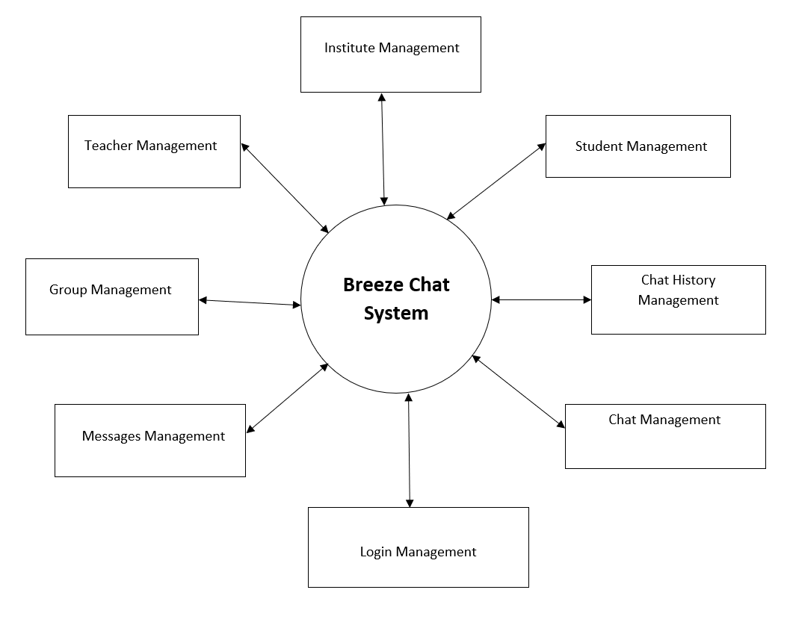

Doodle Classroom System

DFD LEVEL -0

**DFD LEVEL-1**

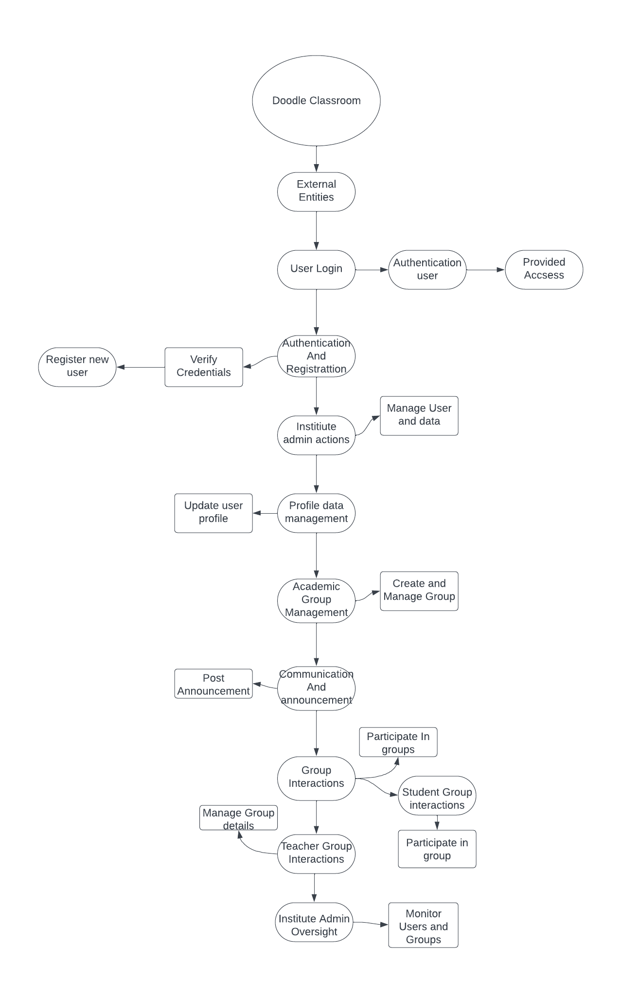

**DFD LEVEL- 1 (Institute)**

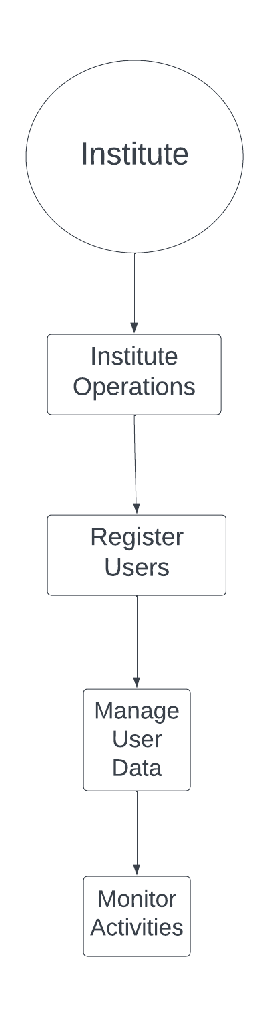

**DFD LEVEL- 1 (Teacher)**

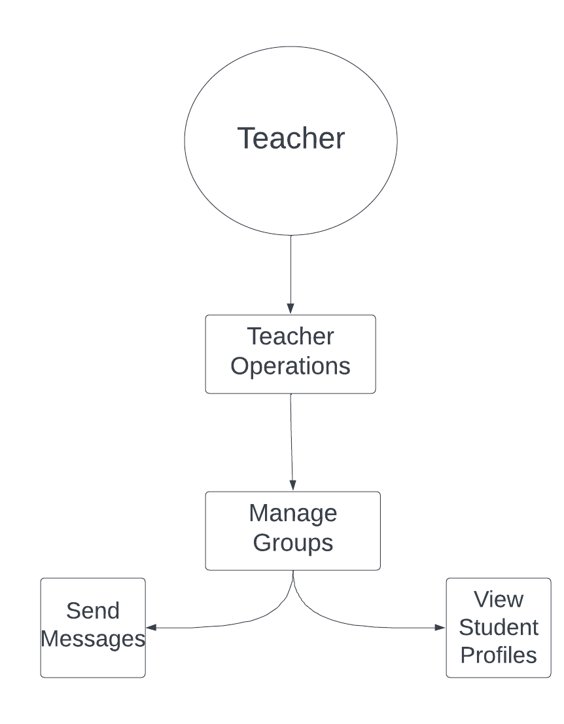

**DFD LEVEL- 1 (Student)**

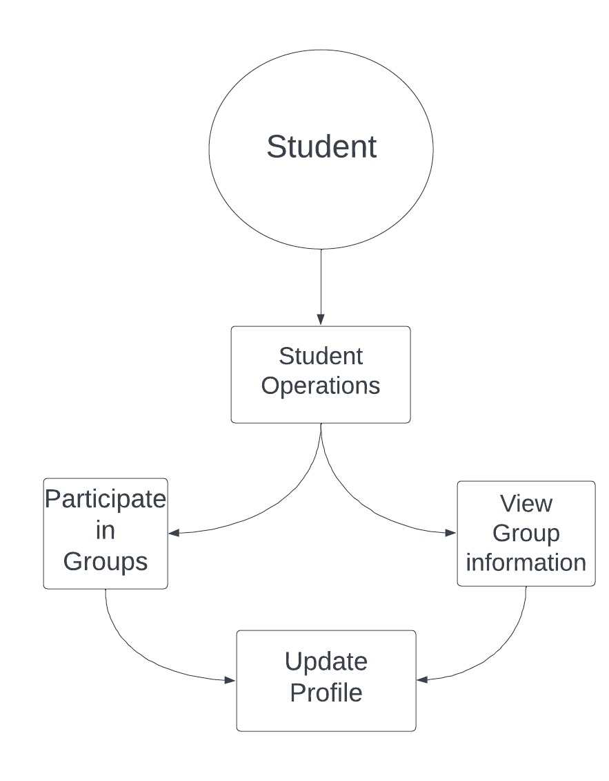

**USE CASE DIAGRAM**

***Teacher/Student Panel:-***

Teacher

Student

**USE CASE DIAGRAM**

***Institute Panel:-***

Institute

**ACTIVITY DIAGRAM**

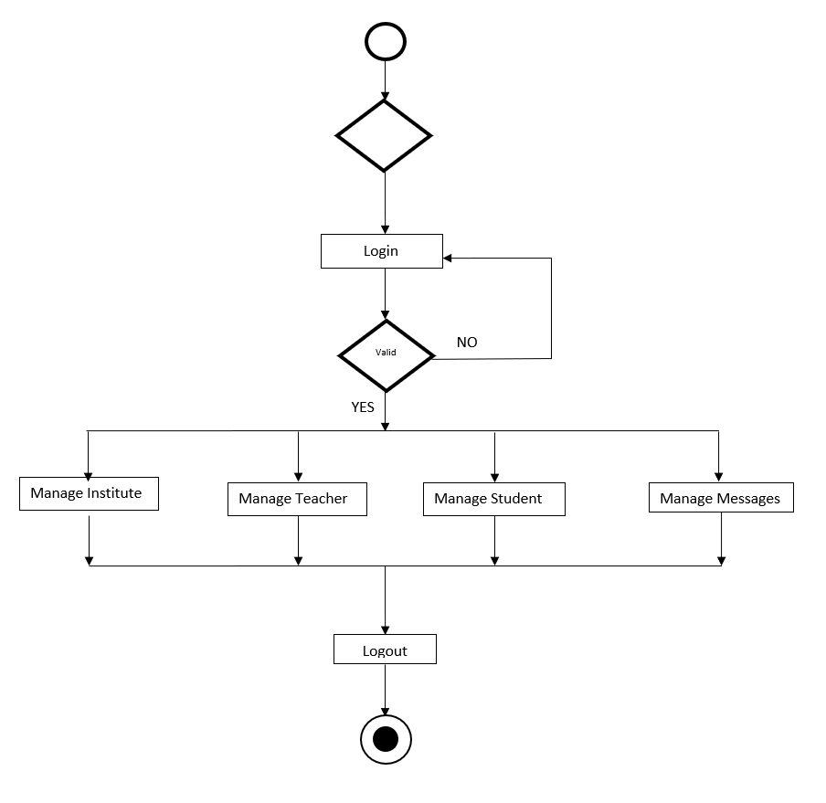

**SEQUENCE DIAGRAM**

***Institute Panel***

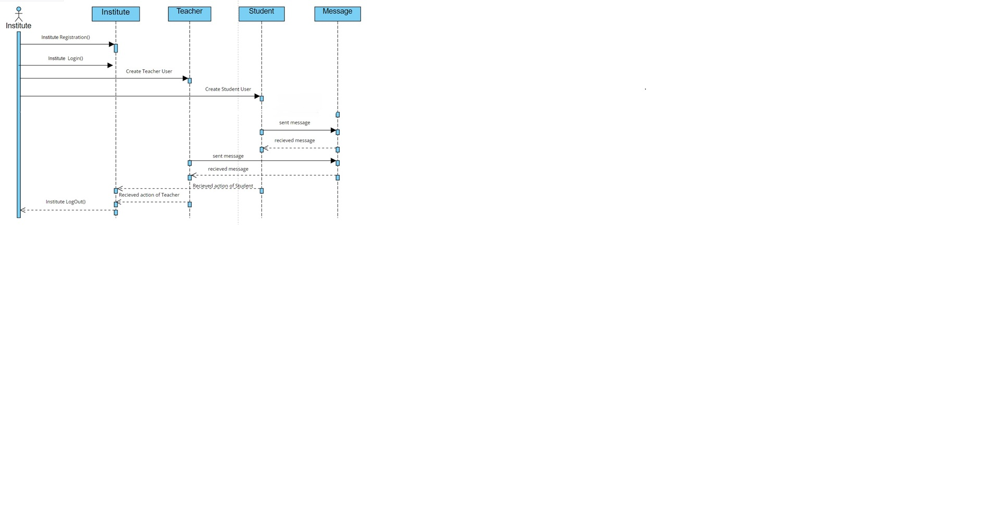



***Teacher Panel***

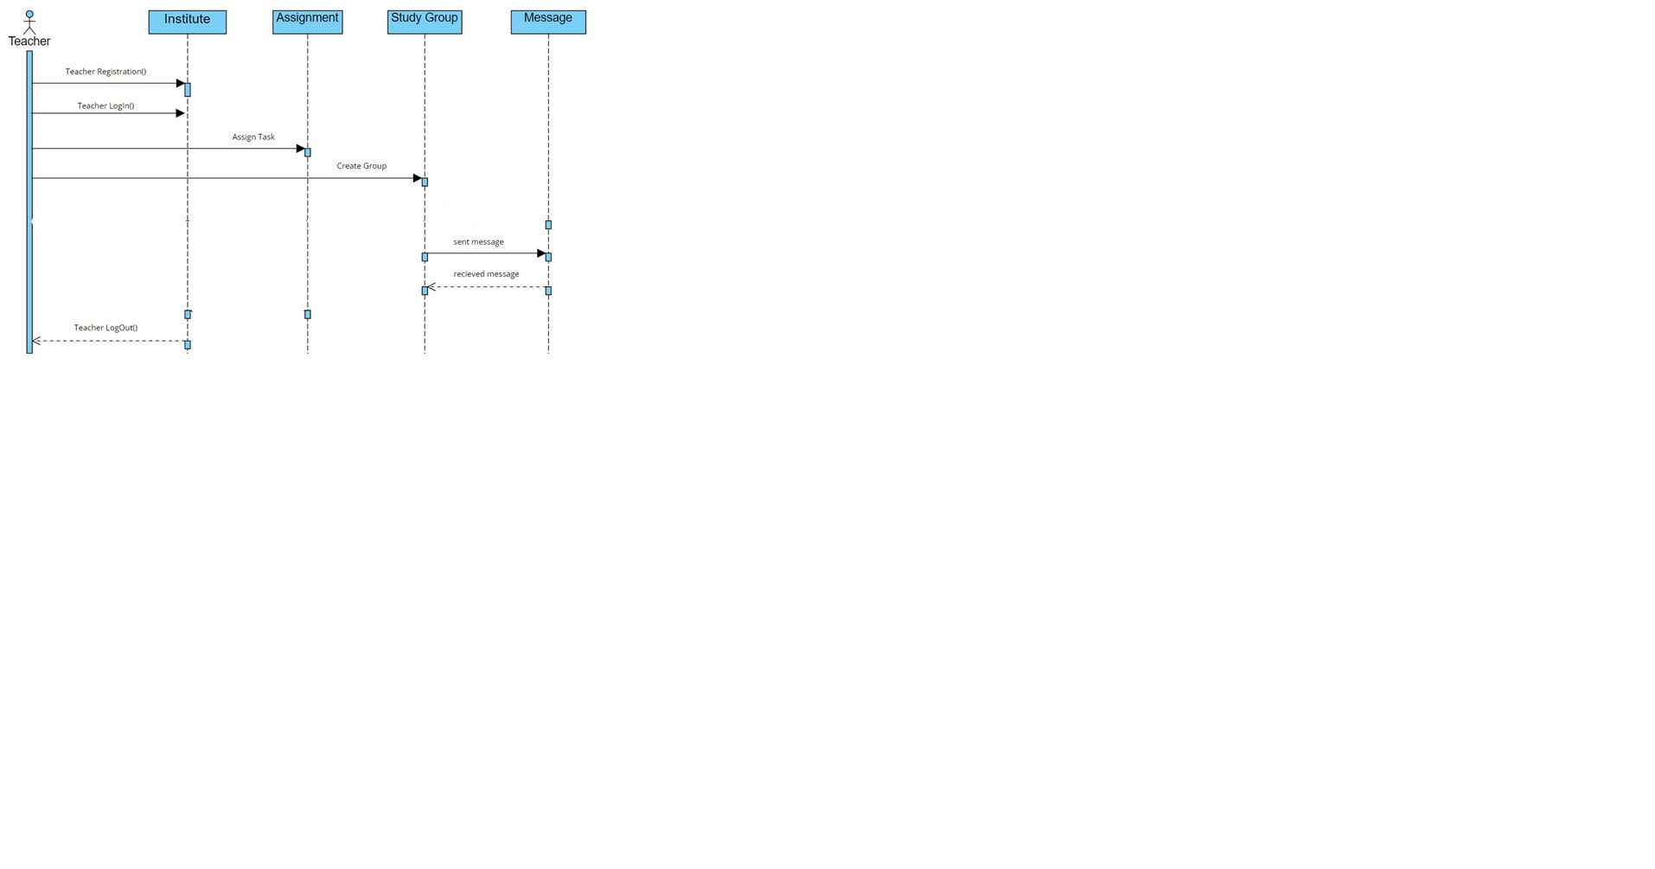

***Student Panel***

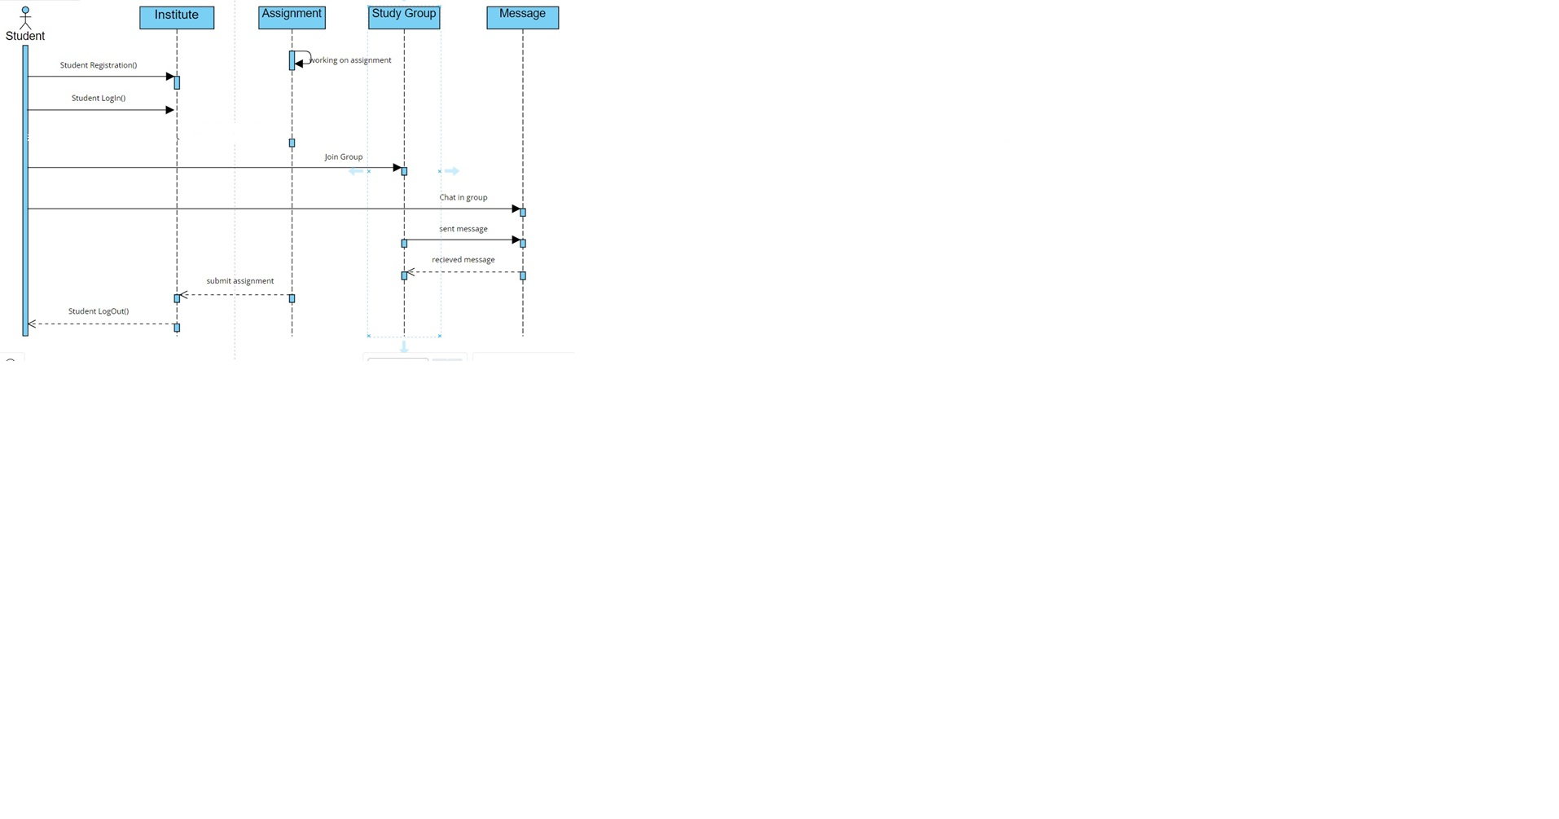

**Deployment Diagram**

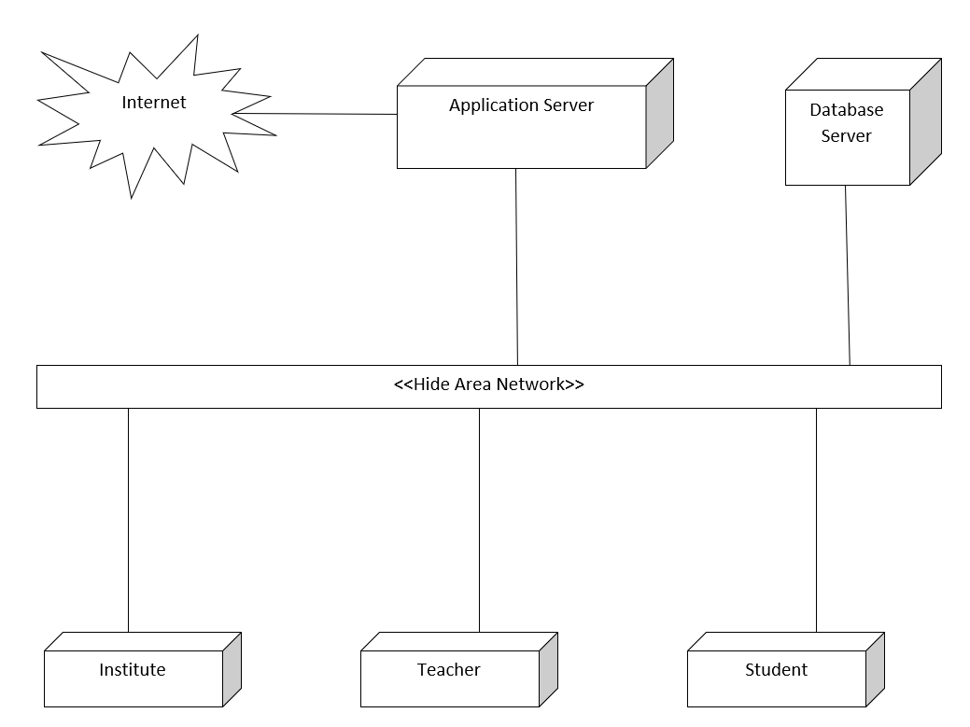

**Class Diagram**

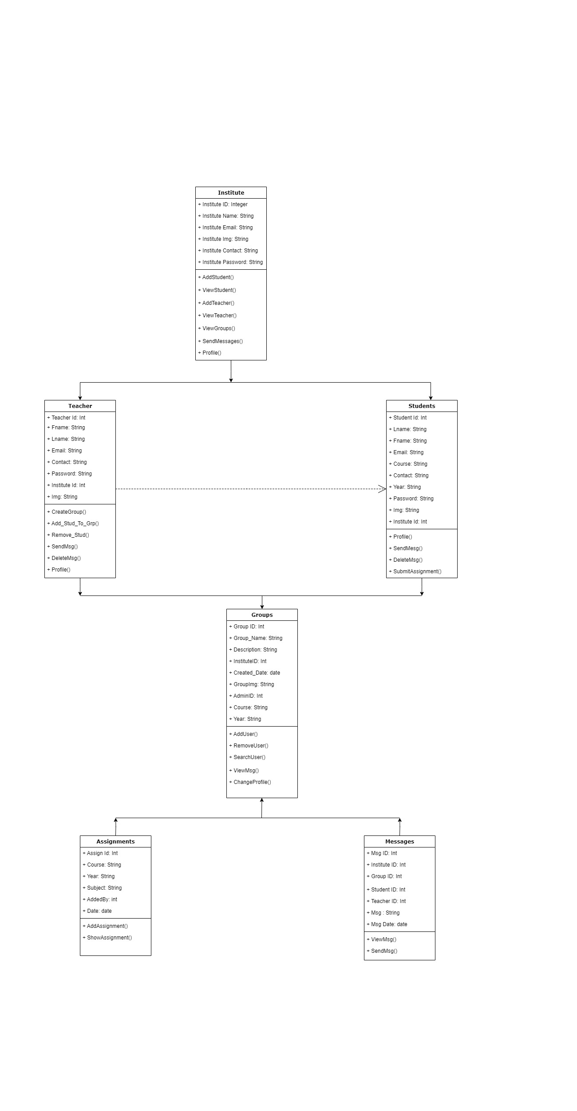

# Other Nonfunctional Requirements

**5.1 Performance Requirements**

* The system manages facilities required by the casual users quickly and easily.
* It offers to take enquiries faster through online. It takes the enquiry details from User and sends the feedback to the management team.

**5.2 Safety Requirements**

* In case the User forgets or loses Password, the repair functionality helps by choosing “forgot password” option in the main login window.

**5.3 Security Requirements**

* This system is provided with authentication without which no user can pass.
* So only legitimate users are allowed to use the application.
* If the legitimate user’s share the authentication information then the system is open to outsiders.

**5.4 Software Quality Attributes Reliability**

* Good validations of user inputs will be done to avoid incorrect storage of records.
  + Maintainability: During the maintenance stage, SRS document can be referred for any validations.
  + Portability: This system can be easily viewed in any browser.
  + Flexibility: The system keeps on updating the data according to the transactions that takes place.
  + Timeless: The system carries out all the operations with consumption of very less time.
  + Security: Security of the system is maintained by giving access to only authenticated user id and password.

**5.5 Business Rules**

All the rules for the design and development of the website will be under the jurisdiction. No terms and conditions will be violated

**Features**

* There is a conversation between students, teachers, and the institute without any inconvenience.
* There is a facility known as mail for verification which gives initial login details to the student, it is for security purposes.
* This system gives all details about curriculum activities, university scholarships, and holidays directly to students and teachers without any manual interruption.
* It is a friendly application.

-***-