**RESUME**

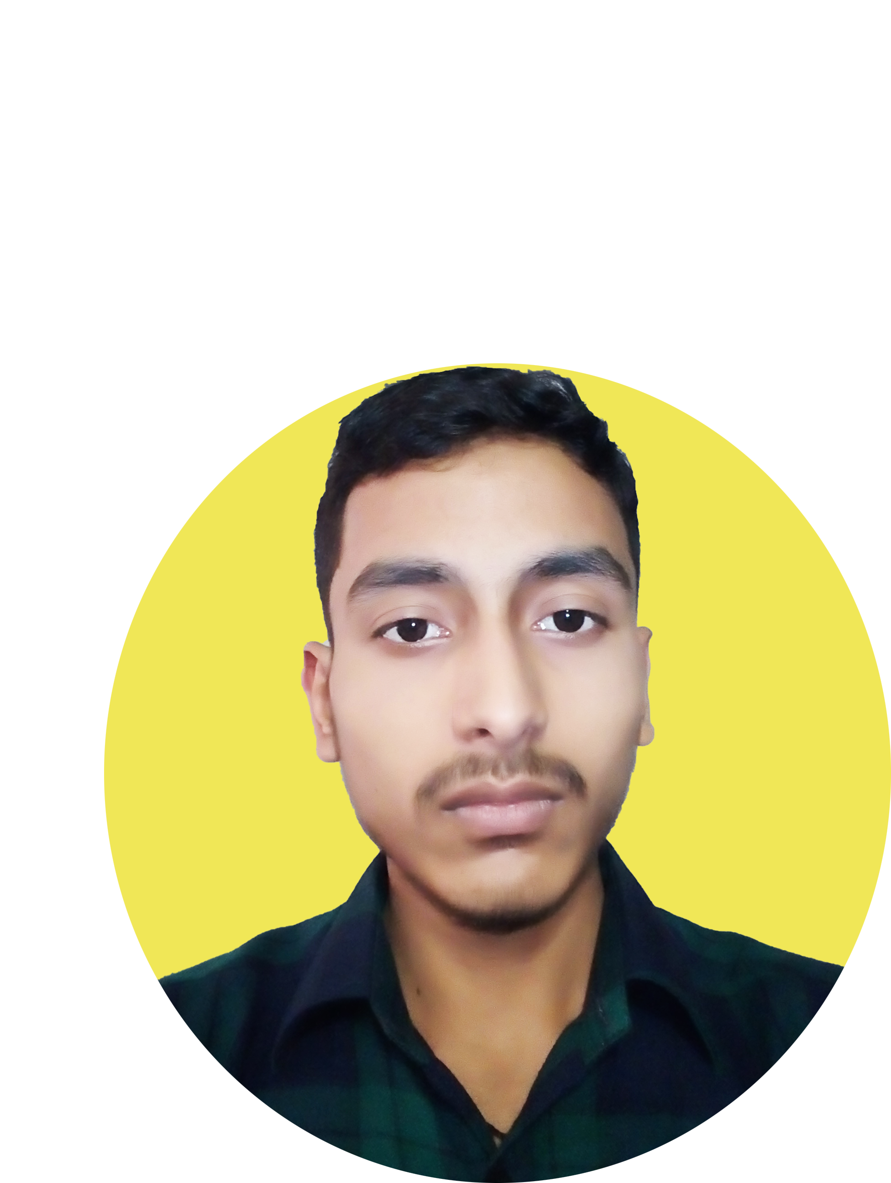

**OMKAR SUMAN**

+91 9315-490543

Email id: [omkar2006suman@gmail.com](mailto:omkar2006suman@gmail.com)

**OBJECTIVE**

To work with an organization where can learn new skills and increase my abilities for the organizational goals as well as myself.

**EDUCATIONAL** QUALIFICATION

* Pursuing B.sc 3rd year from Delhi University.
* Passed out 12th from UP board In 2020

Marks 72%

* Passed out 10th from UP board in 2018

Marks 69%

OTHER ACADAMIC DETAILS

* Got 2nd prize in science project of physics.
* Got 1st prize in web development in computer science.

TECHNICAL SKILLS

* Knowledge about computer fundamentals.
* Web Development and software development.

WORK EXPERIENCE

* FRESHER

STRENGTH & HOBBIES

* Smart work
* Honest & Punctual
* Good communication skill
* Computer , Codings, Reading books

PERSONAL DETAILS

* Father’s Name : Mr. Rakesh Kumar Singh
* Date of Birth : 01-09-2004
* Address : Rajeev vihar khora colony, Noida sec-62, . 201301 (Ghaziabad)
* Marital Status : Single

(Omkar Suman)