INTERNSHIP PROJECT REPORT
Factory Reallocation & Shipping Optimization Recommendation System
for Nassau Candy Distributor

Submitted by:Omkar Ugale
Internship platform: Unified Mentor
October 2026

Abstract
Nassau Candy Distributor assigns products to factories using static, legacy rules and has no way to test the effect of changing those assignments. This report develops a decision-support system that predicts shipping lead time, simulates the reassignment of products to alternative factories, and recommends moves that balance shipping efficiency and profitability.
The study analyses 10,194 order lines (January 2024 to December 2025) for 15 products made at five factories. The date fields were found to be year-shifted and were normalised to a 0–11 day lead time. Geodesic factory-to-customer distance was engineered as the origin feature so that unseen product–factory pairs can be simulated. Linear Regression, Random Forest and Gradient Boosting models reached R² of 0.615–0.630; 120 routes were grouped into four clusters; and a scenario engine with a risk-aware ranking was built and delivered as an interactive Streamlit dashboard.
The results show that lead time is determined almost entirely by ship mode (mean 0.38 days for Same Day against 5.32 for Standard Class), while distance and region have almost no effect (correlation 0.008). Factory reassignment therefore cannot be expected to shorten lead times materially. It can, however, shorten shipping distances: moving the five Wonka Bar products, which make up 96.6% of order lines, to Secret Factory would cut their mean distance by 26.7% and their modelled freight cost by about $1,005 (26.8%). Recommendations for the ten smaller products rest on too little data to act on. A capacity-validated, single-product pilot is recommended before any wider change.
Keywords: supply chain analytics, factory allocation, lead-time prediction, scenario simulation, recommendation system, Streamlit

Executive Summary
The question. Can Nassau Candy ship faster and more profitably by producing products at different factories?
What we did. We analysed two years of orders (10,194 lines, 15 products, 5 factories), built models that predict lead time, simulated moving every product to every factory, and ranked the options by speed, profit and risk. The results are available in an interactive dashboard.
What we found.
- Delivery speed is driven by the ship mode the customer chooses, not by the factory. Same Day orders take under half a day on average and Standard Class about 5.3 days. Distance and region make almost no difference.
- Moving products between factories will therefore not noticeably shorten lead times (predicted change below 1%).
- Moving the five Wonka Bar products to Secret Factory would shorten the distance they travel by about 27% (from about 2,000 km to 1,470 km on average). Under an assumed freight rate, this saves roughly 27% of their freight cost, around $1,000 or 1% of their gross profit over the two years.
- The other ten products sell too little for a reliable recommendation. Two (Lickable Wallpaper and Wonka Gum) should stay where they are.
What we recommend. Do not reorganise the whole network. First confirm Secret Factory’s capacity (it would need to handle more than 45 times its current volume), obtain real freight costs, and then pilot one Wonka Bar for a quarter, comparing actual results with the dashboard’s predictions. If the aim is faster delivery, the most effective lever is the ship-mode mix: shifting 10% of orders from Standard to Second Class would cut the average lead time by about 4%.
Caveats. Freight cost is assumed, customer locations are approximated by state, and the original dates required a correction (Section 4.2). Dollar figures are indicative.
Table of Contents
Abstract i
Executive Summary ii
1. Introduction 1
1.1 Background 1
1.2 Motivation 1
1.3 Structure of the Report 1
2. Problem Statement and Objectives 2
2.1 Problem Statement 2
2.2 Objectives 2
2.3 Scope 2
3. Dataset Description 3
3.1 Source and Fields 3
3.2 Factory Reference Data 3
3.3 Data Quality Assessment 4
3.4 Derived Variables 4
4. Methodology 5
4.1 Overview 5
4.2 Lead-Time Normalisation 5
4.3 Geospatial Features 5
4.4 Preprocessing and Encoding 6
4.5 Predictive Models 6
4.6 Evaluation Metrics 6
4.7 Route Clustering 6
4.8 Scenario Simulation Engine 6
4.9 Optimisation and Recommendation Logic 6
4.10 Key Performance Indicators 7
5. Exploratory Data Analysis 8
5.1 Business Overview 8
5.2 Lead Time and Ship Mode 8
5.3 Region, Distance and Lead Time 9
5.4 Factory and Product Concentration 10
5.5 Summary of EDA Insights 10
6. Predictive Modelling Results 11
6.1 Model Performance 11
6.2 Feature Importance 11
6.3 Model Selection and Interpretation 12
7. Route and Product Clustering 13
8. Scenario Simulation and Recommendations 14
8.1 Worked Example: Wonka Bar – Milk Chocolate 14
8.2 Recommended Reassignments 14
8.3 Speed-versus-Profit Sensitivity 16
8.4 Risk Assessment 16
9. KPI Evaluation 18
10. Streamlit Dashboard 19
10.1 Purpose and Design 19
10.2 Modules 19
10.3 User Controls 19
10.4 Implementation and Deployment 19
11. Discussion and Limitations 20
11.1 Discussion 20
11.2 Limitations 20
12. Conclusion and Future Work 21
12.1 Conclusion 21
12.2 Recommendations 21
12.3 Future Work 21
References 22
List of Tables
Table 1: Fields in the Nassau Candy dataset 3
Table 2: Factory coordinates and product assignment 4
Table 3: Data quality summary 4
Table 4: Business overview by division and region 8
Table 5: Normalised lead time by ship mode (days) 8
Table 6: Factory profile (current assignment) 10
Table 7: Model performance on the test set 11
Table 8: Route clusters 13
Table 9: Simulated scenarios for Wonka Bar – Milk Chocolate (2,137 order lines) 14
Table 10: Best alternative factory for each product (w = 0.5, freight rate $0.05 per unit per 1,000 km). Wonka Bar prefix omitted. 15
Table 11: Sensitivity of the Wonka Bar saving to the freight rate 16
Table 12: Key performance indicators 18
Table 13: Project files 23
List of Figures
Figure 1: Raw gap between Ship Date and Order Date, showing three year-shifted blocks 5
Figure 2: Lead time by ship mode 9
Figure 3: Factory locations and customer states (marker size proportional to order lines) 9
Figure 4: Distance from factory to customer versus lead time (3,000-order sample) 10
Figure 5: Model comparison on the test set 11
Figure 6: Random Forest feature importance (top eight features) 12
Figure 7: Route clusters by mean distance and lead time (marker size proportional to volume) 13
Figure 8: Wonka Bar products: current distance versus Secret Factory, and modelled freight saving 16

1. Introduction

1.1 Background
Confectionery distribution is a low-margin, high-volume business in which small inefficiencies in logistics compound quickly. Nassau Candy Distributor supplies a portfolio of fifteen branded products, grouped into the Chocolate, Sugar and Other divisions, to customers across the United States and Canada. Each product is manufactured at one of five factories and shipped to customers by one of four ship modes: Same Day, First Class, Second Class and Standard Class.
Historically, the assignment of products to factories has followed static rules and legacy processes. Leadership has plenty of descriptive reporting about what shipped, where and when, but not a way to answer the question that matters for decisions: what should we change to improve performance?

1.2 Motivation
The project described in this report moves the analysis from descriptive reporting to decision intelligence. It builds a recommendation system that (i) predicts shipping outcomes under different configurations, (ii) recommends which products should be reassigned to alternative factories, and (iii) balances shipping efficiency against profitability. The system is delivered as a reproducible analytical pipeline and an interactive web dashboard so that non-technical decision makers can test scenarios before committing to operational changes.

1.3 Structure of the Report
Chapter 2 states the problem and objectives. Chapter 3 describes the dataset and its quality. Chapter 4 explains the methodology. Chapters 5 to 9 present the exploratory analysis, predictive models, route clustering, scenario simulation and KPI results. Chapter 10 documents the Streamlit dashboard, Chapter 11 discusses limitations, and Chapter 12 concludes with recommendations and future work.

2. Problem Statement and Objectives

2.1 Problem Statement
Nassau Candy currently assigns products to factories using static rules and legacy processes. According to the project brief, this leads to suboptimal shipping distances, high lead times for certain regions, and margin erosion caused by logistics inefficiencies. In addition, there is no system to simulate factory–product reassignment scenarios, quantify the operational impact before execution, or recommend optimal configurations at scale.

2.2 Objectives
The objectives of the project are to:
- predict expected shipping lead time given the product, origin factory, destination region and ship mode;
- cluster routes and products by performance to identify consistently slow routes and congested region–product combinations;
- simulate the reassignment of each product to alternative factories and estimate the change in lead time and profit;
- rank factory options by lead-time reduction, risk reduction and profit impact and generate top-N reassignment recommendations; and
- deliver the results through an interactive Streamlit dashboard with product, region, ship-mode and speed-versus-profit controls.

2.3 Scope
The analysis uses the 10,194 order lines supplied for the project (January 2024 to December 2025). Factory locations and the product-to-factory mapping were provided in the project brief. The study does not cover production planning, inventory policy or carrier contracts, because the dataset contains no information on them.

3. Dataset Description

3.1 Source and Fields
The dataset is a single table of order lines supplied with the project brief. Each row represents one product on one order. Table 1 lists the 18 fields provided.
Table 1: Fields in the Nassau Candy dataset
Field | Description
Row ID | Unique row identifier
Order ID | Unique order identifier
Order Date | Date of order
Ship Date | Date of shipment
Ship Mode | Shipping method of the order
Customer ID | Unique customer identifier
Country/Region | Country or region of the customer
City | City of the customer
State/Province | State or province of the customer
Postal Code | Postal or ZIP code of the customer
Division | Product division (Chocolate, Sugar, Other)
Region | Region of the customer (Atlantic, Gulf, Interior, Pacific)
Product ID | Unique product identifier
Product Name | Long product name
Sales | Total sales value of the order line
Units | Total units of the order line
Gross Profit | Sales minus cost
Cost | Cost to manufacture

3.2 Factory Reference Data
The brief supplies the coordinates of the five factories and the product each one manufactures. Because the dataset itself has no factory column, the factory of every order line was derived from this mapping (Table 2).
Table 2: Factory coordinates and product assignment
Factory | Latitude | Longitude | Products manufactured
Lot’s O’ Nuts | 32.8819 | -111.7680 | Wonka Bar: Nutty Crunch Surprise, Fudge Mallows, Scrumdiddlyumptious
Wicked Choccy’s | 32.0762 | -81.0884 | Wonka Bar: Milk Chocolate, Triple Dazzle Caramel
Sugar Shack | 48.1191 | -96.1812 | Laffy Taffy, SweeTARTS, Nerds, Fun Dip, Fizzy Lifting Drinks
Secret Factory | 41.4463 | -90.5655 | Everlasting Gobstopper, Lickable Wallpaper, Wonka Gum
The Other Factory | 35.1175 | -89.9711 | Hair Toffee, Kazookles

3.3 Data Quality Assessment
The data were screened for missing values, duplicates, inconsistent identifiers and impossible values. The results are summarised in Table 3. The table is clean in the conventional sense, but the date fields contain a structural anomaly that is central to the analysis and is described in Section 4.2.
Table 3: Data quality summary
Check | Result
Order lines (rows) | 10,194; Row ID is unique
Distinct orders / customers | 8,549 orders; 5,044 customers
Missing values | None in any field
Duplicate rows | None
Gross Profit = Sales − Cost | Holds for every row; no negative profit rows
Countries | United States 9,994 lines; Canada 200 lines
States / provinces | 59, all mapped to a geographic centroid
Order date range | 2 January 2024 to 31 December 2025
Ship Date − Order Date | 904 to 1,642 days (not plausible; see Section 4.2)

3.4 Derived Variables
Five variables were derived: the factory of origin (from the product mapping); the normalised lead time in days (Section 4.2); the customer location as the latitude and longitude of the state or province centroid; the factory-to-customer distance in kilometres (haversine formula); and unit price (Sales ÷ Units).

4. Methodology

4.1 Overview
The pipeline follows the step-by-step methodology set out in the project brief: data preparation and encoding; predictive modelling of lead time; model evaluation; route and product clustering; scenario simulation; and optimisation and recommendation logic. All steps are implemented in Python (pandas, NumPy, scikit-learn) and are shared between the analysis notebook and the dashboard so that both always produce identical results.

4.2 Lead-Time Normalisation
Lead time is defined as Ship Date minus Order Date. Computed directly, however, the gap ranges from 904 to 1,642 days, which cannot be a real shipping time. Figure 1 shows that the values fall into three tight blocks of 904–915, 1,269–1,277 and 1,634–1,642 days, containing 2,051, 4,764 and 3,379 order lines respectively. The pattern is consistent with ship dates that were shifted by whole years when the dataset was prepared.
Within each block the variation is only 8 to 11 days and it is strongly related to ship mode (Same Day orders sit at the bottom of each block and Standard Class orders near the top). The block minimum was therefore treated as the zero-day baseline and subtracted from every order in the block. The result is a lead time between 0 and 11 days (mean 4.29, standard deviation 1.80). This is an assumption about how the data were generated and should be confirmed with the data owner; if the original dates become available, the normalisation step can simply be removed.
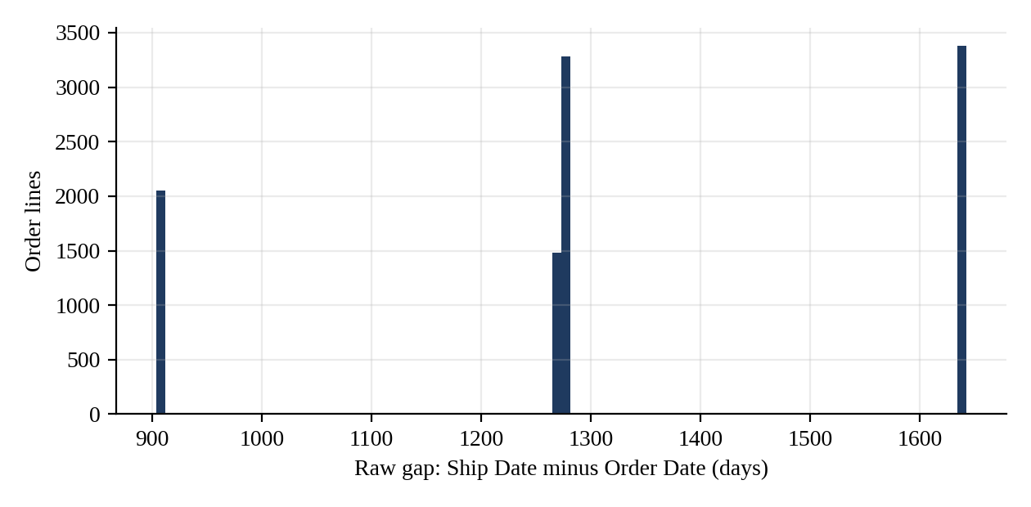
Figure 1: Raw gap between Ship Date and Order Date, showing three year-shifted blocks

4.3 Geospatial Features
The dataset contains the customer’s state or province but no coordinates. Each of the 59 states and provinces was therefore mapped to an approximate geographic centroid. The great-circle distance between the origin factory and the customer centroid was computed with the haversine formula (Sinnott, 1984):
d = 2R · arcsin( √( sin²(Δφ/2) + cos φ₁ · cos φ₂ · sin²(Δλ/2) ) ), R = 6,371 km
where φ is latitude and λ is longitude. Distances range from 158 km to 4,794 km (mean 1,985 km). Because centroids are used, distances are approximations at state level rather than exact delivery distances.

4.4 Preprocessing and Encoding
Numerical features (distance, units, unit price) were standardised to zero mean and unit variance. Categorical features (ship mode, region, division and product) were one-hot encoded. Extreme outliers were removed using a three-standard-deviation rule on lead time, which excluded two order lines (lead time of 11 days). The remaining 10,192 rows were split 80/20 into training and test sets with a fixed random seed (42).

4.5 Predictive Models
The prediction target is the expected shipping lead time in days. Three regressors were trained, as specified in the brief: Linear Regression (baseline), Random Forest Regressor (200 trees, minimum leaf size 5; Breiman, 2001) and Gradient Boosting Regressor (200 trees, depth 3, learning rate 0.05; Friedman, 2001).
Design choice: distance instead of a factory label. In the historical data every product is made at exactly one factory, so a factory label is perfectly confounded with the product. A model that relied on it could never say anything about a product–factory pair it had not seen. The models therefore use the distance from the origin factory to the customer as the origin feature. A product moved to a new factory simply takes a new distance value, and the model can score a scenario that never occurred historically.

4.6 Evaluation Metrics
Models were compared on the held-out test set using three metrics: root mean squared error (RMSE), which penalises large errors; mean absolute error (MAE), the average prediction error in days; and the coefficient of determination (R²), the share of variance explained. The preferred model balances accuracy and interpretability.

4.7 Route Clustering
A route is defined as a factory–destination state pair. Routes with at least five orders (120 routes) were described by their mean lead time, mean distance and order volume, standardised, and grouped with K-means clustering (MacQueen, 1967) into four clusters. The aim is to separate consistently slow routes and heavily loaded region–product combinations from the rest of the network.

4.8 Scenario Simulation Engine
For each product the engine replays the product’s historical orders as if they had been shipped from each of the five factories. For every candidate factory it recomputes the distance to each customer, predicts the lead time with the trained model, and aggregates the results. Comparing a candidate with the product’s current factory gives the change in predicted lead time, the change in shipping distance and the change in freight cost.
Freight cost assumption. The dataset contains no freight or carrier cost, so profit impact cannot be measured directly. It is modelled as freight cost = distance (thousand km) × units × rate, with a default rate of $0.05 per unit per 1,000 km. The rate is an adjustable input of the dashboard, and Section 8.3 tests the sensitivity of the conclusions to it. The profit impact of a move is the freight cost saved (or added) relative to the current assignment.

4.9 Optimisation and Recommendation Logic
Within each product, the candidate factories are ranked by a weighted score. A speed score is computed as the average of the lead-time reduction (%) and the distance reduction (%); the profit score is the freight saving. Both are min–max normalised across the five candidates of the product and combined as:
Score = w × Speed + (1 − w) × Profit
where w is the optimisation-priority slider of the dashboard (w = 1 means speed only, w = 0 means profit only). The top-N alternatives per product form the recommendation list. Each recommendation also receives a confidence score and a risk label:
- Confidence (0–100) = 100 × (1 − 0.5 × σ/σmax) × (1 − 0.5 × e), where σ is the standard deviation of the Random Forest trees’ predictions for the scenario, σmax is the largest σ across scenarios, and e is the share of simulated orders whose distance lies outside the range historically observed for that product (extrapolation).
- Risk is High if the move increases freight cost or confidence is below 50; Medium if confidence is below 70 or more than 30% of orders are extrapolated; otherwise Low.
The confidence score is a transparent heuristic, not a calibrated probability.

4.10 Key Performance Indicators
The four KPIs required by the brief are defined as follows. Lead Time Reduction (%) is the average predicted reduction for the best alternative per product. Profit Impact Stability is the standard deviation of the profit change, expressed as a percentage of gross profit, across the recommended moves; lower values indicate a safer portfolio. Scenario Confidence Score is the mean confidence of the recommended moves. Recommendation Coverage is the share of products for which at least one beneficial alternative exists.

5. Exploratory Data Analysis

5.1 Business Overview
The dataset records sales of $141,783.63 and gross profit of $93,442.80 (a gross margin of 65.9%) on 38,654 units. The Chocolate division dominates the business: it accounts for 96.6% of order lines and 92.9% of sales. Pacific and Atlantic customers generate 61.8% of sales between them (Table 4).
Table 4: Business overview by division and region
Segment | Order lines | Sales ($) | Share of sales | Mean distance (km)
Chocolate | 9,844 | 131,693 | 92.9% | –
Other | 310 | 9,663 | 6.8% | –
Sugar | 40 | 427 | 0.3% | –
Pacific | 3,253 | 46,302 | 32.7% | 2,044
Atlantic | 2,986 | 41,197 | 29.1% | 2,337
Interior | 2,335 | 32,038 | 22.6% | 1,628
Gulf | 1,620 | 22,247 | 15.7% | 1,730

5.2 Lead Time and Ship Mode
After normalisation, the average lead time is 4.29 days (median 4). Ship mode is by far the most important driver. Same Day orders average 0.38 days and Standard Class orders 5.32 days, and the differences between modes are highly significant (one-way ANOVA F = 5,613, p < 0.001). Standard Class is also the dominant mode, accounting for 60.0% of order lines (Table 5, Figure 2).
Table 5: Normalised lead time by ship mode (days)
Ship mode | Order lines | Share | Mean | Std. dev. | Range
Same Day | 547 | 5.4% | 0.38 | 0.53 | 0–2
First Class | 1,548 | 15.2% | 2.55 | 0.89 | 1–5
Second Class | 1,979 | 19.4% | 3.57 | 1.28 | 1–6
Standard Class | 6,120 | 60.0% | 5.32 | 1.13 | 3–11

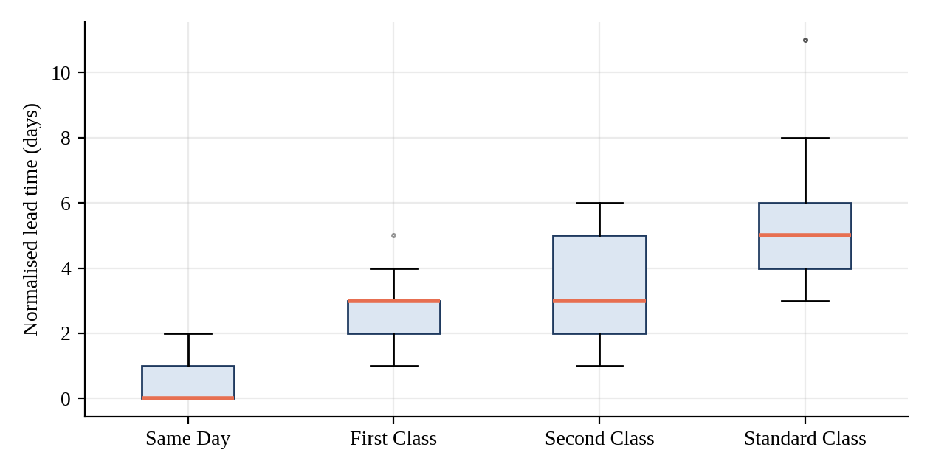
Figure 2: Lead time by ship mode

5.3 Region, Distance and Lead Time
Regional mean lead times are almost identical: 4.24 days in the Atlantic region, 4.27 in the Pacific, 4.30 in the Gulf and 4.38 in the Interior. The differences are statistically detectable (ANOVA p = 0.031) but practically negligible, at about 0.14 days between the fastest and slowest region. Distance behaves the same way: the correlation between factory-to-customer distance and lead time is only 0.008 (Figure 4). A linear model estimates the effect of distance at roughly 0.006 days per additional 1,000 km.
This is a central finding. In this dataset, shipping lead time is determined almost entirely by the ship mode chosen, not by where the product is made or where the customer is. The geography of the network is shown in Figure 3.
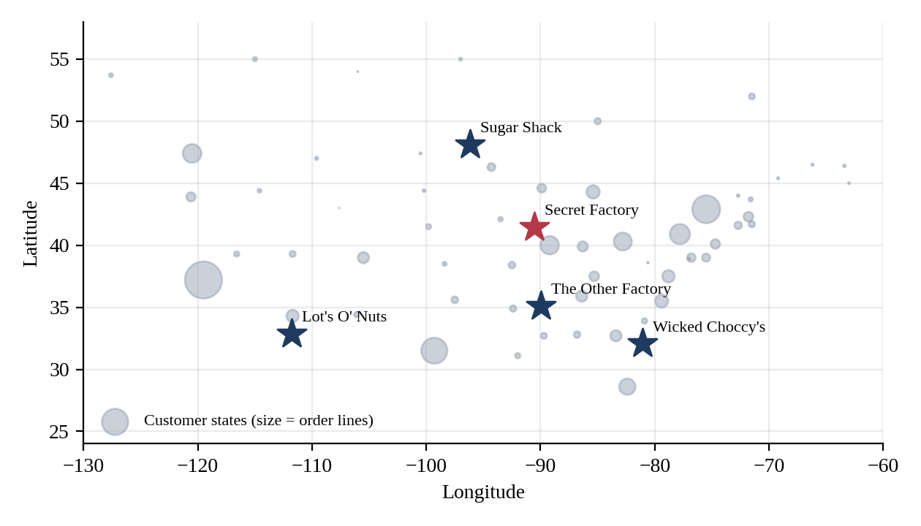
Figure 3: Factory locations and customer states (marker size proportional to order lines)
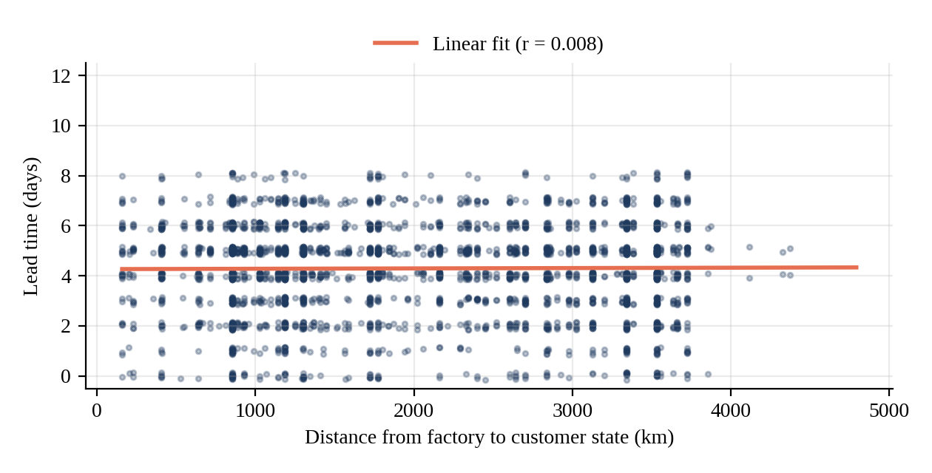
Figure 4: Distance from factory to customer versus lead time (3,000-order sample)

5.4 Factory and Product Concentration
Production is highly concentrated (Table 6). Lot’s O’ Nuts and Wicked Choccy’s together handle 96.5% of order lines and 92.9% of sales, because the five Wonka Bar products are the commercial core of the business. Secret Factory, Sugar Shack and The Other Factory are small by comparison.
The concentration produces long shipping distances for some region–product combinations. The Pacific region receives Triple Dazzle Caramel and Milk Chocolate (made in Georgia) over an average of about 3,400 km, whereas Scrumdiddlyumptious (made in Arizona) travels only about 1,000 km to the same region. The Atlantic region shows the mirror image. These are exactly the mismatches a reassignment analysis should target.
Table 6: Factory profile (current assignment)
Factory | Order lines | Sales ($) | Gross profit ($) | Mean dist. (km) | Mean lead (d)
Lot’s O’ Nuts | 5,692 | 76,340 | 52,771 | 2,088 | 4.26
Wicked Choccy’s | 4,152 | 55,353 | 36,054 | 1,886 | 4.35
Secret Factory | 217 | 8,588 | 4,345 | 1,380 | 4.09
The Other Factory | 100 | 1,282 | 152 | 1,600 | 3.98
Sugar Shack | 33 | 221 | 121 | 1,714 | 4.67

5.5 Summary of EDA Insights
- Lead time is explained mainly by ship mode; distance and region add almost nothing.
- Two factories and five products account for roughly 96.5% of the business, so the results for the Wonka Bars effectively determine the overall outcome.
- Ten of the fifteen products have fewer than 130 order lines (seven have 10 or fewer), so predictions for them rest on very little evidence.
- Kazookles earns a gross margin of only 7.7%, against about 66% for the portfolio, so any extra logistics cost on it is proportionally costly.
- Shifting ten percentage points of orders from Standard Class to Second Class would reduce the average lead time by about 0.18 days (about 4%), a larger effect than any factory reassignment modelled here.

6. Predictive Modelling Results

6.1 Model Performance
Table 7 and Figure 5 compare the three models on the held-out test set of 2,039 order lines. All three explain roughly 62–63% of the variance in lead time, with an average error of about 0.9 days. Gradient Boosting has the best RMSE (1.094) and R² (0.630); Linear Regression is a close second (RMSE 1.097, R² 0.627); Random Forest has the lowest MAE (0.913) but the highest RMSE.
Table 7: Model performance on the test set
Model | RMSE (days) | MAE (days) | R²
Linear Regression | 1.0974 | 0.9229 | 0.6273
Random Forest | 1.1151 | 0.9127 | 0.6153
Gradient Boosting | 1.0935 | 0.9170 | 0.6300

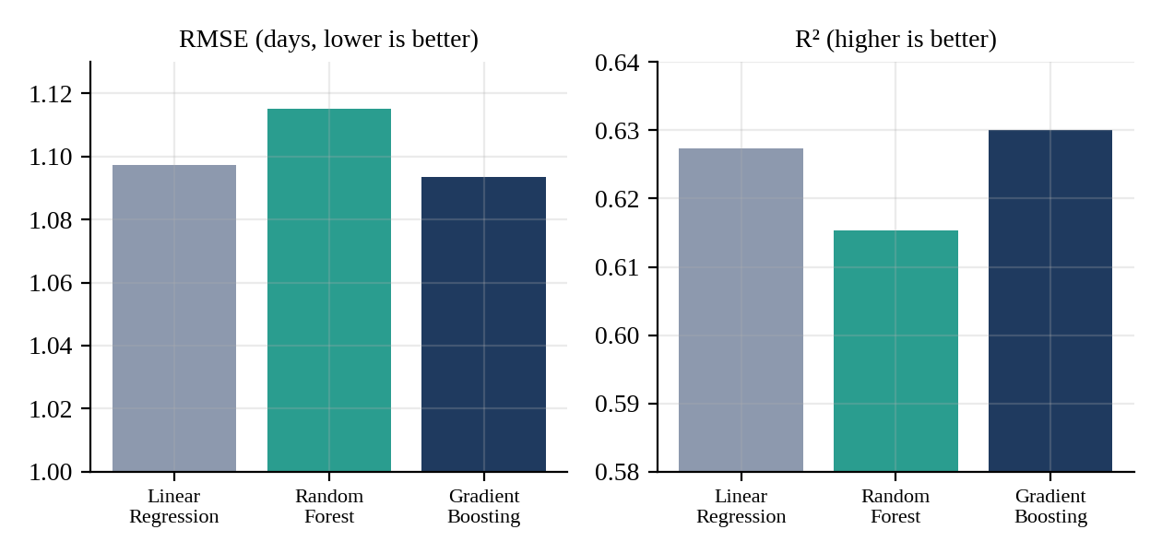
Figure 5: Model comparison on the test set

6.2 Feature Importance
Figure 6 shows the Random Forest feature importances. Ship mode indicators carry 87% of the total importance (Standard Class 68%, Same Day 15%, Second and First Class about 2% each), distance carries 5.4% and units ordered 3.9%. This confirms the exploratory finding: the models learn the ship-mode effect and little else.
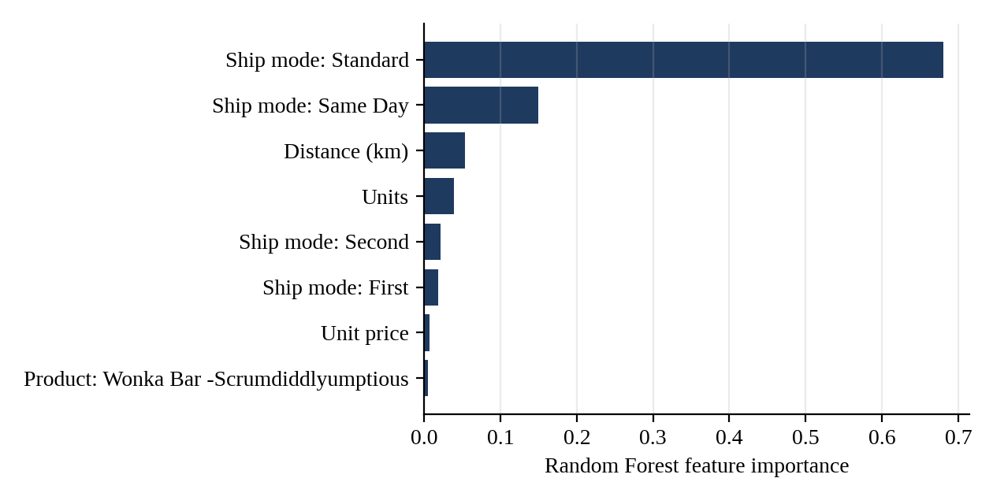
Figure 6: Random Forest feature importance (top eight features)

6.3 Model Selection and Interpretation
The three models are practically indistinguishable (the RMSE range is 0.022 days). Since the brief asks for a balance of accuracy and interpretability, Linear Regression is a defensible production choice because its coefficients can be read directly. Gradient Boosting is retained as the default for simulation because it has the best RMSE and R², and Random Forest is used to estimate prediction uncertainty. The dashboard lets the user switch between models.
The unexplained 37% of variance is a limit of the data: the dataset has no information on carrier, warehouse stock, order processing delay or weather. Accuracy gains from more complex models should not be expected without such variables.

7. Route and Product Clustering
K-means clustering of the 120 routes with at least five orders produced the four groups summarised in Table 8 and Figure 7.
Table 8: Route clusters
Cluster profile | Routes | Order lines | Mean lead (d) | Mean distance (km) | Standard Class share
2: High-volume core | 6 | 3,986 | 4.3 | 1,989 | 59.6%
0: Long-haul, mid-volume | 34 | 2,721 | 4.1 | 2,887 | 57.6%
3: Short-haul long tail | 63 | 2,867 | 4.3 | 1,154 | 61.0%
1: Slow, long-haul, low-volume | 17 | 464 | 5.2 | 2,939 | 71.3%

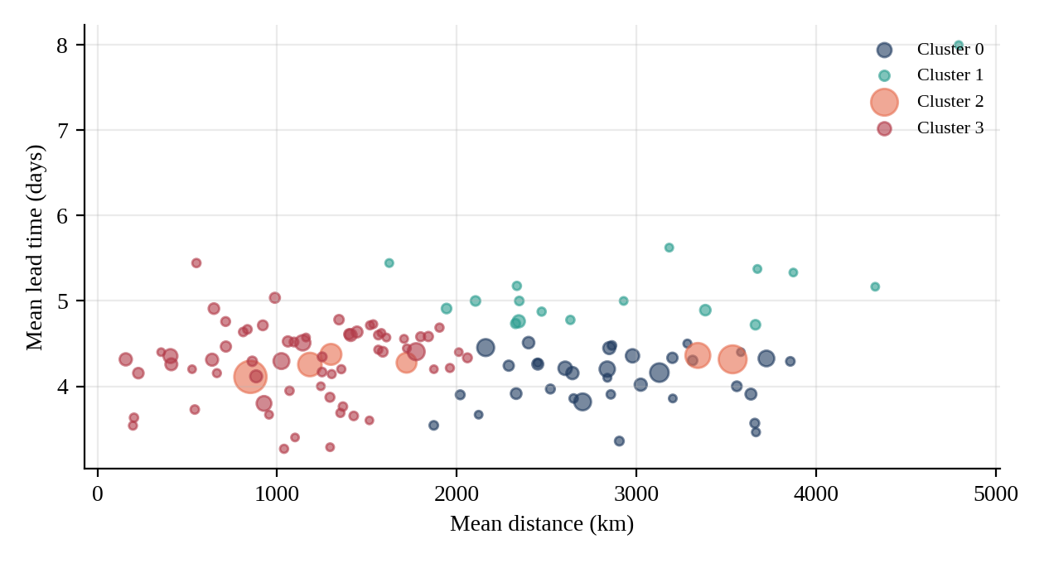
Figure 7: Route clusters by mean distance and lead time (marker size proportional to volume)
High-volume core (cluster 2). Six routes carry 3,986 order lines (the largest share of volume and about $36,100 of gross profit). These routes are long, at roughly 2,000 km on average, and they are the most promising targets for reassignment.
Slow routes (cluster 1). Seventeen routes have the longest mean lead time (5.2 days) but only 464 order lines. The Standard Class share on these routes is 71.3%, against 58–61% elsewhere. The slowness is therefore explained by ship-mode mix rather than by distance (distance on these routes is similar to cluster 0, whose mean lead time is only 4.1 days). Changing the factory would not fix them.
Congested combinations. The busiest region–product combinations are all Wonka Bars in the Pacific and Atlantic regions, each with 570 to 680 order lines. Their lead times (4.2–4.4 days) are normal, so the congestion shows up as concentrated load on the two main factories rather than as longer lead times.

8. Scenario Simulation and Recommendations

8.1 Worked Example: Wonka Bar – Milk Chocolate
Table 9 shows the simulation for the product with the most order lines, Milk Chocolate, which is currently produced at Wicked Choccy’s in Georgia. The predicted lead time barely moves between factories: all five candidates fall within 4.365–4.394 days, a spread of 0.03 days. Lead-time differences of this size are within model noise and should not be interpreted as real gains. Shipping distance, in contrast, changes substantially: producing Milk Chocolate at Secret Factory (Iowa/Illinois border) would cut the average distance by 22.0%, and at The Other Factory (Tennessee) by 17.6%. Moving it to Lot’s O’ Nuts (Arizona) would lengthen the average distance by 12.9%.
Table 9: Simulated scenarios for Wonka Bar – Milk Chocolate (2,137 order lines)
Factory | Mean distance (km) | Distance change | Predicted lead (d) | Freight saving ($) | Risk
Secret Factory | 1,461 | −22.0% | 4.380 | 172 | Medium
The Other Factory | 1,543 | −17.6% | 4.370 | 141 | Medium
Sugar Shack | 1,762 | −6.0% | 4.390 | 52 | Medium
Wicked Choccy's (current) | 1,873 | 0.0% | 4.370 | 0 | Low
Lot's O' Nuts | 2,115 | +12.9% | 4.370 | −75 | High

8.2 Recommended Reassignments
Table 10 gives the best alternative factory for every product at a balanced priority setting (w = 0.5). Because ranking within a product is relative, a “best alternative” can still be a bad move, so each recommendation was classified using the evidence behind it:
- Move: at least 1,000 order lines, distance reduction of 20% or more, positive freight saving, and Medium or lower risk.
- Pilot only: the distance gain is large, but fewer than 20 order lines support it, so the estimate is unreliable (High or Medium risk).
- Marginal: distance reduction below 5%; the saving does not justify disruption.
- Retain: the alternative lengthens shipping distance or raises freight cost.
Table 10: Best alternative factory for each product (w = 0.5, freight rate $0.05 per unit per 1,000 km). Wonka Bar prefix omitted.
Product | Order lines | Best alternative | Distance change | Freight saving ($) | Decision
Milk Chocolate | 2,137 | Secret Factory | −22.0% | 172.20 | Move
Scrumdiddlyumptious | 2,064 | Secret Factory | −28.9% | 240.36 | Move
Triple Dazzle Caramel | 2,015 | Secret Factory | −22.1% | 165.63 | Move
Fudge Mallows | 1,818 | Secret Factory | −30.5% | 211.27 | Move
Nutty Crunch Surprise | 1,810 | Secret Factory | −29.9% | 215.14 | Move
Wonka Gum | 120 | The Other Factory | +3.1% | −0.60 | Retain
Kazookles | 96 | Secret Factory | −1.8% | 0.41 | Marginal
Lickable Wallpaper | 94 | The Other Factory | +10.0% | −2.74 | Retain
Laffy Taffy | 10 | Wicked Choccy's | −28.7% | 1.43 | Pilot only
SweeTARTS | 10 | Secret Factory | −25.1% | 0.93 | Pilot only
Fizzy Lifting Drinks | 6 | Secret Factory | −32.2% | 0.56 | Pilot only
Hair Toffee | 4 | Secret Factory | −2.2% | 0.07 | Marginal
Nerds | 4 | Secret Factory | −28.9% | 0.23 | Pilot only
Everlasting Gobstopper | 3 | The Other Factory | −19.8% | 0.13 | Pilot only
Fun Dip | 3 | Secret Factory | −50.2% | 0.26 | Pilot only

The result is concentrated. All five Wonka Bars (9,844 order lines, 96.6% of the portfolio) show the same pattern: Secret Factory is the best alternative, reducing their order-weighted mean distance from 2,003 km to 1,469 km (−26.7%) and the modelled freight cost from $3,751 to $2,747, a saving of $1,005 (26.8%). The saving per product is between 0.9% and 1.3% of its gross profit (Figure 8). Lickable Wallpaper and Wonka Gum should stay where they are, and the remaining small products give no reliable signal.
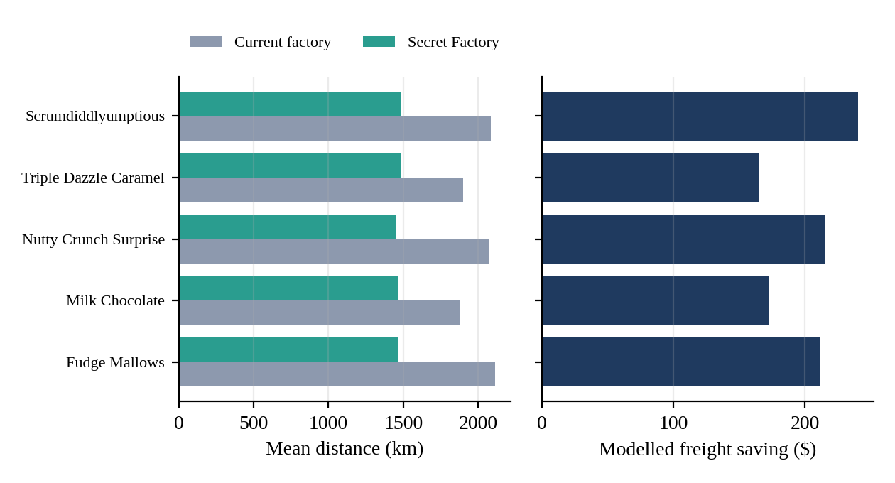
Figure 8: Wonka Bar products: current distance versus Secret Factory, and modelled freight saving

8.3 Speed-versus-Profit Sensitivity
The optimisation-priority slider produced no change in the recommendation for any Wonka Bar: Secret Factory ranks first at w = 0, w = 0.5 and w = 1. The reason is that, in this data, the factory that is closest to the customers is also the cheapest to ship from (since freight is modelled on distance) and has an indistinguishable predicted lead time. There is no real trade-off between speed and profit to resolve. Only for a few low-volume products (for example Hair Toffee) does the top choice change between w = 0 and w = 0.5.
The size of the saving depends directly on the assumed freight rate (Table 11). The ranking of factories does not depend on the rate, because freight is proportional to distance, but the dollar value does. Real freight tariffs should be substituted before presenting financial figures externally.
Table 11: Sensitivity of the Wonka Bar saving to the freight rate
Freight rate ($ per unit per 1,000 km) | Modelled saving ($) | Saving as % of Wonka Bar gross profit
0.02 | 402 | 0.5%
0.05 (default) | 1,005 | 1.1%
0.10 | 2,009 | 2.3%
0.25 | 5,023 | 5.7%

8.4 Risk Assessment
- Capacity risk (most important). Secret Factory currently handles 217 order lines (2.1% of the total). Receiving the five Wonka Bars would add 9,844 lines, more than 45 times its current volume. The dataset contains no capacity information, so the models cannot say whether this is feasible.
- Evidence risk. Seven of the fifteen products carry a High risk label, either because they have too few orders to support a reliable estimate or because the move would raise freight cost. None of them should be moved on the strength of this analysis alone.
- Extrapolation risk. Moving a product to a factory it has never used produces distances outside its historical range. The Wonka Bar scenarios have Medium risk and confidence of 57–59 out of 100; for Milk Chocolate, for example, the current assignment is the only Low-risk option.
- Financial risk. Gains are small relative to gross profit (about 1%), so a modest rise in production cost or freight rate at the new factory could erase them.

9. KPI Evaluation
Table 12 reports the four KPIs for the default setting (w = 0.5, Gradient Boosting, freight rate $0.05). Values are shown for the full portfolio of fifteen products and for the five Wonka Bars, which carry the evidence.
Table 12: Key performance indicators
KPI | All 15 products | Wonka Bars | Interpretation
Lead Time Reduction (%) | 0.15% | 0.08% | Negligible; lead time is set by ship mode, not factory
Distance Reduction (%), supporting indicator | – | 26.7% | Substantial and consistent across the five products
Profit Impact Stability (std. dev. of change, % of gross profit) | 1.66 pp | 0.16 pp | Savings are small but stable (0.9% to 1.3% of gross profit)
Scenario Confidence Score (0–100) | 50.8 | 58.1 | Moderate; Medium risk for Wonka Bars
Recommendation Coverage | 100% of products; 96.6% of order lines with a supported move | 100% | Every product has a candidate, but only the Wonka Bars have enough data

The headline interpretation is therefore a split one. The operational KPI that the brief emphasises, lead-time reduction, is essentially nil. The efficiency KPI, shipping distance, shows a clear gain on the products that matter, with a stable but modest financial benefit.

10. Streamlit Dashboard

10.1 Purpose and Design
The dashboard turns the pipeline into a tool that a manager can use without writing code. It opens with the dataset already loaded and trains the three models on start-up (results are cached so that interaction remains fast). It uses a dark purple-and-pink theme, an interactive map of the five factories, and colour-coded risk badges.

10.2 Modules
The dashboard implements the four modules required by the brief plus a diagnostics tab:
- Factory Optimization Simulator: select a product and view the predicted lead time, mean distance, freight saving, confidence and risk for each of the five factories, with a map showing the current factory and the best alternative.
- What-If Scenario Analysis: compare the current assignment with the best or a manually chosen factory, with metrics and charts for lead time, distance and freight cost and an automatically written summary sentence.
- Recommendation Dashboard: a ranked table of top-N reassignment suggestions with expected efficiency gains, and a scatter plot of distance reduction against freight saving.
- Risk & Impact Panel: profit-impact alerts for moves that raise freight cost, warnings for high-risk or low-confidence moves, and a heat map of savings by product and factory.
- Data & Models: model comparison table, lead time by ship mode, distance-versus-lead-time scatter, route clusters, and a warning that states the weak distance–lead-time relationship.

10.3 User Controls
The sidebar provides the controls specified in the brief: a product selector, a region selector, a ship-mode filter, and an optimisation-priority slider (speed versus profit). It adds a model selector, a top-N setting and the freight-rate input, so that users can see how assumptions change the answer. The four KPI cards at the top of every page update with the filters.

10.4 Implementation and Deployment
The application is written in Python with Streamlit for the interface, Plotly for charts, and scikit-learn for modelling. The shared module core.py contains the data preparation, models, simulation and ranking logic, so the notebook and the dashboard cannot diverge. The application can be run locally with the command streamlit run app.py, from Google Colab through a public tunnel, or deployed free of charge on Streamlit Community Cloud from a GitHub repository (Appendix A lists the files). Because the dataset is stored beside the application, deployed users see the data immediately and are never asked to upload anything.

11. Discussion and Limitations

11.1 Discussion
The project brief assumes that reassigning products to better-located factories would shorten lead times. The data do not support that premise: lead time depends on ship mode, and distance explains almost none of its variation. The value of the reassignment analysis lies elsewhere. It identifies a clear geographic inefficiency in the Wonka Bar network (a 27% reduction in shipping distance) and quantifies the effect on freight cost. It also shows that the largest lever on lead time lies in the ship-mode mix, which is a commercial decision rather than a manufacturing one.
Reporting this plainly is itself a result. A recommendation system that promised large lead-time gains would have been unsupported by the evidence.

11.2 Limitations
- Date anomaly. Lead times depend on the assumption that the year-shifted gaps can be normalised by block (Section 4.2). The assumption should be validated with the data owner.
- Approximate geography. Customer locations are state centroids, so distances are approximate, particularly for large states and for Canadian provinces (200 order lines).
- Assumed freight cost. Profit impact rests on a modelled freight rate, not observed carrier costs. Dollar values are indicative only.
- No capacity or production-cost data. Factory capacity, changeover costs, local labour and ingredient costs and inventory are outside the dataset, yet any real reassignment depends on them.
- Sparse products. Ten products have fewer than 130 order lines, so their results are unreliable.
- Model scope. Models explain about 63% of the variance, and a random rather than time-based split was used. The confidence score is a heuristic and has not been calibrated against real outcomes.
- Single-factory history. Because each product has only ever been made at one factory, the effect of changing factory is inferred from distance, not observed.

12. Conclusion and Future Work

12.1 Conclusion
This project built an end-to-end decision-support system for factory reallocation at Nassau Candy Distributor: a cleaned and normalised dataset, three lead-time models, a route clustering, a scenario-simulation engine, a ranking and risk framework, and an interactive Streamlit dashboard. The main findings are that (i) lead time is governed almost entirely by ship mode; (ii) factory choice has no material effect on predicted lead time; (iii) the five Wonka Bar products would travel about 27% less far if produced at Secret Factory, saving roughly 1% of their gross profit in modelled freight; and (iv) the evidence for the other ten products is too thin to support any reassignment.

12.2 Recommendations
- Validate before acting. Confirm the date normalisation, obtain actual freight costs and obtain Secret Factory’s capacity and unit production cost.
- Pilot one product. If capacity allows, move a single Wonka Bar (for example Milk Chocolate, the largest by volume) to Secret Factory, or to The Other Factory as an alternative (−17.6% distance), and compare observed freight cost and lead time against the model for one quarter.
- Do not move the small products. Keep Lickable Wallpaper and Wonka Gum where they are. Re-evaluate the others when more orders are available.
- Address ship-mode mix. Because Standard Class accounts for 60% of orders and is about 1.75 days slower than Second Class, review incentives and thresholds for faster modes if shorter lead time is the goal.
- Adopt the dashboard as a standing tool, refreshing it with new orders and real cost data.

12.3 Future Work
- Replace the heuristic freight model with carrier rate tables and add production cost and capacity constraints, turning the ranking into a constrained optimisation (for example, linear or integer programming).
- Include operational variables (order-processing time, carrier, inventory position, seasonality) to explain the remaining 37% of lead-time variance.
- Use a time-based train/test split and calibrate the confidence score on pilot results.
- Add a ship-mode optimisation module, since ship mode is the dominant driver of lead time.
- Replace state centroids with geocoded delivery addresses from city and postal-code fields.

References
Breiman, L. (2001). Random forests. Machine Learning, 45(1), 5–32.
Chopra, S., & Meindl, P. (2016). Supply chain management: Strategy, planning, and operation (6th ed.). Pearson.
Friedman, J. H. (2001). Greedy function approximation: A gradient boosting machine. The Annals of Statistics, 29(5), 1189–1232.
Hastie, T., Tibshirani, R., & Friedman, J. (2009). The elements of statistical learning (2nd ed.). Springer.
MacQueen, J. (1967). Some methods for classification and analysis of multivariate observations. In Proceedings of the 5th Berkeley Symposium on Mathematical Statistics and Probability (Vol. 1, pp. 281–297). University of California Press.
McKinney, W. (2010). Data structures for statistical computing in Python. In Proceedings of the 9th Python in Science Conference (pp. 56–61).
Nassau Candy Distributor. (n.d.). Company website. https://www.nassaucandy.com/
Pedregosa, F., et al. (2011). Scikit-learn: Machine learning in Python. Journal of Machine Learning Research, 12, 2825–2830.
Sinnott, R. W. (1984). Virtues of the haversine. Sky and Telescope, 68(2), 159.
Streamlit Inc. (n.d.). Streamlit documentation. https://docs.streamlit.io

Appendix A: Project Files and Reproducibility
All code and data needed to reproduce the results are provided in the project repository (Table 13). The notebook and the dashboard import the same module, core.py.
Table 13: Project files
File | Purpose
app.py | Streamlit dashboard
core.py | Data preparation, models, simulation, ranking and clustering
Nassau_Candy_Distributor.csv | Dataset, loaded automatically (no upload box)
Nassau_Candy_Optimization.ipynb | Google Colab notebook with EDA, models, clustering and simulation
requirements.txt | Python dependencies: streamlit, pandas, numpy, scikit-learn, plotly
.streamlit/config.toml | Dashboard theme
README.md | Run and deployment instructions

To run locally: install the dependencies with pip install -r requirements.txt, then start the dashboard with streamlit run app.py. To deploy, push the repository to GitHub and create a new app on Streamlit Community Cloud with app.py as the main file.

