Windows Support Lab

Exercise 1: DNS and Network Troubleshooting

Environment: Windows 11 Virtual Machine — Oracle VirtualBox
Network type: VirtualBox NAT
Date: 26 October 2026

1. Objective :- To verify network connectivity and DNS name resolution, then practise
diagnosing and resolving a controlled DNS configuration fault using
evidence-based troubleshooting.

2. Baseline Tests :- The following tests were completed before introducing the fault. They confirmed that the virtual machine had a valid IP configuration, external network connectivity, and working DNS name resolution.

Test | Command | Result
IP configuration | ipconfig | IPv4 address present
Network connectivity | ping 8.8.8.8 | Replies received; 0% loss
DNS resolution | nslookup google.com | Google IP addresses resolved

Baseline evidence: “ipconfig”, “ping 8.8.8.8”, “nslookup google.com”, “ipconfig /all”.

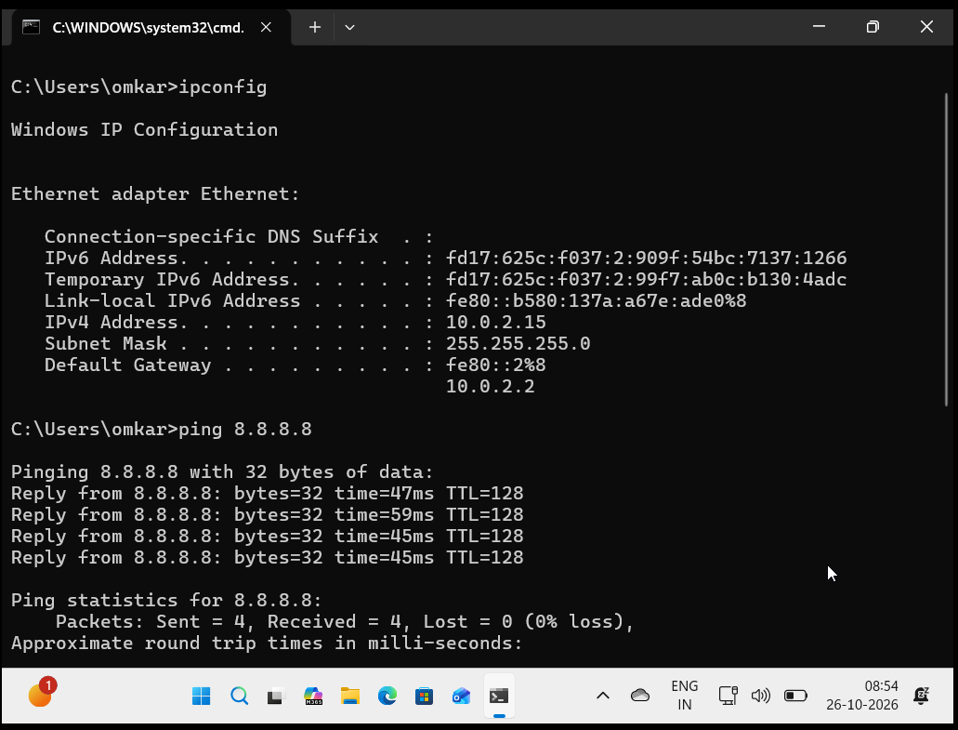
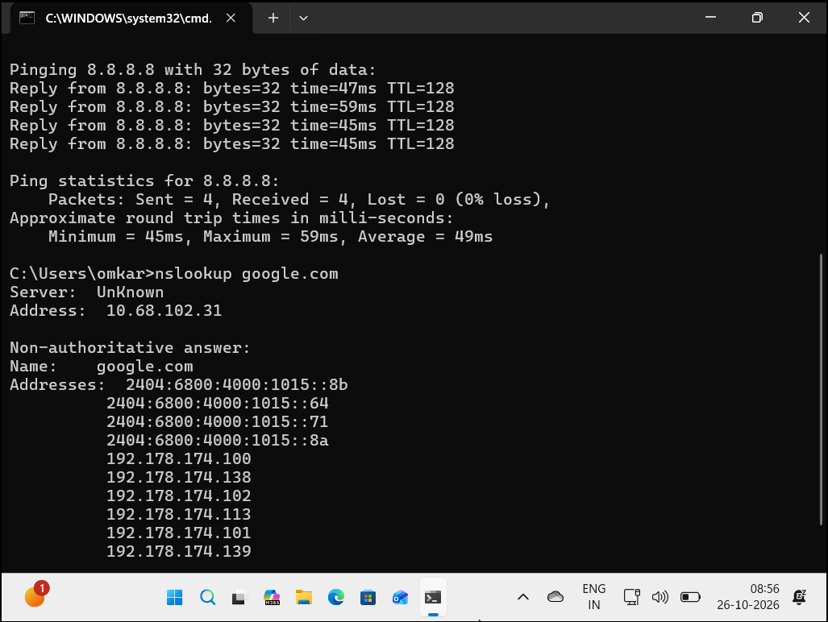

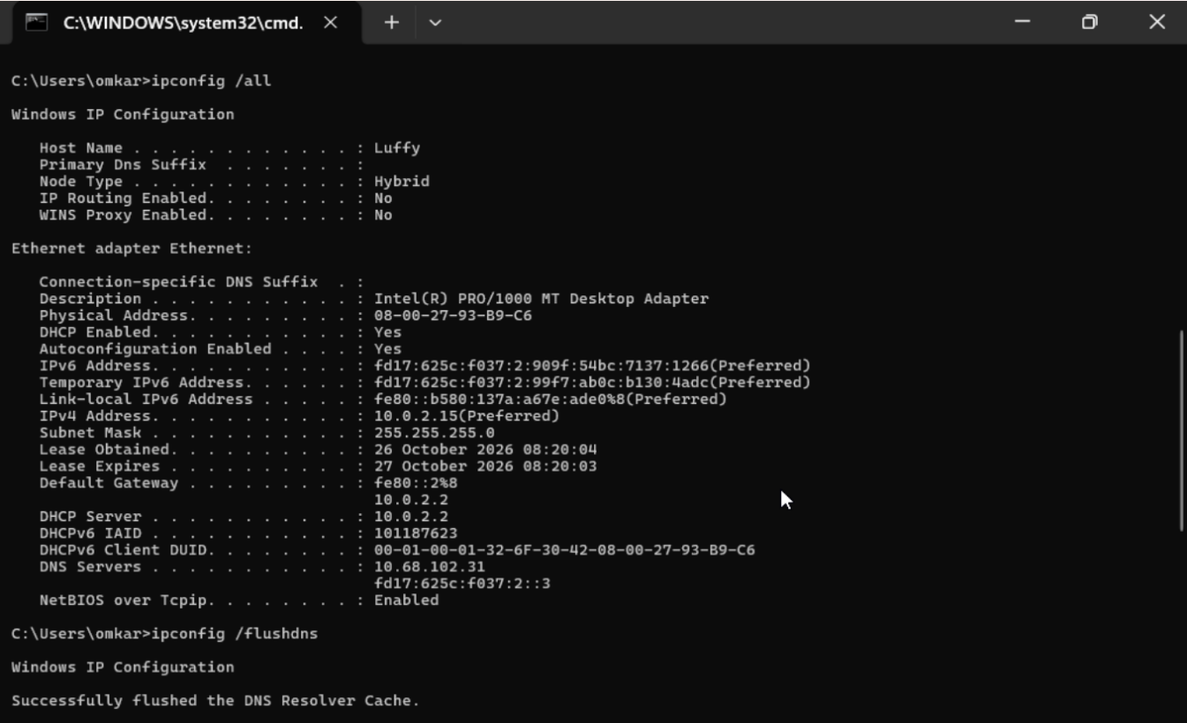

3. Fault Introduced :- The IPv4 DNS server assignment on the Ethernet adapter was changed from Automatic DHCP to Manual. The preferred DNS server was set to 192.0.2.99, an invalid documentation/test address. IPv6 was temporarily disabled so that the VM would use only the invalid IPv4 DNS server.

4. Symptom :- User cannot browse websites. When attempting to open https://www.google.com in Microsoft Edge, the page does not load and the browser displays “This site can’t be reached”.

5. Evidence Collected After the Fault

Command: ipconfig /all

Result:
DNS Servers . . . . . . . . . . . : 192.0.2.99
IPv4 Address . . . . . . . . . . : 10.0.2.15
Default Gateway . . . . . . . . . : 10.0.2.2
DHCP Enabled . . . . . . . . . . : Yes

Meaning:
The Ethernet adapter still had an IPv4 address and default gateway, but its
configured DNS server was 192.0.2.99.

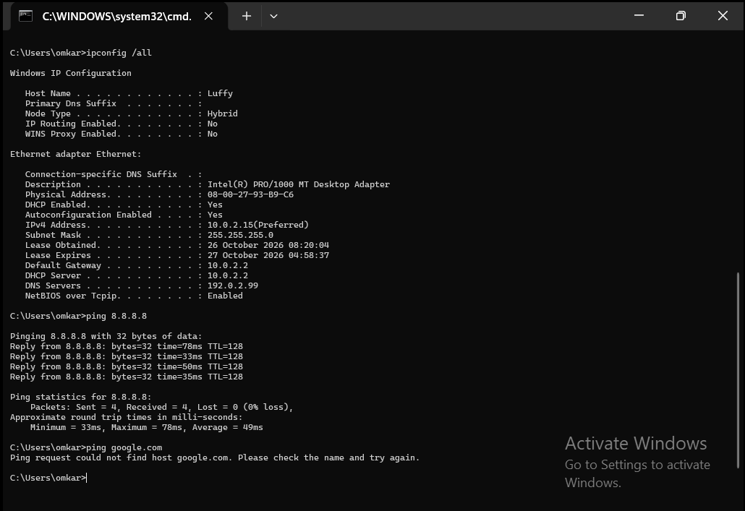

Command: ping 8.8.8.8

Result:
Reply from 8.8.8.8: bytes=32 time=47ms TTL=128
Reply from 8.8.8.8: bytes=32 time=59ms TTL=128
Reply from 8.8.8.8: bytes=32 time=45ms TTL=128
Reply from 8.8.8.8: bytes=32 time=45ms TTL=128

Packets: Sent = 4, Received = 4, Lost = 0 (0% loss)

Meaning:
The VM could reach an external IP address. This showed that the VM could reach an external IP address, which supports that the active network path and default gateway were functioning; it does not independently prove every component is fault-free..

Command: ping google.com

Result:
Ping request could not find host google.com.
Please check the name and try again.

Meaning:
The VM could not resolve the domain name google.com into an IP address.

Command: nslookup google.com

Result:
Server: UnKnown
Address: 192.0.2.99

DNS request timed out.
Timeout was 2 seconds.
*** Request to UnKnown timed-out

Meaning: Windows attempted to query the configured DNS server, 192.0.2.99, but that
server did not respond. DNS name resolution failed.

Browser test: Microsoft Edge could not open https://www.google.com.

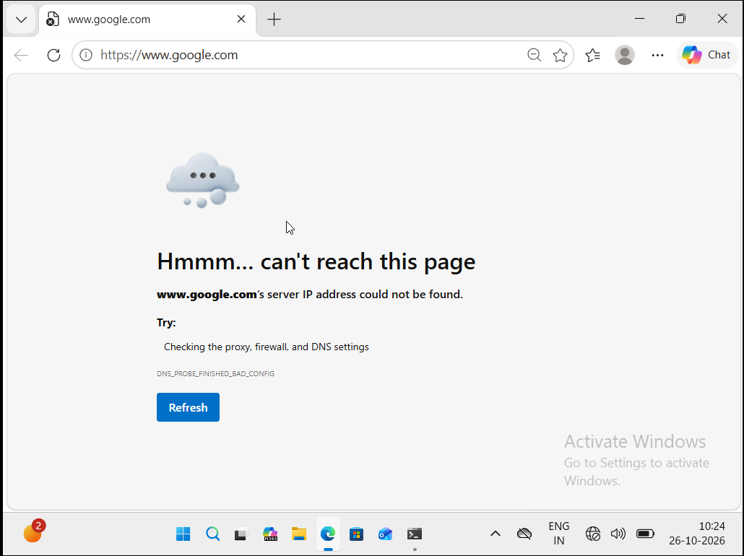

6. Analysis :-The evidence isolated the problem to DNS name resolution.
- ping 8.8.8.8 succeeded, so the VM had IP-level connectivity to the internet.
- ping google.com failed, so the VM could not translate the hostname into an IP address.
- nslookup google.com timed out using DNS server 192.0.2.99, confirming that the DNS server was unreachable or invalid.
- ipconfig /all confirmed that 192.0.2.99 was the configured IPv4 DNS server.

Because the VM could communicate with an external IP address but could not
resolve a domain name, the fault was not caused by the virtual adapter,
default gateway, DHCP lease, or general internet connection. The evidence
pointed directly to an invalid DNS server configuration.

Microsoft’s DNS client troubleshooting guidance recommends verifying the
client’s IP configuration and DNS server entries, then using nslookup to
reproduce DNS resolution failures.

7. Root Cause :- An invalid IPv4 DNS server, 192.0.2.99, was manually configured on the
Ethernet adapter. Windows could not obtain DNS responses from that server, so it could not resolve website domain names.

8. Fix Applied :- The smallest safe fix was to restore the DNS configuration to its original
automatic setting.

Steps:
1. Opened Settings.
2. Went to Network & internet > Ethernet.
3. Opened DNS server assignment.
4. Changed IPv4 DNS from Manual back to Automatic DHCP.
5. Re-enabled IPv6 on the Ethernet adapter.
6. Ran ipconfig /flushdns to clear the DNS resolver cache.

The ipconfig /flushdns command flushes and resets the contents of the DNS
client resolver cache.

9. Final Validation

Command: ipconfig /all

Result: DNS server returned to the DHCP-assigned address, 10.68.102.31.

Command: nslookup google.com

Result: Google IP addresses were returned successfully.
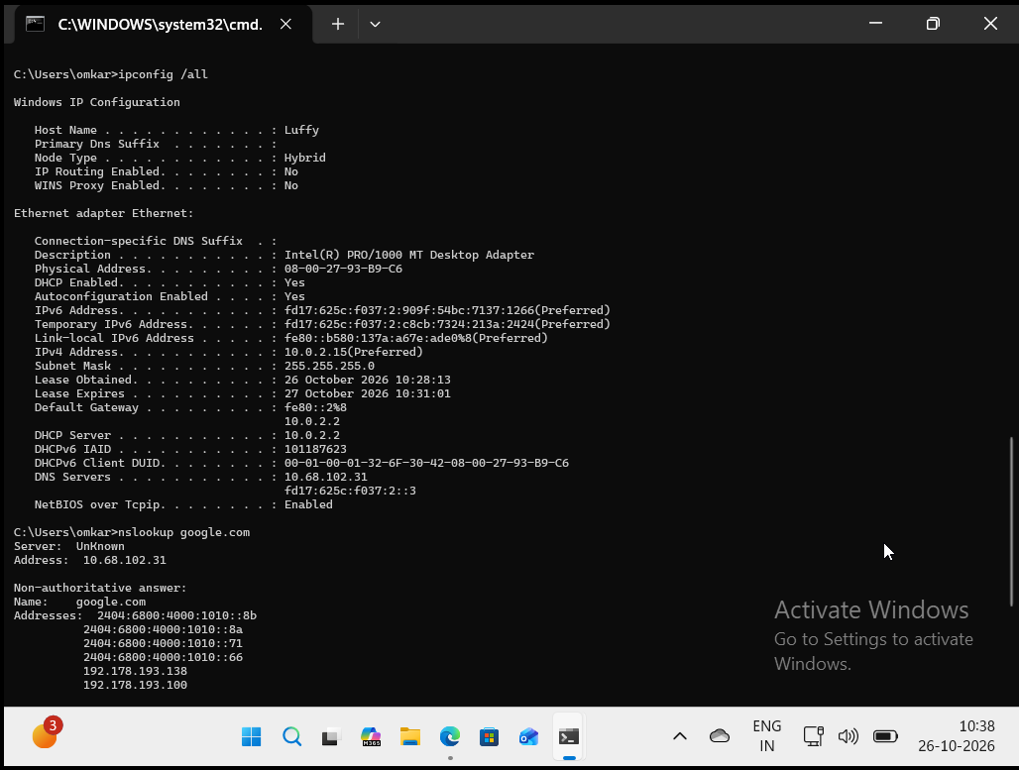
Command: ping google.com

Result: Replies were received successfully.

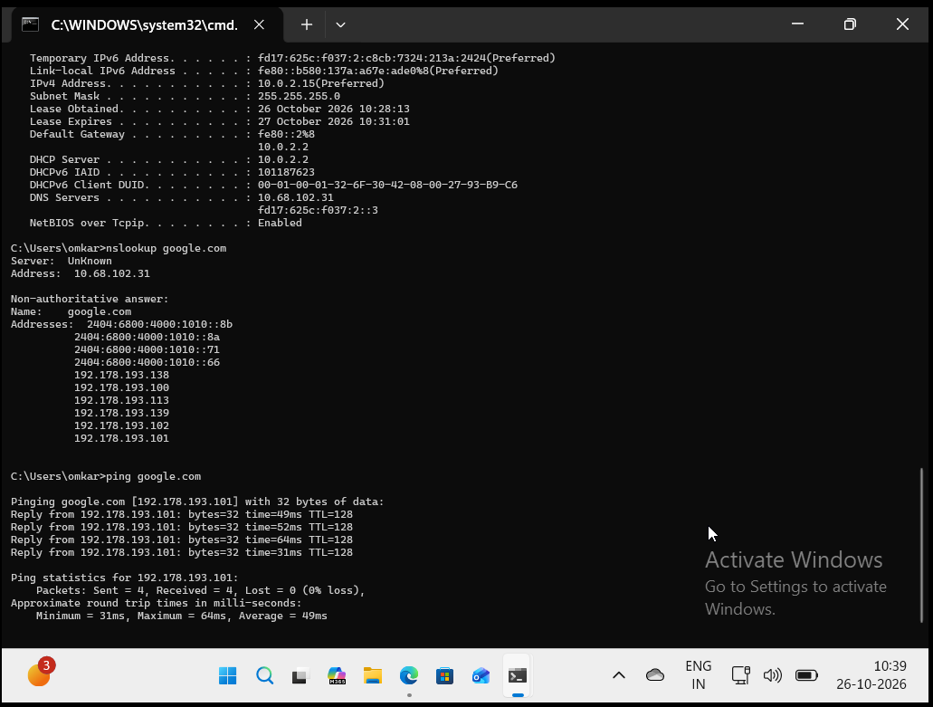

Browser test: Microsoft Edge successfully opened https://www.google.com.

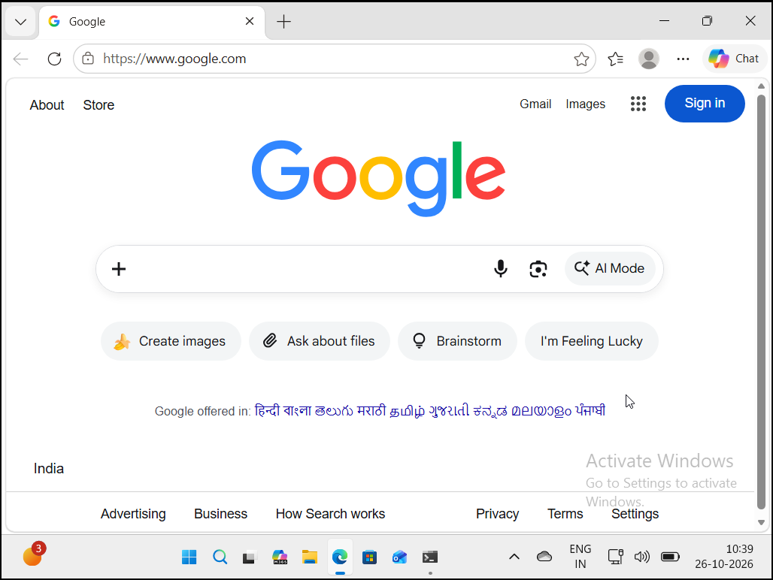
10. Prevention :-
- Use DHCP-provided DNS settings unless a specific DNS server is required.
- Document any manual DNS changes.
- Test DNS resolution after changing network settings.
- Use ipconfig /all and nslookup to verify DNS configuration.
- Restore the VM baseline snapshot after completing controlled fault exercises.

