DocuMind
Enterprise Document Q&A Assistant
A RAG-based Chatbot — Low-Level Design (LLD) Document

Prepared by: Omkar
Prepared for: Junior AI/ML Engineer — Technical Interview Qualifier
Document Version: 1.0
Date: June 20, 2026

Table of Contents
1. Executive Summary
2. Goals and Non-Goals
3. High-Level Architecture
4. Component Breakdown
5. Design Patterns Used
6. Class Design (Low-Level)
7. Sequence Diagrams
8. API Contracts
9. Database Schema
10. Caching Strategy
11. Error Handling & Edge Cases
12. Scalability & Production Considerations
13. Testing Strategy
14. Technology Stack
15. Future Enhancements
Appendix A — Running the Prototype
Appendix B — Reference Web UI

1. Executive Summary
DocuMind is an internal knowledge assistant that lets employees ask natural-language questions against company documents — HR policies, IT security guidelines, onboarding manuals, process docs — and receive grounded, cited answers instead of manually searching through PDFs and wikis. It is built on a Retrieval-Augmented Generation (RAG) pipeline: documents are chunked and embedded once at ingestion time, and every question is answered by retrieving the most relevant chunks and grounding the language model's response in that retrieved context, rather than relying on the model's parametric memory alone.
This document is the Low-Level Design (LLD) for the system: it specifies the internal class structure, sequence of operations, API contracts, and database schema needed to actually build it — not just the high-level boxes-and-arrows view. Every major component sits behind an interface (Strategy, Factory, Repository, and Facade patterns), so the embedding model, vector database, and LLM vendor can each be swapped independently without touching the rest of the codebase. This is the single design decision that matters most in a real RAG system, because every one of those three components changes faster than the system around it: vendors update pricing, better embedding models ship, and self-hosted vector databases get adopted as scale grows.
A working prototype accompanies this document. It runs fully offline with zero API keys (TF-IDF embeddings + an extractive answer fallback) so it can be cloned and verified in under a minute, and it switches to real Claude-generated answers automatically the moment an API key is supplied — demonstrating that the swap points described in this document are real, not aspirational.

2. Goals and Non-Goals

2.1 Goals
- Ingest multiple document formats (.txt, .md, with a defined extension point for .pdf/.docx) and split them into semantically coherent chunks.
- Answer natural-language questions using only the organization's own documents, with retrieved sources cited back to the user.
- Keep every architectural seam (chunking, embedding, vector storage, generation) swappable behind an interface, so vendor or algorithm changes are config changes, not rewrites.
- Persist conversation history per user so follow-up questions have a record, and documents can be audited (who uploaded what, when).
- Expose the system as a REST API that a web or Slack-bot front end can call.
- Degrade gracefully: no indexed documents, a low-confidence retrieval, or an unsupported file type should produce a clear response, not a crash.

2.2 Non-Goals (out of scope for this prototype)
- Authentication/SSO and multi-tenant data isolation — a single demo user stands in for a real auth layer; the seam (get_current_user_id) is identified but not implemented.
- Token-by-token streaming responses — the API returns a complete answer per request.
- Fine-tuning or training any model — this is a retrieval system around frozen, off-the-shelf models.
- A production front-end UI — the documented system boundary is the API, validated via CLI demo and Swagger UI. A minimal reference chat client is included (Appendix B) purely as a demo convenience; it is a thin caller of the same REST contract and introduces no new architecture.

3. High-Level Architecture
The system is organized into five layers. Requests flow strictly downward (Client → API → Orchestration → Core Services → Storage); no layer reaches back up, which keeps each layer independently testable.
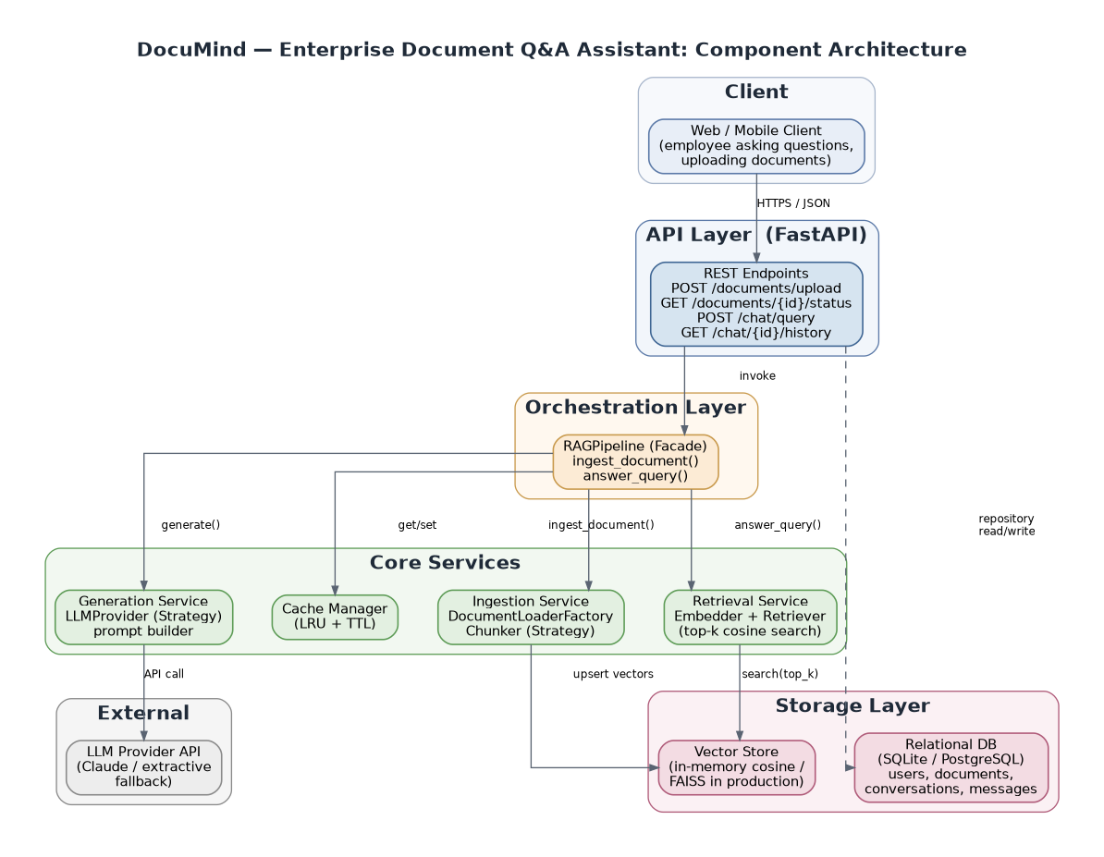
Figure 1 — Component architecture: five layers, request flow shown top to bottom.
- Client — any consumer of the REST API (web app, Slack bot, internal portal).
- API Layer (FastAPI) — thin controllers: validate request → call the orchestration facade → serialize the response. No business logic lives here.
- Orchestration Layer — a single RAGPipeline Facade that coordinates ingestion and query flows across every core service.
- Core Services — Ingestion, Embedding+Retrieval, Generation, and Cache. Each is internally pluggable (Strategy pattern).
- Storage Layer — a vector store for embeddings and a relational database for operational data (users, documents, conversations).

4. Component Breakdown
Each row below is one bounded responsibility. This decomposition is what makes the system's class diagram (Section 6) and test suite (Section 13) possible — every component can be unit-tested in isolation because it depends only on interfaces, never concrete sibling components.
Component | Responsibility | Key Classes
Ingestion Service | Loads raw files and splits them into semantically coherent, retrievable chunks. | DocumentLoaderFactory, TxtLoader, MarkdownLoader, PdfLoader, ChunkerFactory, FixedSizeChunker, SentenceAwareChunker
Embedding Service | Converts text into numeric vectors for similarity search. | EmbedderFactory, TfidfEmbedder, AnthropicEmbedder
Vector Store | Persists embeddings and performs nearest-neighbor search. | VectorStoreFactory, InMemoryVectorStore, FaissVectorStore
Retrieval Service | Embeds the query, searches the vector store, filters low-confidence matches. | Retriever, RetrievedChunk
Generation Service | Synthesizes a grounded, cited answer from the retrieved context. | LLMProviderFactory, ExtractiveLLMProvider, AnthropicLLMProvider
Orchestration (Facade) | Coordinates the full ingest and query flows end to end. | RAGPipeline
Cache | Avoids recomputation for repeated questions. | LRUCache
Persistence | Stores users, documents, chunk metadata, conversations, and messages. | SQLAlchemy models, UserRepository, DocumentRepository, ChunkRepository, ConversationRepository
API Layer | Exposes REST endpoints; validates input and serializes output. | FastAPI app (main.py), Pydantic schemas

5. Design Patterns Used
LLD interviews look specifically for this section — not just “what boxes exist” but “why is the code organized this way, and what does it buy you.” Each pattern below was chosen to solve a concrete change-management problem this system will actually face.
Pattern | Where Used | Why It Matters
Strategy | Chunker, Embedder, LLMProvider, VectorStore | Each is an abstract interface with interchangeable implementations. Swapping TF-IDF for a neural embedder, or the extractive fallback for Claude, is a one-line config change — zero edits to the pipeline, API, or tests.
Factory Method | DocumentLoaderFactory, ChunkerFactory, EmbedderFactory, VectorStoreFactory, LLMProviderFactory | New file type or new vendor = one new class registered with the factory. Existing code is never modified (Open/Closed Principle), which avoids regressions in code that already works.
Facade | RAGPipeline | The API layer talks to one object with two methods (ingest_document, answer_query) instead of wiring together eight sub-components on every request.
Repository | UserRepository, DocumentRepository, ChunkRepository, ConversationRepository | All persistence logic is isolated from the API layer. The ORM or database engine can change without touching a single endpoint.
Singleton | Config | Guarantees every component reads the exact same settings object for the process lifetime — avoids config drift across modules.
Dependency Injection | RAGPipeline constructor, every repository | Every dependency is passed in rather than hard-coded, which is what makes the 9-test unit suite possible without a live database or network call.

6. Class Design (Low-Level)

6.1 Retrieval, Generation & Orchestration
RAGPipeline is the Facade: it owns one Embedder, one VectorStore, one LLMProvider, one LRUCache, and exposes only ingest_document() and answer_query(). Retriever sits between the pipeline and the vector store, owning the embed-then-search-then-filter sequence so re-ranking or hybrid search can be added here later without touching the pipeline.
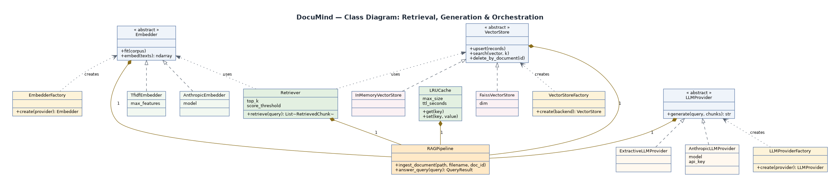
Figure 2 — Core class diagram: abstract interfaces (white) with concrete Strategy implementations and their Factories (cream).

6.2 Ingestion Layer
DocumentLoader and Chunker are independent Strategy hierarchies on purpose: file format and chunking algorithm vary independently (a .txt file might use either chunker; a future .pdf loader still plugs into the same ChunkerFactory).
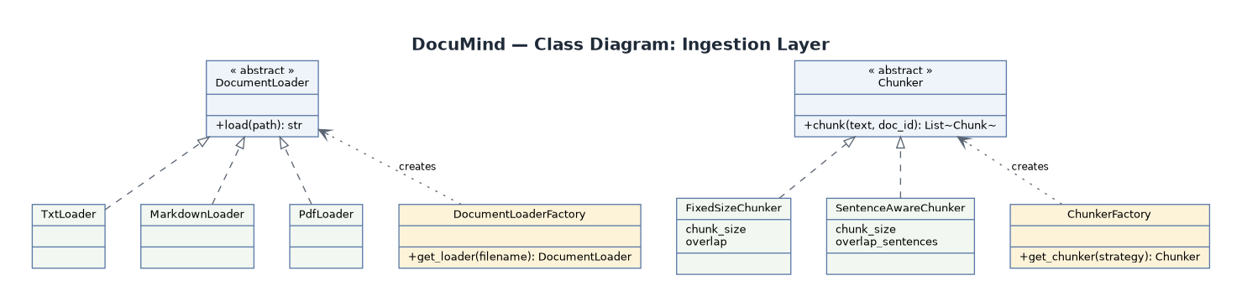
Figure 3 — Ingestion layer class diagram.

7. Sequence Diagrams

7.1 Document Ingestion Flow
Triggered by POST /documents/upload. The relational DB tracks status (pending → processing → ready/failed) independently of the vector store, so a failed embedding step never leaves an orphaned “ready” document.
- Client uploads a file to POST /documents/upload.
- API creates a Document row with status = pending, then processing.
- API calls RAGPipeline.ingest_document(path, filename, doc_id).
- Pipeline asks DocumentLoaderFactory for the right loader and reads raw text.
- Pipeline asks ChunkerFactory for the configured chunking Strategy and splits the text.
- Pipeline (re)fits the Embedder on the corpus and embeds the new chunks.
- Pipeline upserts the resulting vectors into the VectorStore.
- API mirrors chunk text into the relational DB via ChunkRepository and sets status = ready.
- API returns 200 with document_id, status, and chunk_count.

7.2 Query → Retrieval → Generation Flow
Triggered by POST /chat/query. The cache is checked before any retrieval or generation work happens, and every turn — user question and assistant answer — is persisted so /chat/{id}/history can replay the conversation.
- Client sends POST /chat/query with a question and an optional conversation_id.
- API gets or creates the Conversation row.
- API calls RAGPipeline.answer_query(query).
- Pipeline checks the LRUCache for a hashed-query hit; on a hit, the cached answer is returned immediately (steps 5–14 are skipped).
- On a cache miss, Pipeline calls Retriever.retrieve(query).
- Retriever embeds the query with the same Embedder used at ingestion.
- Retriever calls VectorStore.search(query_vector, top_k).
- VectorStore returns a ranked list of (chunk, similarity score).
- Retriever filters out anything below the similarity threshold and returns RetrievedChunk objects.
- Pipeline calls LLMProvider.generate(query, chunks).
- LLMProvider returns a grounded answer (citing sources, or declining if context is insufficient).
- Pipeline writes the answer into the cache.
- API persists both the user question and assistant answer via ConversationRepository.
- API returns 200 with the answer, cited sources, and a cache_hit flag.

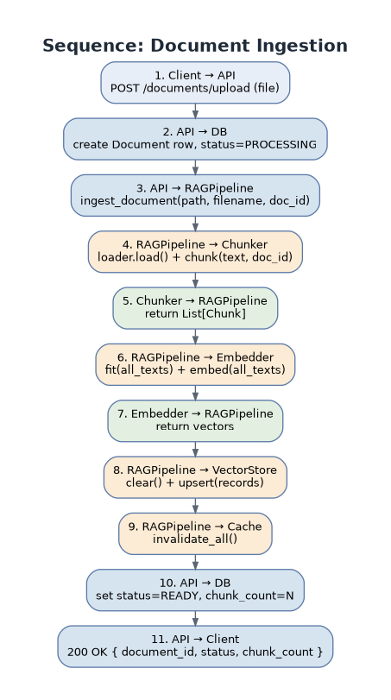  Figure 4 — Ingestion sequence | 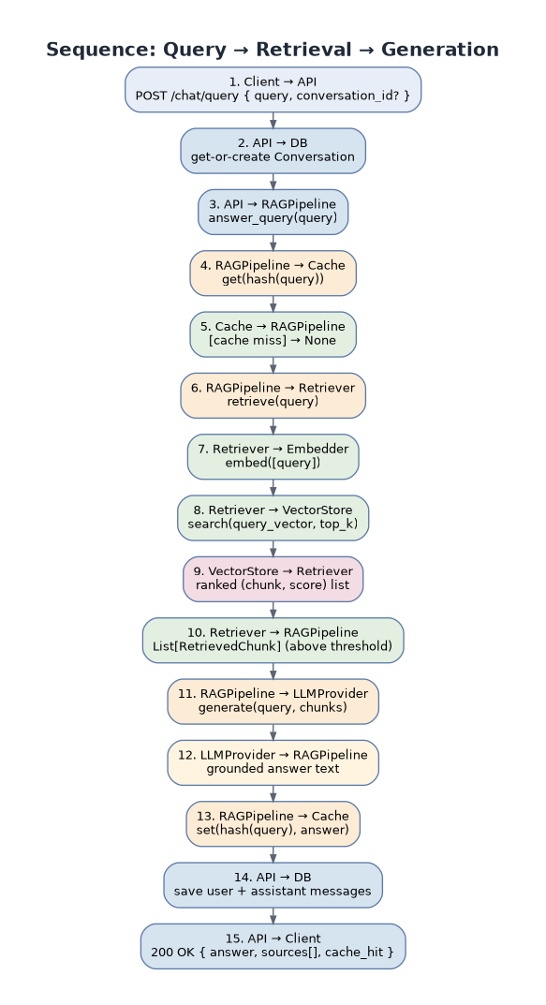  Figure 5 — Query sequence

8. API Contracts
All endpoints are implemented in src/api/main.py and validated against the Pydantic schemas in src/api/schemas.py. The full interactive contract is also available at /docs (Swagger UI) once the server is running.

8.1 POST /documents/upload
Uploads and indexes a document (multipart/form-data, field name: file).
Field | Type | Notes
Request | multipart/form-data: file | Accepted extensions: .txt, .md (PDF loader stubbed for production)
Response 200 | document_id, filename, status, chunk_count | status = “ready” on success
Response 422 | detail: string | Ingestion failed (unsupported type, empty file, parse error)

8.2 GET /documents/{document_id}/status
Field | Type | Notes
Response 200 | document_id, filename, status, chunk_count, uploaded_at | status one of: pending, processing, ready, failed
Response 404 | detail: string | Document not found

8.3 DELETE /documents/{document_id}
Field | Type | Notes
Response 200 | deleted: bool, document_id: string | Removes vectors from the VectorStore and the row (cascades to chunks) from the DB
Response 404 | detail: string | Document not found

8.4 POST /chat/query
Field | Type | Notes
Request | conversation_id?: string, query: string (1–2000 chars) | Omit conversation_id to start a new conversation
Response 200 | conversation_id, answer, sources: [{document_id, chunk_id, text, score}], cache_hit: bool | sources is empty on a cache hit

8.5 GET /chat/{conversation_id}/history
Field | Type | Notes
Response 200 | conversation_id, messages: [{role, content, created_at}] | Ordered chronologically

8.6 GET /health
Liveness probe. Returns { "status": "ok" } with no auth required — used by orchestrators (Kubernetes, ECS) to verify the process is up.

9. Database Schema
The relational database stores operational data — who uploaded what, conversation history, audit trail. The embedding vectors themselves live only in the Vector Store; document_chunks.text is a denormalized copy kept here so chunk content can be inspected or re-indexed without re-parsing the original file.
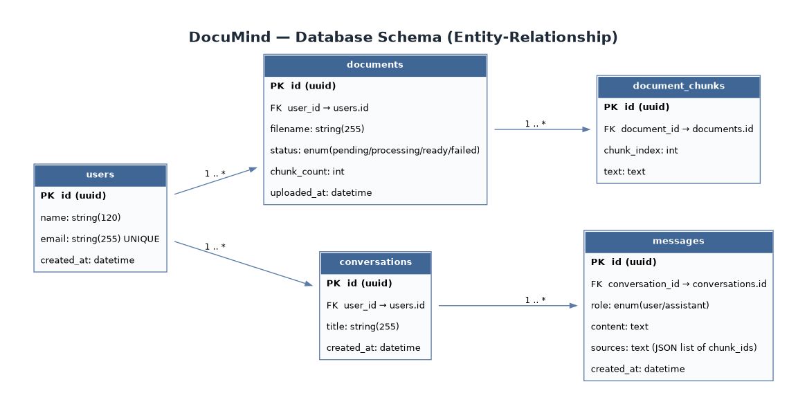
Figure 6 — Entity-relationship diagram.
Table | Purpose | Key Fields
users | One row per account. | id (PK), name, email (unique), created_at
documents | One row per uploaded file; tracks ingestion lifecycle. | id (PK), user_id (FK), filename, status, chunk_count, uploaded_at
document_chunks | Metadata + text for every chunk produced from a document. | id (PK, = vector_id), document_id (FK), chunk_index, text
conversations | One row per chat session. | id (PK), user_id (FK), title, created_at
messages | One row per turn (user question or assistant answer). | id (PK), conversation_id (FK), role, content, sources (JSON chunk ids), created_at

10. Caching Strategy
- Cache key = SHA-256 hash of the normalized query text — case- and whitespace-insensitive, so trivial rephrasing still hits the cache.
- LRU eviction with a configurable max size (default 256 entries) plus a TTL (default 600s), so stale answers don't persist indefinitely even without a document change.
- The entire cache is invalidated whenever a document is ingested or deleted, since the corpus — and therefore the correct answer — may have changed.
- In-process today; the interface (get/set/invalidate_all) is identical to a Redis client, so multi-instance deployments swap to Redis with no caller changes.

11. Error Handling & Edge Cases
Scenario | Behavior
Query received before any document is indexed | Pipeline short-circuits and returns a clear “no documents indexed yet” message instead of calling the LLM with empty context.
Unsupported file extension on upload | DocumentLoaderFactory raises ValueError; API catches it, sets status = failed, returns HTTP 422 with the reason.
All retrieved chunks score below the similarity threshold | Retriever filters them out; the LLMProvider receives an empty context list and responds that it cannot answer from the indexed documents, rather than hallucinating.
Document/Conversation not found | Repository lookup returns None; API translates that into HTTP 404 rather than a 500.
Exception during ingestion (parse error, encoding issue) | Document status is set to failed and the temp file is always cleaned up in a finally block, so partial failures never leave orphaned chunks in the vector store.
DB write fails mid-request | get_session() is a context manager that rolls back on any exception, so a failed request never leaves a half-written row.

12. Scalability & Production Considerations

12.1 Component swap points
Every component below is wired through a Factory at startup (src/api/main.py), so moving to production-grade infrastructure is a configuration change, not a rewrite:
Component | Demo Default | Production Swap
Embeddings | TfidfEmbedder (offline) | AnthropicEmbedder / Voyage / OpenAI / sentence-transformers
Vector store | InMemoryVectorStore | FaissVectorStore, or a managed service (Pinecone / Weaviate / pgvector)
Generation | ExtractiveLLMProvider (offline) | AnthropicLLMProvider (Claude API, already implemented)
Database | SQLite | PostgreSQL — a one-line DB_URL change
Cache | In-process LRU | Redis — identical get/set interface

12.2 Beyond the prototype
- Async ingestion: large documents should go through a queue (e.g. Celery/SQS) instead of blocking the upload request — the API would return 202 Accepted and the client would poll /documents/{id}/status.
- Horizontal scaling: the API layer is stateless per request, but RAGPipeline is currently composed once in-process at startup. Multi-instance deployments need the vector store, DB, and cache to live outside any single process (already true for Postgres/Redis/FAISS-as-a-service).
- Auth: replace get_current_user_id()'s demo-user stand-in with real JWT/OAuth resolution — the seam is already isolated to that one function.
- Observability: structured logging is already in place (src/utils/logger.py); production would add request tracing and metrics (e.g. OpenTelemetry) around the ingest and query paths specifically, since those are the latency- and cost-sensitive operations.
- Retrieval quality: add a re-ranking stage (cross-encoder) after initial vector search, and consider hybrid search (BM25 + vector) for queries with exact keyword/ID matches that embeddings alone handle poorly.

13. Testing Strategy
Dependency injection throughout the system (Section 5) is what makes this test suite possible without a live database, network call, or real LLM:
- Unit tests per layer — chunkers, vector store similarity search, retriever score-thresholding, cache LRU/TTL behavior, and the full pipeline wired with fakes (9 tests, all passing).
- Integration test — FastAPI's TestClient exercises the /health endpoint and can be extended to upload → query → history without a running server process.
- Manual end-to-end verification — run_demo.py ingests the two sample policy documents and asks four real questions from the command line, with no server or API key required.

14. Technology Stack
Layer | Technology
Language / runtime | Python 3.12
API framework | FastAPI + Uvicorn
Validation | Pydantic v2
ORM / database | SQLAlchemy + SQLite (PostgreSQL-ready)
Embeddings (demo) | scikit-learn TF-IDF
Generation (optional) | Anthropic Claude API
Testing | pytest

15. Future Enhancements
- Hybrid retrieval (BM25 keyword search + vector search) for queries that hinge on exact terms, IDs, or policy numbers.
- Cross-encoder re-ranking of the top-k candidates before generation, to improve precision without slowing the initial vector search.
- Streaming responses (token-by-token) for a more responsive chat UI.
- An automated answer-quality evaluation harness (e.g. RAGAS-style faithfulness/relevance scoring) run against a fixed question set on every deploy.
- Role-based access control so retrieval results respect document-level permissions, not just user identity.

Appendix A — Running the Prototype

Setup
pip install -r requirements.txt

CLI demo (no server, no API key required)
python run_demo.py

REST API
uvicorn src.api.main:app --reload
Then open http://127.0.0.1:8000/docs for interactive Swagger UI.

Tests
pytest -v

Switching on real Claude-generated answers
export ANTHROPIC_API_KEY=sk-...
export LLM_PROVIDER=anthropic
No other code changes are required — LLMProviderFactory picks up the new provider at startup.

Appendix B — Reference Web UI
A minimal chat client ships at the API root (/) for demo purposes. It is intentionally outside the system boundary defined in Section 2 — a thin, framework-free HTML/CSS/JS client that calls only the documented REST endpoints (no new business logic, no separate backend).
File | Purpose
static/index.html | Layout: a document sidebar and a chat panel.
static/css/styles.css | Theming via CSS custom properties; a light/dark toggle swaps a single data-theme attribute.
static/js/app.js | Calls GET /documents, POST /documents/upload, POST /chat/query, DELETE /documents/{id}; no framework or build step.
The one deliberate UI design choice worth calling out: every assistant answer is followed by collapsible source chips showing the originating document, the exact retrieved passage, and a visual confidence bar from the similarity score. This makes the RAG pipeline's grounding inspectable in the UI itself, rather than something only visible in the API response body.

