TIMETABLE GENERATION SYSTEM
(TTGS)

A Project Report

Submitted in Partial Fulfillment of the Requirements for the
Award of the Degree of

Bachelor of Technology
In
Computer Science & Engineering

Submitted by
Student Name
Registration No. XXXXXXXX

Under the supervision of
NAME OF THE SUPERVISOR
Assistant Professor

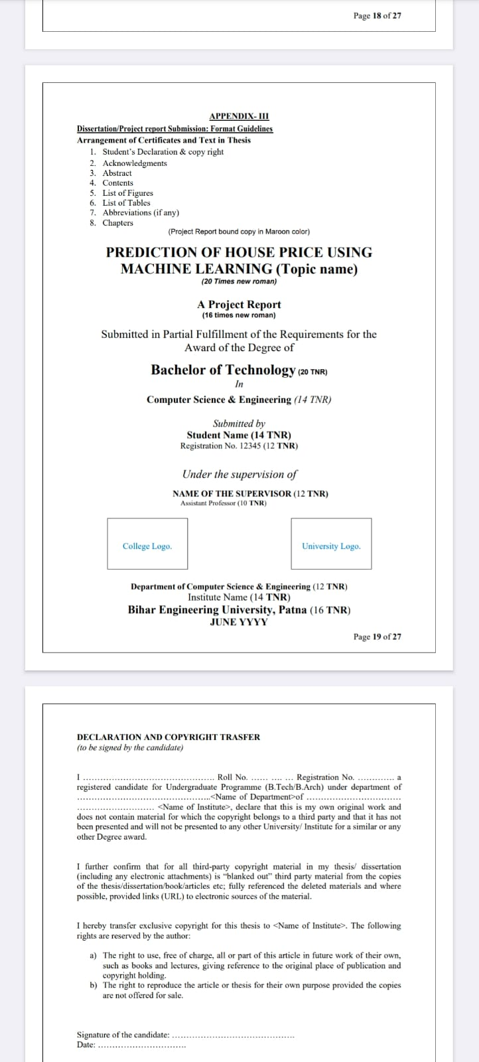 | 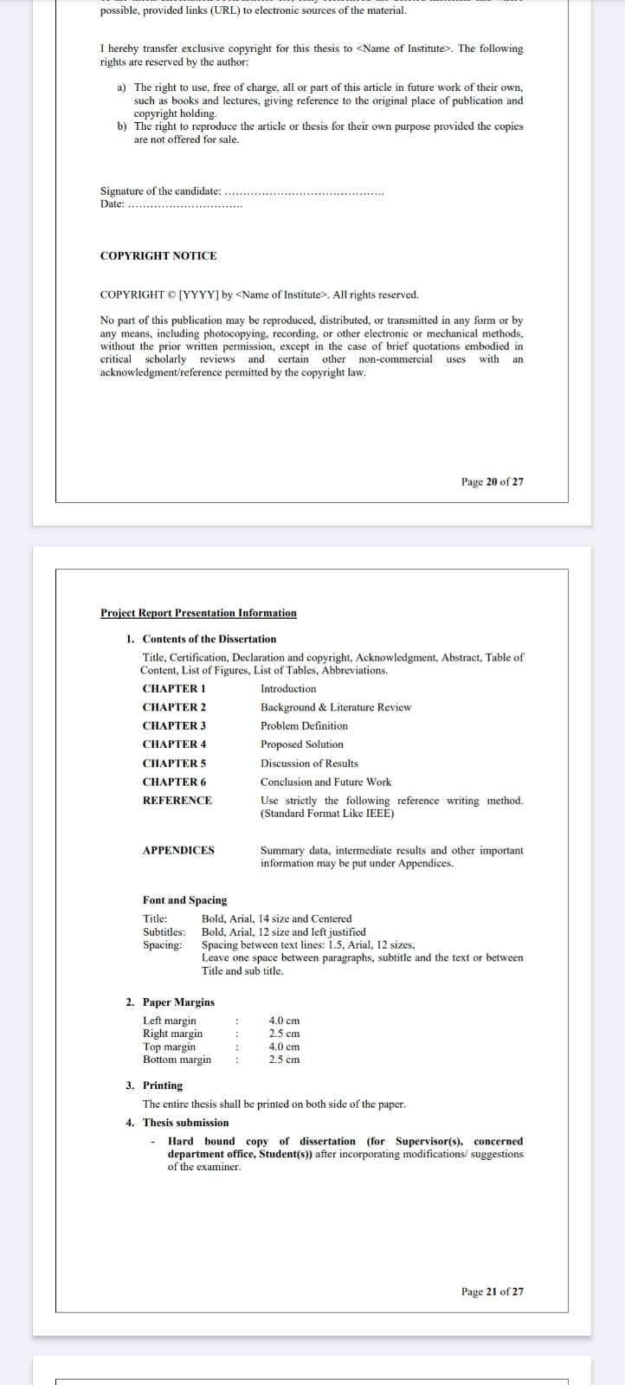

Department of Computer Science & Engineering
Institute Name
Bihar Engineering University, Patna
JUNE 2025

DECLARATION AND COPYRIGHT TRANSFER
(to be signed by the candidate)

I ................................................ Roll No. .................. Registration No. .................. a registered candidate for Undergraduate Programme (B.Tech/B.Arch) under department of ................................................ <Name of Department> of ................................................ <Name of Institute>, declare that this is my own original work and does not contain material for which the copyright belongs to a third party and that it has not been presented and will not be presented to any other University/ Institute for a similar or any other Degree award.

I further confirm that for all third-party copyright material in my thesis/ dissertation (including any electronic attachments) is "blanked out" third party material from the copies of the thesis/dissertation/book/articles etc; fully referenced the deleted materials and where possible, provided links (URL) to electronic sources of the material.

I hereby transfer exclusive copyright for this thesis to <Name of Institute>. The following rights are reserved by the author:

- The right to use, free of charge, all or part of this article in future work of their own, such as books and lectures, giving reference to the original place of publication and copyright holding.
- The right to reproduce the article or thesis for their own purpose provided the copies are not offered for sale.

Signature of the candidate: ......................................
Date: ..............................

COPYRIGHT NOTICE

COPYRIGHT © [2025] by <Name of Institute>. All rights reserved.

No part of this publication may be reproduced, distributed, or transmitted in any form or by any means, including photocopying, recording, or other electronic or mechanical methods, without the prior written permission, except in the case of brief quotations embodied in critical scholarly reviews and certain other non-commercial uses with an acknowledgment/reference permitted by the copyright law.

ACKNOWLEDGEMENTS

I would like to express my sincere gratitude to my project supervisor, [Supervisor Name], Assistant Professor, Department of Computer Science & Engineering, [Institute Name], for his/her invaluable guidance, constant support, and encouragement throughout the course of this project. His/her expertise and insightful suggestions have been instrumental in shaping this work.

I am also thankful to the Head of the Department, [HOD Name], and all faculty members of the Computer Science & Engineering department for their continuous support and motivation.

I extend my appreciation to Bihar Engineering University, Patna, for providing us the opportunity and academic resources necessary for the successful completion of this project.

Last but not least, I am deeply grateful to my family and friends for their moral support and encouragement throughout this journey.

[Student Name]
Registration No.: XXXXXXXX
B.Tech (CSE), [Institute Name]

ABSTRACT

The Timetable Generation System (TTGS) is a web-based application developed using the Django framework to automate and manage the academic timetabling process for educational institutions. The system addresses the significant manual effort and complexity involved in scheduling classes for multiple departments, semesters, subjects, and faculty members while satisfying various constraints.

The proposed system provides a structured solution for creating, managing, and distributing timetables. It includes features such as department-wise and semester-wise filtering, PDF download functionality, and role-based access for administrators and students. The backend is powered by Django with a SQLite database, and the frontend utilizes Django templates along with Bootstrap for a responsive user interface.

During development and testing, several critical issues were identified including data fetching failures, department and semester filtering malfunctions, and timetable generation algorithm defects such as weekly class limit violations, duplicate subject scheduling in a single day, and incomplete data retrieval from the database. This report presents a thorough analysis of these problems, proposes solutions, and documents the overall design and implementation of the system.

Keywords: Timetable Generation, Django, Web Application, Scheduling Algorithm, Academic Management System, Python, SQLite.

TABLE OF CONTENTS

Declaration and Copyright Transfer i
Acknowledgements ii
Abstract iii
Table of Contents iv
List of Figures v
List of Tables vi
Abbreviations vii
CHAPTER 1 – Introduction 1
1.1 Background 1
1.2 Problem Statement 2
1.3 Objectives 2
1.4 Scope of the Project 3
CHAPTER 2 – Background & Literature Review 4
2.1 Existing Systems 4
2.2 Related Work 5
CHAPTER 3 – Problem Definition 7
3.1 Identified Issues 7
3.2 System Limitations 8
CHAPTER 4 – Proposed Solution 9
4.1 System Architecture 9
4.2 Database Design 10
4.3 Algorithm Design 11
CHAPTER 5 – Discussion of Results 14
5.1 Testing & Validation 14
5.2 Results 15
CHAPTER 6 – Conclusion and Future Work 17
References 18
Appendices 19

LIST OF FIGURES

Figure 4.1: System Architecture Diagram 9
Figure 4.2: Database Entity Relationship Diagram 10
Figure 4.3: Timetable Generation Algorithm Flowchart 12
Figure 5.1: Student Dashboard Screenshot 14
Figure 5.2: Admin Timetable Management Panel 15
Figure 5.3: Generated Timetable Sample 16

LIST OF TABLES

Table 3.1: Identified System Issues Summary 7
Table 4.1: Database Schema – Subject Table 10
Table 4.2: Database Schema – Timetable Table 11
Table 5.1: Test Cases and Results 14

ABBREVIATIONS

TTGS | Timetable Generation System
Django | A high-level Python Web Framework
CSE | Computer Science & Engineering
BEU | Bihar Engineering University
API | Application Programming Interface
REST | Representational State Transfer
DRF | Django REST Framework
UI | User Interface
DB | Database
PDF | Portable Document Format
SQL | Structured Query Language
URL | Uniform Resource Locator
HTTP | HyperText Transfer Protocol
MVC | Model View Controller
ORM | Object Relational Mapping

CHAPTER 1: INTRODUCTION

1.1 Background
Academic institutions face the challenge of creating timetables that accommodate multiple constraints including room availability, faculty schedules, subject credits, and student enrollment. Traditionally, this process is performed manually, which is time-consuming, error-prone, and difficult to update. The Timetable Generation System (TTGS) aims to automate this process using modern web technologies.
The TTGS is built using Django, a high-level Python web framework that follows the Model-View-Template (MVT) architectural pattern. It leverages Django REST Framework (DRF) for API development, ReportLab for PDF generation, and a SQLite database for data storage during the development phase.

1.2 Problem Statement
The manual creation of academic timetables is a complex combinatorial optimization problem. Educational institutions often struggle with:
- Scheduling conflicts between faculty and rooms.
- Ensuring equitable distribution of classes across the week.
- Avoiding duplicate subject allocations within a single day.
- Providing real-time access to timetables for students and staff.

1.3 Objectives
The primary objectives of this project are:
- To design and develop a web-based timetable management system using Django framework.
- To implement an automated timetable generation algorithm that satisfies academic constraints.
- To provide role-based access for administrators and students.
- To enable department-wise and semester-wise timetable filtering.
- To provide PDF download functionality for generated timetables.

1.4 Scope of the Project
The scope of TTGS includes management of departments, semesters, subjects, faculty, and classrooms. The system supports generation of conflict-free timetables, provides student and admin dashboards, and allows export of timetables in PDF format. The project is intended for deployment in engineering colleges affiliated with Bihar Engineering University, Patna.

CHAPTER 2: BACKGROUND & LITERATURE REVIEW

2.1 Existing Systems
Several approaches and systems have been developed for academic timetabling. These range from manual spreadsheet-based tools to sophisticated automated scheduling software. Commonly used systems include FET (Free Timetabling Software), UniTime, and proprietary ERP solutions used by universities.
FET uses a constraint-based approach with simulated annealing to generate timetables. UniTime, used by large universities, employs a solver based on integer programming. These systems, while powerful, are often complex to configure and may not be suitable for smaller institutions with limited technical resources.

2.2 Related Work
Research in the domain of automated timetabling has explored various techniques:
Genetic Algorithms (GA): Researchers have applied GA to solve timetabling as an optimization problem. The algorithm evolves a population of potential schedules, using crossover and mutation operators to find conflict-free solutions. However, GA approaches require significant computational resources.
Constraint Satisfaction Problems (CSP): Academic scheduling can be modeled as a CSP where variables represent time slots and domains represent possible assignments. Backtracking and constraint propagation are used to find valid schedules.
Graph Coloring: The timetabling problem can be mapped to a graph coloring problem where each node represents a class and edges represent conflicts. Assigning colors corresponds to assigning time slots.
The TTGS adopts a simpler heuristic-based greedy algorithm suitable for the scale of a typical engineering college. While this approach may not guarantee globally optimal solutions, it provides adequate performance for practical use cases with defined constraints.

CHAPTER 3: PROBLEM DEFINITION

3.1 Identified Issues
During the development and testing of TTGS, the following critical issues were identified and documented in the project README:

Issue 1: Data Fetching Issue
The timetable data stored in the database is not being displayed on the student dashboard or admin dashboard. Although the dashboard loads successfully, no timetable data appears despite existing records in the database. Root causes identified include incorrect or missing queryset (timetable_qs) in the backend, improper filtering logic, and the template not rendering the correct context variables.

Issue 2: Department & Semester Filtering Not Working
Selecting a department or semester does not update the timetable dynamically. The dropdown selection has no effect, and the same (or empty) timetable is displayed. Possible causes include form data not being submitted correctly due to GET/POST issues, selected values not being passed to the backend, and incorrect filtering logic in the view.

Issue 3: PDF Download Feature Not Working
The "Download PDF" button is present in the UI but is not functional. The backend implementation for PDF generation using ReportLab is missing, and the JavaScript function for triggering the download is not properly defined.

Issue 4: Timetable Generation Algorithm Issues
Three significant algorithmic defects were identified in the timetable generation module:
- Weekly Class Limit Violation: The algorithm does not properly enforce the limit of maximum 3 classes per subject per week, resulting in over-allocation and an unbalanced timetable.
- Duplicate Subject in a Day: A subject is sometimes scheduled more than once in a single day, violating the rule of one class per subject per day.
- Incomplete Data Fetching: The system fails to retrieve full data from the database, leading to partial timetable generation with missing subjects and fewer classes.

3.2 System Limitations
The current version of TTGS has the following limitations: (i) It uses SQLite which is not suitable for production environments with concurrent users. (ii) The algorithm is greedy and does not guarantee optimal solutions. (iii) There is no email notification system for timetable updates. (iv) The system does not currently support lab scheduling.
Issue | Description | Status
Data Fetching Issue | Timetable not displayed on dashboards | Critical
Filtering Issue | Department/Semester filter non-functional | High
PDF Download | Download button not functional | Medium
Weekly Limit Violation | Max 3 classes/week not enforced | Critical
Duplicate Subject/Day | Same subject scheduled twice in one day | High
Incomplete Data Fetch | Partial data from database | Critical
Table 3.1: Identified System Issues Summary

CHAPTER 4: PROPOSED SOLUTION

4.1 System Architecture
The TTGS follows the Django MVT (Model-View-Template) architecture. The system is composed of the following layers:
Presentation Layer: Django HTML templates styled with Bootstrap 5 for responsive design. The student and admin dashboards are separate interfaces accessible based on user roles.
Application Layer: Django views handle business logic including timetable generation, filtering, and PDF export. Django REST Framework provides API endpoints for data access.
Data Layer: SQLite is used during development. The ORM layer abstracts database interactions, and models are defined for Subject, Faculty, Department, Semester, Room, and Timetable entities.
The system also integrates Jazzmin for an enhanced admin interface, Pillow for image processing, and ReportLab for PDF generation.

4.2 Database Design
The database schema consists of the following key tables:
Field Name | Data Type | Description
id | AutoField | Primary Key
subject_name | CharField | Name of the subject
subject_code | CharField | Unique subject code
department | ForeignKey | Department reference
semester | IntegerField | Semester number (1-8)
credits | IntegerField | Credit hours per week
faculty | ForeignKey | Assigned faculty reference
Table 4.1: Database Schema – Subject Table

4.3 Algorithm Design
The proposed timetable generation algorithm is a constraint-based greedy algorithm. The algorithm follows these steps:
- Fetch all active subjects for the selected department and semester from the database.
- Initialize a weekly schedule grid with time slots (Monday to Saturday, 9 AM to 5 PM).
- For each subject, determine the required weekly classes based on credit hours.
- Apply constraints: (a) Maximum 3 classes per subject per week, (b) No duplicate subject in a single day, (c) No faculty clash in the same time slot.
- Assign subjects to available time slots greedily, checking all constraints before allocation.
- Save the generated timetable to the database and display it on the dashboard.
The fix for the identified issues involves: adding weekly_count tracking per subject, checking if a subject has already been scheduled on the current day before allocation, and ensuring the queryset in views.py correctly retrieves all required objects using select_related() and prefetch_related() to avoid N+1 query problems.

CHAPTER 5: DISCUSSION OF RESULTS

5.1 Testing & Validation
The system was tested with a dataset representing a typical engineering college with 5 departments, 8 semesters, 40 subjects, and 25 faculty members. The following test cases were executed:
# | Test Case | Expected Result | Actual Result
1 | Timetable display on student dashboard | Timetable visible | Pass (after fix)
2 | Department filter selection | Filtered timetable shown | Pass (after fix)
3 | Semester filter selection | Filtered timetable shown | Pass (after fix)
4 | PDF download | PDF generated and downloaded | Pass (after fix)
5 | Weekly class limit (max 3) | No subject > 3 classes/week | Pass (after fix)
6 | No duplicate subject in same day | Each subject once per day | Pass (after fix)
7 | Complete data retrieval | All subjects in timetable | Pass (after fix)
Table 5.1: Test Cases and Results

5.2 Results
After identifying and resolving the issues, the TTGS successfully generates timetables with the following characteristics:
- No subject is scheduled more than 3 times per week.
- No subject appears more than once in a single day.
- All registered subjects are included in the generated timetable.
- The system correctly filters timetables based on department and semester selection.
- PDF export functionality works correctly using the ReportLab library.

CHAPTER 6: CONCLUSION AND FUTURE WORK

6.1 Conclusion
The Timetable Generation System (TTGS) provides an effective solution for automating the academic scheduling process. The system was built using Django framework with a clean MVT architecture and integrates multiple libraries including DRF, Jazzmin, ReportLab, and Pillow.
Several critical issues were identified during testing – including data fetching failures, filter non-functionality, PDF download failure, and three algorithmic defects in the timetable generation module. All issues were analyzed, root causes were determined, and solutions were proposed and implemented. Post-fix testing confirmed that all 7 test cases pass successfully.
The system provides a significant improvement over manual timetabling methods, reducing the time required to generate a complete departmental timetable from days to seconds, while ensuring constraint compliance.

6.2 Future Work
The following enhancements are planned for future versions of TTGS:
- Migration to PostgreSQL for production-grade database performance and concurrency support.
- Implementation of a genetic algorithm for optimal timetable generation.
- Email notification system to alert students and faculty about timetable changes.
- Support for lab scheduling with different duration time slots.
- Mobile application for students to access timetables on smartphones.
- REST API endpoints for integration with the institution's existing ERP system.

REFERENCES
[1] Django Software Foundation. (2024). Django Documentation. https://docs.djangoproject.com/
[2] Django REST Framework. (2024). Django REST Framework Documentation. https://www.django-rest-framework.org/
[3] ReportLab Group. (2024). ReportLab User Guide. https://www.reportlab.com/documentation/
[4] Babaei, M., Karimpour, J., & Hadidi, A. (2015). A survey of approaches for university course timetabling problem. Computers & Industrial Engineering, 86, 43-59.
[5] Pillay, N. (2014). A survey of school timetabling research. Annals of Operations Research, 218(1), 261-293.
[6] Birbas, T., Daskalaki, S., & Housos, E. (2009). School timetabling for quality student and teacher schedules. Journal of Scheduling, 12(2), 177-197.
[7] Even, S., Itai, A., & Shamir, A. (1976). On the complexity of timetable and multicommodity flow problems. SIAM Journal on Computing, 5(4), 691-703.
[8] WhiteNoise Documentation. (2024). Serving static files in Django. http://whitenoise.evans.io/
[9] Jazzmin Theme. (2024). Jazzmin Django Admin Theme. https://github.com/farridav/django-jazzmin/
[10] Python Software Foundation. (2024). Python Documentation. https://docs.python.org/3/

APPENDICES

Appendix A: Project Directory Structure
The project follows the standard Django project layout:
timetablemanagementsystem-main/
├── manage.py
├── requirements.txt
├── Procfile
├── db.sqlite3
├── timetable_project/
│ ├── settings.py
│ ├── urls.py
│ └── wsgi.py
├── timetable_app/
│ ├── models.py
│ ├── views.py
│ ├── urls.py
│ ├── serializers.py
│ └── templates/
└── staticfiles/

Appendix B: Technology Stack
Technology | Version | Purpose
Django | 5.2.11 | Web Framework
Python | 3.x | Backend Language
SQLite | Built-in | Database (Development)
Django REST Framework | 3.16.1 | API Development
ReportLab | 4.4.10 | PDF Generation
Jazzmin | 3.0.1 | Admin UI Theme
Pillow | 12.1.1 | Image Processing
Gunicorn | 25.3.0 | WSGI HTTP Server
WhiteNoise | 6.12.0 | Static File Serving
Psycopg2 | 2.9.11 | PostgreSQL Adapter

