Offline Diabetic Retinopathy Screening with a Low-Cost Raspberry Pi Fundus Camera and Quality-Gated EfficientNet Grading
Omm Sanjog Barik Prasant Kumar Patra Laganjeet Jena
School of Electronics Engineering School of Electronics Engineering School of Electronics Engineering
KIIT (Deemed to be University) KIIT (Deemed to be University) KIIT (Deemed to be University)
Bhubaneswar, India Bhubaneswar, India Bhubaneswar, India
ommsanjog723@gmail.com ppatrafet@kiit.ac.in 2330378@kiit.ac.in
ORCID: 0009-0009-4085-8099
Piyush Raj Riddhi Khanna
School of Electronics Engineering School of Electronics Engineering
KIIT (Deemed to be University) KIIT (Deemed to be University)
Bhubaneswar, India Bhubaneswar, India
2330383@kiit.ac.in 2330393@kiit.ac.in

Abstract—Diabetic retinopathy (DR) is a leading cause of preventable blindness, yet routine screening in India reaches only a fraction of the estimated 101 million people with diabetes because fundus cameras are costly, graders are scarce and cloud-based tele-grading depends on connectivity. This paper presents a low-cost, portable fundus camera and analysing unit that captures the retina and grades DR entirely on the device. The optical head implements indirect ophthalmoscopy with a 20 D condensing lens, a Raspberry Pi Camera Module 3 NoIR, 850 nm infrared alignment and a short white-LED flash; a sampling analysis shows that a camera placed about 160 mm behind the lens resolves the fundus at roughly 1,400 pixels (≈ 9 µm/pixel). A Raspberry Pi 5 rejects ungradable and non-retinal images through a quality and fundus gate, normalises illumination, and runs an EfficientNet-B0 regression network (4.0 M parameters, 1.13 GMACs at 384 × 384) whose score is mapped to the five-level International Clinical DR scale with validation-tuned thresholds. Trained on APTOS 2019, the model achieves a quadratic weighted kappa of 0.877 and referable-DR sensitivity, specificity and AUC of 93.7 %, 90.8 % and 0.973 on a 550-image held-out test set. The 16.0 MB FP32 ONNX export reproduces the trained model (max. error 2 × 10⁻⁶), whereas post-training INT8 quantisation reduced the kappa to 0.570 and was rejected by an accuracy-gated export rule. Grad-CAM indicates partial reliance on dataset-specific cues, motivating external validation. The fundus gate correctly rejected a mis-aligned anterior-segment capture that a grader would otherwise have scored. The prototype costs about ₹40,000.
Index Terms—diabetic retinopathy, fundus imaging, deep learning, EfficientNet, edge AI, Raspberry Pi, quantization, medical screening
I. Introduction
Diabetes affects an estimated 537 million adults worldwide [1] and about 101 million people in India [2]. Diabetic retinopathy (DR), its microvascular complication in the retina, affected 103 million people globally in 2020 and is projected to affect 161 million by 2045 [3]. In India, the SMART India survey found DR in 15.5 % of people with known diabetes and 8.0 % of those with undiagnosed diabetes [4]. Because DR is asymptomatic until vision-threatening stages, annual fundus screening with referral of moderate or worse disease prevents most DR-related blindness [5].
Screening is graded on the International Clinical DR (ICDR) scale — no DR, mild, moderate and severe non-proliferative DR, and proliferative DR — with grade ≥ 2 considered referable [6]. Three practical barriers limit screening in primary care: table-top fundus cameras are expensive and immobile; trained graders are concentrated in cities; and tele-grading requires connectivity that field studies identify as a major source of workflow failure [7]. Deep learning has reached ophthalmologist-level grading [8], [9] and regulatory approval for autonomous use [10], but deployed systems typically rely on commercial cameras and cloud inference.
This paper describes an open, offline device that combines low-cost capture with on-device grading. Its contributions are:
- an indirect-ophthalmoscopy optical head based on a 20 D lens and a Raspberry Pi NoIR camera, with a sampling analysis linking camera distance to lesion resolution;
- an EfficientNet-B0 regression grader with validation-tuned thresholds, trained end-to-end through a reproducible one-click cloud notebook and exported to ONNX for a Raspberry Pi 5 with an accuracy-gated choice between FP32 and INT8;
- a quality and fundus-image gate placed before the model, so that the device requests a retake instead of grading unusable or non-retinal images;
- an evaluation reporting not only accuracy but also the failure of post-training INT8 quantisation and a Grad-CAM shortcut-learning risk.
II. Related Work
A. Deep-Learning DR Grading
Gulshan et al. trained an Inception-v3 ensemble on 128,175 images and reported an AUC of 0.991 for referable DR on EyePACS-1 [8]. Ting et al. validated a deep-learning system on 494,661 multi-ethnic images (AUC 0.936; sensitivity 90.5 %, specificity 91.6 %) [9], and prospective Indian validation reported sensitivities of 88.9–92.1 % [11]. The autonomous IDx-DR system achieved 87.2 % sensitivity and 90.7 % specificity in a 900-patient pivotal trial [10]. Krause et al. showed that single-grader labels limit both training and evaluation compared with adjudicated references [12]. Kaggle competitions popularised Ben Graham’s local-contrast normalisation [13] and the quadratic weighted kappa (QWK) metric [14] used here.
B. Offline and Smartphone-Based Screening
Medios, an offline AI running on the smartphone of the Remidio Fundus-on-Phone camera, achieved 100 % sensitivity and 88.4 % specificity for referable DR in community screening in India [15]. EyeArt applied to smartphone fundus images achieved 95.8 % sensitivity for any DR [16]. Both systems are proprietary. Efficient architectures — MobileNetV3 [17] and EfficientNet [18] — and integer quantisation [19] make CNN inference practical on embedded processors.
C. Low-Cost Fundus Imaging
Haddock et al. showed that a smartphone and a hand-held 20 D lens produce high-quality fundus photographs [20]. Shen and Mukai built a non-mydriatic Raspberry Pi fundus camera with a NoIR sensor and coaxial 850 nm/white LEDs for about US $185, with light output an order of magnitude below a conventional ophthalmoscope [21]; it did not grade images. The present work combines this class of hardware with on-device, quality-gated grading.
III. System Design
A. Architecture
Fig. 1 shows the processing chain. The optical head forms an aerial retinal image captured by the camera over MIPI CSI-2. A Raspberry Pi 5 (8 GB; 4 × Cortex-A76, 2.4 GHz) [22] controls the LEDs through hardware PWM, evaluates image quality, pre-processes accepted images and runs the CNN with ONNX Runtime [23]. Results are shown on a 7-inch touch display and stored locally under anonymised identifiers; no network connection is used.
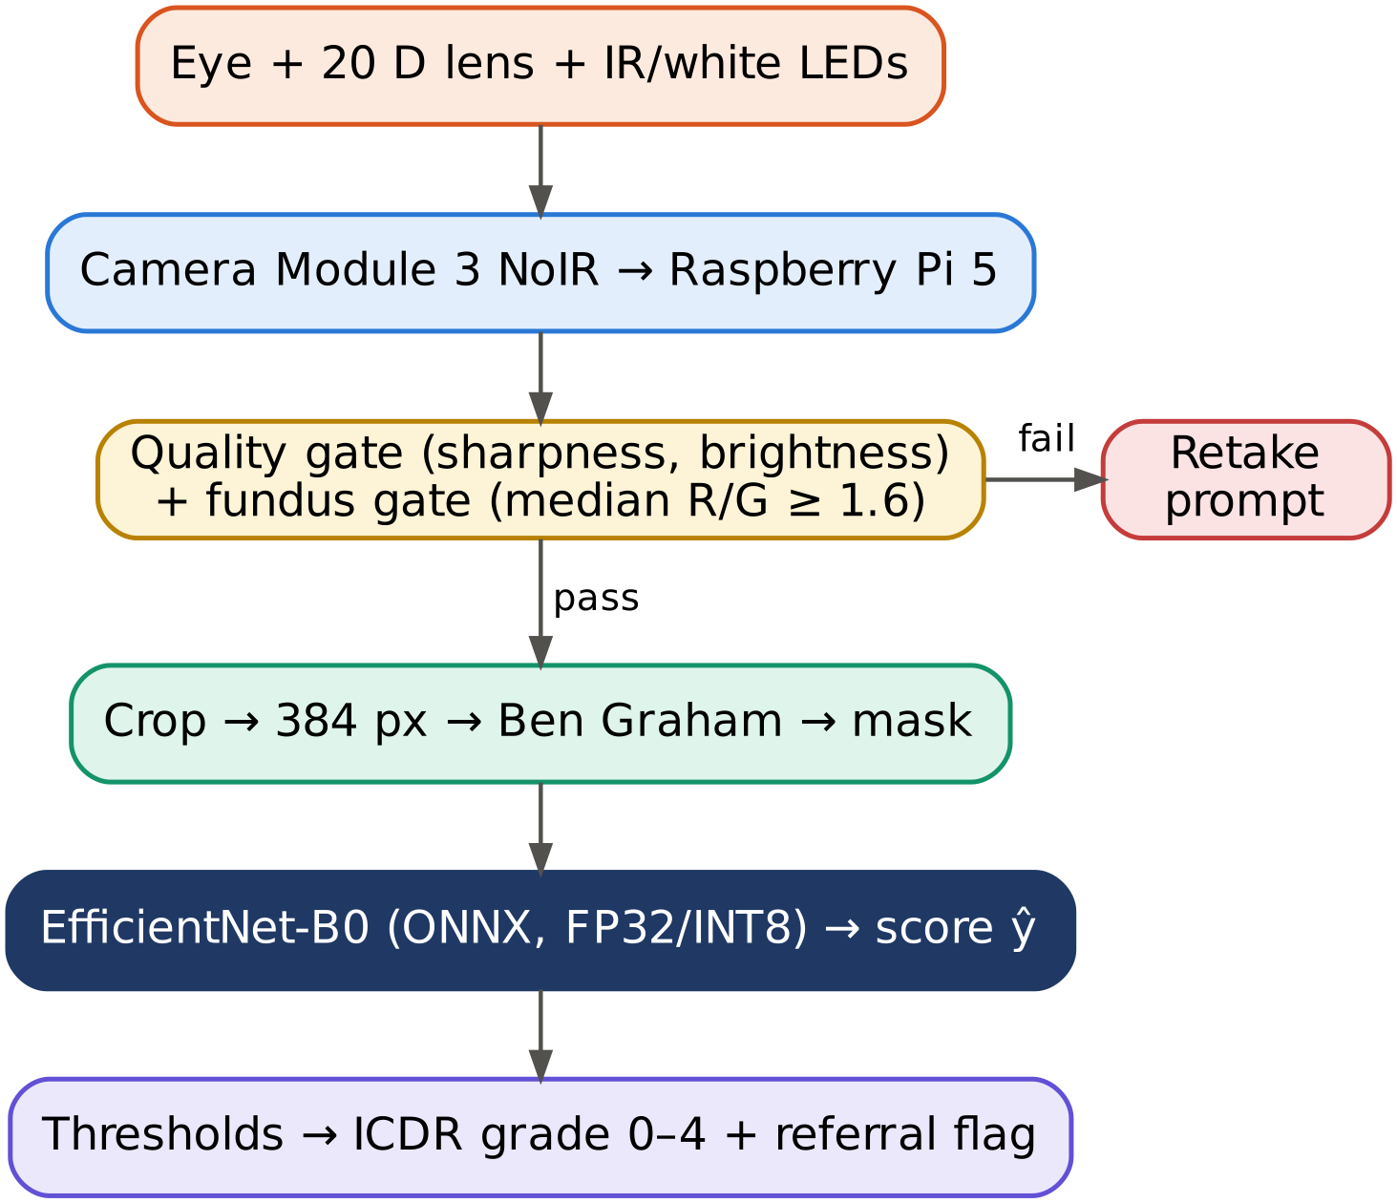
Fig. 1. Processing chain of the proposed unit. Images that fail the quality or fundus gate are never graded.
B. Optical Head
The +20 D condensing lens (f = 1/P = 50 mm) is held about one focal length from the eye and forms an inverted aerial image near its back focal plane (Fig. 2). For an emmetropic eye of power ≈ 60 D the lateral magnification of indirect ophthalmoscopy is
m ≈ P_{eye} / P_{lens} = 60 / 20 = 3. (1)
A ≈ 45° field covers about 13 mm of retina (0.29 mm/°), giving an aerial image of D ≈ 39 mm. The Camera Module 3 (IMX708, 4,608 × 2,592 px, 66° horizontal field) [24] must see this image under θ = 66° × N/4,608 to sample it with N pixels; for N = 1,400, θ ≈ 20° and the camera-to-image distance is
d = (D/2) / tan(θ/2) = 19.5 / tan 10° ≈ 111 mm, (2)
i.e. about 160 mm from the lens, above the camera’s 100 mm minimum focus. The sensor then samples the retina at ≈ 9.3 µm/px, and the 384 px network input at ≈ 34 µm/px, so a 50 µm microaneurysm still spans 1–2 pixels (at 224 px it would fall below one pixel).
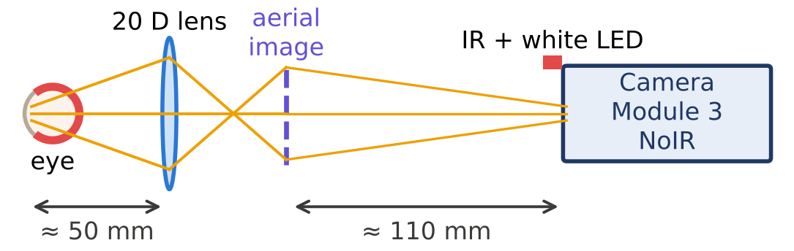
Fig. 2. Optical layout of the fundus head (schematic, not to scale).
C. Illumination and Electronics
As in [21], an 850 nm LED array provides an IR live preview: the NoIR sensor sees it but the patient does not, so the pupil stays naturally dilated in a dim room. Two warm-white LEDs are flashed for ≤ 200 ms during capture, before the pupillary reflex constricts the pupil. Both strings run from the 5 V rail through AO3400 low-side MOSFETs driven by GPIO PWM. With V_{f} ≈ 1.5 V at 50 mA, each IR LED uses R = (5 − 1.5)/0.05 = 70 Ω → 68 Ω (0.18 W); white LEDs use 100 Ω at 20 mA. IR dimming uses 20 kHz PWM to avoid rolling-shutter banding. The estimated peak power is 10.8 W, giving about 3.9 h of operation from a 10,000 mAh USB-C PD power bank. The unit is SELV-only (≤ 5.1 V); light exposure is designed to remain within ISO 15004-2 limits [25] and will be verified by measurement.
D. Prototype
A first table-top prototype was assembled to test the optical path and integration (Fig. 3). The enclosure is screw-assembled white acrylic with 3D-printed brackets; the condensing lens sits in a 3D-printed front eyepiece mount. The camera rides on a carriage on twin steel guide rails and is moved by a side lever, so the camera-to-lens distance — and hence focus on the aerial image — is set mechanically. A Raspberry Pi 5 with active cooler, an Arduino Nano co-processor and a side-mounted touch display complete the unit. For speed of integration, prototype v1 uses a USB webcam; because such cameras usually include an IR-cut filter, it will be replaced by the Camera Module 3 NoIR to enable IR alignment.
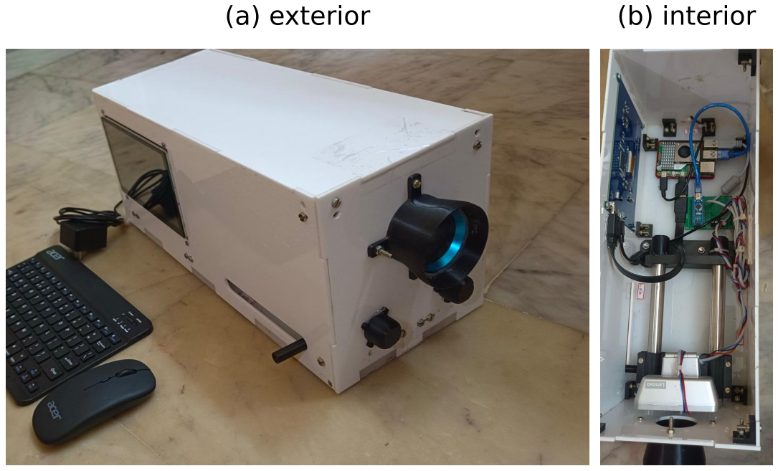
Fig. 3. Prototype v1: (a) acrylic enclosure with front eyepiece mount, side display and focus lever; (b) interior with Raspberry Pi 5, Arduino Nano, guide rails and sliding camera carriage.
IV. Method
A. Pre-processing
The black surround is cropped (grey level > 7), the image padded to a square and resized to S = 384 px. Each channel I is then normalised by Ben Graham’s local-contrast operation [13]
I′ = 4I − 4(G_{σ} ∗ I) + 128, σ = S/30, (3)
which suppresses slow illumination gradients while enhancing vessels and lesions; a circular mask of radius 0.47S removes the edge ring (Fig. 4). The same source code is used in training and on the device to avoid train–deploy mismatch.
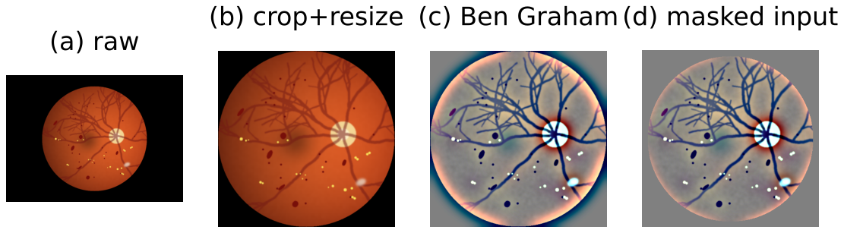
Fig. 4. Pre-processing stages (schematic input image).
B. Quality and Fundus Gates
Two green-channel metrics are computed inside the fundus disc: brightness B = mean(G) and sharpness Q = Var(∇²G). Images are rejected if Q is below the 1st percentile of the training data or B lies outside its 0.5–99.5th percentile range. Quality alone cannot detect a sharp image of the wrong object, so a fundus gate exploits the red dominance of the choroidal reflex and accepts an image only if
median( R / (G + 1) ) ≥ 1.6 (4)
over non-black pixels. Rejected images trigger a retake prompt with the reason; after three failures the device recommends direct referral.
C. Model and Training
EfficientNet-B0 [18] (MBConv blocks with squeeze-and-excitation [26]) is initialised from ImageNet via timm [27] and given a single linear output after dropout 0.3, totalling 4.01 M parameters. Because grades are ordinal, the network regresses a score ŷ trained with the Smooth-L1 loss, and the grade is
g = Σ_{i=1…4} 1[ ŷ > t_{i} ], (5)
with thresholds initialised at 0.5, 1.5, 2.5, 3.5 and refined on the validation set by coordinate descent (step 0.02, three passes) to maximise QWK. Training uses AdamW (weight decay 10⁻⁴) [28] with a one-cycle schedule peaking at 3 × 10⁻⁴ [29], batch 32, 20 epochs and mixed precision on a Tesla T4, with best-QWK checkpointing. Augmentation comprises flips, ±180° rotation, 85–100 % resized crops, colour jitter and occasional blur, the latter two chosen to improve robustness to the device’s optics. Grad-CAM [30] provides visual explanations.
D. Edge Export
The network is wrapped with built-in input normalisation, exported to ONNX (opset 17), checked for parity against PyTorch, and statically quantised to INT8 (QDQ format; per-channel weights, 200 calibration images) [19]. The INT8 model is deployed only if its test QWK is within 0.01 of FP32. The deployment bundle requires only ONNX Runtime, OpenCV and NumPy.
E. Metrics
Five-level agreement is measured with the quadratic weighted kappa
κ_{w} = 1 − Σ w_{ij}O_{ij} / Σ w_{ij}E_{ij}, w_{ij} = (i − j)²/(K − 1)², (6)
where O and E are the observed and chance-expected confusion matrices and K = 5 [14]. Referable DR (grade ≥ 2) is evaluated with sensitivity, specificity and AUC.
V. Experiments and Results
A. Dataset and Setup
APTOS 2019 [31] contains 3,662 fundus images from rural India graded on the ICDR scale (1,805 / 370 / 999 / 193 / 295 for grades 0–4). A stratified 70/15/15 split (seed 42) yields 2,563 training, 549 validation and 550 test images; the test set contains 223 referable and 327 non-referable images and is used once, after thresholds are frozen. Complexity and latency were measured with ONNX Runtime 1.29 on a two-thread x86 development PC (batch 1, median of 15 runs); Raspberry Pi 5 timings are reported in future work.
B. Backbone Complexity
Table I and Fig. 5 compare candidate backbones with an identical single-output head at 384 px. EfficientNet-B0 requires 10.6× fewer MACs than ResNet-50 [32] and runs 3.7× faster. MobileNetV3-L is 2.3× faster still, but EfficientNet-B0 was retained for its higher expected accuracy on fine-grained lesions; its 36 ms CPU latency leaves a wide margin against the 1 s on-device budget.
TABLE I
Measured Backbone Complexity at 384 × 384
Backbone | Params (M) | GMACs | ONNX (MB) | Latency (ms)
MobileNetV3-L | 4.20 | 0.63 | 16.7 | 15.6
EfficientNet-B0 | 4.01 | 1.13 | 15.9 | 36.3
EfficientNet-B2 | 7.70 | 1.93 | 30.6 | 59.1
DenseNet-121 | 6.95 | 8.33 | 27.8 | 149.1
ResNet-50 | 23.51 | 12.01 | 79.3 | 133.5

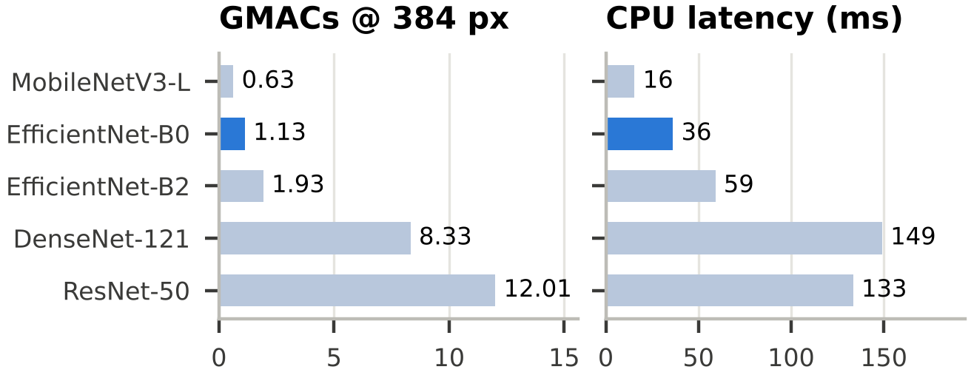
Fig. 5. Computation and measured CPU latency of candidate backbones (development PC).
C. Edge Deployment
In the training run the maximum absolute difference between PyTorch and ONNX outputs was 2 × 10⁻⁶, and the FP32 ONNX model reproduced the test QWK exactly. Post-training INT8 quantisation reduced the file from 16.0 MB to 4.8 MB (−70 %) but lowered test QWK from 0.877 to 0.570; on the x86 PC it was also 1.7× slower (60.9 vs 36.4 ms). EfficientNet’s depthwise convolutions, SiLU activations and squeeze-and-excitation gates are known to be sensitive to post-training quantisation [19]. The accuracy-gated rule therefore deployed FP32 (Table II). Pre-processing of a 2,600 × 1,900 capture took about 25 ms and quality metrics 19 ms. On the Raspberry Pi 5 of the prototype, the complete analysis takes about 3 s per image, above the 2 s target; a persistent model session, multi-threaded inference and quantisation-aware INT8 are planned to close the gap.
TABLE II
FP32 vs INT8 and Edge Measurements
Quantity | FP32 | INT8
Model size (MB) | 16.0 | 4.8
Test QWK | 0.877 | 0.570
PyTorch–ONNX max. abs. error | 2 × 10⁻⁶ | –
Latency, 384 px, dev. PC (ms) | 36.4 | 60.9
Pre-processing + quality (ms) | 43.7 | 43.7
Time per image on Pi 5 (s) | ≈ 3 | –

D. Fundus Gate
A first capture trial, with the lens held against the face, produced a sharp, well-exposed image of the anterior segment (iris, sclera, lashes) instead of the retina (Fig. 6a). It passed the blur and brightness checks, and an ungated model assigns it a DR grade like any other input. Its median R/G ratio was 1.29, against 2.54 for a fundus image, and the gate rejected it (Fig. 6c). The threshold of 1.6 is provisional and will be re-calibrated on labelled captures from the device.
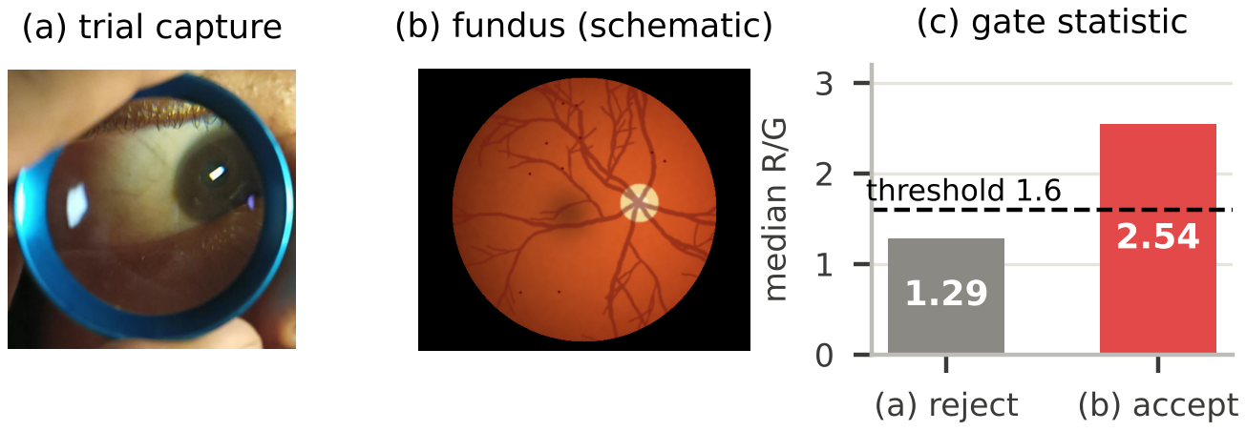
Fig. 6. Fundus-image gate: (a) mis-aligned trial capture; (b) schematic fundus image; (c) median red/green ratio with threshold.
E. Grading Performance
Training on a Tesla T4 took about 22 min (Fig. 7). Validation QWK peaked at 0.819 (epoch 18); threshold tuning moved the thresholds to (0.58, 1.08, 1.88, 2.72) and raised validation QWK to 0.877. On the test set, used once, QWK rose from 0.835 with default to 0.877 with tuned thresholds (Table III).
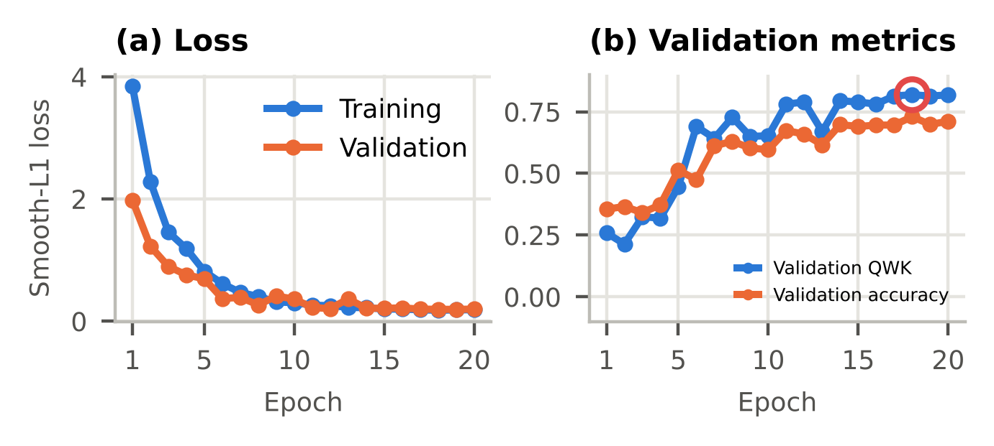
Fig. 7. Training and validation loss (a) and validation QWK/accuracy (b) over 20 epochs.
TABLE III
Grading Performance on the APTOS 2019 Test Set (n = 550)
Metric | Value
QWK (default thresholds) | 0.835
QWK (tuned thresholds) | 0.877
Five-class accuracy | 69.8 %
Referable sensitivity (95 % CI) | 93.7 % (89.7–96.2)
Referable specificity (95 % CI) | 90.8 % (87.2–93.5)
Referable AUC | 0.973

Fig. 8 shows the confusion matrix. Of 271 eyes without DR, 250 were graded correctly and only one was referred; 209 of 223 referable eyes were referred, and 10 of the 14 misses were moderate cases graded as mild or normal. Most five-class errors fall within the referable group (53 moderate eyes graded severe), which lowers five-class accuracy but not the referral decision. Recall is lowest for mild DR (0.38), consistent with microaneurysms spanning only 1–2 pixels at 384 px, and severe NPDR has low precision (0.15).
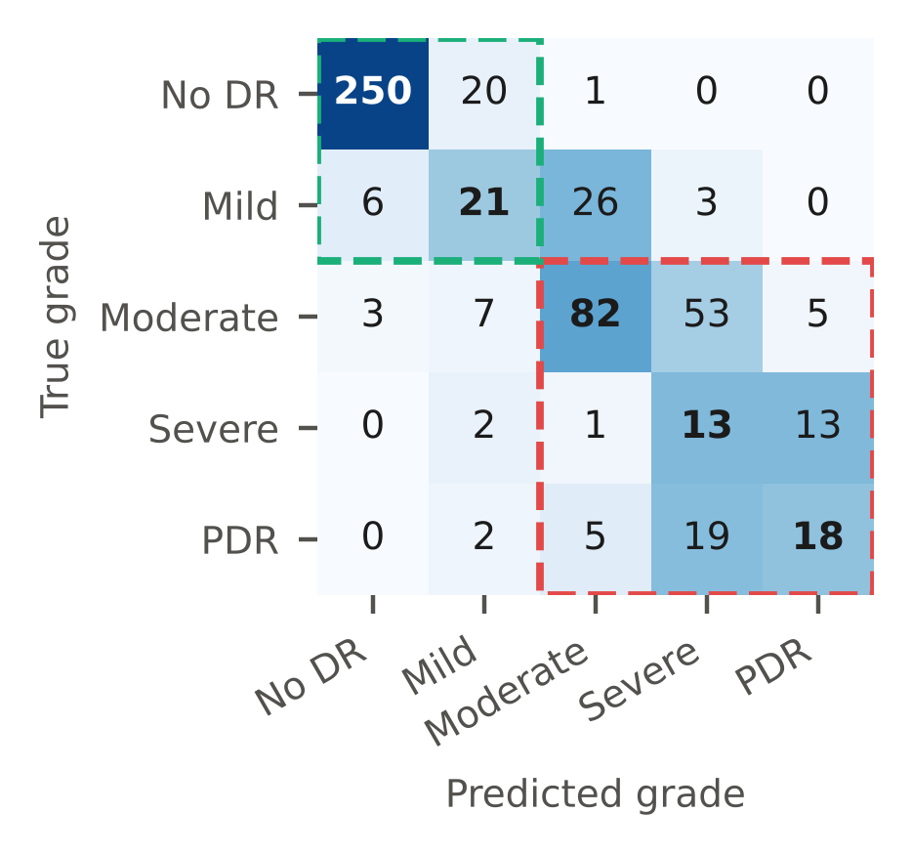
Fig. 8. Test-set confusion matrix (counts; shading normalised per true grade). Green: non-referable block; red: referable block.
Grad-CAM maps of correctly referred test images concentrated in the grey corners and at the fundus border rather than on lesions. Besides the coarse 12 × 12 resolution of the final feature map, this suggests that the network may partly exploit acquisition cues — APTOS images from different sources differ in cropping — that would not transfer to new cameras.
F. Comparison
Table IV situates the system among related work. Published figures come from larger, often adjudicated datasets and prospective studies, so they are not directly comparable — and the Grad-CAM finding suggests the APTOS figures may be optimistic; the distinguishing features of this work are open hardware, offline grading and an explicit input gate at low cost.
TABLE IV
Comparison with Related Systems
 | This work | [8] | [15] | [21]
Grading | ICDR 0–4 | Referable | Referable | None
Inference | On device | Server | Phone, offline | –
Hardware | Pi + 20 D lens | Clinical camera | Commercial | Pi + 20 D lens
Test set | 550, retro. | 11,711 | 213, prosp. | –
Ref. sens. | 93.7 % | 97.5 % | 100 % | –
Ref. spec. | 90.8 % | 93.4 % | 88.4 % | –
Input gate | Yes | – | – | –
Openness | Open | Closed | Closed | Open

VI. Discussion and Limitations
The grader exceeds its targets (QWK ≥ 0.85; referable sensitivity ≥ 85 %, specificity ≥ 80 %) with a 4 M-parameter network that runs in tens of milliseconds on a desktop CPU, so computation is not the bottleneck of offline screening. Three findings, however, shaped the design. First, post-training INT8 quantisation — often treated as a free optimisation — cost 0.31 in QWK; gating the export on accuracy prevented a silently degraded model from being deployed. Second, a sharp photograph of the wrong part of the eye would be graded by any regression model; consistent with field reports that image quality limits AI screening [7], input gating was made a core safety requirement. Third, Grad-CAM revealed that the model may rely on dataset-specific cues, a risk invisible to any metric computed on APTOS itself.
The main limitations are: (i) the possible shortcut learning and the domain shift between clinical cameras and the device’s smaller, undilated field; (ii) single-grader APTOS labels, which cap agreement between adjacent grades [12]; (iii) only 29 severe NPDR test images; (iv) on-device analysis takes ≈ 3 s per image, above the 2 s target, and battery life and retinal exposure are design estimates pending measurement; and (v) the colour gate is calibrated on few real failures.
VII. Conclusion and Future Work
We presented a low-cost, portable fundus camera and analysing unit that captures and grades diabetic retinopathy entirely offline on a Raspberry Pi 5. An indirect-ophthalmoscopy head with IR alignment provides adequate retinal sampling by design, an EfficientNet-B0 regression grader with tuned thresholds is exported exactly to ONNX (16.0 MB), and a quality and fundus gate prevents grading of unusable inputs, at a prototype cost of about ₹40,000. The grader reached a test QWK of 0.877 and referable-DR sensitivity and specificity of 93.7 % and 90.8 %. A first hardware prototype has been assembled. Future work will remove shortcut cues (border masking, random erasing) and verify attention with Grad-CAM, recover an accurate INT8 model through quantisation-aware training, replace the prototype's USB webcam with the NoIR camera, characterise the optical head, measure light exposure and on-device latency, collect consented images with ophthalmologist grading under ethics approval, fine-tune the model on device images, replace the colour rule with a learned gradability classifier, and validate the complete device clinically and on Messidor-2 [33] and IDRiD [34].
Code, notebook, results and hardware files are available at https://github.com/Omm-Sanjog/DR-Retinopathy-Fundus-Camera-.
Acknowledgment
The authors thank the School of Electronics Engineering, KIIT (Deemed to be University), for its support, and the Asia Pacific Tele-Ophthalmology Society and Aravind Eye Hospital for releasing the APTOS 2019 dataset.
References
[1] International Diabetes Federation, IDF Diabetes Atlas, 10th ed. Brussels, Belgium: IDF, 2021.
[2] R. M. Anjana et al., “Metabolic non-communicable disease health report of India: the ICMR-INDIAB national cross-sectional study (ICMR-INDIAB-17),” Lancet Diabetes Endocrinol., vol. 11, no. 7, pp. 474–489, Jul. 2023.
[3] Z. L. Teo et al., “Global prevalence of diabetic retinopathy and projection of burden through 2045: systematic review and meta-analysis,” Ophthalmology, vol. 128, no. 11, pp. 1580–1591, Nov. 2021.
[4] R. Raman et al., “Prevalence of diabetic retinopathy in India stratified by known and undiagnosed diabetes, urban–rural locations, and socioeconomic indices: results from the SMART India population-based cross-sectional screening study,” Lancet Glob. Health, vol. 10, no. 12, pp. e1764–e1773, Dec. 2022.
[5] D. S. W. Ting et al., “Artificial intelligence and deep learning in ophthalmology,” Br. J. Ophthalmol., vol. 103, no. 2, pp. 167–175, Feb. 2019.
[6] C. P. Wilkinson et al., “Proposed international clinical diabetic retinopathy and diabetic macular edema disease severity scales,” Ophthalmology, vol. 110, no. 9, pp. 1677–1682, Sep. 2003.
[7] E. Beede et al., “A human-centered evaluation of a deep learning system deployed in clinics for the detection of diabetic retinopathy,” in Proc. CHI Conf. Human Factors Comput. Syst., Honolulu, HI, USA, 2020, pp. 1–12.
[8] V. Gulshan et al., “Development and validation of a deep learning algorithm for detection of diabetic retinopathy in retinal fundus photographs,” JAMA, vol. 316, no. 22, pp. 2402–2410, Dec. 2016.
[9] D. S. W. Ting et al., “Development and validation of a deep learning system for diabetic retinopathy and related eye diseases using retinal images from multiethnic populations with diabetes,” JAMA, vol. 318, no. 22, pp. 2211–2223, Dec. 2017.
[10] M. D. Abràmoff, P. T. Lavin, M. Birch, N. Shah, and J. C. Folk, “Pivotal trial of an autonomous AI-based diagnostic system for detection of diabetic retinopathy in primary care offices,” npj Digit. Med., vol. 1, Art. no. 39, Aug. 2018.
[11] V. Gulshan et al., “Performance of a deep-learning algorithm vs manual grading for detecting diabetic retinopathy in India,” JAMA Ophthalmol., vol. 137, no. 9, pp. 987–993, Sep. 2019.
[12] J. Krause et al., “Grader variability and the importance of reference standards for evaluating machine learning models for diabetic retinopathy,” Ophthalmology, vol. 125, no. 8, pp. 1264–1272, Aug. 2018.
[13] B. Graham, “Kaggle diabetic retinopathy detection competition report,” Univ. of Warwick, Coventry, U.K., Tech. Rep., 2015.
[14] J. Cohen, “Weighted kappa: nominal scale agreement with provision for scaled disagreement or partial credit,” Psychol. Bull., vol. 70, no. 4, pp. 213–220, 1968.
[15] S. Natarajan, A. Jain, R. Krishnan, A. Rogye, and S. Sivaprasad, “Diagnostic accuracy of community-based diabetic retinopathy screening with an offline artificial intelligence system on a smartphone,” JAMA Ophthalmol., vol. 137, no. 10, pp. 1182–1188, Oct. 2019.
[16] R. Rajalakshmi, R. Subashini, R. M. Anjana, and V. Mohan, “Automated diabetic retinopathy detection in smartphone-based fundus photography using artificial intelligence,” Eye, vol. 32, no. 6, pp. 1138–1144, Jun. 2018.
[17] A. Howard et al., “Searching for MobileNetV3,” in Proc. IEEE/CVF Int. Conf. Comput. Vis. (ICCV), 2019, pp. 1314–1324.
[18] M. Tan and Q. V. Le, “EfficientNet: rethinking model scaling for convolutional neural networks,” in Proc. 36th Int. Conf. Mach. Learn. (ICML), Long Beach, CA, USA, 2019, pp. 6105–6114.
[19] B. Jacob et al., “Quantization and training of neural networks for efficient integer-arithmetic-only inference,” in Proc. IEEE/CVF Conf. Comput. Vis. Pattern Recognit. (CVPR), 2018, pp. 2704–2713.
[20] L. J. Haddock, D. Y. Kim, and S. Mukai, “Simple, inexpensive technique for high-quality smartphone fundus photography in human and animal eyes,” J. Ophthalmol., vol. 2013, Art. no. 518479, 2013.
[21] B. Y. Shen and S. Mukai, “A portable, inexpensive, nonmydriatic fundus camera based on the Raspberry Pi computer,” J. Ophthalmol., vol. 2017, Art. no. 4526243, Mar. 2017.
[22] Raspberry Pi Ltd., “Raspberry Pi 5 product brief,” Cambridge, U.K., 2023. [Online]. Available: https://datasheets.raspberrypi.com
[23] ONNX Runtime developers, “ONNX Runtime: cross-platform, high-performance ML inferencing,” Microsoft, 2021. [Online]. Available: https://onnxruntime.ai
[24] Raspberry Pi Ltd., “Raspberry Pi Camera Module 3 product brief,” Cambridge, U.K., 2023. [Online]. Available: https://datasheets.raspberrypi.com
[25] Ophthalmic Instruments — Fundamental Requirements and Test Methods — Part 2: Light Hazard Protection, ISO 15004-2:2007, International Organization for Standardization, 2007.
[26] J. Hu, L. Shen, and G. Sun, “Squeeze-and-excitation networks,” in Proc. IEEE/CVF Conf. Comput. Vis. Pattern Recognit. (CVPR), 2018, pp. 7132–7141.
[27] R. Wightman, “PyTorch image models (timm),” GitHub repository, 2019. [Online]. Available: https://github.com/huggingface/pytorch-image-models
[28] I. Loshchilov and F. Hutter, “Decoupled weight decay regularization,” in Proc. Int. Conf. Learn. Represent. (ICLR), New Orleans, LA, USA, 2019.
[29] L. N. Smith and N. Topin, “Super-convergence: very fast training of neural networks using large learning rates,” in Proc. SPIE 11006, Artificial Intelligence and Machine Learning for Multi-Domain Operations Applications, 2019, Art. no. 1100612.
[30] R. R. Selvaraju, M. Cogswell, A. Das, R. Vedantam, D. Parikh, and D. Batra, “Grad-CAM: visual explanations from deep networks via gradient-based localization,” in Proc. IEEE Int. Conf. Comput. Vis. (ICCV), 2017, pp. 618–626.
[31] Asia Pacific Tele-Ophthalmology Society, “APTOS 2019 Blindness Detection,” Kaggle competition dataset, 2019. [Online]. Available: https://www.kaggle.com/c/aptos2019-blindness-detection
[32] K. He, X. Zhang, S. Ren, and J. Sun, “Deep residual learning for image recognition,” in Proc. IEEE Conf. Comput. Vis. Pattern Recognit. (CVPR), 2016, pp. 770–778.
[33] E. Decencière et al., “Feedback on a publicly distributed image database: the Messidor database,” Image Anal. Stereol., vol. 33, no. 3, pp. 231–234, 2014.
[34] P. Porwal et al., “Indian Diabetic Retinopathy Image Dataset (IDRiD): a database for diabetic retinopathy screening research,” Data, vol. 3, no. 3, Art. no. 25, Jul. 2018.

