
A Major Project-1 Report on
AI-BASED PORTABLE FUNDUS CAMERA AND ANALYSING UNIT FOR DIABETIC RETINOPATHY SCREENING
Submitted in partial fulfilment of the requirements for the award of the degree of
Bachelor of Technology
in
Electronics and Computer Science Engineering
by
OMM SANJOG BARIK | 2330382
LAGANJEET JENA | 2330378
PIYUSH RAJ | 2330383
RIDDHI KHANNA | 2330393
Under the guidance of
Prof. Prasant Kumar Patra
SCHOOL OF ELECTRONICS ENGINEERING
KALINGA INSTITUTE OF INDUSTRIAL TECHNOLOGY
(Deemed to be University)
Bhubaneswar – 751024, Odisha, India
NOVEMBER 2026

Certificate

This is to certify that the project report entitled “AI-Based Portable Fundus Camera and Analysing Unit for Diabetic Retinopathy Screening”, submitted by Omm Sanjog Barik (2330382), Laganjeet Jena (2330378), Piyush Raj (2330383) and Riddhi Khanna (2330393) in partial fulfilment of the requirements for the award of the degree of Bachelor of Technology in Electronics and Computer Science Engineering, is a bona fide record of the work carried out by them under my guidance and supervision at the School of Electronics Engineering, KIIT (Deemed to be University), Bhubaneswar, during the academic year 2026–2027.

Prof. Prasant Kumar Patra
Supervisor
School of Electronics Engineering

Declaration of Originality

We, the undersigned members of the project group, declare that:
This report presents our own work, carried out under the supervision named in the Certificate. Ideas, data, figures, text and code taken from other sources are acknowledged and referenced. Where AI-based writing or coding assistants were used, their output was reviewed, tested and edited by the team, and the team takes full responsibility for the content.

Name | Roll No. | Signature
Omm Sanjog Barik | 2330382
Laganjeet Jena | 2330378
Piyush Raj | 2330383
Riddhi Khanna | 2330393
Date: ___/11/2026 Place: Bhubaneswar

Acknowledgements

We feel immense pleasure and privilege in expressing our deepest and most sincere gratitude to our supervisor, Prof. Prasant Kumar Patra, for his excellent guidance throughout this project. His constant support, valuable suggestions and attention to detail — particularly his insistence that every design decision be backed by a measurement or a reference — shaped both the system and this report. We are thankful for his patience in reviewing our work at every stage and for the constructive feedback that helped us turn an idea into an engineered prototype.
We are also very thankful to Dr. (Mrs.) Sarita Nanda, Associate Dean and Associate Professor, and Dr. (Mrs.) Suprava Patnaik, Dean and Professor, School of Electronics Engineering, along with the Project Coordinators, for their support and valuable suggestions during the 7th semester of our undergraduate programme.
We acknowledge the Asia Pacific Tele-Ophthalmology Society (APTOS) and Aravind Eye Hospital for releasing the APTOS 2019 fundus image dataset, and the open-source communities behind PyTorch, timm, ONNX Runtime, OpenCV and Raspberry Pi OS, without which a student team could not build a system of this kind. Finally, we thank our families and friends for their encouragement throughout the project.

Abstract

Diabetic retinopathy (DR) is a leading cause of preventable blindness. India has an estimated 101 million people with diabetes, yet routine eye screening reaches only a fraction of them because fundus cameras are expensive, graders are scarce and cloud-based tele-grading needs connectivity. This project designs and builds a low-cost fundus camera and analysing unit that photographs the retina and grades DR on the device itself, offline.
The optical head uses indirect ophthalmoscopy: a 20 dioptre condensing lens forms an aerial image of the retina, captured by a Raspberry Pi Camera Module 3 NoIR under 850 nm infrared alignment and a brief white-LED flash. A Raspberry Pi 5 rejects blurred, badly exposed and non-retinal images, normalises illumination, and runs an EfficientNet-B0 network (4.0 million parameters) whose continuous severity score is mapped to the five-level International Clinical DR scale. The model was trained on the APTOS 2019 dataset (3,662 graded images) through a self-contained Google Colab pipeline and exported to a 16.0 MB ONNX model that reproduces the trained network to within 2 × 10⁻⁶; post-training INT8 quantisation lost too much accuracy and was rejected automatically.
On a held-out test set of 550 images the model achieves a quadratic weighted kappa of 0.877 and, for referable DR (grade 2 or worse), a sensitivity of 93.7 %, a specificity of 90.8 % and an area under the ROC curve of 0.973, exceeding all targets. Grad-CAM analysis, however, suggests partial reliance on dataset-specific cues, so external validation is required. The fundus-image gate correctly rejected the team’s first, mis-aligned capture. A first table-top prototype has been built with a rail-mounted camera carriage. The estimated design cost is ₹20,050. The work shows that an offline, student-built device can provide referral-level DR screening for primary health centres, subject to the clinical validation planned for Project-II.
Keywords: diabetic retinopathy, fundus imaging, deep learning, EfficientNet, edge AI, Raspberry Pi
Sustainable Development Goals addressed: SDG 3 – Good Health and Well-being (target 3.4: reduce premature mortality and morbidity from non-communicable diseases; target 3.8: universal health coverage); SDG 10 – Reduced Inequalities (target 10.2: inclusion irrespective of location or economic status); SDG 9 – Industry, Innovation and Infrastructure (target 9.5: enhance research and technological capability).

Project Summary Sheet

Project title | AI-Based Portable Fundus Camera and Analysing Unit for Diabetic Retinopathy Screening
Team members | Omm Sanjog Barik (2330382) – team lead; optical head, embedded integration, ML pipeline  Laganjeet Jena (2330378) – dataset, pre-processing, model training & evaluation  Piyush Raj (2330383) – Raspberry Pi software, ONNX deployment, benchmarking  Riddhi Khanna (2330393) – literature, standards & ethics, testing, documentation
Supervisor | Prof. Prasant Kumar Patra, School of Electronics Engineering
Semester / academic year | VII (Project-I) – VIII (Project-II) / 2026–2027
Project type (tick one) | ☑ Product ☐ Application ☐ Research ☐ Review
Thrust area (tick one) | ☐ Wireless & Mobile Communication ☐ VLSI & Embedded Systems ☐ Signal & Image Processing ☐ RF & Microwave ☐ Instrumentation & Control ☐ IoT & Automation ☑ AI/ML ☐ Power, Energy & EV
Sustainable Development Goals | SDG 3 (targets 3.4, 3.8); SDG 10 (target 10.2); SDG 9 (target 9.5) – see 1.5
Codes and standards applied | ISO 15004-2 and IEC 62471 (light-hazard limits for the LEDs); ISO 10940 (fundus-camera field of view and resolution targets); IEC 62304 (software life-cycle discipline); ISO 14971 (risk register); ICDR severity scale (output definition) – see 3.6
Realistic design constraints | Economic (prototype ≤ ₹25,000); health & safety (retinal light exposure, non-dilated pupils); regulatory (CDSCO Medical Devices Rules 2017 – research use only); ethical/privacy (DPDP Act 2023); operational (offline, battery powered) – see 3.3
Significant design trade-offs | Backbone: EfficientNet-B0 vs MobileNetV3 vs ResNet-50 (accuracy vs latency); output: regression + thresholds vs 5-class softmax; precision: INT8 (−70 % size, but test QWK 0.877 → 0.570) vs FP32 (selected); input size 384 px vs 224 px (lesion detail vs compute) – see 3.4
Environment and sustainability | ≈ 8–12 W peak; ≈ 0.4–0.6 Wh per screening; RoHS-compliant parts; PLA enclosure; avoids patient travel to city hospitals – see 6.1
Health, safety and risk | Retinal light exposure, missed referable DR, ungradable images, data leaks, domain shift – mitigated by IR alignment, short flash, quality gate, referral bias, offline storage – see 6.2
Ethics, security and inclusion | Informed consent, anonymised IDs, on-device processing, dataset licences, transparent limitations; low-literacy icon UI and local-language plan – see 6.3–6.5
Cost | Total prototype cost ≈ ₹20,050 (estimated); estimated unit cost at volume ≈ ₹12,000 – see 6.6
Modern tools used | PyTorch, timm, ONNX Runtime, OpenCV, Google Colab (T4 GPU), Raspberry Pi 5, Camera Module 3 NoIR, Graphviz, Matplotlib, Fusion 360 / 3D printing – see 3.7
Computing aspects | GPU training in the cloud; CPU-only INT8/FP32 inference on ARM Cortex-A76; image-quality and fundus gates; threshold optimisation for QWK; Grad-CAM explanations – see 3.5
Key results against targets | Test QWK 0.877 (target ≥ 0.85 ✔); referable-DR sensitivity 93.7 % / specificity 90.8 % (targets ≥ 85 % / ≥ 80 % ✔); AUC 0.973; FP32 ONNX 16.0 MB with parity error 2 × 10⁻⁶ ✔ – see 5.2
Outcomes | ☑ Working prototype (software pipeline + hardware prototype v1 built) ☐ Publication ☐ Patent filed ☐ Award / exhibition ☐ Start-up / technology transfer
Knowledge drawn from courses | Digital Image Processing, Machine Learning, Embedded Systems, Microprocessors & Microcontrollers, Analog Electronic Circuits, Signals & Systems, Engineering Physics (optics), Python Programming
Repository / demonstration | https://github.com/Omm-Sanjog/[repository-name] – notebook, Pi bundle, figures (Appendix D)

Table of Contents

Certificate ii
Declaration of Originality iii
Acknowledgements iv
Abstract v
Project Summary Sheet vi
List of Figures x
List of Tables xii
List of Abbreviations and Symbols xiii
Chapter 1: Introduction 1
1.1 Background and Motivation 1
1.2 Problem Statement 3
1.3 Objectives 4
1.4 Scope and Limitations 4
1.5 Relevance to Society, Industry and the Sustainable Development Goals 5
1.6 Organisation of the Report 5
Chapter 2: Literature Review and Research Gap 6
2.1 Review of Existing Work 6
2.2 Existing Products, Patents and Standards 9
2.3 Research Gap and Novelty of the Proposed Work 10
Chapter 3: Requirements, Design and Methodology 12
3.1 Requirements and Specifications 12
3.2 Complex Engineering Problem Characteristics 13
3.3 Realistic Design Constraints 13
3.4 Design Alternatives and Trade-off Analysis 14
3.5 System Architecture and Detailed Design 15
3.6 Engineering Standards and Codes Applied 23
3.7 Modern Tools and Resources 24
3.8 Methodology and Project Plan 25
Chapter 4: Implementation and Testing 27
4.1 Hardware and Software Implementation 27
4.2 Experimental Set-up and Data Collection 32
4.3 Validation against Specifications and Standards 35
Chapter 5: Results and Discussion 37
5.1 Results 37
5.2 Achievement of Specifications 43
5.3 Comparison with Existing Work 44
5.4 Error, Uncertainty and Limitation Analysis 44
5.5 Discussion 45
Chapter 6: Societal, Environmental, Ethical and Economic Considerations 46
6.1 Environmental Impact and Sustainability 46
6.2 Health, Safety and Risk Assessment 46
6.3 Professional Ethics and Legal Aspects 48
6.4 Security Considerations 49
6.5 Equality, Diversity, Inclusion and Accessibility 49
6.6 Economic Analysis 49
6.7 Summary of Compliance 51
Chapter 7: Conclusion and Future Scope 52
7.1 Conclusions 52
7.2 Limitations 53
7.3 Work to be carried out in 8^th^ Semester 53
References 54
Appendix A: Project Management and Teamwork 58
Team Structure and Individual Contributions 58
Supervision and Review Record 58
Lifelong Learning 58
Appendix B: Gantt Chart 60
Appendix C: Datasheets and Design Calculations 61
Key datasheet parameters 61
Summary of design calculations 61
Appendix D: Code, Design Files and Data 63
Key code excerpts 63
Appendix E: Individual Contribution Reports 65
Appendix G: Publications, Patents and Certificates 69

List of Figures

Figure 1.1: (a) Structures of the eye through which light passes to reach the retina; (b) landmarks 1
Figure 1.2: Burden of diabetic retinopathy: (a) global number of people with any DR and vision-threa 2
Figure 1.3: The five grades of the ICDR severity scale (schematic illustrations of increasing lesion 3
Figure 2.1: Map of the literature reviewed and the gap addressed by this project. 6
Figure 2.2: Size of the public DR grading datasets considered (log scale). APTOS 2019 was selected f 8
Figure 3.1: Block diagram of the proposed AI-based fundus camera and analysing unit. 16
Figure 3.2: Optical layout of the fundus head (indirect ophthalmoscopy with a 20 D lens). Rays are s 17
Figure 3.3: Interfacing of the camera, LED drivers, capture button, display and power supply with th 18
Figure 3.4: Layered software architecture of the analysing unit. 19
Figure 3.5: Level-1 data-flow diagram: capture, quality assessment, grading and reporting. 20
Figure 3.6: Structure of the MBConv block used throughout EfficientNet-B0. 21
Figure 3.7: Mapping of the continuous model output to ICDR grades; grades 2–4 constitute referable D 22
Figure 3.8: Flowchart of a screening session on the device. 23
Figure 3.9: State machine of the analysing unit. 23
Figure 3.10: Project methodology. 25
Figure 3.11: Training and export pipeline implemented in the Colab notebook. 26
Figure 4.1: Export pipeline from the trained PyTorch checkpoint to the deployed ONNX model. 28
Figure 4.2: Concept design of the hand-held enclosure (side view). 29
Figure 4.3: Prototype v1: (a) three-quarter view; (b) front panel with lens port and rotary controls 30
Figure 4.4: Interior of prototype v1 with the main sub-assemblies labelled. 30
Figure 4.5: Class distribution of the APTOS 2019 training set. 32
Figure 4.6: Pre-processed APTOS 2019 images of each grade, as produced by cell 4 of the training not 33
Figure 4.7: Number of images per grade in the training, validation and test sets. 33
Figure 4.8: Pre-processing stages applied to a fundus image (schematic input). 34
Figure 4.9: Examples of random training augmentations applied to one pre-processed image. 34
Figure 5.1: Parameters, computation and measured CPU latency of candidate backbones at 384 × 384 inp 37
Figure 5.2: FP32 versus INT8 EfficientNet-B0: file size and test QWK from the training run, latency 38
Figure 5.3: Median pre-processing time per stage for a full-resolution capture on the development PC 38
Figure 5.4: (a) First capture trial: the 20 D lens held against the face images the anterior segment 39
Figure 5.5: Training and validation loss, validation QWK and validation accuracy for the 20-epoch tr 40
Figure 5.6: Confusion matrix on the test set (counts; shading normalised per true grade). Green box: 41
Figure 5.7: ROC curve for referable DR on the test set, with the operating point given by the tuned 41
Figure 5.8: Per-grade precision and recall on the test set. 42
Figure 5.9: Grad-CAM for six test images. Top: pre-processed input with true grade; bottom: heat-map 43
Figure 6.1: Risk heat map before mitigation; identifiers refer to Table 6.1. 47
Figure 6.2: Breakdown of the estimated prototype cost. 50
Figure B.1: Project schedule — Project-I and Project-II, month by month. 60

List of Tables

Table 1.1: Project objectives and how they are verified 4
Table 2.1: Summary of the literature reviewed 8
Table 2.2: Comparison with existing products and research prototypes 10
Table 3.1: Requirements and specifications 12
Table 3.2: Complex engineering problem attributes addressed 13
Table 3.3: Realistic design constraints 13
Table 3.4: Decision matrix for the selection of the CNN backbone 14
Table 3.5: Decision matrix for the selection of the processing platform 14
Table 3.6: Decision matrix for the model output formulation 14
Table 3.7: Power budget of the hand-held unit (design estimates; to be measured in Project-II) 18
Table 3.8: EfficientNet-B0 stages at 384 × 384 input with a single regression output 21
Table 3.9: Standards and codes applied 23
Table 3.10: Hardware, software and test equipment used 24
Table 4.1: Structure of the training notebook 27
Table 4.2: Contents of the Raspberry Pi bundle (dr_pi_bundle.zip) 28
Table 4.3: Design (Chapter 3) versus prototype v1 as built 31
Table 4.4: Training hyper-parameters 34
Table 4.5: Computing environment 35
Table 4.6: Test plan and traceability to requirements 35
Table 5.1: Measured complexity of candidate backbones (384 × 384 input, single regression output) 37
Table 5.2: Edge-deployment measurements 38
Table 5.3: Classification performance on the held-out APTOS 2019 test set (550 images) 40
Table 5.4: Per-grade results on the test set 42
Table 5.5: Targets versus achieved performance 43
Table 5.6: Comparison with reported work and existing products 44
Table 6.1: Risk register (Likelihood L and Severity S on a 1–5 scale; Risk = L × S) 47
Table 6.2: Licences of software and data used 48
Table 6.3: Bill of materials and prototype cost (estimated retail prices, October 2026) 49
Table 6.4: Summary of societal considerations 51
Table 7.1: Achievement of objectives 52
Table A.1: Roles and contributions of team members 58
Table A.2: Summary of review meetings with Supervisor 58
Table C.1: Raspberry Pi 5 — parameters relevant to the design 61
Table C.2: Raspberry Pi Camera Module 3 NoIR — parameters relevant to the design 61
Table C.3: Components of the LED driver 61
Table C.4: Summary of design calculations 61
Table D.1: Repository information 63

List of Abbreviations and Symbols

Abbreviation / Symbol | Meaning | Unit
AI | Artificial Intelligence | –
AMP | Automatic Mixed Precision | –
AUC | Area Under the ROC Curve | –
BN | Batch Normalisation | –
CNN | Convolutional Neural Network | –
CSI | Camera Serial Interface (MIPI CSI-2) | –
CDSCO | Central Drugs Standard Control Organisation (India) | –
D | Dioptre (optical power = 1/focal length) | m⁻¹
DME | Diabetic Macular Oedema | –
DPDP | Digital Personal Data Protection Act, 2023 | –
DR | Diabetic Retinopathy | –
DSI | Display Serial Interface | –
FN / FP | False Negative / False Positive | count
FP32 / INT8 | 32-bit floating point / 8-bit integer precision | –
GAP | Global Average Pooling | –
GMAC | 10⁹ multiply–accumulate operations | –
GPIO | General-Purpose Input/Output | –
Grad-CAM | Gradient-weighted Class Activation Mapping | –
ICDR | International Clinical Diabetic Retinopathy (severity scale) | –
IR | Infrared | –
IRMA | Intraretinal Microvascular Abnormalities | –
MA | Microaneurysm | –
MBConv | Mobile Inverted Bottleneck Convolution | –
NPDR / PDR | Non-proliferative / Proliferative Diabetic Retinopathy | –
ONNX | Open Neural Network Exchange | –
PD | USB Power Delivery | –
PWM | Pulse-Width Modulation | –
QDQ | Quantise–Dequantise (ONNX quantisation format) | –
QWK, κ_{w} | Quadratic Weighted Kappa | –
R/G | Ratio of red to green channel intensity | –
ROC | Receiver Operating Characteristic | –
SE | Squeeze-and-Excitation | –
SDG | Sustainable Development Goal | –
TP / TN | True Positive / True Negative | count
VTDR | Vision-Threatening Diabetic Retinopathy | –
V_{f} | LED forward voltage | V
I_{f} | LED forward current | mA
R | Current-limiting resistance | Ω
P | Power dissipation | W
f | Focal length | mm
λ | Wavelength | nm
ŷ | Continuous severity score predicted by the model | –
t₁ … t₄ | Grade thresholds applied to ŷ | –
σ | Standard deviation of Gaussian blur | px

Chapter 1: Introduction

1.1 Background and Motivation

1.1.1 Diabetes and the eye
Diabetes mellitus is no longer a disease of affluent cities. The International Diabetes Federation estimated that 537 million adults were living with diabetes worldwide in 2021 [1], and the ICMR-INDIAB national survey found that about 11.4 % of Indian adults — roughly 101 million people — have diabetes, with a further 136 million living with prediabetes [2]. Chronically raised blood glucose damages small blood vessels throughout the body, and the retina, which has one of the highest metabolic demands of any tissue, is among the first organs to show that damage.
Diabetic retinopathy (DR) is the resulting microvascular disease of the retina. In its early, non-proliferative stages the capillary walls weaken and balloon into microaneurysms, leak blood (dot-and-blot haemorrhages) and lipid (hard exudates), and close off, starving areas of the retina of oxygen (cotton-wool spots). In the late, proliferative stage the ischaemic retina releases growth factors that cause fragile new vessels to grow on the retina and optic disc; these bleed into the vitreous and pull on the retina, causing sudden and often permanent loss of vision. Fluid leaking into the macula — diabetic macular oedema — can blur central vision at any stage. Figure 1.1 shows the anatomy involved and the landmarks visible in a fundus photograph.
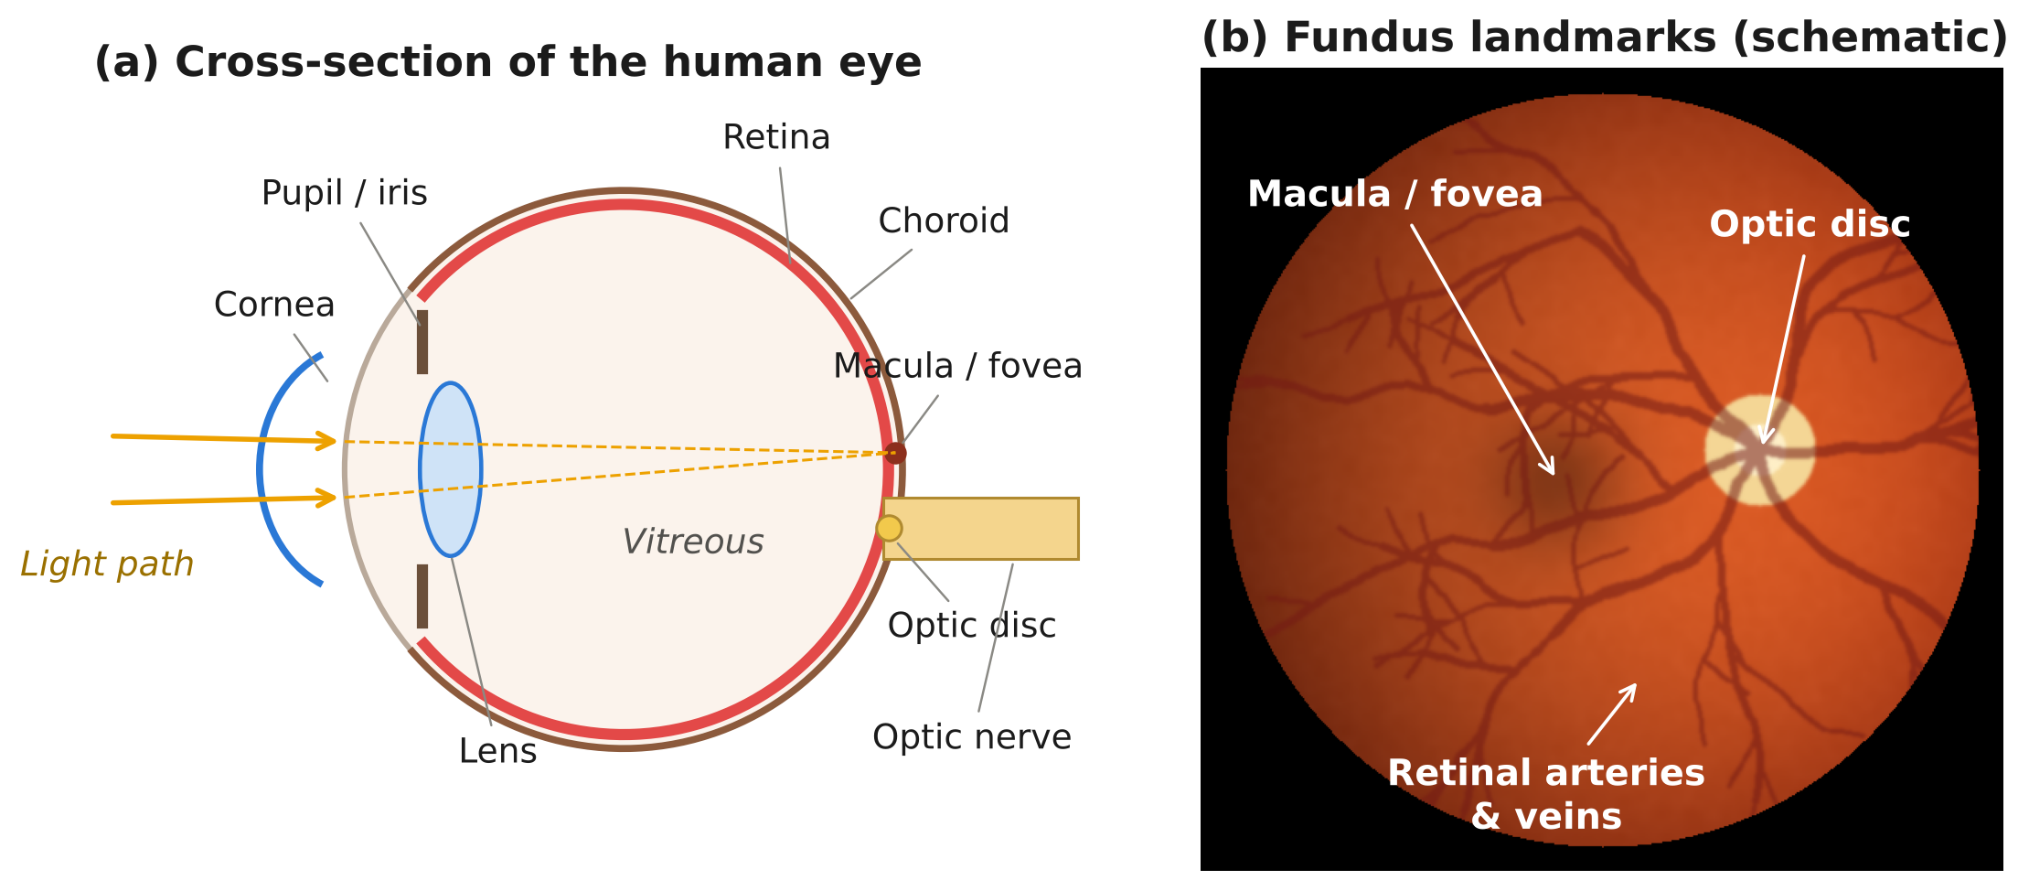
Figure 1.1: (a) Structures of the eye through which light passes to reach the retina; (b) landmarks visible in a fundus image — optic disc, macula and the retinal vascular arcades (schematic illustration).
The crucial clinical fact is that DR is silent until late. A person can have moderate or even severe non-proliferative disease with perfect vision. By the time symptoms appear, laser photocoagulation or anti-VEGF injections can only preserve what remains. Regular screening of every person with diabetes — at least once a year — therefore prevents most DR-related blindness, and this has been demonstrated by national screening programmes in the United Kingdom and Singapore [3].

1.1.2 Burden of diabetic retinopathy
A meta-analysis of 59 population studies estimated that 22.27 % of people with diabetes worldwide have some DR and 6.17 % have vision-threatening DR; in absolute numbers, 103.12 million people had DR in 2020, projected to rise to 160.50 million by 2045 [4]. In India, the SMART India population survey found DR in 15.5 % of people with known diabetes and 8.0 % of those whose diabetes had not yet been diagnosed, with vision-threatening disease in 5.3 % and 2.4 % respectively [5]. Figure 1.2 summarises these figures.
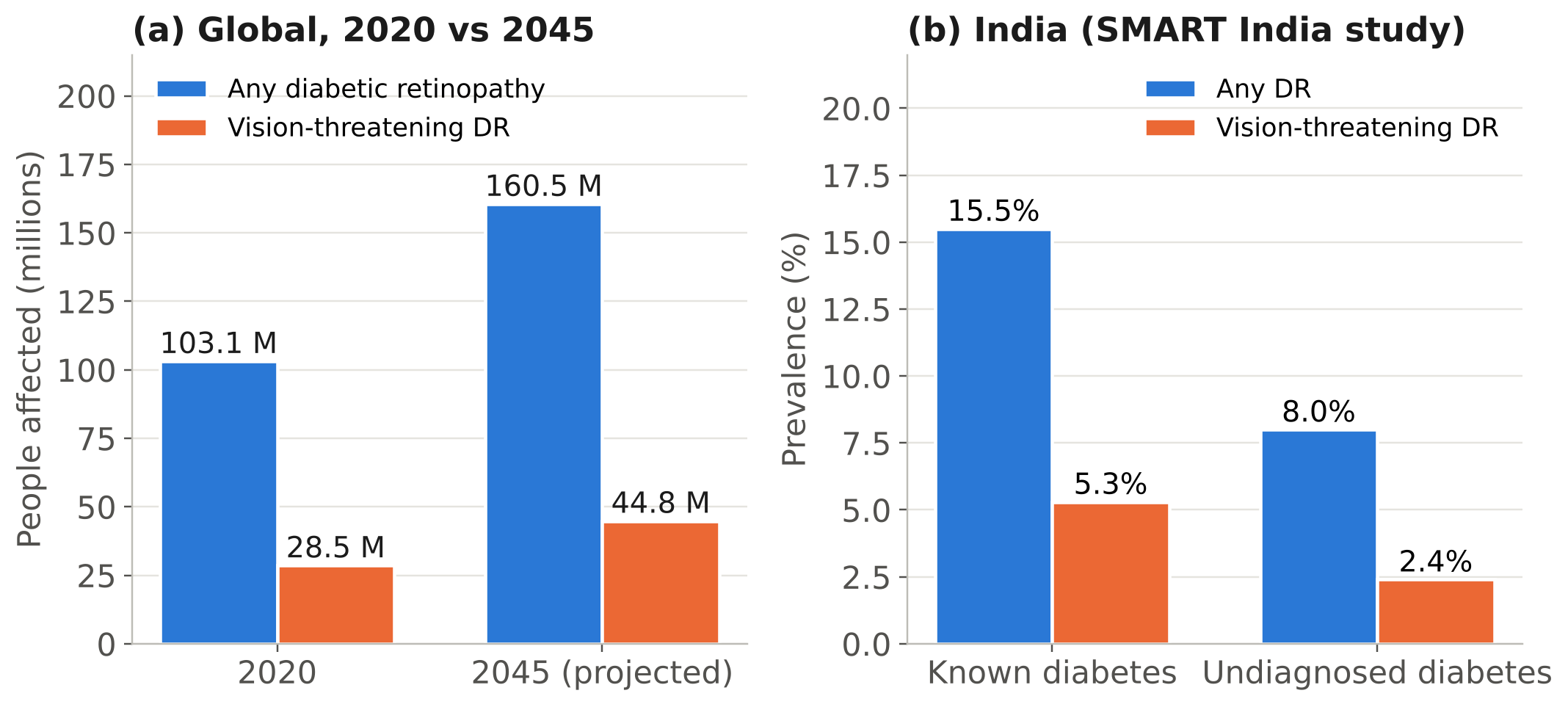
Figure 1.2: Burden of diabetic retinopathy: (a) global number of people with any DR and vision-threatening DR, 2020 and projected 2045 [4]; (b) prevalence among people with known and undiagnosed diabetes in India [5].
Applied to India’s diabetic population, these percentages correspond to more than ten million people with DR, a large share of whom do not know they have diabetes, let alone retinopathy. The World Health Organization lists DR among the conditions for which effective, low-cost screening could avoid most vision loss [6].

1.1.3 The screening gap
Screening for DR is simple in principle: a photograph of the retina (a fundus image) is taken and graded by a trained reader on the International Clinical Diabetic Retinopathy (ICDR) scale shown in Figure 1.3 [7]. People with referable disease — moderate non-proliferative DR or worse, or any macular oedema — are sent to an ophthalmologist; the rest are re-screened after a year.
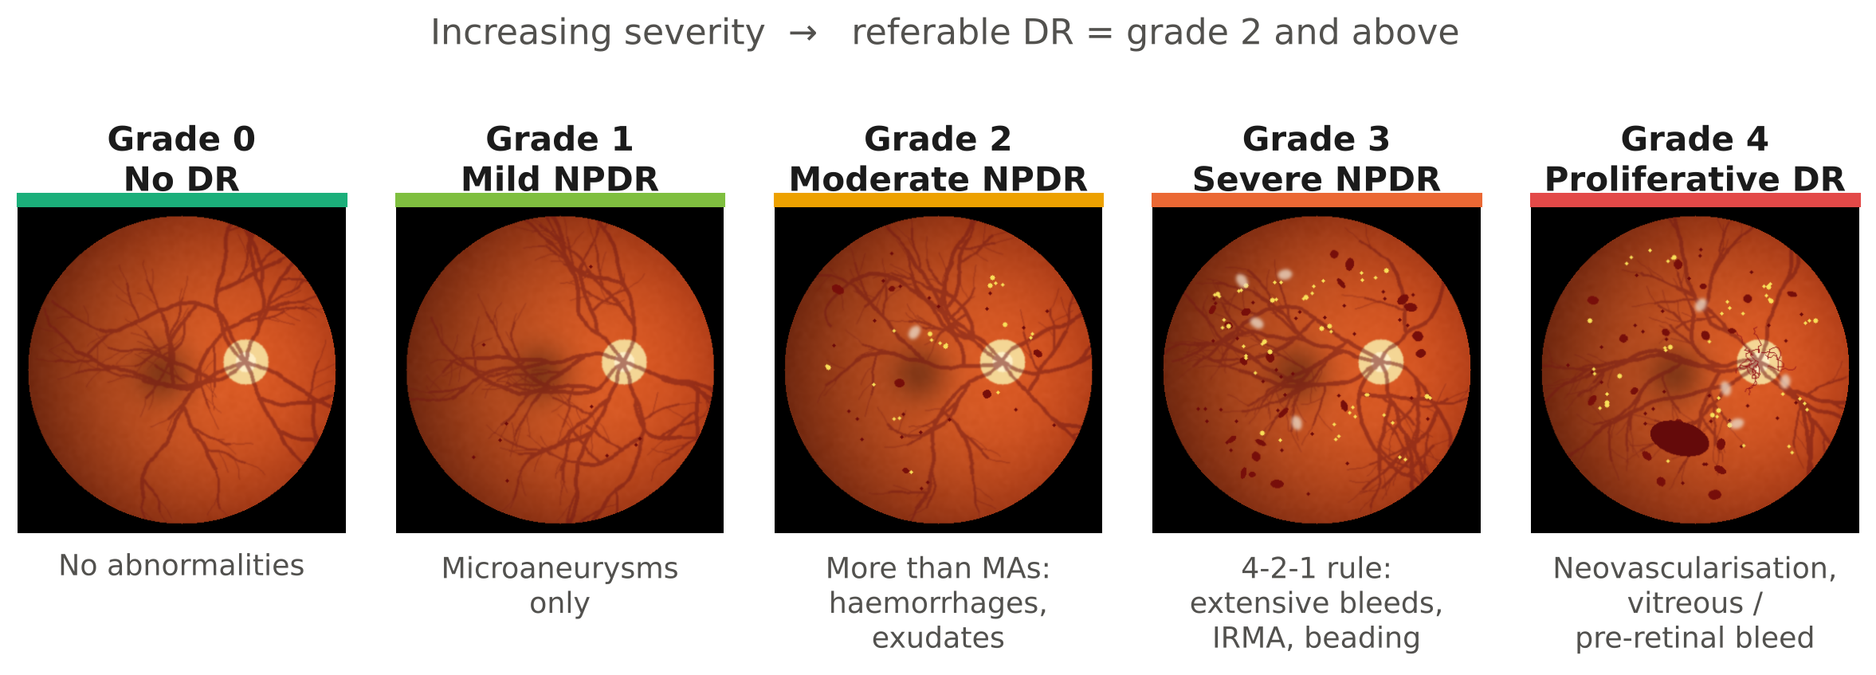
Figure 1.3: The five grades of the ICDR severity scale (schematic illustrations of increasing lesion load). Grades 2–4 are “referable” and require an ophthalmologist’s review.
In practice, three bottlenecks prevent this from happening for most Indian patients:
- Equipment cost. Conventional table-top non-mydriatic fundus cameras cost several lakh rupees, need a dark room and a trained technician, and are rarely found below the district-hospital level.
- Grader availability. Ophthalmologists and trained graders are concentrated in cities, while a large share of people with diabetes live in rural and semi-urban areas served by primary health centres.
- Connectivity and logistics. Tele-ophthalmology models that upload images for remote grading depend on reliable internet access and on the patient returning for the result; in field studies, poor connectivity and delays were major reasons for programme drop-out [8].

1.1.4 Why AI on the edge
Deep convolutional neural networks (CNNs) have reached ophthalmologist-level accuracy in grading referable DR from fundus photographs [9], [10], and autonomous AI systems have received regulatory approval for use in primary care [11], [12]. However, most of these systems run on cloud servers and assume images from expensive cameras. Two developments now make an alternative possible: smartphone-class processors such as the Raspberry Pi 5 can run compact CNNs in well under a second, and low-cost optical designs based on a hand-held condensing lens can capture usable fundus images through an undilated pupil [13], [14].
The motivation for this project is to combine the two in one portable, offline unit: a device that a health worker at a primary health centre or a screening camp can use to photograph the retina and receive an immediate, referral-level DR grade, without internet access and at a cost a district health budget can absorb.
In one sentence: DR blindness is largely preventable, screening is the bottleneck, and the bottleneck is cost, skilled graders and connectivity — the three things an offline, low-cost, AI-enabled fundus camera addresses.

1.2 Problem Statement
People with diabetes in rural and semi-urban India, particularly those attending primary health centres and community screening camps, are not screened for diabetic retinopathy at the recommended yearly interval because fundus cameras are expensive and immobile, trained graders are scarce, and cloud-based tele-grading depends on internet connectivity that is often unavailable. Existing low-cost smartphone adapters still require an expert to interpret the images, and existing AI graders are tied to specific commercial cameras or to cloud servers. There is a need for a portable, low-cost unit that captures a gradable retinal image, rejects ungradable images at the point of capture, and reports a referral decision on the device within seconds, with no network connection.

1.3 Objectives
The project has five objectives, each with a measurable target. Objectives O1–O3 and O5 are addressed in Project-I (7th semester); O4 requires images from the team’s own device and clinical ground truth and is completed in Project-II (8th semester).
Table 1.1: Project objectives and how they are verified
No. | Objective | Measurable target | Verified in
O1 | To develop a deep-learning model that grades DR on the five-level ICDR scale from a fundus photograph | Test-set QWK ≥ 0.85; referable-DR sensitivity ≥ 85 % and specificity ≥ 80 % | 5.1.4, 5.2
O2 | To deploy the model for offline inference on a Raspberry Pi 5 | Model ≤ 20 MB; FP32–ONNX parity error < 10⁻³; end-to-end time ≤ 2 s per image | 5.1.1–5.1.2
O3 | To design a low-cost optical head for non-mydriatic fundus capture | 20 D indirect-ophthalmoscopy layout; camera sampling ≥ 1,000 px across the fundus; prototype cost ≤ ₹25,000 | 3.5.2, 6.6
O4 | To validate the complete device on images captured by the team’s own camera | Agreement with ophthalmologist grading (QWK ≥ 0.75) on ≥ 100 eyes | Project-II (7.3)
O5 | To make the device safe to use and honest about uncertainty | Automatic rejection of ungradable / non-fundus images; LED exposure within ISO 15004-2 Group 1 limits | 4.3, 5.1.3, 6.2

1.4 Scope and Limitations
In scope (Project-I): the complete software pipeline — dataset acquisition, pre-processing, training of an EfficientNet-B0 grader on APTOS 2019, evaluation, explainability, ONNX FP32/INT8 export and a Raspberry Pi inference package with image-quality and fundus gates; the design of the optical head, LED driver, power system and enclosure; the first capture trials; and the safety, ethical, regulatory and economic analysis.
Out of scope: diagnosis of diseases other than DR (glaucoma, age-related macular degeneration, hypertensive retinopathy); separate grading of diabetic macular oedema; treatment decisions; and any clinical use. The device is a screening and referral aid: it decides whether a patient should see an ophthalmologist, not what treatment they need.
Assumptions and limitations: the model is trained on images from conventional fundus cameras, so its accuracy on the team’s own low-cost captures is unknown until it is measured in Project-II (domain shift, discussed in 5.4). Ground-truth labels in APTOS 2019 come from a single grading per image, which limits the achievable agreement [15]. Light-safety compliance is established by design calculation in Project-I and by measurement in Project-II; no human eye other than team volunteers is imaged before ethics approval.

1.5 Relevance to Society, Industry and the Sustainable Development Goals
Users and beneficiaries. The primary users are health workers, optometrists and technicians at primary health centres, diabetes clinics and screening camps; the beneficiaries are people with diabetes who would otherwise go unscreened, and ophthalmologists, whose limited time is focused on patients who actually need treatment.
Industry and research linkage. India has an active ophthalmic-device and AI sector, including smartphone-based fundus cameras with offline AI that have been validated in Indian communities [16], [17]. This project builds an open, reproducible reference design on general-purpose hardware that can be adapted by start-ups, NGOs and academic groups, and provides a platform for research on domain adaptation to low-cost optics.
Sustainable Development Goals.
- SDG 3, target 3.4 — reduce premature mortality and morbidity from non-communicable diseases: DR is a direct complication of diabetes, the most common non-communicable disease in India.
- SDG 3, target 3.8 — universal health coverage: a low-cost, portable screening tool extends an essential service to primary care.
- SDG 10, target 10.2 — social and economic inclusion: screening becomes available irrespective of location or income, since the device does not depend on internet access or a city hospital.
- SDG 9, target 9.5 — enhance research and technological capability: the design uses open-source software and commodity hardware and can be reproduced in Indian institutions.

1.6 Organisation of the Report
Chapter 2 reviews published work on automated DR grading, edge inference and low-cost fundus imaging, and identifies the research gap. Chapter 3 converts the objectives into requirements and presents the design alternatives, system architecture, optical, electronic and software design, standards and project plan. Chapter 4 describes the implementation of the training pipeline, the Raspberry Pi package and the optical head, and the verification tests. Chapter 5 presents and discusses the results against the specifications. Chapter 6 covers environmental, safety, ethical, security, inclusion and economic considerations. Chapter 7 concludes the report and lays out the work for the 8th semester. Appendices A–G give project-management records, the Gantt chart, datasheets, code, individual contribution reports and outcomes.

Chapter 2: Literature Review and Research Gap

This chapter reviews automated DR screening along the five lines of work shown in Figure 2.1: classical image processing, machine learning on hand-crafted features, deep-learning grading, edge and offline inference, and low-cost fundus imaging hardware. The review compares approaches against the needs of this project — offline operation, low cost and robustness to image quality — rather than summarising papers one after another.
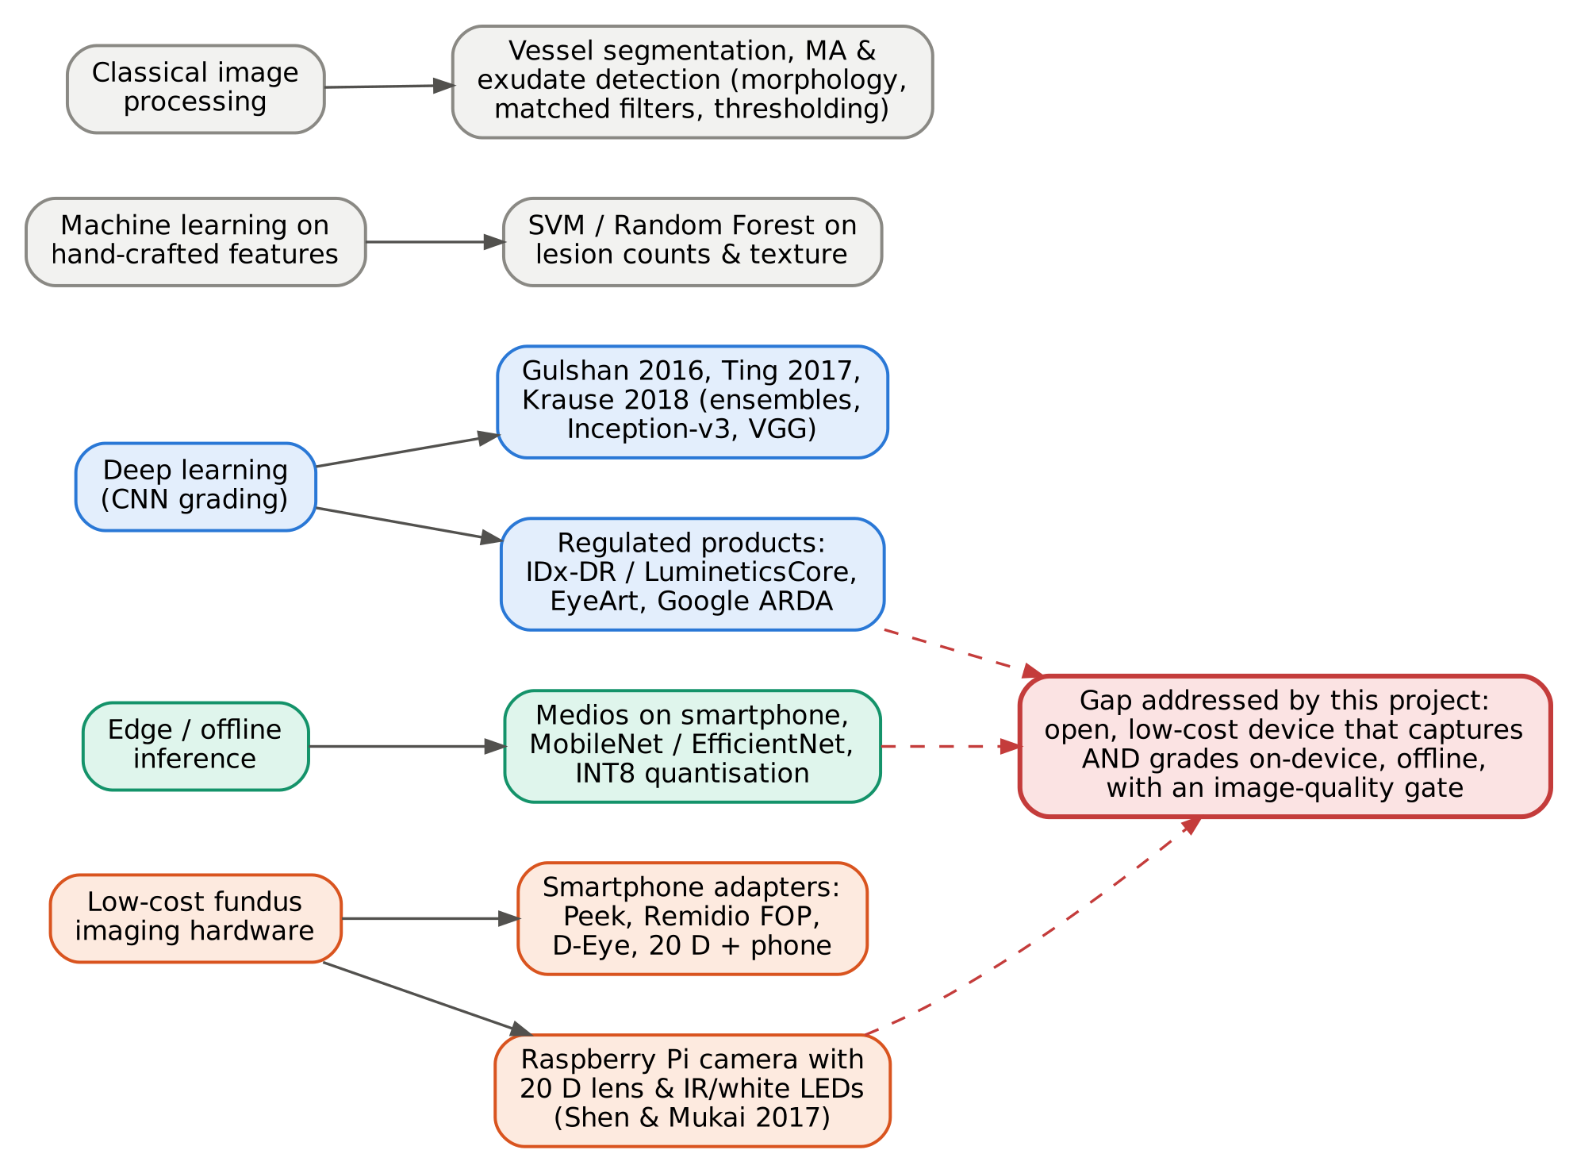
Figure 2.1: Map of the literature reviewed and the gap addressed by this project.

2.1 Review of Existing Work

2.1.1 Clinical grading standards
Every automated system is trained and judged against a human grading scale. The research gold standard is the Early Treatment Diabetic Retinopathy Study (ETDRS) scale, graded on seven-field stereoscopic photographs [18]; it is precise but too elaborate for screening. The International Clinical DR (ICDR) scale condensed it into five levels — no DR, mild, moderate and severe non-proliferative DR, and proliferative DR — that can be applied to a single 45° photograph [7]. Severe NPDR is defined by the “4-2-1 rule”: extensive haemorrhages in all four quadrants, venous beading in two or more quadrants, or intraretinal microvascular abnormalities (IRMA) in at least one. The ICDR scale is used by all the public datasets in this review and is adopted as the output definition of this project.
Even expert graders disagree. Krause et al. showed that individual ophthalmologists’ grades disagree substantially with an adjudicated panel consensus, and that models trained and tested on adjudicated labels performed noticeably better [15]. This sets a practical ceiling on any model trained on single-grader labels, and is one reason this project reports a referable vs. non-referable decision alongside the five-level grade.

2.1.2 Classical image processing
Before deep learning, automated DR detection was built from hand-designed lesion detectors. Walter et al. detected hard exudates by combining morphological reconstruction with colour thresholding [19]; Niemeijer et al. detected red lesions (microaneurysms and haemorrhages) with a pixel classifier after suppressing the vasculature [20]; and Staal et al. segmented vessels using ridge detection and released the DRIVE dataset [21]. These methods are transparent and computationally cheap, but each lesion type needs its own carefully tuned pipeline, and performance falls sharply when illumination, focus or camera change — exactly the conditions of a low-cost portable device.

2.1.3 Machine learning on hand-crafted features
A second generation fed lesion counts, texture descriptors and vessel features into support-vector machines or random forests. This removed some manual threshold tuning but kept the dependency on the quality of the feature extractors. Its legacy for this project is pre-processing: Ben Graham’s winning solution to the 2015 Kaggle DR competition showed that subtracting a heavily blurred copy of the image — a simple local-contrast normalisation — removes much of the illumination variation between cameras [22]. The same operation is used in this project (Section 3.5.5).

2.1.4 Deep-learning grading
Gulshan et al. trained an ensemble of Inception-v3 networks on 128,175 graded images and reported an area under the ROC curve (AUC) of 0.991 for referable DR on the EyePACS-1 validation set and 0.990 on Messidor-2; at a high-sensitivity operating point, sensitivity was 97.5 % with specificity 93.4 % [9]. Ting et al. validated a VGG-based system on 494,661 images from multi-ethnic Asian populations, with AUC 0.936, sensitivity 90.5 % and specificity 91.6 % for referable DR [10]. The same group of algorithms was later tested prospectively in India, where it achieved sensitivity of 88.9 % and 92.1 % at two hospitals, with specificity of 92.2 % and 95.2 % [23], and in Thailand’s national screening programme [24]. Dai et al. extended deep-learning grading across the full disease spectrum with lesion-aware sub-networks [25].
Two systems have gone through regulatory pivotal trials. IDx-DR, an autonomous AI system, achieved 87.2 % sensitivity and 90.7 % specificity for more-than-mild DR in 900 primary-care patients and became the first autonomous AI diagnostic authorised by the U.S. FDA [11], [12]. EyeArt was evaluated in a similar pivotal study across primary-care and ophthalmology sites [26]. These results establish that a CNN can perform referral-level grading; they were, however, obtained with table-top cameras, trained graders operating them, and cloud or workstation inference.
Field deployment exposed what accuracy figures hide. In an observational study of a deep-learning system in Thai clinics, Beede et al. found that a substantial share of images were rejected as ungradable because of poor lighting and small pupils, and that slow, unreliable internet uploads disrupted the clinic workflow [8]. Image quality and connectivity, not model accuracy, were the limiting factors — a finding that directly motivates this project’s on-device quality gate and offline design.

2.1.5 Edge and offline inference
To remove the dependence on connectivity, Medios AI was built to run offline on the smartphone that controls the Remidio Fundus-on-Phone camera. In a community screening study in Mumbai it achieved 100 % sensitivity and 88.4 % specificity for referable DR [16]. Rajalakshmi et al. applied the EyeArt algorithm to smartphone-captured fundus images in Chennai and reported 95.8 % sensitivity and 80.2 % specificity for any DR [17]. These studies show that accuracy survives the move to low-cost capture when the optics are engineered for it.
On the model side, efficient architectures make edge inference practical. MobileNetV2 introduced the inverted residual block with depthwise convolutions [27]; MobileNetV3 refined it with neural architecture search and squeeze-and-excitation [28], [29]; and EfficientNet scaled depth, width and resolution together, giving higher accuracy per operation than ResNet-type networks [30], [31]. Integer quantisation further reduces model size and, on processors with integer dot-product instructions, latency [32].

2.1.6 Low-cost fundus imaging hardware
Haddock et al. showed that a smartphone and a hand-held 20 D condensing lens — the indirect-ophthalmoscopy technique used by every ophthalmologist — can produce high-quality fundus photographs [14]. The Peek adapter was clinically validated for optic-disc imaging in Kenya [33]. Most relevant to this project, Shen and Mukai built a portable, non-mydriatic fundus camera from a Raspberry Pi 2, an infrared-sensitive NoIR camera, a 20 D lens and coaxial 850 nm infrared and white LEDs for about US $185 [13]. Infrared light, invisible to the patient, allows alignment without constricting the pupil; a brief white flash then captures a colour image before the pupil reacts. Their measured light output (150–170 µW white) was an order of magnitude below a conventional indirect ophthalmoscope. Their device did not, however, grade the images — an expert still had to read them.

2.1.7 Public datasets
Figure 2.2 compares the datasets considered. EyePACS is the largest but is graded by a single reader per image and comes from U.S. clinics [34]. APTOS 2019 was collected by Aravind Eye Hospital technicians in rural India and is therefore closest to the target population [35]. IDRiD, also Indian, adds pixel-level lesion masks [36]; Messidor-2 is a clean European reference set widely used for external validation [37]; and DDR adds 13,673 images from 147 Chinese hospitals [38].
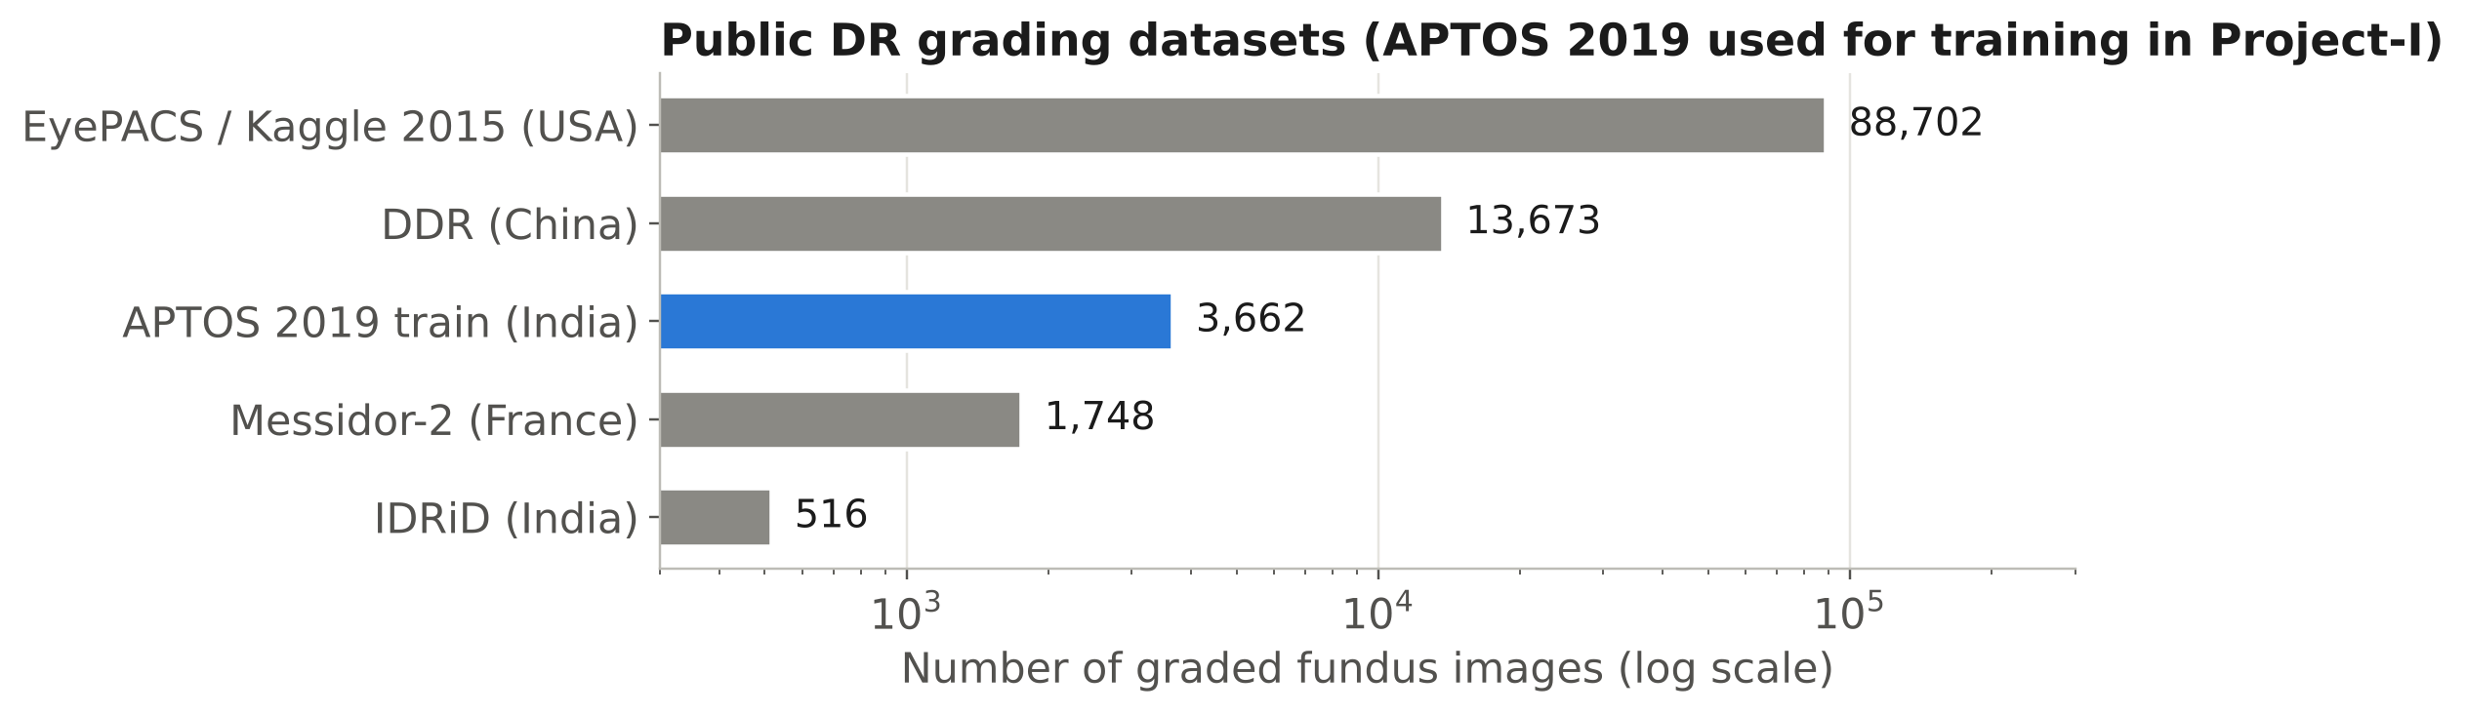
Figure 2.2: Size of the public DR grading datasets considered (log scale). APTOS 2019 was selected for Project-I; Messidor-2 and IDRiD are reserved for external testing.
Table 2.1: Summary of the literature reviewed
Ref. | Approach / technology | Key result | Limitation relevant to this project
[19] | Morphology + colour thresholds for exudates | Interpretable exudate maps | Hand-tuned; brittle to illumination and camera change
[20] | Pixel classification of red lesions | Detects MAs and haemorrhages | Separate pipeline per lesion; needs high-quality images
[21] | Ridge-based vessel segmentation (DRIVE) | Benchmark vessel maps | Segmentation only; no grading
[22] | Local-contrast normalisation + CNN (Kaggle 2015) | Winning QWK ≈ 0.85 | Competition model; heavy ensembling
[9] | Inception-v3 ensemble, 128 k images | AUC 0.991 (EyePACS-1), 0.990 (Messidor-2) | Cloud inference; table-top cameras
[10] | VGG-based DLS, 494 k images, multi-ethnic | Referable DR AUC 0.936; sens 90.5 %, spec 91.6 % | Large model; specialised capture
[15] | Adjudicated reference standard | Adjudication improves model and evaluation | Highlights label noise in single-grader datasets
[11] | IDx-DR autonomous AI, pivotal trial (900 pts) | Sens 87.2 %, spec 90.7 % | Tied to a specific commercial camera
[23] | Prospective validation in India | Sens 88.9–92.1 %, spec 92.2–95.2 % | Server inference; hospital setting
[26] | EyeArt pivotal study | Regulatory-grade referable-DR detection | Commercial, cloud-based
[25] | DeepDR, lesion-aware sub-networks | Grading across full DR spectrum | Large multi-network system
[24] | National programme deployment (Thailand) | Real-time screening at scale | Requires connectivity and infrastructure
[8] | Human-centred field evaluation | Ungradable images and connectivity disrupted workflow | Motivates quality gate and offline design
[16] | Offline AI on smartphone (Medios + Remidio) | Referable DR sens 100 %, spec 88.4 % | Proprietary device and model
[17] | EyeArt on smartphone fundus images | Any-DR sens 95.8 %, spec 80.2 % | Cloud grading; proprietary
[14] | Smartphone + 20 D lens technique | High-quality fundus photos at low cost | Manual alignment; no automated grading
[33] | Peek smartphone adapter, Kenya | Clinically validated optic-disc imaging | Not designed for DR grading
[13] | Raspberry Pi + NoIR camera + 20 D lens + IR/white LED | ≈ US $185; non-mydriatic images | No AI; proof of concept
[30] | EfficientNet compound scaling | Best accuracy per FLOP (ImageNet) | Generic; needs task-specific fine-tuning
[32] | Integer-only quantisation | ≈ 4× smaller models, faster integer inference | Small accuracy loss; hardware-dependent speed-up

2.2 Existing Products, Patents and Standards
Table 2.2 compares commercial and research systems closest to the proposed device. Published prices are not available for most medical devices (they are sold on quotation), so availability and deployment model are compared instead.
Table 2.2: Comparison with existing products and research prototypes
Product / system | Key features | Availability | Limitation for target use
IDx-DR / LumineticsCore (Digital Diagnostics, USA) | Autonomous AI; FDA De Novo 2018 [12] | Commercial (USA, EU) | Specific table-top camera; cloud processing; high cost
EyeArt (Eyenuk, USA) | Autonomous referable / vision-threatening DR detection [26] | Commercial | Cloud-based; licence fee per screening
Google ARDA | Deep-learning grading deployed in India and Thailand [23], [24] | Through partner hospitals | Needs connectivity and partner infrastructure
Remidio Fundus-on-Phone + Medios AI (India) | Smartphone-based camera with offline AI [16] | Commercial (India) | Proprietary; closed model; device cost
Portable/hand-held fundus cameras (e.g. Forus 3nethra, India) | Portable imaging for primary care | Commercial (India) | Grading by expert or separate software
Peek Retina adapter | Smartphone clip-on adapter [33] | Low cost | Manual interpretation
Raspberry Pi fundus camera (research) | ≈ US $185 open design [13] | Published design | No automated grading
This project | Open design; on-device EfficientNet grading; quality & fundus gates; offline | Prototype | Clinical validation pending (Project-II)

Patents. A structured patent search (Indian Patent Office, Google Patents) on combinations of “fundus camera”, “condensing lens”, “Raspberry Pi” and “diabetic retinopathy” is scheduled for the start of Project-II, before any disclosure that could affect patentability; Project-I relies on published literature only.
Standards. The standards that govern this class of device — light-hazard protection for ophthalmic instruments (ISO 15004-2), photobiological safety of LEDs (IEC 62471), fundus-camera performance (ISO 10940), medical-device software life cycle (IEC 62304), risk management (ISO 14971) and the Indian Medical Devices Rules 2017 — are discussed with their application in Section 3.6.

2.3 Research Gap and Novelty of the Proposed Work
Tables 2.1 and 2.2 show three groups of work that have not been brought together in an open design:
- Low-cost Raspberry Pi and smartphone fundus cameras demonstrate that images can be captured cheaply, but leave grading to an expert [13], [14].
- Deep-learning graders reach referral-level accuracy, but mostly run in the cloud and are tied to commercial cameras [9], [11].
- The one offline system validated in India is proprietary [16], and field studies show that image quality and connectivity, not model accuracy, limit real-world screening [8].
The novelty of this project is an open, reproducible, sub-₹25,000 unit that (i) captures fundus images with a 20 D indirect-ophthalmoscopy optical head and IR-assisted alignment, (ii) runs a compact EfficientNet-B0 grader entirely on a Raspberry Pi 5 without network access, and (iii) places an automatic quality and fundus-image gate in front of the model so that the device asks for a retake instead of returning a confident grade on an unusable image. In addition, the project measures and reports the effect of INT8 quantisation on both model size and latency, and makes the complete training-to-deployment pipeline runnable in one click on free cloud hardware, which lowers the barrier for other institutions to reproduce and extend it.

Chapter 3: Requirements, Design and Methodology

3.1 Requirements and Specifications
The objectives of Section 1.3 were translated into the numbered, testable requirements of Table 3.1. The same identifiers are used in the test plan (Table 4.6) and in the results (Table 5.5).
Table 3.1: Requirements and specifications
ID | Requirement | Type | Target value | Verification method
R1 | Grade DR on the five-level ICDR scale | Functional | Grades 0–4 + referable flag | Inspection of output (test)
R2 | Agreement with reference grades | Performance | QWK ≥ 0.85 on held-out test set | Test (550 images)
R3 | Detect referable DR (grade ≥ 2) | Performance | Sensitivity ≥ 85 %, specificity ≥ 80 % | Test (550 images)
R4 | Run fully offline on the device | Functional | No network calls during inference | Inspection + test with Wi-Fi off
R5 | Inference time on Raspberry Pi 5 | Performance | ≤ 1 s model; ≤ 2 s button-to-result | Test (timing, 100 runs)
R6 | Model storage footprint | Performance | ≤ 20 MB | Inspection
R7 | Exported model equals trained model | Performance | max abs. difference < 10⁻³; ΔQWK ≤ 0.01 | Test (parity check)
R8 | Reject ungradable / non-fundus images | Safety | Blurred, dark, over-exposed and non-retinal images flagged | Test (gate test set)
R9 | Retinal light exposure | Safety / regulatory | Within ISO 15004-2 Group 1 limits; IR for alignment; flash ≤ 200 ms | Analysis (P-I), measurement (P-II)
R10 | Electrical safety | Safety | SELV ≤ 5.1 V DC; no mains in the hand-held unit | Inspection
R11 | Camera sampling of the fundus | Performance | ≥ 1,000 px across the fundus image | Analysis (3.5.2)
R12 | Portable operation | Functional | ≥ 3 h on a 10,000 mAh PD bank; mass ≤ 800 g | Analysis (P-I), test (P-II)
R13 | Prototype cost | Economic | ≤ ₹25,000 | Analysis (BOM)
R14 | Patient privacy | Ethical / legal | No names stored; anonymised IDs; local storage only | Inspection
R15 | Explainability | Functional | Grad-CAM heat-map available for review | Test

3.2 Complex Engineering Problem Characteristics
Table 3.2: Complex engineering problem attributes addressed
Attribute | Description | How it applies to this project
WP1 Depth of knowledge | Cannot be resolved without in-depth engineering knowledge | Requires geometric optics (indirect ophthalmoscopy, magnification, sampling), analogue design (LED drivers, MOSFET switching), embedded Linux, digital image processing, deep learning and quantisation, and clinical grading standards.
WP2 Conflicting requirements | Wide-ranging or conflicting technical and non-technical issues | Accuracy vs. latency vs. cost; brighter flash (better images) vs. retinal safety; higher input resolution (small lesions) vs. compute; sensitivity vs. specificity of referral.
WP3 Depth of analysis | No obvious solution; requires originality to formulate models | Choice of regression-with-thresholds formulation; design of a fundus/quality gate without labelled ungradable data; sampling analysis linking optics to lesion size.
WP4 Familiarity of issues | Infrequently encountered issues | Domain shift from clinical cameras to a home-built optical head; pupil constriction; INT8 behaving differently on x86 and ARM.
WP5 Extent of applicable codes | Outside problems encompassed by standards | No standard covers an AI grader on a student-built fundus camera; ISO 15004-2, ISO 10940, IEC 62304 and ISO 14971 are applied by analogy.
WP6 Stakeholder involvement | Diverse stakeholders with widely varying needs | Patients (safety, privacy), health workers (simplicity), ophthalmologists (reliable referrals), regulators (CDSCO) and funders (cost).
WP7 Interdependence | High-level problems with many components | Optics, illumination, camera, embedded software, pre-processing, model and UI must all work together; a failure in any one (e.g. focus) defeats the rest.

3.3 Realistic Design Constraints
Table 3.3: Realistic design constraints
Constraint category | Constraint (quantified where possible) | Effect on the design / design response
Economic | Prototype cost ≤ ₹25,000; no recurring cloud or licence fees | Commodity Raspberry Pi 5, Camera Module 3 and generic 20 D lens; open-source software; offline inference removes per-screening fees.
Health & safety | Retinal light exposure within ISO 15004-2; patient’s pupil not dilated | 850 nm IR (invisible) for alignment so the pupil stays large; white flash ≤ 200 ms; current-limited LEDs; intensity fixed by resistor + PWM.
Regulatory | CDSCO Medical Devices Rules 2017: AI screening software is a regulated medical device | Device labelled “research prototype – not for diagnosis”; IEC 62304-style documentation and ISO 14971-style risk register kept from the start.
Ethical / privacy | DPDP Act 2023; informed consent for any human images | No names on device; anonymised IDs; data never leaves device; consent form and ethics approval before Project-II data collection.
Operational | No reliable internet or mains at screening camps | All inference on-device; USB-C PD power bank; ≥ 3 h runtime target.
Data | Only 3,662 labelled images in APTOS 2019; heavy class imbalance (49 % grade 0) | Transfer learning from ImageNet; strong augmentation; regression loss; threshold tuning; stratified splits.
Compute | Training needs a GPU the team does not own; free Colab GPUs are not always available | Self-contained Colab notebook with automatic CPU fall-back and caching; small backbone.

3.4 Design Alternatives and Trade-off Analysis
Three design decisions had the largest effect on the system. For each, alternatives were scored from 1 (poor) to 5 (excellent) against weighted criteria. Latency, size and compute figures for the backbones were measured (Section 5.1.1); accuracy potential is judged from the literature [28], [30], [31].
Table 3.4: Decision matrix for the selection of the CNN backbone
Criterion | Weight | MobileNetV3-L | EfficientNet-B0 | EfficientNet-B2 | ResNet-50
Expected grading accuracy | 0.30 | 3 | 4 | 5 | 4
CPU latency at 384 px (measured) | 0.25 | 5 | 4 | 3 | 1
Model size (measured) | 0.15 | 4 | 4 | 3 | 1
Export / tooling maturity | 0.15 | 4 | 5 | 5 | 5
Memory at 384 px | 0.15 | 5 | 4 | 3 | 2
Weighted total | 1.00 | 4.10 | 4.15 | 3.90 | 2.65

Table 3.5: Decision matrix for the selection of the processing platform
Criterion | Weight | Raspberry Pi 5 | Raspberry Pi 4 | Jetson Orin Nano | ESP32-S3 | Android phone
CNN compute capability | 0.30 | 4 | 2 | 5 | 1 | 4
Cost | 0.25 | 4 | 4 | 1 | 5 | 3
Power consumption | 0.15 | 3 | 4 | 2 | 5 | 4
Camera & display integration | 0.15 | 5 | 5 | 4 | 2 | 3
Software ecosystem | 0.15 | 5 | 5 | 4 | 3 | 3
Weighted total | 1.00 | 4.15 | 3.70 | 3.25 | 3.05 | 3.45

Table 3.6: Decision matrix for the model output formulation
Criterion | Weight | 5-class softmax | Regression + thresholds | Binary referable only
Uses ordering of grades | 0.35 | 2 | 5 | 1
Directly optimises QWK | 0.25 | 2 | 5 | 1
Provides referral decision | 0.20 | 4 | 5 | 5
Implementation simplicity | 0.20 | 5 | 4 | 5
Weighted total | 1.00 | 3.00 | 4.80 | 2.60

Selected options. EfficientNet-B0 was chosen as the backbone, the Raspberry Pi 5 as the processing platform and a single-output regression head with tuned thresholds as the output formulation. The backbone decision was close: MobileNetV3-Large was 2.3× faster on the development PC but has lower expected accuracy on fine-grained medical images, and the 36 ms latency of EfficientNet-B0 already leaves a large margin against the 1 s requirement (R5).
Trade-off 1 — input resolution vs. compute. Microaneurysms, the earliest sign of DR, are 25–100 µm across. At 224 px the fundus is sampled at about 58 µm per pixel and the smallest lesions fall below one pixel; at 384 px the sampling is about 34 µm per pixel (Section 3.5.2) at the cost of 2.9× more computation. 384 px was chosen; the notebook falls back to 224 px only when no GPU is available.
Trade-off 2 — INT8 vs. FP32. INT8 quantisation reduces the model from 16.0 MB to 4.8 MB (−70 %), but it can cost accuracy and, on processors without fast integer dot-product paths, even speed. The export pipeline therefore produces both versions and selects INT8 only if its test QWK is within 0.01 of FP32. In the training run INT8 lowered test QWK from 0.877 to 0.570 and was 1.7× slower on the x86 development PC, so the rule selected the FP32 model (Section 5.1.2).
Trade-off 3 — sensitivity vs. specificity. A missed referable case can cost a patient’s sight; a false referral costs an unnecessary clinic visit. Thresholds are first tuned for QWK, and the referral threshold can then be shifted downward to raise sensitivity at the expense of specificity, as is standard practice in screening [9].
Trade-off 4 — illumination. A brighter, longer flash improves the signal-to-noise ratio of the image but increases retinal exposure and pupil constriction during the exposure. Infrared alignment plus a short (≤ 200 ms) white flash follows the approach validated by Shen and Mukai [13].

3.5 System Architecture and Detailed Design

3.5.1 Block diagram
Figure 3.1 shows the system. The optical head forms an aerial image of the retina, which the camera captures over the CSI-2 interface. The Raspberry Pi 5 controls the LEDs, gates the image for quality, pre-processes it and runs the CNN; the result is shown on the touch display and stored locally.
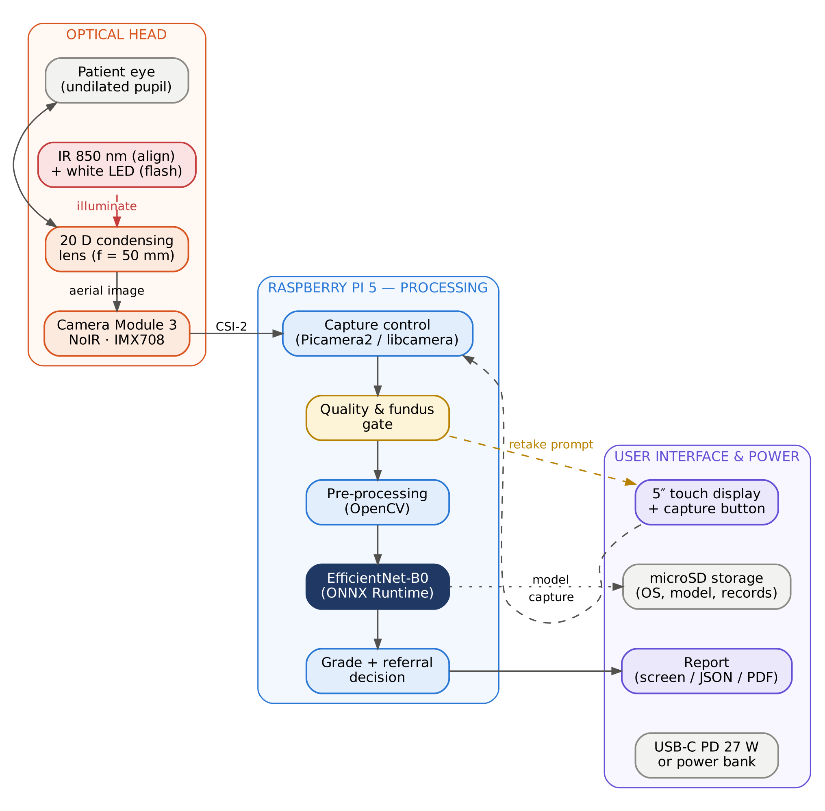
Figure 3.1: Block diagram of the proposed AI-based fundus camera and analysing unit.
Hardware–software partitioning follows the latency requirement: everything time-critical (LED switching, capture triggering) is handled by the Pi’s hardware PWM and camera pipeline, while all image analysis runs in user-space Python on the CPU. No microcontroller is needed because the Pi 5’s RP1 I/O controller provides hardware PWM and debounced GPIO input directly.

3.5.2 Optical design and sampling calculation
The optical head implements indirect ophthalmoscopy (Figure 3.2). A +20 D condensing lens, held about one focal length from the patient’s eye, collects light leaving the pupil and forms a real, inverted aerial image of the retina near its back focal plane. The camera is focused on this aerial image.
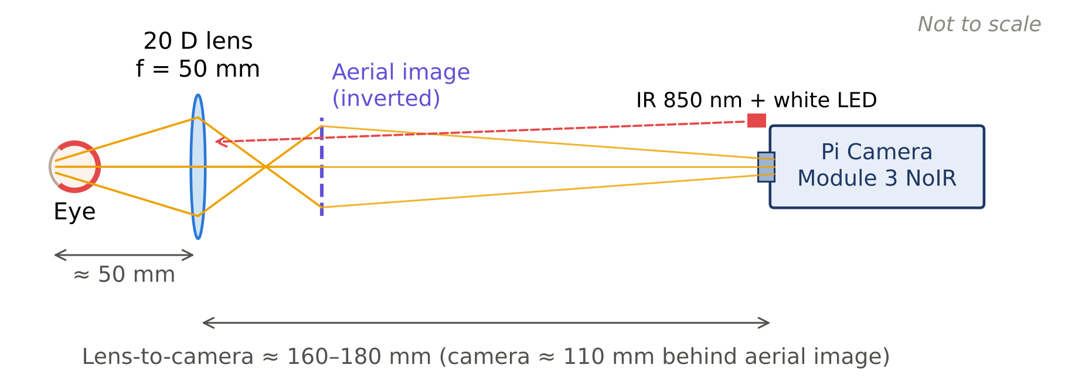
Figure 3.2: Optical layout of the fundus head (indirect ophthalmoscopy with a 20 D lens). Rays are schematic.
Focal length of the condensing lens:
f = 1 / P = 1 / (20 m⁻¹) = 0.05 m = 50 mm (3.1)
Magnification of the aerial image. For an emmetropic eye of total power about 60 D, the lateral magnification of indirect ophthalmoscopy is approximately the ratio of the eye’s power to the lens power:
m ≈ P_{eye} / P_{lens} = 60 D / 20 D = 3× (3.2)
Size of the aerial image. One degree of visual angle corresponds to about 0.29 mm on the retina. A 20 D lens gives a field of roughly 45° through a well-dilated pupil (less through an undilated pupil), i.e. a retinal patch of about 45 × 0.29 ≈ 13 mm, so the aerial image is about 3 × 13 ≈ 39 mm across.
Camera distance for adequate sampling (R11). The Camera Module 3 has a 4,608 × 2,592-pixel IMX708 sensor and a 66° horizontal field of view [39]. For the aerial image (width D = 39 mm) to span N = 1,400 pixels, it must subtend θ = 66° × 1,400 / 4,608 ≈ 20°, which fixes the camera distance d from the aerial image:
d = (D / 2) / tan(θ / 2) = 19.5 mm / tan 10° ≈ 111 mm (3.3)
The lens-to-camera distance is therefore about 50 + 111 ≈ 160 mm, and the eye-to-camera path about 210–230 mm, which sets the length of the enclosure tube (Figure 4.2). This distance is above the camera’s 100 mm minimum autofocus distance.
Retinal sampling. At 1,400 px across 13 mm of retina the sensor samples about 9.3 µm per pixel, comfortably finer than the smallest microaneurysms (≈ 25 µm). After resizing to the 384 px model input the sampling becomes 13,000 µm / 384 ≈ 34 µm per pixel, so a 50 µm microaneurysm still covers 1–2 pixels. At 224 px it would be 58 µm per pixel, which is why 384 px was chosen (Trade-off 1).
Illumination. Following Shen and Mukai [13], an 850 nm infrared LED array provides a live preview for alignment: the NoIR camera is sensitive to it but the patient sees nothing, so the pupil remains dilated in a dim room. A pair of warm-white LEDs is then flashed for ≤ 200 ms during capture, before the pupillary light reflex (latency ≈ 200–250 ms) constricts the pupil. Corneal reflections are reduced by tilting the lens a few degrees and by placing the LEDs slightly off-axis.

3.5.3 Electronic design and calculations
Figure 3.3 shows the interfacing. Both LED strings run from the 5 V rail and are switched on the low side by AO3400 N-channel MOSFETs driven from the Pi’s hardware-PWM pins, so that the GPIO pins (3.3 V logic) supply only gate charge.
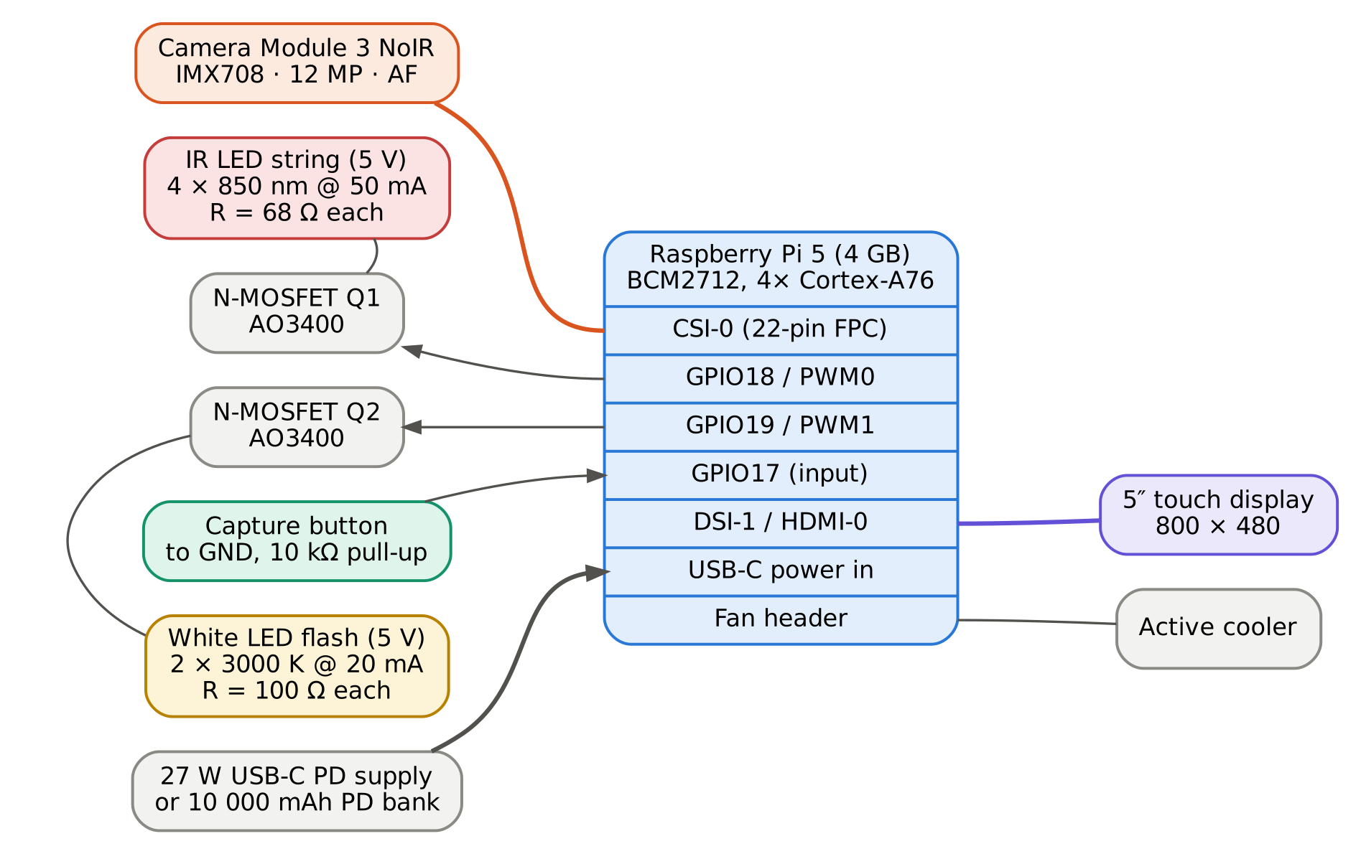
Figure 3.3: Interfacing of the camera, LED drivers, capture button, display and power supply with the Raspberry Pi 5.
IR LED current-limiting resistor (V_{f} ≈ 1.5 V at I_{f} = 50 mA, typical 850 nm LED):
R = (V_{CC} − V_{f}) / I_{f} = (5.0 − 1.5) V / 0.050 A = 70 Ω → 68 Ω (E12) (3.4)
With 68 Ω the current is 3.5 / 68 = 51.5 mA and the resistor dissipates P = I²R = 0.0515² × 68 ≈ 0.18 W, so a 0.25 W resistor has a 28 % margin. Four branches draw 206 mA in total.
White LED resistor (V_{f} ≈ 3.0 V at 20 mA): R = (5.0 − 3.0) / 0.020 = 100 Ω, dissipating 0.04 W.
MOSFET check. The AO3400 has V_{GS(th)} of 0.65–1.45 V and R_{DS(on)} of about 50 mΩ at V_{GS} = 2.5 V, so 3.3 V drive fully enhances it. Conduction loss with all IR LEDs on is 0.206² × 0.05 ≈ 2 mW — negligible. A 220 Ω gate resistor limits the gate-charging current to 15 mA (within the GPIO rating) and a 100 kΩ pull-down keeps the LEDs off while the Pi boots.
PWM frequency. The camera uses a rolling shutter; PWM dimming at low frequency would produce dark bands across the image. The IR preview is therefore dimmed at 20 kHz, well above the line rate’s beat frequencies, and the white flash is driven at 100 % duty cycle for its 200 ms duration.
Table 3.7: Power budget of the hand-held unit (design estimates; to be measured in Project-II)
Load | Voltage (V) | Current (mA) | Power (W)
Raspberry Pi 5 during inference (estimate) | 5.1 | 1,200 | 6.1
5″ display incl. backlight | 5.0 | 300 | 1.5
Camera Module 3 (streaming) | 3.3 (from Pi) | 180 | 0.6
IR LEDs (4 × 51.5 mA, during alignment) | 5.0 | 206 | 1.0
White LEDs (flash, 200 ms) | 5.0 | 40 | 0.2
Active cooler | 5.0 | 80 | 0.4
Peak total |  |  | ≈ 9.8

With a 10,000 mAh power bank (37 Wh at 3.7 V, about 31 Wh usable after conversion losses) and an average draw of about 7 W, the estimated runtime is 31 / 7 ≈ 4.4 h. At roughly three minutes per patient this corresponds to about 0.35 Wh and some 85 screenings per charge, meeting R12. The 27 W USB-C supply covers the 9.8 W peak with a large margin.

3.5.4 Software architecture and data flow
The software is organised in four layers (Figure 3.4): the platform layer (Raspberry Pi OS, libcamera, Python), an inference and vision layer, an application layer and a presentation layer. The inference layer is a single Python module, pi_inference.py, which contains exactly the same pre-processing functions that were used during training — copied verbatim by the notebook — so that training and deployment cannot drift apart. Figure 3.5 is the level-1 data-flow diagram.
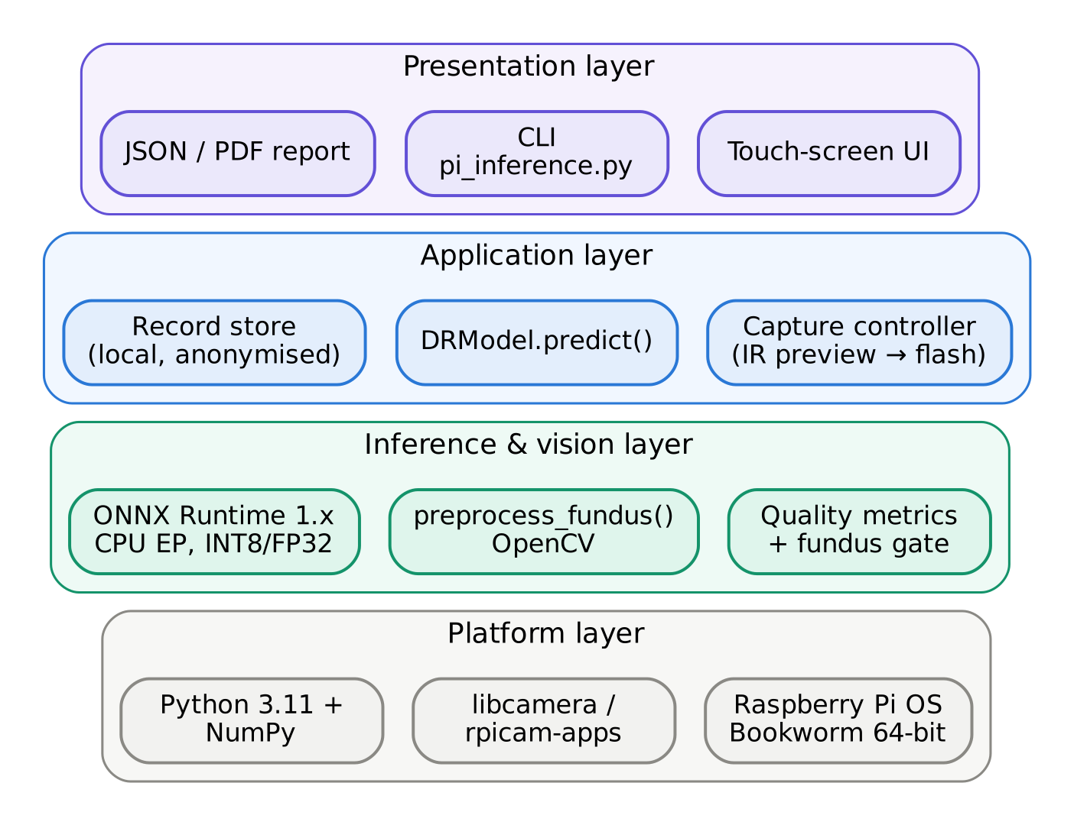
Figure 3.4: Layered software architecture of the analysing unit.
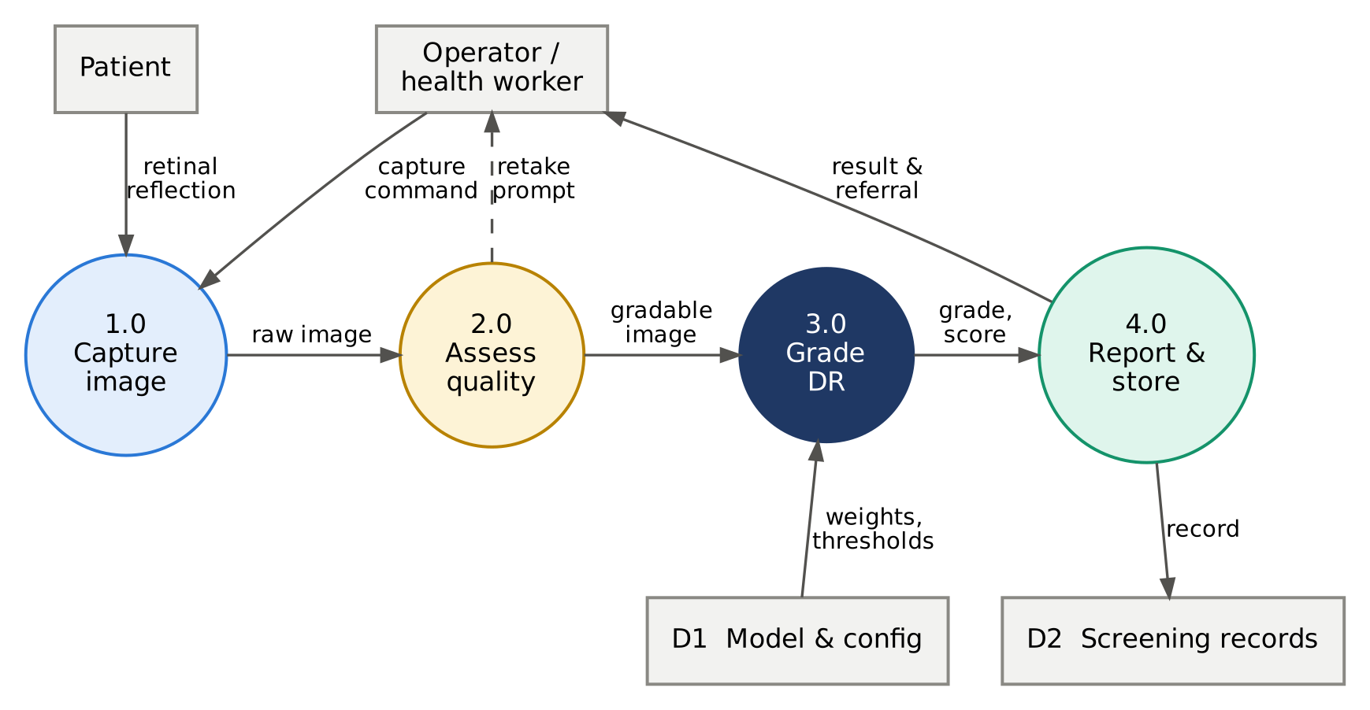
Figure 3.5: Level-1 data-flow diagram: capture, quality assessment, grading and reporting.

3.5.5 Image pre-processing and quality algorithms
Border cropping. Fundus photographs contain a black surround whose size depends on the camera. Pixels with grey level above a tolerance of 7 are taken as the fundus; the image is cropped to their bounding box and zero-padded to a square so the circular fundus keeps its shape.
Ben Graham local-contrast normalisation [22]. After resizing to S = 384 px, each colour channel I is replaced by:
I′ = 4·I − 4·(G_{σ} ∗ I) + 128, σ = S / 30 ≈ 12.8 px (3.5)
where G_{σ} ∗ I is a Gaussian-blurred copy. Subtracting the blur removes slow illumination gradients (vignetting, uneven flash) while amplifying local detail such as vessels, haemorrhages and exudates; adding 128 centres the result. A circular mask of radius 0.47 S then removes the bright ring that the filter produces at the fundus edge. Figure 4.8 shows each stage.
Image-quality metrics. Two metrics are computed on the green channel (which carries most retinal contrast) inside the fundus circle at 512 px:
B = mean(G), Q_{sharp} = Var(∇²G) (3.6)
where ∇² is the Laplacian operator; blur lowers the variance of the Laplacian. Images are flagged if Q_{sharp} falls below the 1st percentile of the training data, or B falls outside the 0.5th–99.5th percentile range. These data-derived limits are stored in config.json and are re-calibrated on images from the team’s own camera in Project-II.
Fundus-image gate. A retinal image is dominated by red because of the choroidal blood supply, while skin, sclera and room scenes are much more balanced. The gate computes the median red-to-green ratio over all non-black pixels and accepts the image only if
median( R / (G + 1) ) ≥ 1.6 (3.7)
The threshold of 1.6 lies between the ratio measured on the team’s first, mis-aligned capture (1.29) and that of fundus images (≈ 2.5); see Section 5.1.3.

3.5.6 CNN model
EfficientNet-B0 [30] is built from mobile inverted-bottleneck (MBConv) blocks (Figure 3.6) [27]: a 1 × 1 convolution expands the channels six-fold, a depthwise k × k convolution filters each channel spatially, a squeeze-and-excitation unit re-weights channels by global context [29], and a 1 × 1 convolution projects back down, with a skip connection when the shapes match. Table 3.8 lists the stages at the 384 px input used here.
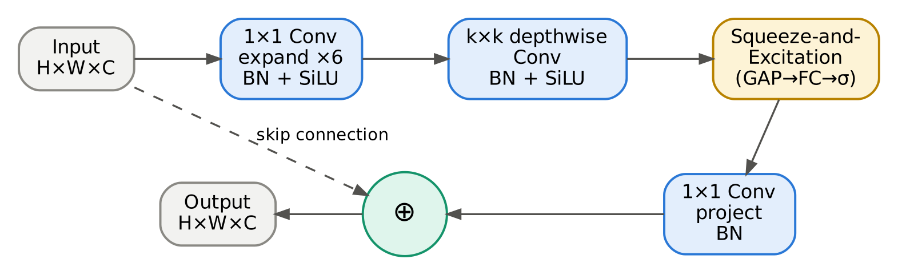
Figure 3.6: Structure of the MBConv block used throughout EfficientNet-B0.
Table 3.8: EfficientNet-B0 stages at 384 × 384 input with a single regression output
Stage | Operator | Kernel | Output resolution | Channels | Layers | Stride
1 | Conv, BN, SiLU (stem) | 3 × 3 | 192 × 192 | 32 | 1 | 2
2 | MBConv1 | 3 × 3 | 192 × 192 | 16 | 1 | 1
3 | MBConv6 | 3 × 3 | 96 × 96 | 24 | 2 | 2
4 | MBConv6 | 5 × 5 | 48 × 48 | 40 | 2 | 2
5 | MBConv6 | 3 × 3 | 24 × 24 | 80 | 3 | 2
6 | MBConv6 | 5 × 5 | 24 × 24 | 112 | 3 | 1
7 | MBConv6 | 5 × 5 | 12 × 12 | 192 | 4 | 2
8 | MBConv6 | 3 × 3 | 12 × 12 | 320 | 1 | 1
9 | Conv 1 × 1, GAP, dropout 0.3, FC | 1 × 1 | 1 × 1 | 1 | 1 | –
 | Total |  |  | 4.01 M parameters | 1.13 GMACs

Regression formulation and loss. Because DR grades are ordered, the network outputs a single continuous score ŷ and is trained against the integer grade y with the Smooth-L1 (Huber) loss, which behaves quadratically for small errors and linearly for large ones, so occasional label noise does not dominate training:
L(ŷ, y) = 0.5 (ŷ − y)² if |ŷ − y| < 1; |ŷ − y| − 0.5 otherwise (3.8)
Mapping scores to grades. The grade is the number of thresholds t₁ < t₂ < t₃ < t₄ that the score exceeds (Figure 3.7):
grade = Σ_{i=1…4} 1[ ŷ > t_{i} ] (3.9)
The thresholds start at 0.5, 1.5, 2.5, 3.5 and are then adjusted one at a time in steps of 0.02 on the validation set to maximise the quadratic weighted kappa (three coordinate-descent passes). They are frozen before the test set is touched.
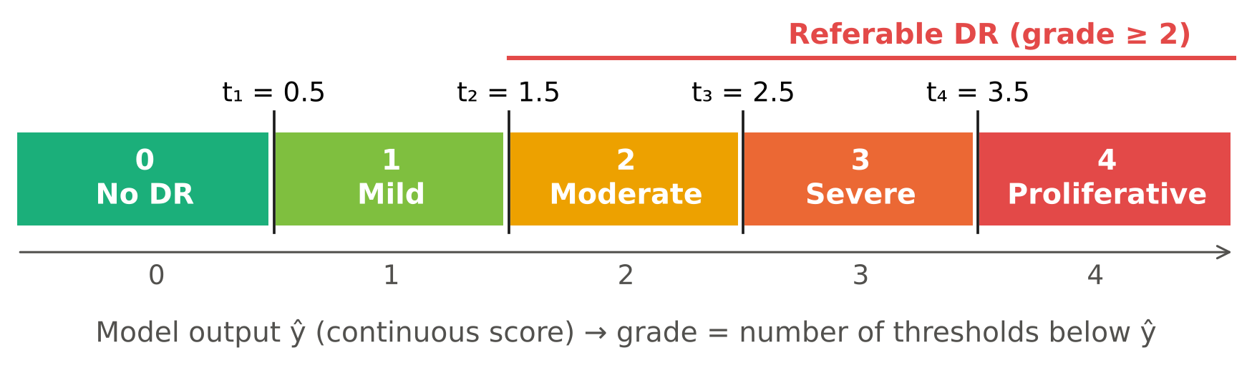
Figure 3.7: Mapping of the continuous model output to ICDR grades; grades 2–4 constitute referable DR.
Evaluation metrics. Agreement on the five-level scale is measured with the quadratic weighted kappa [40], the standard metric of the APTOS and Kaggle DR competitions:
κ_{w} = 1 − ( Σ_{i,j} w_{ij} O_{ij} ) / ( Σ_{i,j} w_{ij} E_{ij} ), w_{ij} = (i − j)² / (K − 1)² (3.10)
where O is the observed confusion matrix, E the matrix expected by chance from the marginal totals, and K = 5. κ_{w} = 1 is perfect agreement and 0 is chance level; large disagreements (e.g. grade 0 vs. 4) are penalised much more than adjacent ones. For the referral decision, with “positive” meaning grade ≥ 2:
Sensitivity = TP / (TP + FN), Specificity = TN / (TN + FP) (3.11)
Explainability. Grad-CAM [41] highlights the image regions that drive the score. With A^{k} the k-th feature map of the last convolutional layer:
α_{k} = (1/Z) Σ_{i,j} ∂ŷ / ∂A^{k}_{ij}, L_{Grad-CAM} = ReLU( Σ_{k} α_{k} A^{k} ) (3.12)
Quantisation. For INT8 deployment, each tensor x is represented by an 8-bit integer q with a scale s and zero-point z, both calibrated on 200 validation images [32]:
q = clamp( round(x / s) + z, 0, 255 ), x̂ = s (q − z) (3.13)
Weights are quantised per output channel, activations per tensor, in ONNX’s quantise–dequantise (QDQ) format.

3.5.7 Device operation
Figure 3.8 is the flowchart of one screening, and Figure 3.9 the corresponding state machine implemented in the application layer. The two gates sit before the model: an image that fails either gate never receives a grade, and the operator is told why (blur, too dark, too bright or “not a retina”) and asked to retake it. After three failed attempts the device recommends direct referral rather than repeated flashes.
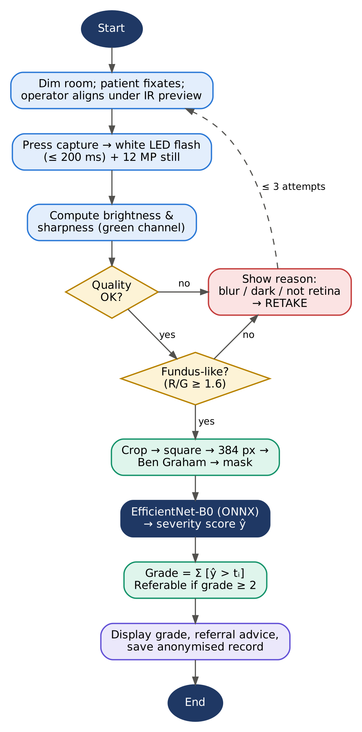
Figure 3.8: Flowchart of a screening session on the device.
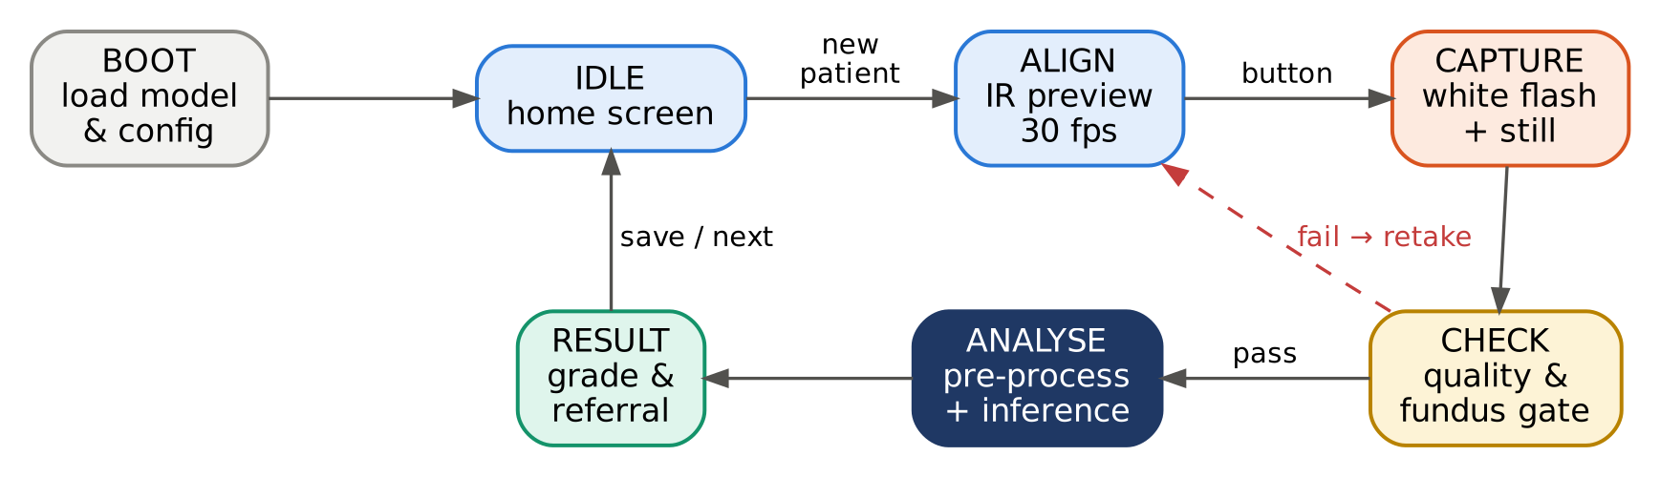
Figure 3.9: State machine of the analysing unit.

3.6 Engineering Standards and Codes Applied
Table 3.9: Standards and codes applied
Standard / code | Title | How it was applied | Verified in
ISO 15004-2:2007 [42] | Ophthalmic instruments — light hazard protection | IR alignment, ≤ 200 ms flash and current-limited LEDs chosen to stay within Group 1; exposure to be measured at the eye plane | 3.5.2, 6.2; measurement in P-II
IEC 62471:2006 [43] | Photobiological safety of lamps and LED systems | LED risk-group classification used in component selection (exempt / RG0 parts preferred) | 6.2
ISO 10940:2009 [44] | Ophthalmic instruments — fundus cameras | Field-of-view and resolving-power requirements used as design targets for the optical head (R11) | 3.5.2
IEC 62304:2006+A1 [45] | Medical device software — life cycle | Version-controlled code, requirements traceability (R-IDs), documented verification tests | 4.3, App. D
ISO 14971:2019 [46] | Application of risk management to medical devices | Hazard identification, L × S risk scoring, mitigation and residual risk | 6.2
IEC 60601-1 [47] | Medical electrical equipment — basic safety | SELV-only (≤ 5.1 V) hand-held design; no mains inside the unit | 4.3
ICDR scale [7] | International clinical DR severity scale | Definition of the five output grades and of referable DR | 3.5.6, 5.1
Medical Devices Rules 2017 [48] | Regulation of medical devices in India | Device restricted to research use; classification and approval path identified | 6.3
DPDP Act 2023 [49] | Digital personal data protection (India) | Consent, purpose limitation, anonymisation and local storage of screening data | 6.3, 6.4

3.7 Modern Tools and Resources
Table 3.10: Hardware, software and test equipment used
Tool / equipment | Version / model | Purpose in this project
Google Colab | Tesla T4 GPU (16 GB) | Model training and evaluation in the cloud
PyTorch [50] | 2.x | Deep-learning framework
timm [51] | 1.0.x | Pre-trained EfficientNet / MobileNet / ResNet backbones
ONNX & ONNX Runtime [52] | opset 17; ORT 1.2x | Model export, INT8 quantisation, CPU inference on the Pi
OpenCV, NumPy, scikit-learn | 4.x, 2.x, 1.x | Pre-processing, quality metrics, metrics and data splits
Hugging Face datasets | 3.x | Automatic download of APTOS 2019
Raspberry Pi 5 [53] | 4 GB, Raspberry Pi OS Bookworm 64-bit | Edge processing unit
Raspberry Pi Camera Module 3 NoIR [39] | IMX708, 12 MP | Fundus image capture (IR-sensitive)
20 D condensing lens | Aspheric, ≈ 50 mm diameter | Indirect-ophthalmoscopy optics
Fusion 360 + FDM 3D printer | PLA | Enclosure and lens-mount design and fabrication
Digital multimeter, USB-C power meter | – | LED current and power-budget verification
Optical power meter (planned) | 400–1,100 nm | Retinal-plane light-exposure measurement (P-II)
Matplotlib, Graphviz | 3.x, 2.x | Figures, flowcharts and diagrams in this report
Git / GitHub | – | Version control and code release

3.8 Methodology and Project Plan
The project follows the six-phase method of Figure 3.10, an iterative variant of the V-model in which each design phase has a matching verification step and failures in verification feed back into design.
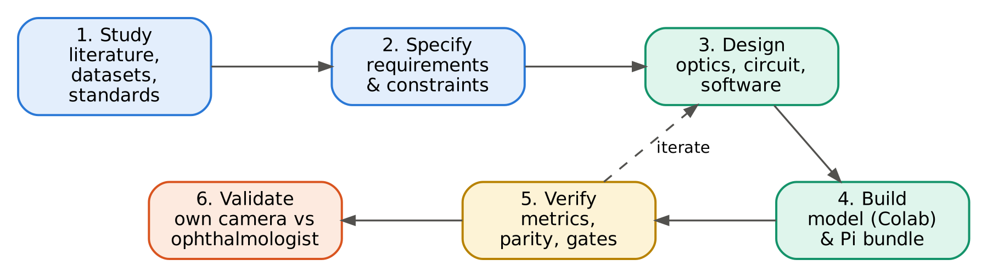
Figure 3.10: Project methodology.
- Study — literature, datasets and applicable standards (Chapter 2).
- Specify — requirements, constraints and acceptance tests (Sections 3.1–3.3).
- Design — trade-off studies, optics, electronics and software (Sections 3.4–3.5).
- Build — the one-click Colab training notebook, the Raspberry Pi inference bundle and the optical head (Chapter 4). The training pipeline is shown in Figure 3.11.
- Verify — metrics against R1–R15, export parity, gate behaviour, timing (Chapters 4–5).
- Validate — on the team’s own captures against ophthalmologist grading, after ethics approval (Project-II).
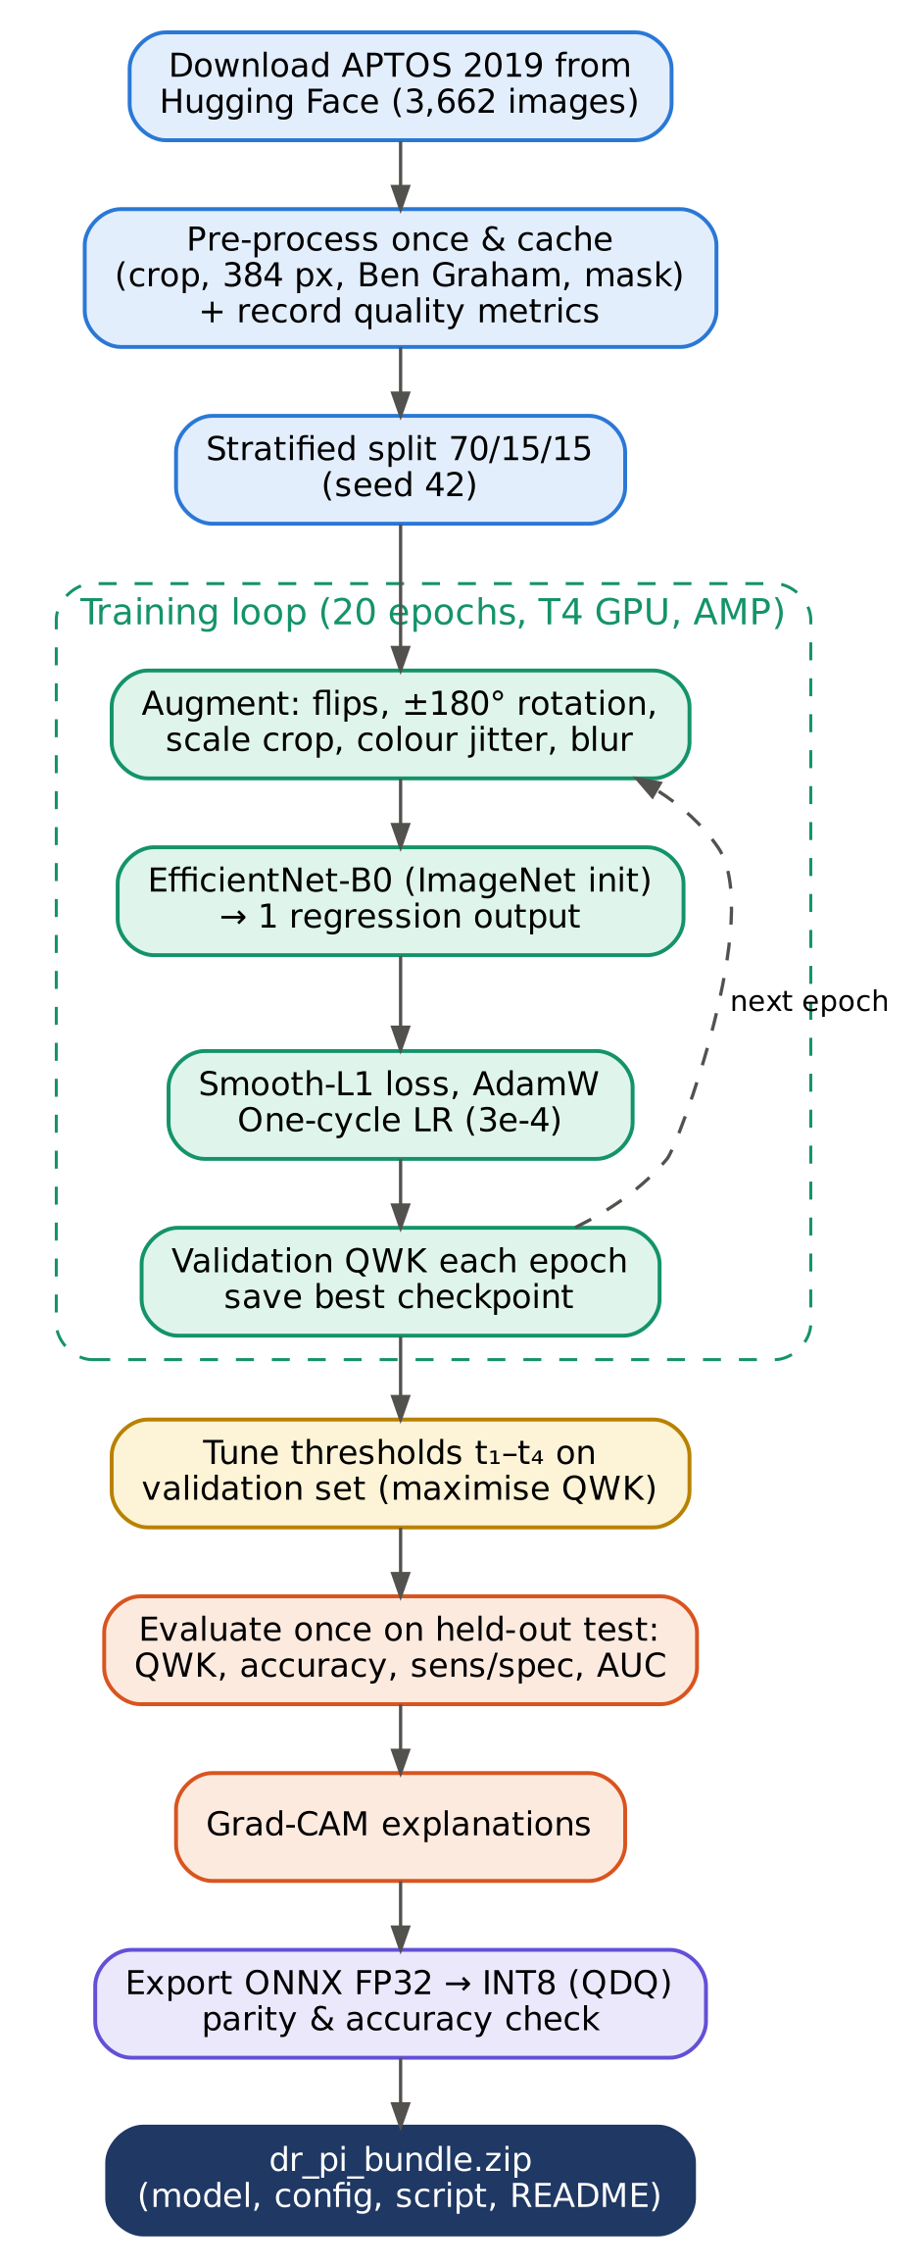
Figure 3.11: Training and export pipeline implemented in the Colab notebook.
The work is scheduled across two semesters: Project-I (July–November 2026) covers phases 1–5 for the software pipeline and phases 1–3 for the optical head; Project-II (January–April 2027) completes hardware fabrication, data collection, domain adaptation and validation. The Gantt chart is given in Appendix B.

Chapter 4: Implementation and Testing

4.1 Hardware and Software Implementation

4.1.1 One-click training notebook
The complete training pipeline is a single Google Colab notebook, DR_Fundus_Training.ipynb, designed so that a user only uploads it and selects Runtime → Run all. It downloads the data, pre-processes and caches it, trains and evaluates the model, produces explanations and exports a ready-to-copy Raspberry Pi bundle. Table 4.1 lists its cells.
Table 4.1: Structure of the training notebook
Cell | Name | Function
1 | Settings | Data mode (full 384 px / quick 224 px), backbone, epochs (20), batch size (32), learning rate (3 × 10⁻⁴), seed (42)
2 | Install & import | Installs timm, ONNX, ONNX Runtime and datasets; detects GPU; if no GPU is available, switches automatically to CPU-friendly settings (224 px, 6 epochs)
3 | Pre-processing | Defines crop_fundus, pad_to_square, preprocess_fundus and quality_metrics as a source string that is executed here and written verbatim into the Pi script
4 | Download & cache | Loads APTOS 2019 from Hugging Face, pre-processes every image in parallel threads, records quality metrics, writes a cached PNG set and meta.csv; derives quality thresholds
5 | Split & loaders | Stratified 70 / 15 / 15 split; training augmentation; PyTorch data loaders
6 | Train | EfficientNet-B0 (ImageNet weights) with a single regression output; AdamW, one-cycle LR, Smooth-L1 loss, mixed precision; best-QWK checkpointing; learning curves
7 | Thresholds & test | Coordinate-descent threshold tuning on validation; single evaluation on the test set: QWK, accuracy, per-class report, referable sensitivity/specificity/AUC, confusion matrix, ROC
8 | Grad-CAM | Heat-maps for referable and non-referable test images
9 | Export | ONNX FP32 export with built-in normalisation; PyTorch–ONNX parity check; INT8 static quantisation; FP32 vs INT8 test QWK; automatic model selection
10 | Pi bundle | Writes config.json, pi_inference.py, requirements_pi.txt and README; zips and downloads dr_pi_bundle.zip (optionally copies to Google Drive)
11 | Upload demo | Optional: upload fundus photos from a laptop and analyse them with the exported model

Three engineering details make the notebook robust for students on free resources. First, pre-processed images are cached, so a disconnected session resumes without re-processing 9 GB of data. Second, the same pre-processing source code is used for training and for the Pi, eliminating a common source of train–deploy mismatch. Third, the notebook does not request a GPU when it opens; when Colab could not assign a GPU backend during development, the notebook was changed to start on any runtime and adapt its settings, which removed a blocking failure.
The optimiser is AdamW (decoupled weight decay 10⁻⁴) [54] with a one-cycle learning-rate schedule peaking at 3 × 10⁻⁴ after 10 % of the steps [55]. Training uses automatic mixed precision on the GPU and saves the checkpoint with the highest validation QWK; the test set is used exactly once, after the thresholds are frozen.

4.1.2 Export for the Raspberry Pi
Figure 4.1 shows the export path. The trained network is wrapped in a module that applies the ImageNet mean/standard-deviation normalisation internally, so that the Pi only has to supply an RGB image scaled to [0, 1]. The wrapped model is exported to ONNX (opset 17) as a single self-contained file, re-loaded and compared with PyTorch on test images, and then statically quantised to INT8 with 200 validation images for calibration. Both models are evaluated on the full test set; the INT8 model is selected only if its QWK is within 0.01 of FP32.
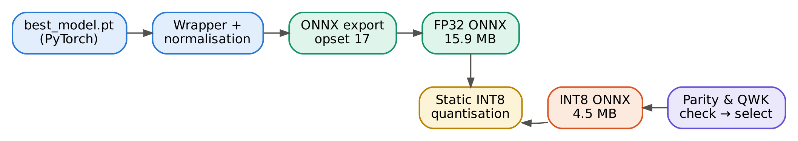
Figure 4.1: Export pipeline from the trained PyTorch checkpoint to the deployed ONNX model.

4.1.3 Raspberry Pi inference package
The bundle produced by the notebook is listed in Table 4.2. pi_inference.py provides a DRModel class and a command-line interface (python3 pi_inference.py eye.jpg, or --camera to capture with rpicam-still first). For each image it returns the grade, grade name, raw score, referral flag, image-quality verdict with reasons, inference time and model file, as human-readable text or JSON.
Table 4.2: Contents of the Raspberry Pi bundle (dr_pi_bundle.zip)
File | Size | Purpose
dr_model_fp32.onnx | 16.0 MB | Full-precision model — selected for deployment
dr_model_int8.onnx | 4.8 MB | Quantised model (rejected in the training run: test QWK 0.570)
config.json | < 1 kB | Input size, thresholds t₁–t₄, grade names, quality limits, test metrics, selected model
pi_inference.py | ≈ 7 kB | Pre-processing (identical to training), quality checks, DRModel, CLI and camera capture
requirements_pi.txt | < 1 kB | onnxruntime, opencv-python-headless, numpy
best_model.pt | 16.3 MB | PyTorch weights for further fine-tuning (Project-II)
README.md | ≈ 2 kB | Set-up and usage on Raspberry Pi OS
*.png | – | Training curves, test results, Grad-CAM examples

The deployment depends on only three Python packages and no deep-learning framework, which keeps installation on the Pi to a single pip install in a virtual environment and avoids building PyTorch for ARM.

4.1.4 Optical head, enclosure and prototype v1
The design-stage enclosure concept (Figure 4.2) was in three parts so that the optical path can be adjusted while the optics are being tuned: a soft eyecup and forehead rest, a sliding holder for the 20 D lens, and a light-tight telescopic tube leading to the main housing, which contains the camera with its LED ring, the Raspberry Pi 5 with active cooler and, on the rear face, the 5″ touch display. A handle below the housing holds the USB-C power bank and the capture button. The tube is printed in PLA and painted matte black inside to suppress stray reflections.
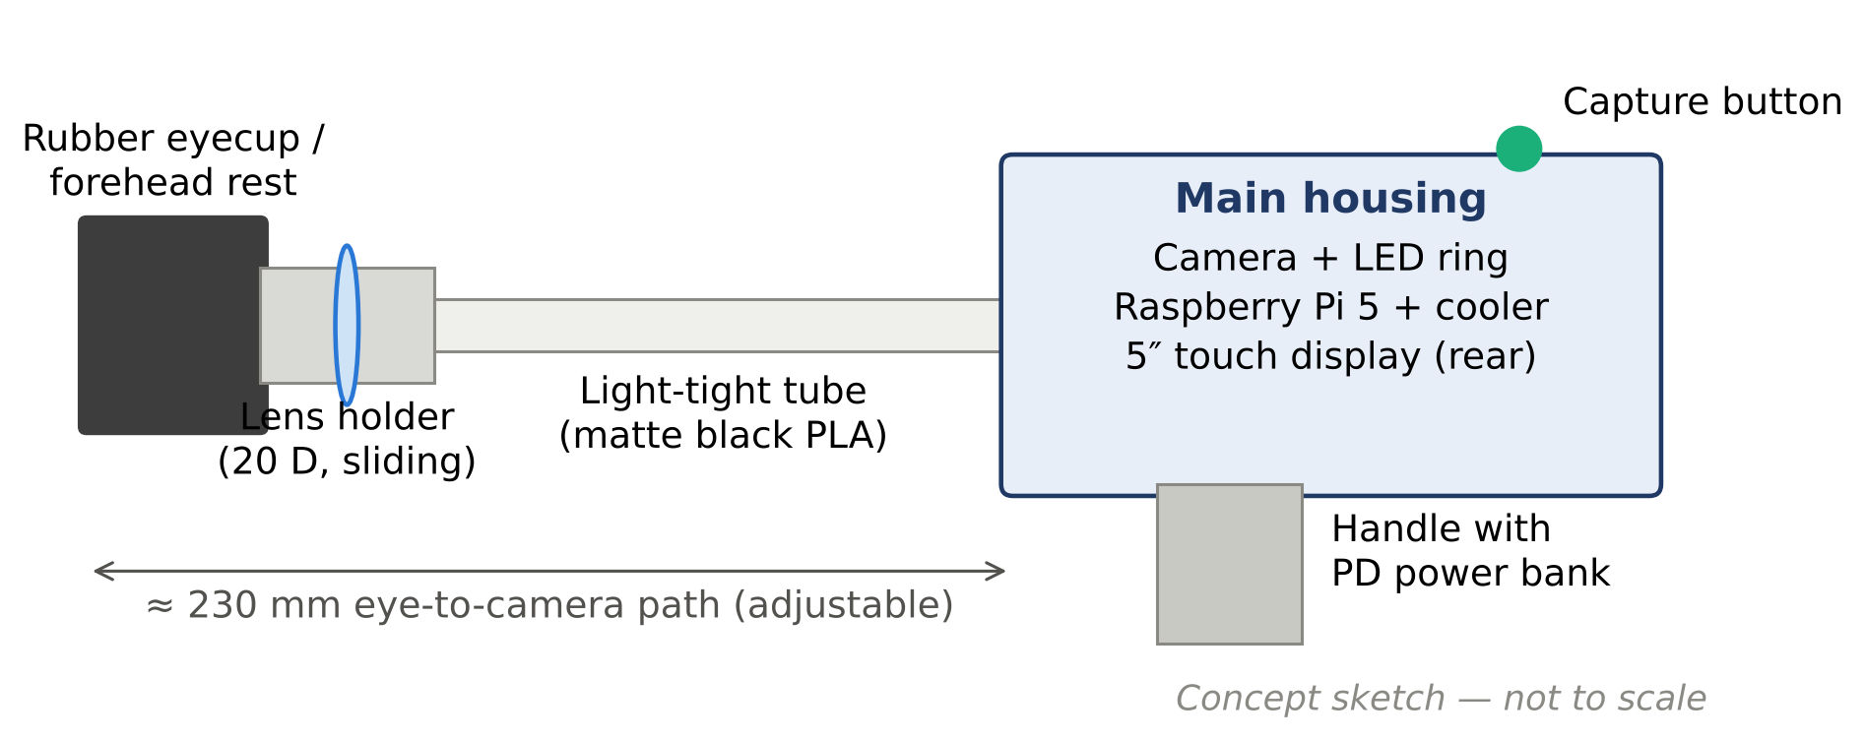
Figure 4.2: Concept design of the hand-held enclosure (side view).
Prototype v1 (as built). A first complete prototype was assembled to test the optical path and the integration of all parts (Figures 4.3 and 4.4). It is a table-top unit built in white acrylic sheet, joined with screws and 3D-printed corner brackets so that every panel can be removed during tuning. The condensing lens sits in a 3D-printed eyepiece mount at the centre of the front panel, with two rotary controls below it. Inside, the camera is mounted on a carriage that slides along twin stainless-steel guide rails towards or away from the lens; a lever passing through a slot in the side wall moves the carriage, so the camera-to-lens distance — and therefore focus on the aerial image (Section 3.5.2) — is adjusted mechanically. The Raspberry Pi 5 with its active cooler and an Arduino Nano on a perfboard are mounted at the rear, a touch display is set into the left side panel, and a Bluetooth keyboard and mouse are used during development.
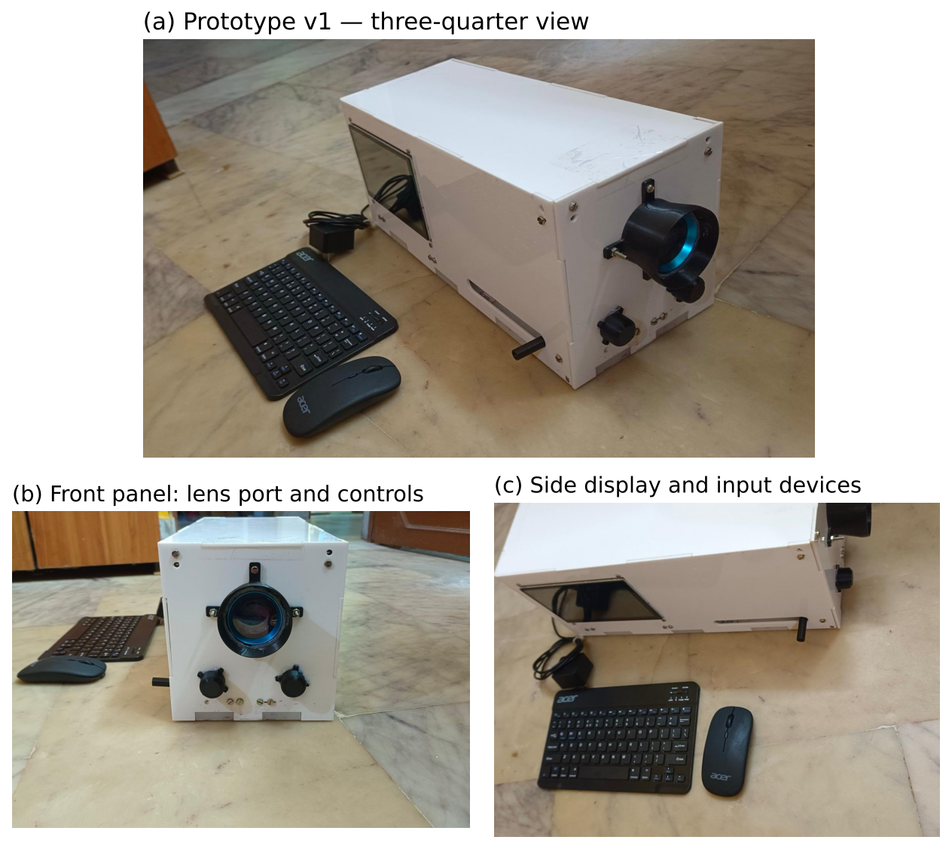
Figure 4.3: Prototype v1: (a) three-quarter view; (b) front panel with lens port and rotary controls; (c) side-mounted display with development keyboard and mouse.
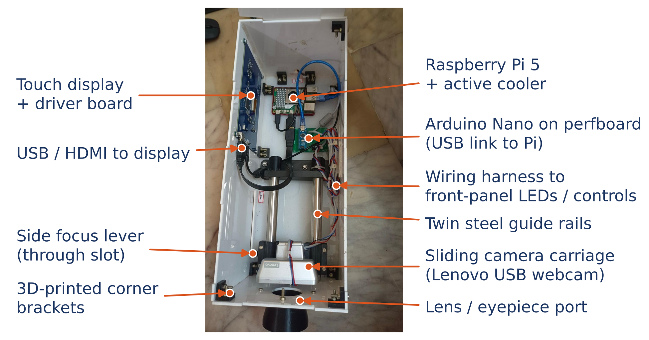
Figure 4.4: Interior of prototype v1 with the main sub-assemblies labelled.
Building the prototype led to several practical substitutions relative to the design of Chapter 3, summarised in Table 4.3. The most significant is the camera: prototype v1 uses a readily available USB webcam instead of the Camera Module 3 NoIR. This was the fastest way to obtain images through the optical path, but USB webcams usually include an infrared-cut filter, which prevents the 850 nm alignment scheme, and their resolution and field of view differ from the IMX708, so the sampling calculation of Section 3.5.2 must be repeated for the actual camera. Replacing the webcam with the NoIR module is the first hardware task of Project-II.
Table 4.3: Design (Chapter 3) versus prototype v1 as built
Subsystem | Design | Prototype v1 (as built) | Remark
Enclosure | Hand-held 3D-printed tube and housing | Table-top white acrylic box, screw-assembled with 3D-printed corner brackets | Easy to open and modify during tuning
Camera | Camera Module 3 NoIR (CSI-2) | Lenovo USB webcam on a sliding carriage | NoIR module planned for v2 (IR alignment)
Focusing | Autofocus + sliding lens holder | Carriage on twin steel guide rails, moved by a side lever | Mechanical camera-to-lens distance
Optics | 20 D condensing lens | Condensing lens in a 3D-printed front eyepiece mount | Confirm lens power
I/O control | Pi 5 GPIO PWM drives LED MOSFETs | Pi 5 + Arduino Nano co-processor on perfboard (USB link) | Confirm Nano role (LED driving / control inputs)
Front controls | Capture push-button | Two rotary controls on the front panel | Confirm function (e.g. illumination / focus)
Display / input | 5″ touch display | Side-mounted touch display; Bluetooth keyboard and mouse | Keyboard/mouse for development only
Power | USB-C PD supply or power bank | External mains adapter (SELV output) | Battery operation planned for v2

First capture trial. To learn how the lens behaves, a first trial was made by holding the 20 D lens against the face in room light and photographing through it with a phone camera. The result (Figure 5.4a) is a magnified image of the front of the eye — iris, pupil, sclera and eyelashes — rather than the retina. This is the expected behaviour when the lens is used as a magnifier (object inside its focal length) instead of being held about 50 mm in front of the eye with the light source coaxial with the camera, as in Figure 3.2. The trial was valuable in three ways: it confirmed the geometry required by the design calculation, it produced a realistic “wrong” image for testing the fundus gate, and it showed that the room must be darkened so that the pupil dilates naturally. The corrected procedure — lens about 5 cm from the eye, camera about 16 cm behind the lens, light in line with the camera, dim room — is followed for the next captures, starting from the red reflex and refocusing until vessels appear.
Safety rule followed during trials: only team volunteers are imaged, the white LED is used only in short bursts, and no image is processed or stored beyond the trial. Imaging of any other person waits for ethics approval and written consent (Section 6.3).

4.2 Experimental Set-up and Data Collection

4.2.1 Dataset
The APTOS 2019 Blindness Detection training set [35] contains 3,662 colour fundus photographs collected by technicians of Aravind Eye Hospital in rural India using several camera models, each graded by a clinician on the ICDR scale. The notebook downloads it automatically from a public Hugging Face mirror (full-resolution sngsfydy/aptos, ≈ 9 GB, or a 224 px copy bumbledeep/aptos for quick runs), so no Kaggle account is needed. The class distribution (Figure 4.5) is strongly imbalanced: nearly half the images show no DR, and severe NPDR accounts for only 5.3 %.
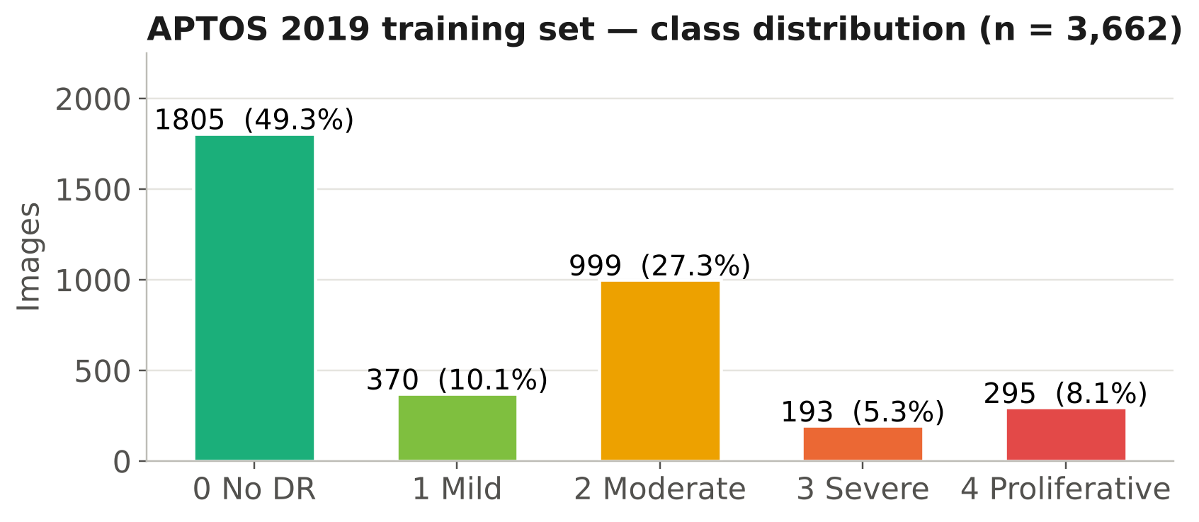
Figure 4.5: Class distribution of the APTOS 2019 training set.
Figure 4.6 shows pre-processed images of each grade from the actual training run. The quality limits derived from the training data were: sharpness (variance of the Laplacian) ≥ 9.63, and mean green-channel brightness between 27.8 and 114.2.
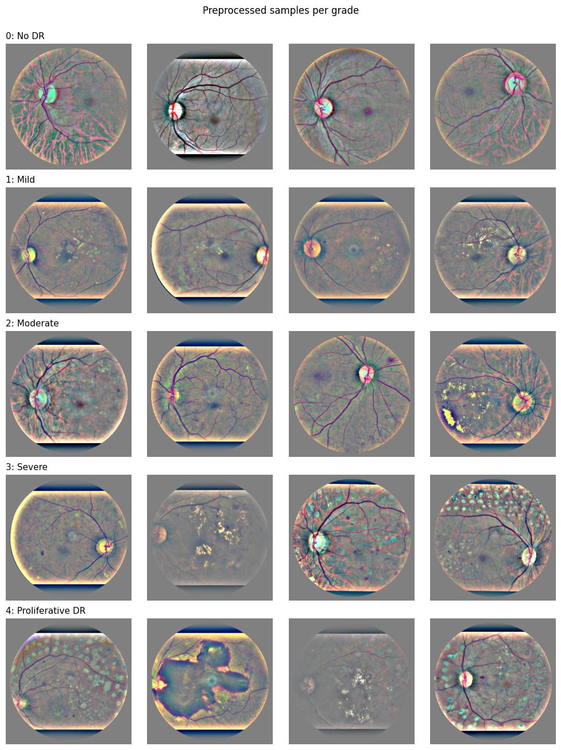
Figure 4.6: Pre-processed APTOS 2019 images of each grade, as produced by cell 4 of the training notebook (rows: grades 0–4).
The data are split once, stratified by grade, into training (70 %), validation (15 %) and test (15 %) sets with a fixed random seed (Figure 4.7). Stratification preserves the class proportions in every subset; the test set contains 223 referable and 327 non-referable images.
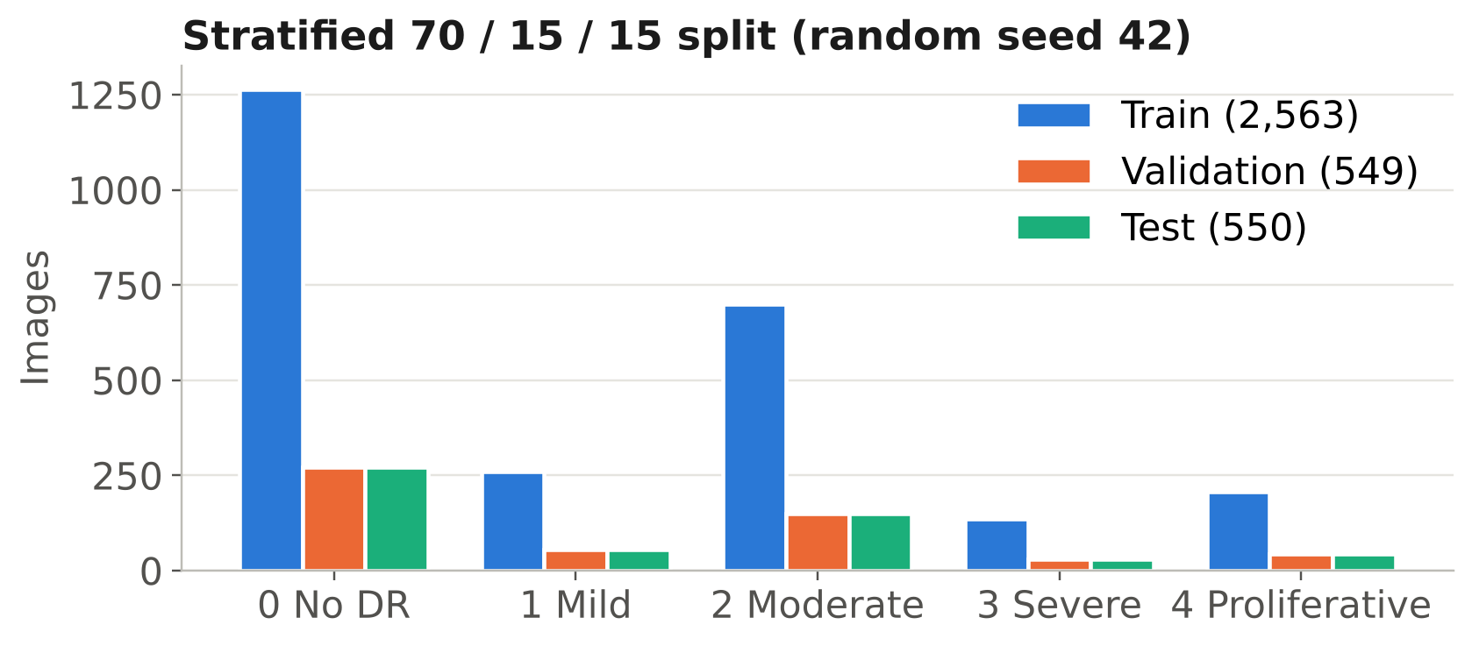
Figure 4.7: Number of images per grade in the training, validation and test sets.

4.2.2 Pre-processing and augmentation
Every image passes through the pipeline of Section 3.5.5, illustrated step by step in Figure 4.8. Pre-processing is performed once and cached; augmentation is applied on the fly during training only (Figure 4.9): random horizontal and vertical flips, rotation by up to ±180° (the fundus has no preferred orientation once laterality is ignored), random resized crops covering 85–100 % of the image, small brightness, contrast, saturation and hue jitter, and occasional Gaussian blur. The colour and blur augmentations are deliberately included to make the model less sensitive to the different optics and illumination of the team’s own camera.
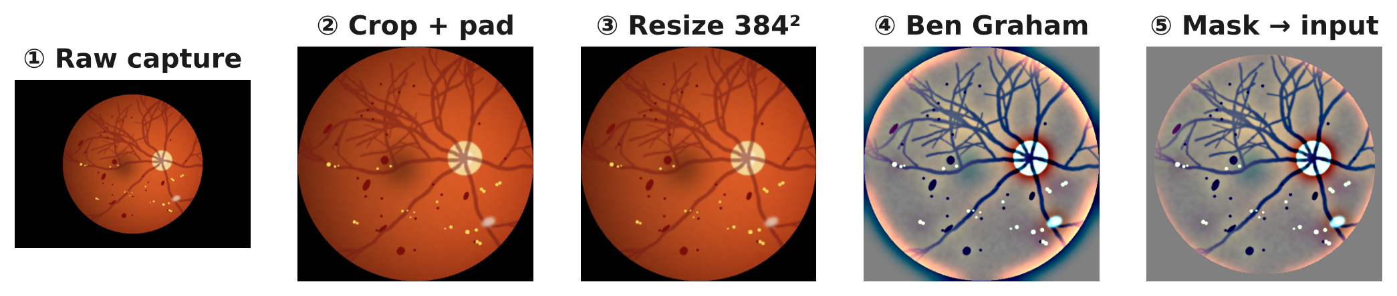
Figure 4.8: Pre-processing stages applied to a fundus image (schematic input).
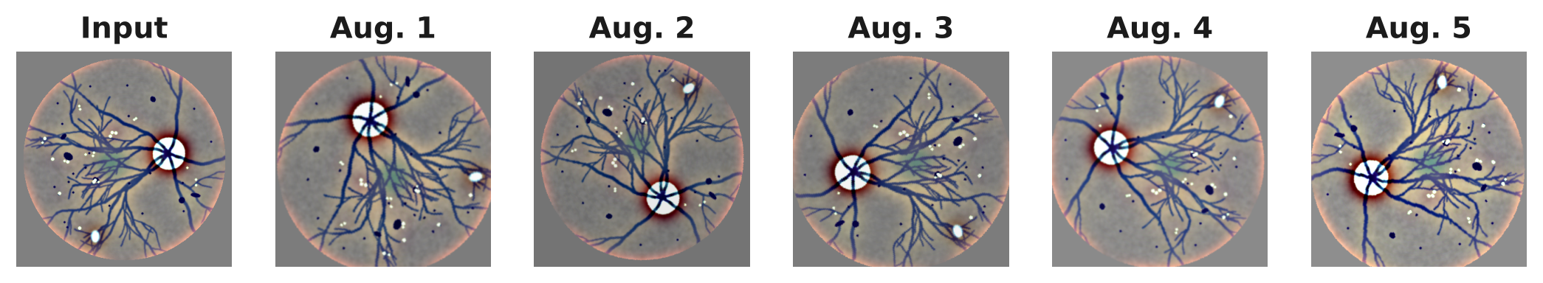
Figure 4.9: Examples of random training augmentations applied to one pre-processed image.

4.2.3 Training configuration and computing environment
Table 4.4: Training hyper-parameters
Parameter | Full mode (GPU) | Fallback (CPU)
Input size | 384 × 384 | 224 × 224
Epochs | 20 | 6
Batch size | 32 | 16
Optimiser | AdamW, weight decay 10⁻⁴ | same
Learning rate schedule | One-cycle, peak 3 × 10⁻⁴, 10 % warm-up | same
Loss | Smooth-L1 (regression on grade) | same
Dropout before output | 0.3 | same
Precision | Automatic mixed precision (FP16/FP32) | FP32
Checkpoint selection | Best validation QWK | same
Random seed | 42 | 42

Table 4.5: Computing environment
Item | Specification
Training | Google Colab, NVIDIA Tesla T4 (16 GB), Python 3.13, PyTorch 2.11, timm 1.0.30; 61–96 s per epoch, ≈ 22 min for 20 epochs
Development / benchmarking PC | 2 CPU threads (x86-64), ONNX Runtime 1.29, Python 3.13
Target device | Raspberry Pi 5, 4 GB, BCM2712 (4 × Cortex-A76 @ 2.4 GHz), Raspberry Pi OS Bookworm 64-bit

4.3 Validation against Specifications and Standards

4.3.1 Test plan
Table 4.6 maps each requirement to its test, the data used and the pass criterion. Tests T1–T9 are executed in Project-I; T10–T14 need the fabricated optical head, the Pi 5 hardware set-up or clinical images and are scheduled for Project-II.
Table 4.6: Test plan and traceability to requirements
Test | Req. | Procedure | Data | Pass criterion
T1 | R1 | Run the bundle on test images; inspect output fields | APTOS test set | Grade 0–4 and referral flag present
T2 | R2 | Compute QWK with frozen thresholds | 550 test images | κ_{w} ≥ 0.85
T3 | R3 | Compute referable sensitivity and specificity | 550 test images | ≥ 85 % / ≥ 80 %
T4 | R7 | Compare PyTorch and ONNX outputs; FP32 vs INT8 test QWK | 8 test images; full test set | Δ < 10⁻³; ΔQWK ≤ 0.01
T5 | R6 | Measure exported file sizes | Bundle | ≤ 20 MB
T6 | R8 | Run gates on deliberately bad images (blurred, dark, over-exposed, anterior-segment) | Synthetic + capture trial | All flagged
T7 | R4 | Run the full notebook end-to-end on a fresh runtime; run Pi script with networking disabled | Synthetic stand-in data | All cells complete; no network access
T8 | R15 | Generate Grad-CAM for referable and non-referable images | Test images | Heat-maps produced
T9 | R13 | Cost the bill of materials | BOM | ≤ ₹25,000
T10 | R5 | Time capture → result on Pi 5, 100 runs | Pi 5 | Model ≤ 1 s; total ≤ 2 s
T11 | R9 | Measure optical power at eye plane | Power meter | Within ISO 15004-2 Group 1
T12 | R11, R12 | Measure field of view, sampling and battery runtime | Test chart, power bank | ≥ 1,000 px; ≥ 3 h
T13 | R14 | Inspect stored records | Device storage | No personal identifiers
T14 | O4 | Grade own-device captures vs ophthalmologist | ≥ 100 eyes | κ_{w} ≥ 0.75

4.3.2 Verification carried out in Project-I
End-to-end pipeline test (T7). Before training on the real data, every cell of the notebook was executed end-to-end in a clean environment with a stand-in dataset of 150 synthetic fundus images (30 per grade), two epochs and no network-downloaded weights. All eleven cells completed: pre-processing, split, training, threshold tuning, evaluation, Grad-CAM, ONNX export, INT8 quantisation, bundle creation and the upload cell. The run was repeated after each change to the notebook (switching from process- to thread-based pre-processing, adding the CPU fallback and making the notebook runtime-agnostic). The accuracy figures from this run are meaningless by design — the purpose was to verify the plumbing, not the model.
Export parity (T4, T5). In the pipeline test the maximum absolute difference between PyTorch and ONNX Runtime outputs was 1 × 10⁻⁶; in the full training run it was 2 × 10⁻⁶, and the FP32 ONNX model reproduced the PyTorch test QWK exactly (0.877). The FP32 model file is 16.0 MB and the INT8 model 4.8 MB, both within R6; the INT8 model failed the accuracy check (Section 5.1.2).
Stand-alone deployment test (T1, T6). The generated bundle was unzipped into an empty directory and pi_inference.py was run on its own on a 1,600 × 1,200 test image, with both the INT8 and the FP32 model, in text and JSON modes. The script loaded the configuration, applied the quality checks, ran inference and reported the result, demonstrating that the bundle has no hidden dependency on the notebook. The image-quality checks correctly flagged a deliberately blurred, over-bright test image, and the fundus gate rejected the anterior-segment capture trial (Section 5.1.3).
Electrical safety (R10). By inspection, the hand-held unit contains no mains-voltage circuitry; the highest voltage present is the 5.1 V USB-C PD rail, which is within the safety extra-low voltage range assumed by IEC 60601-1 for patient-accessible parts [47].
Light safety (R9). In Project-I compliance is argued by design: alignment under invisible 850 nm light, a white flash of at most 200 ms and fixed, resistor-limited LED currents. Shen and Mukai measured 150–170 µW of white light from a similar Raspberry Pi design, about one-tenth of a standard indirect ophthalmoscope [13]. The team’s own exposure will be measured at the eye plane with an optical power meter before any volunteer imaging beyond the trial stage (T11).

Chapter 5: Results and Discussion

This chapter reports two kinds of results. Classification performance, export fidelity and the effect of quantisation come from the full training run of the notebook on Google Colab (Tesla T4, 384 px, 20 epochs). Model complexity, latency and pre-processing cost were measured separately on the development PC with the same architecture; these quantities do not depend on the trained weights.

5.1 Results

5.1.1 Model complexity and backbone comparison
To ground the backbone decision in measurements rather than published ImageNet figures, the five candidate networks were instantiated with the same single-output head, exported to ONNX at the 384 px input size and timed with ONNX Runtime on the development PC (two CPU threads, batch size 1, median of 15 runs after three warm-up runs). Figure 5.1 and Table 5.1 give the results.
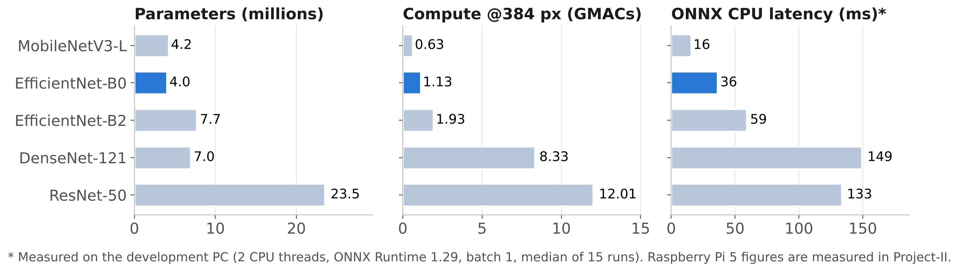
Figure 5.1: Parameters, computation and measured CPU latency of candidate backbones at 384 × 384 input.
Table 5.1: Measured complexity of candidate backbones (384 × 384 input, single regression output)
Backbone | Parameters (M) | Compute (GMACs) | ONNX file (MB) | CPU latency (ms)
MobileNetV3-Large | 4.20 | 0.63 | 16.7 | 15.6
EfficientNet-B0 (selected) | 4.01 | 1.13 | 15.9 | 36.3
EfficientNet-B2 | 7.70 | 1.93 | 30.6 | 59.1
DenseNet-121 | 6.95 | 8.33 | 27.8 | 149.1
ResNet-50 | 23.51 | 12.01 | 79.3 | 133.5

EfficientNet-B0 needs 10.6× less computation than ResNet-50 for a 3.7× shorter latency; the gap in latency is smaller than the gap in operations because depthwise convolutions use the CPU less efficiently than dense ones. MobileNetV3-Large is the fastest, but EfficientNet-B0 was retained for its higher expected accuracy (Section 3.4). Even allowing for the Pi 5 being several times slower than the development PC, a model latency of a few hundred milliseconds is expected, inside the 1 s requirement (R5).

5.1.2 Edge deployment: export fidelity, quantisation and pre-processing cost
Export fidelity. In the training run the maximum absolute difference between PyTorch and ONNX Runtime outputs was 2 × 10⁻⁶, and the FP32 ONNX model reproduced the test QWK of the PyTorch model exactly (0.8773). The exported model is therefore numerically equivalent to the trained one (R7).
Quantisation. Figure 5.2 summarises the effect of post-training static INT8 quantisation. The file shrank from 16.0 MB to 4.8 MB (−70 %), but test QWK fell from 0.877 to 0.570, and on the development PC the INT8 model was also 1.7× slower (60.9 ms against 36.4 ms) because the quantise–dequantise operations around each layer outweigh the cheaper integer arithmetic on that processor. The accuracy loss is consistent with known difficulties of post-training quantisation for EfficientNet-type networks: depthwise convolutions have wide per-channel weight ranges, and the SiLU activations and squeeze-and-excitation gates are sensitive to activation clipping [32]. Because the drop exceeded the 0.01 tolerance, the export rule deployed the FP32 model — the safeguard worked as designed. Recovering an accurate INT8 model (quantisation-aware training, or keeping sensitive layers in FP32) is planned for Project-II.
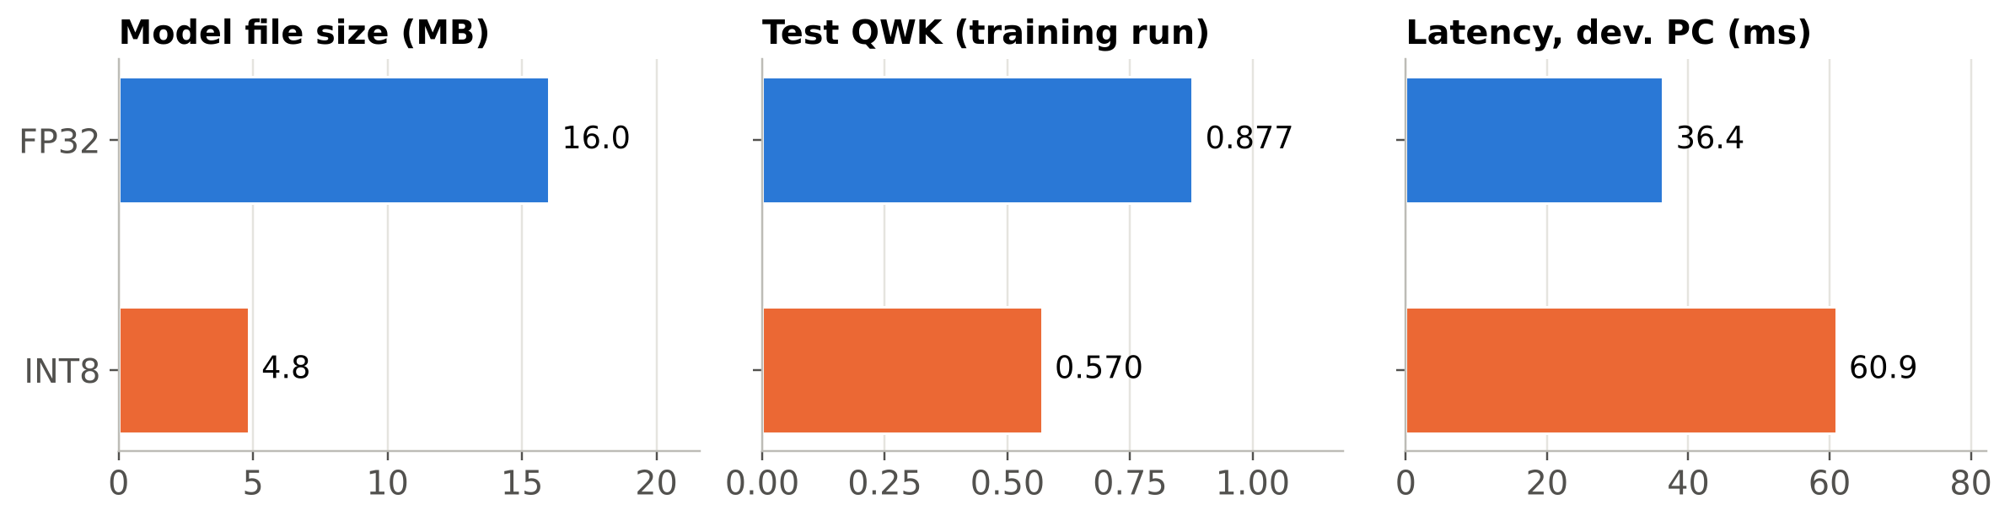
Figure 5.2: FP32 versus INT8 EfficientNet-B0: file size and test QWK from the training run, latency on the development PC.
Pre-processing cost. Pre-processing was measured on a 2,600 × 1,900-pixel image, the size of a full-resolution capture (Figure 5.3). Border cropping, padding, resizing and the Ben Graham filter together take about 25 ms; the quality metrics, which work on a 512 px copy, take about 19 ms. Pre-processing therefore adds well under 0.1 s and is not the bottleneck.
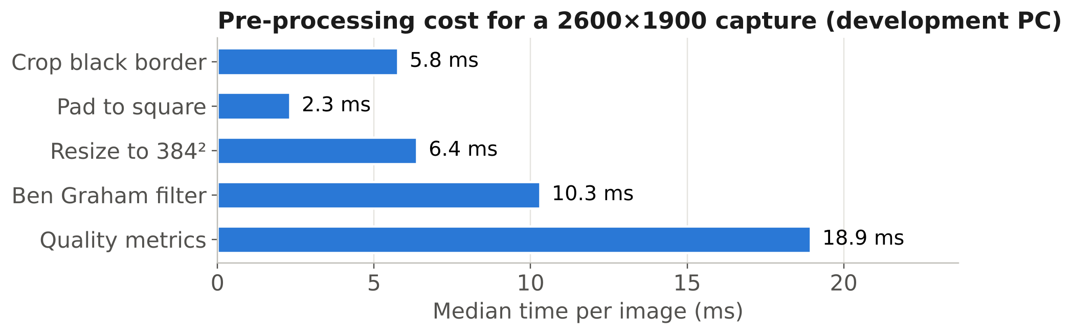
Figure 5.3: Median pre-processing time per stage for a full-resolution capture on the development PC.
Table 5.2: Edge-deployment measurements
Quantity | FP32 | INT8 | Source
Model file size (MB) | 16.0 | 4.8 | Training run
Test QWK | 0.877 | 0.570 | Training run
PyTorch–ONNX max. abs. difference | 2 × 10⁻⁶ | – | Training run
Model latency, 384 px (ms) | 36.4 | 60.9 | Development PC
Pre-processing + quality checks (ms) | 43.7 | 43.7 | Development PC
Model latency on Raspberry Pi 5 | [T10] | – | Project-II

5.1.3 Fundus-image gate on the first capture trial
The first capture trial (Section 4.1.4) provided a realistic example of the most dangerous input for an AI grader: a sharp, well-exposed photograph that is not a retina. Figure 5.4 shows the trial image, a schematic fundus image of the intended view and the gate statistic for each. The trial image has a median red-to-green ratio of 1.29 — typical of skin and sclera — against 2.54 for the fundus image, and is rejected by the 1.6 threshold.
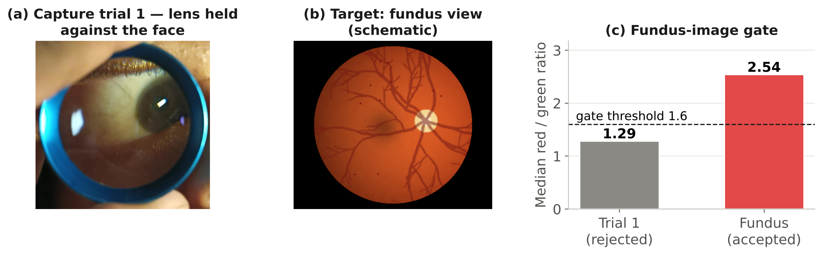
Figure 5.4: (a) First capture trial: the 20 D lens held against the face images the anterior segment; (b) schematic fundus image of the intended view; (c) median red/green ratio of each and the gate threshold.
During development, the same trial image was passed through the pipeline-test model without the gate, and it was assigned a grade (“Mild”) like any other input. That model had been trained only on synthetic images, so the specific grade means nothing — but the behaviour generalises: a regression network always returns a score, and any trained model will grade an out-of-distribution input without warning. The image also passed the blur and brightness checks, showing that quality metrics alone are not sufficient. The red/green threshold is a deliberately simple first gate; in Project-II it will be re-calibrated on the team’s own captures and complemented by a small learned gradable/ungradable classifier.

5.1.4 Classification performance on the test set
Training behaviour. Figure 5.5 shows the learning curves. Training loss fell steadily from 3.85 to 0.19; validation loss fell from 1.98 to about 0.20 and tracked the training loss closely from epoch 11 onward, so there is no sign of over-fitting. Validation QWK rose from 0.26 to a best of 0.819 at epoch 18 and fluctuated by up to ±0.1 between epochs before epoch 14, a typical behaviour with a small validation set and a one-cycle learning-rate schedule; checkpointing on the best validation QWK makes the selected model insensitive to this noise.
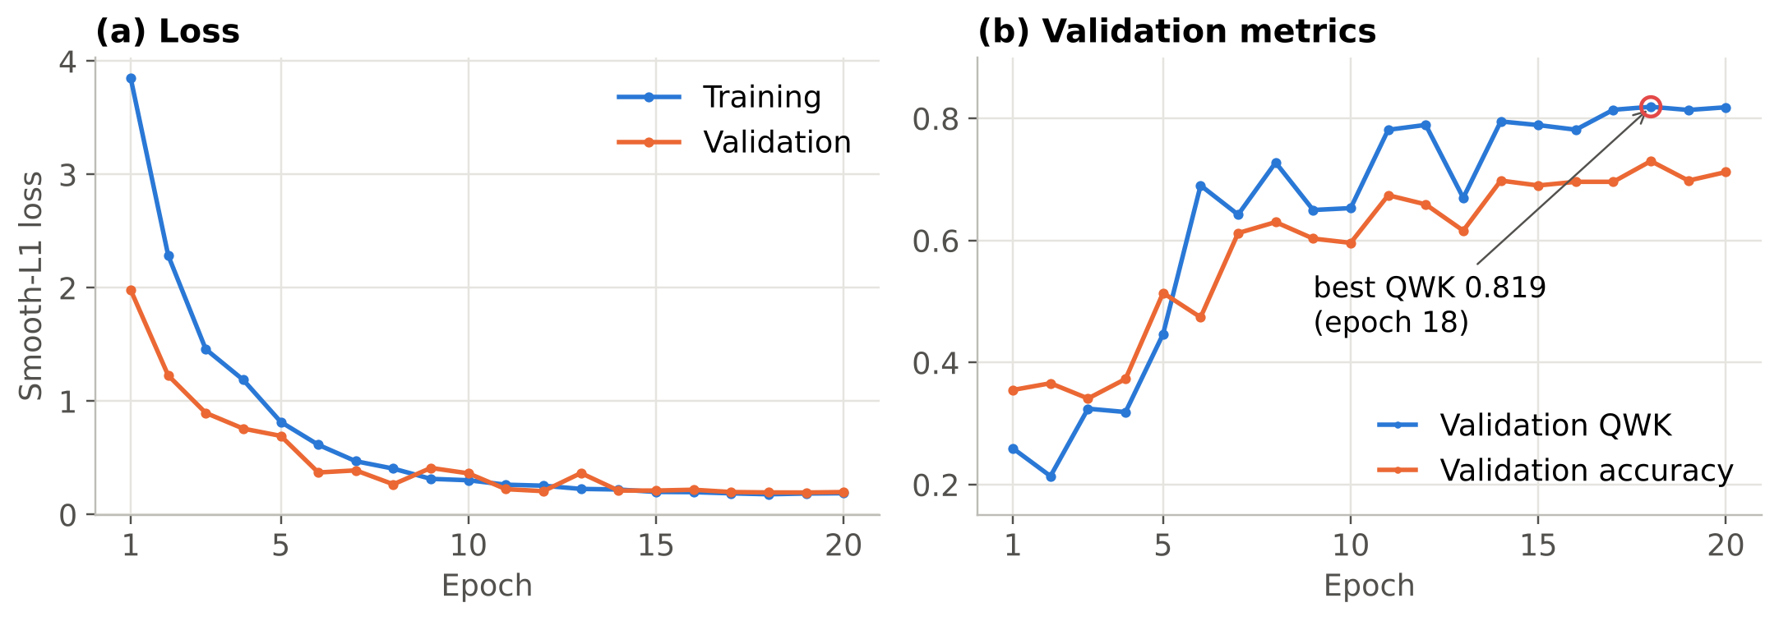
Figure 5.5: Training and validation loss, validation QWK and validation accuracy for the 20-epoch training run.
Threshold tuning. Coordinate-descent tuning on the validation set moved the thresholds from (0.5, 1.5, 2.5, 3.5) to (0.58, 1.08, 1.88, 2.72) and raised validation QWK from 0.819 to 0.877. The lower thresholds for grades 2–4 compensate for the regression output’s tendency to shrink towards the frequent middle grades. On the test set, used once with these frozen thresholds, QWK rose from 0.835 (default thresholds) to 0.877 (tuned), confirming that the gain generalises (Table 5.3).
Table 5.3: Classification performance on the held-out APTOS 2019 test set (550 images)
Metric | Result | Target
Quadratic weighted kappa (default thresholds) | 0.835 | –
Quadratic weighted kappa (tuned thresholds) | 0.877 | ≥ 0.85 ✔
Five-class accuracy | 69.8 % | –
Referable DR sensitivity (grade ≥ 2) | 93.7 % (209 / 223) | ≥ 85 % ✔
95 % confidence interval (Wilson) | 89.7 – 96.2 % | –
Referable DR specificity | 90.8 % (297 / 327) | ≥ 80 % ✔
95 % confidence interval (Wilson) | 87.2 – 93.5 % | –
Referable DR AUC | 0.973 | –
Tuned thresholds t₁–t₄ | 0.58, 1.08, 1.88, 2.72 | –
Best validation QWK (epoch) | 0.819 (18) → 0.877 after tuning | –

Confusion matrix and referral decision. Figure 5.6 gives the confusion matrix. Of 271 eyes without DR, 250 (92.3 %) were graded correctly and only one was graded as referable. Of the 223 referable eyes, 209 were referred, giving a sensitivity of 93.7 %; the 14 missed referable eyes were graded as mild (11) or no DR (3), and 10 of them came from the moderate class, the mildest referable grade. Most five-class errors occur within the referable group — 53 of 150 moderate eyes were graded severe, and 19 proliferative eyes were graded severe — which lowers five-class accuracy (69.8 %) but does not change the referral decision. The ROC curve (Figure 5.7) has an AUC of 0.973; the chosen operating point lies near its upper-left corner.
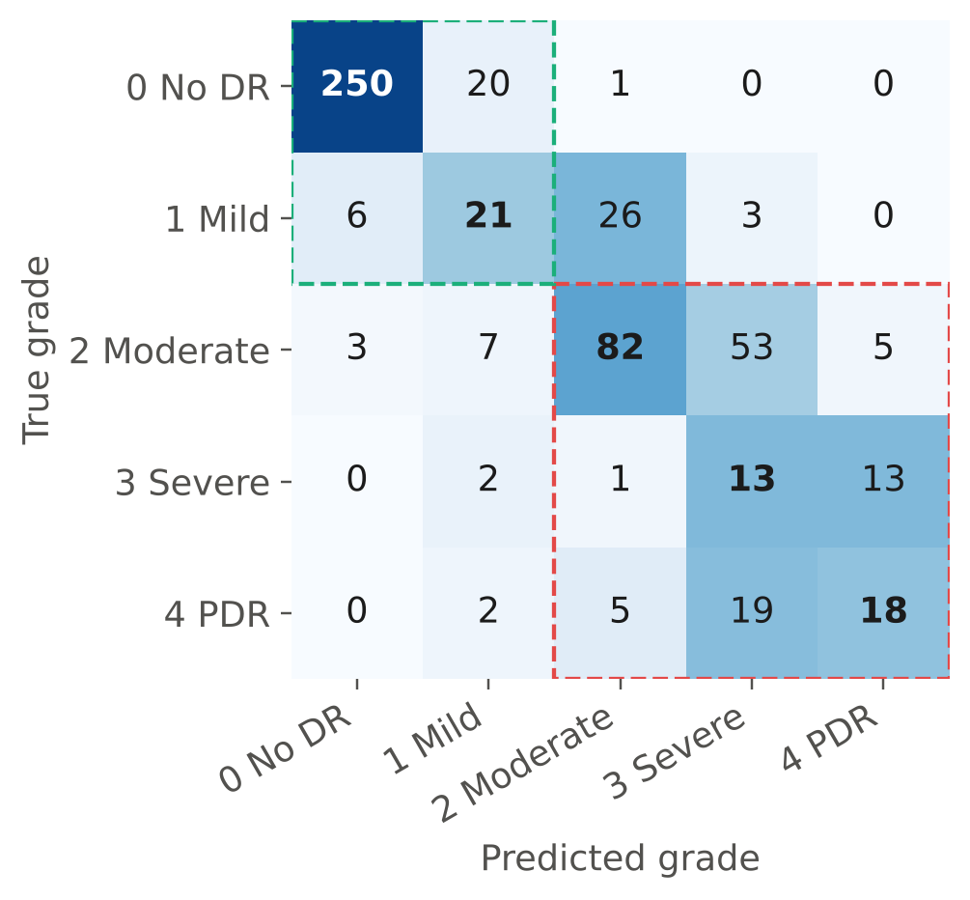
Figure 5.6: Confusion matrix on the test set (counts; shading normalised per true grade). Green box: non-referable; red box: referable.
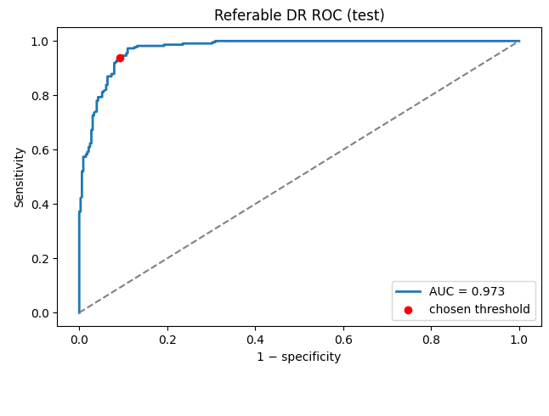
Figure 5.7: ROC curve for referable DR on the test set, with the operating point given by the tuned threshold t₂.
Per-grade performance. Figure 5.8 and Table 5.4 show precision and recall per grade. No DR is recognised reliably (F1 0.94). Mild DR has the lowest recall (0.38): mild disease consists of microaneurysms only, which cover 1–2 pixels at the 384 px input (Section 3.5.2), and 26 of 56 mild eyes were over-graded as moderate. Severe NPDR has moderate recall (0.45) but very low precision (0.15): the tuned thresholds route many moderate and proliferative eyes into the severe band, which favours referral but makes the exact severe grade unreliable.
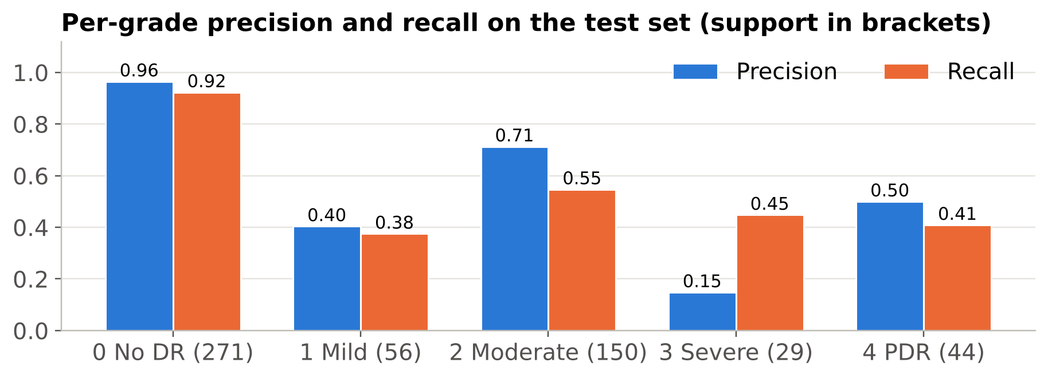
Figure 5.8: Per-grade precision and recall on the test set.
Table 5.4: Per-grade results on the test set
Grade | Precision | Recall | F1-score | Support
0 No DR | 0.965 | 0.923 | 0.943 | 271
1 Mild | 0.404 | 0.375 | 0.389 | 56
2 Moderate | 0.713 | 0.547 | 0.619 | 150
3 Severe | 0.148 | 0.448 | 0.222 | 29
4 Proliferative | 0.500 | 0.409 | 0.450 | 44
Weighted average | 0.759 | 0.698 | 0.721 | 550

Grad-CAM. Figure 5.9 shows Grad-CAM maps for four referable and two non-referable test images. All six predictions are correct in referral terms, but the heat-maps do not concentrate on haemorrhages, exudates or new vessels; the strongest activations lie in the grey corners outside the fundus and at the circular border, with weak activation over the retina itself. Two explanations are possible. First, Grad-CAM on the final 12 × 12 feature map is coarse, and the circular mask creates a strong edge that can dominate the gradients. Second — more concerning — APTOS 2019 has been reported in competition analyses to contain acquisition cues: images from different cameras and clinics have different crops (for example the flattened top and bottom edges visible in Figure 5.9) and these correlate with disease grade, so a network can partly learn where the image came from rather than what the retina shows. This would inflate APTOS test performance and would not transfer to the team’s camera. This finding is therefore treated as an open risk (R5 in Table 6.1) and is the first item of the Project-II model work: stronger masking of the border region, random erasing outside the fundus, Grad-CAM at a higher-resolution layer, and testing on Messidor-2 and IDRiD, which come from different sources.
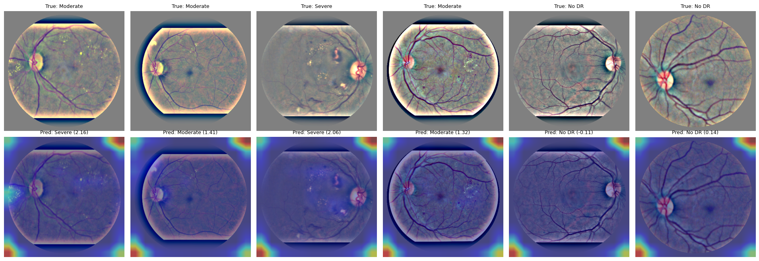
Figure 5.9: Grad-CAM for six test images. Top: pre-processed input with true grade; bottom: heat-map overlay with predicted grade and score. Activations concentrate outside the retina (see text).

5.2 Achievement of Specifications
Table 5.5: Targets versus achieved performance
Req. ID | Parameter | Target | Achieved | Met?
R1 | ICDR grade + referral output | Grades 0–4 + flag | Implemented (DRModel.predict) | Yes
R2 | Test QWK | ≥ 0.85 | 0.877 | Yes
R3 | Referable sensitivity / specificity | ≥ 85 % / ≥ 80 % | 93.7 % / 90.8 % (AUC 0.973) | Yes
R4 | Offline operation | No network | Pure local ONNX Runtime inference | Yes
R5 | Inference time on Pi 5 | ≤ 1 s / ≤ 2 s | 36 ms model + 44 ms pre-processing on PC; Pi pending | Partly (P-II)
R6 | Model size | ≤ 20 MB | 16.0 MB (FP32, deployed) | Yes
R7 | Export fidelity | Δ < 10⁻³; ΔQWK ≤ 0.01 | FP32: 2 × 10⁻⁶, ΔQWK 0.000; INT8: ΔQWK −0.307 (rejected) | Yes (FP32)
R8 | Reject ungradable / non-fundus images | Flag all test cases | Blurred/over-bright and anterior-segment images flagged | Yes (P-I set)
R9 | Light safety | ISO 15004-2 Group 1 | Design measures in place; measurement pending | Partly (P-II)
R10 | Electrical safety | SELV ≤ 5.1 V | 5.1 V USB-C PD only | Yes
R11 | Fundus sampling | ≥ 1,000 px | ≈ 1,400 px by design calculation | Yes (analysis)
R12 | Portable runtime | ≥ 3 h | ≈ 4.4 h estimated | Yes (analysis)
R13 | Prototype cost | ≤ ₹25,000 | ≈ ₹20,050 | Yes
R14 | Privacy | No identifiers stored | Anonymised IDs, local storage by design | Yes (design)
R15 | Explainability | Grad-CAM available | Implemented; maps reveal a shortcut risk | Yes (with finding)

5.3 Comparison with Existing Work
Table 5.6: Comparison with reported work and existing products
Parameter | This work | Gulshan et al. [9] | IDx-DR [11] | Medios [16] | Shen & Mukai [13]
Automated grading | Yes (ICDR 0–4) | Yes (referable) | Yes (more-than-mild) | Yes (referable) | No
Inference location | On device, offline | Server | Cloud | Smartphone, offline | –
Capture hardware | Pi camera + 20 D lens | Table-top cameras | Table-top camera | Smartphone-based camera | Pi camera + 20 D lens
Training images | 2,563 (APTOS) | 128,175 | – | – | –
Test set | 550 (retrospective) | 9,963 + 1,748 | 900 (prospective) | 213 (prospective) | –
Referable sensitivity | 93.7 % | 97.5 % (high-sens. point) | 87.2 % | 100 % | –
Referable specificity | 90.8 % | 93.4 % | 90.7 % | 88.4 % | –
Model size | 16.0 MB (FP32) | Ensemble of Inception-v3 | Not published | Not published | –
Hardware cost | ≈ ₹20,050 | Clinical camera | Clinical camera | Commercial device | ≈ US $185
Openness | Open code & design | Closed | Closed | Closed | Open design

The referral performance of this work (93.7 % / 90.8 %) is in the same range as published systems, but the comparison must be read with care: those systems were evaluated on larger, often adjudicated and sometimes prospective data, whereas this project’s figures come from a 550-image retrospective test set from the same source as the training data, graded once — and the Grad-CAM finding suggests the APTOS figures may be optimistic. The value of this work is the combination of open hardware, offline grading and a quality gate at a fraction of the cost, with a clear path to external validation.

5.4 Error, Uncertainty and Limitation Analysis
Statistical uncertainty. The 95 % Wilson intervals are 89.7–96.2 % for sensitivity and 87.2–93.5 % for specificity (Table 5.3); the lower bounds still exceed the 85 % and 80 % targets. Differences of a few percentage points between model variants are within this uncertainty. Per-grade figures for severe NPDR (29 images) are much less certain.
Label noise. Each APTOS image was graded once. Single-grader labels disagree with adjudicated consensus often enough to cap measurable performance [15]; the confusion between moderate and severe, and between mild and moderate, is partly disagreement in the reference itself.
Class imbalance. The minority grades (mild, severe) have the weakest results. The regression formulation and tuned thresholds protect the referral decision but not the exact grade, so the device reports the referral decision as its primary output and the five-level grade as secondary information.
Shortcut learning. As discussed with Figure 5.9, the model may exploit acquisition artefacts specific to APTOS. This is the most important limitation of the Project-I results, because it would not show up in any metric computed on APTOS itself; only external datasets and the team’s own captures can reveal it.
Domain shift. APTOS images come from clinical fundus cameras; the team’s device uses different optics, a smaller field through an undilated pupil, different illumination and lower contrast. Accuracy on the device cannot be inferred from APTOS results and must be measured (O4).
Resolution limit. At the 384 px model input the fundus is sampled at about 34 µm per pixel, so the smallest microaneurysms occupy only 1–2 pixels — consistent with the low recall for mild DR (0.38).
Measurement conditions. Latency figures were measured on a two-thread x86 development PC, not on the Pi 5. The INT8 latency result is specific to that processor; the INT8 accuracy loss, in contrast, is a property of the quantised model and will hold on any hardware.
Gate limitations. The red/green gate was tuned on a single real failure case and schematic images; very dark fundus images and reddish non-retinal scenes could be misclassified until it is re-calibrated on labelled device captures.

5.5 Discussion
The Project-I results show that the software side of the device works end to end. A single notebook trained an EfficientNet-B0 grader in about 22 minutes on a free cloud GPU, reaching a test QWK of 0.877 and referable-DR sensitivity and specificity of 93.7 % and 90.8 % — above every accuracy target — and exported it to a 16 MB ONNX model that reproduces PyTorch exactly and runs without the training framework.
Three findings changed the design or the plan. First, post-training INT8 quantisation, usually presented as a free speed-up, destroyed much of the model’s accuracy (QWK 0.570); the accuracy-gated export rule caught this automatically, which justifies having built the rule. Second, the first capture trial showed that a sharp photograph of the wrong part of the eye would still be graded by any model, which moved the fundus and quality gates from an optional feature to a core safety requirement (R8). Third, Grad-CAM revealed that the model’s attention is not on the lesions, raising the possibility that APTOS performance partly reflects dataset artefacts. Together these findings point the same way: the reliability of the device is limited less by the size or accuracy of the network than by what it is given and what it has learned to look at. The most valuable work in Project-II is therefore external validation, shortcut removal, and capture quality on the team’s own optical head — not a larger model.

Chapter 6: Societal, Environmental, Ethical and Economic Considerations

6.1 Environmental Impact and Sustainability
- Energy in use. The unit draws about 9.8 W at peak and about 7 W on average (Table 3.7). A three-minute screening therefore consumes roughly 0.35 Wh. At 20 screenings per day for 250 days a year, a unit uses about 1.75 kWh per year — less than a single household LED bulb used for a few hours a day. On-device inference also avoids the energy cost of uploading every image to a data centre.
- Stand-by and power management. The application blanks the display and switches off the IR LEDs after one minute without activity; the Pi 5 can be powered down completely between camps. The design response to this consideration was to choose a USB-C PD power bank, which can be charged from any solar or grid source, rather than a custom battery pack.
- Materials and hazardous substances. All electronic parts selected (Raspberry Pi 5, Camera Module 3, MOSFETs, LEDs, passive components) are available in RoHS-compliant versions. The enclosure is printed in PLA, a bio-derived thermoplastic, and is designed as screw-assembled parts with no adhesives so that it can be disassembled for repair.
- E-waste and end of life. The Pi, camera, display and lens are standard modules that can be re-used in other projects or replaced individually; only the printed parts are specific to the device. The lithium-ion power bank is the main hazardous item and is returned through an authorised e-waste collector under the E-Waste (Management) Rules at end of life.
- Environmental benefit. Every patient screened locally who would otherwise travel to a district or city hospital for an eye examination avoids a round trip, often by road over tens of kilometres, together with an accompanying person. Early detection also avoids the far larger resource use of treating advanced, proliferative disease.

6.2 Health, Safety and Risk Assessment
Hazards to users, patients and the team, and the main project risks, were identified following the approach of ISO 14971 [46], scored for likelihood (L) and severity (S) on a 1–5 scale, and mitigated in the design or plan. Figure 6.1 places the unmitigated risks on a heat map; Table 6.1 is the risk register.
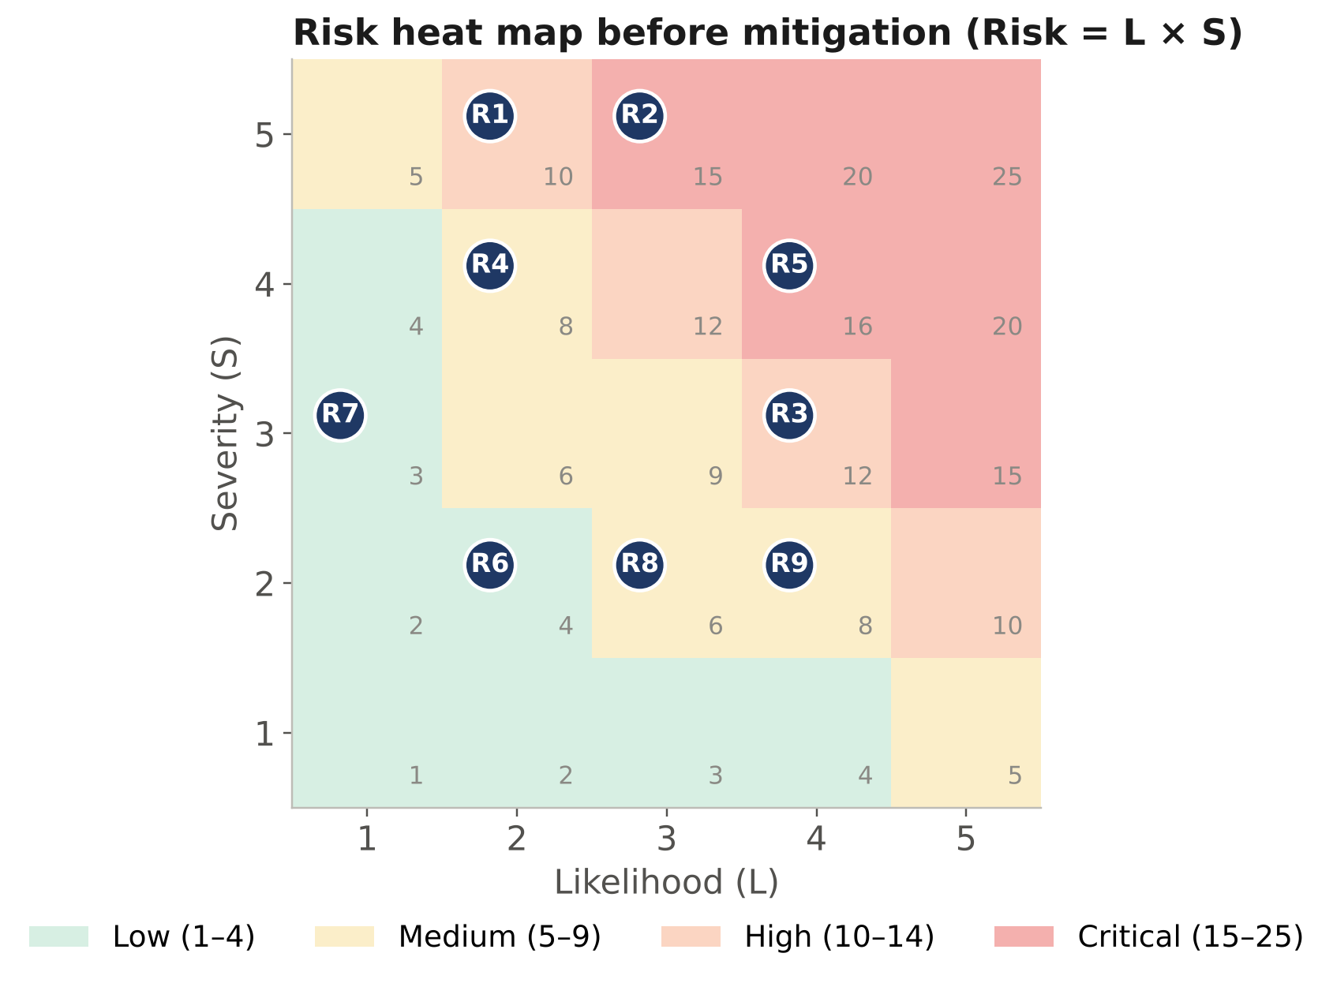
Figure 6.1: Risk heat map before mitigation; identifiers refer to Table 6.1.
Table 6.1: Risk register (Likelihood L and Severity S on a 1–5 scale; Risk = L × S)
Hazard / risk | L | S | Risk | Mitigation in the design or plan | Residual risk
R1 Retinal light exposure from LEDs | 2 | 5 | 10 | IR (850 nm) for alignment; white flash ≤ 200 ms; resistor-limited currents; exposure measured to ISO 15004-2 before volunteer imaging | Low
R2 Missed referable DR (false negative) | 3 | 5 | 15 | Sensitivity-first operating point; “refer if in doubt” rule after 3 failed captures; device labelled as screening aid, not diagnosis; annual re-screening advice | Medium
R3 Ungradable images graded as normal | 4 | 3 | 12 | Quality and fundus gates before the model; retake prompts with reasons | Low
R4 Leak of patient images or results | 2 | 4 | 8 | No names stored; anonymised IDs; no network services; encrypted storage (P-II) | Low
R5 Domain shift / shortcut learning reduces accuracy on new images | 4 | 4 | 16 | Colour/blur augmentation; Ben Graham normalisation; border masking and Grad-CAM checks; external tests (Messidor-2, IDRiD); fine-tuning and validation on own captures before any use (O4) | Medium
R6 Raspberry Pi overheating / throttling | 2 | 2 | 4 | Active cooler; vented housing; latency measured under sustained load | Low
R7 Electric shock or burn | 1 | 3 | 3 | SELV 5 V only; no mains in hand-held unit; certified USB-C PD supply | Low
R8 Component delivery delay | 3 | 2 | 6 | Common parts with multiple Indian suppliers; ordered early in Project-II | Low
R9 Colab GPU unavailable for training | 4 | 2 | 8 | Notebook runs on any runtime with automatic CPU fallback; Kaggle notebooks as alternative; caching | Low

The two medium residual risks, R2 and R5, are the reason the device is not used on patients in Project-I and why clinical validation (O4) is a precondition for any field use.

6.3 Professional Ethics and Legal Aspects
- Data privacy and informed consent. The APTOS 2019 images were released de-identified for research. No new patient images are collected in Project-I beyond trial images of team volunteers, taken with their consent and not retained. Before data collection in Project-II, the protocol, consent form (in English, Odia and Hindi) and data-handling plan will be submitted to the institutional ethics committee. Processing follows the principles of the Digital Personal Data Protection Act, 2023 — consent, purpose limitation, data minimisation and storage limitation [49].
- Regulation. Software intended to detect disease is a medical device under the Medical Devices Rules, 2017 [48]. The prototype is therefore labelled “research prototype – not for diagnostic use”, and IEC 62304-style documentation and an ISO 14971-style risk file are maintained from the beginning so that a future regulatory submission is possible.
- Intellectual property and licences. Table 6.2 lists the licences of the software and data used. All software components are open source with permissive licences compatible with academic and commercial use. The dataset is used under the terms of its release for research; its terms would have to be confirmed with the data owners before any commercial use. The code and design files written by the team are original work and will be released under the MIT licence.
- Honest reporting. Results are reported on a held-out test set used once; development-PC measurements are not presented as Raspberry Pi results; test results from the pipeline verification (synthetic data) are not presented as model accuracy; and values still to be measured are clearly marked.
- Responsible use of AI tools. AI coding and writing assistants were used to draft parts of the code and of this report. All generated code was executed and tested, and all text and figures were reviewed, corrected and approved by the team, who take responsibility for the content (see the Declaration of Originality).
- Possible misuse and safeguards. The main misuse risk is over-reliance — using the device as a substitute for an eye examination. The result screen always states the referral advice and that the device does not diagnose other eye diseases.
Table 6.2: Licences of software and data used
Component | Licence | Use in this project
PyTorch | BSD-3-Clause | Training
timm (PyTorch Image Models) | Apache-2.0 | Backbone and ImageNet weights
ONNX, ONNX Runtime | Apache-2.0 / MIT | Export and on-device inference
OpenCV | Apache-2.0 | Pre-processing and quality metrics
NumPy, scikit-learn, pandas | BSD-3-Clause | Numerical work, splits and metrics
Hugging Face datasets | Apache-2.0 | Dataset download
APTOS 2019 dataset | Released for the APTOS 2019 Kaggle competition (research use) | Training, validation and testing
Team code, notebook and CAD | MIT (planned) | Released with the report

6.4 Security Considerations
The device processes health data, so its security is designed in proportion to that sensitivity while keeping it usable offline:
- No network attack surface in use. Inference requires no network; in the deployed image Wi-Fi, Bluetooth and SSH are disabled, and updates are installed from USB media.
- Data at rest. Records contain only an anonymised ID, date, eye, grade and image. In Project-II the record store is placed on an encrypted partition (LUKS), so that a lost or stolen device does not expose images.
- Model and configuration integrity. A SHA-256 hash of the model and configuration will be checked at start-up, so a modified model or altered thresholds are detected before use.
- Physical tampering. The enclosure is screw-assembled and the microSD card is internal; tamper-evident seals will be used on field units.

6.5 Equality, Diversity, Inclusion and Accessibility
- Economic inclusion. At about ₹20,000 the unit is within the equipment budget of a primary health centre or an NGO; screening has no per-use fee and does not require a smartphone or data plan.
- Language and literacy. The interface is designed around large icons, a traffic-light result (green / amber / red) that always carries a text label and an icon, so it does not depend on colour vision, and short messages in Odia, Hindi and English. Voice prompts for alignment are planned.
- Physical accessibility. The hand-held design with a forehead rest allows screening of patients who cannot sit at a table-top camera (elderly or wheelchair users), and the handle and button work for left- or right-handed operators.
- Population fairness. APTOS 2019 was collected in India, so the training data come from a population similar to the intended users. Pigmentation of the fundus varies between individuals, which affects the colour gate and model; Project-II validation will report performance across sex and age groups to check for unequal accuracy.
- Inclusive teamwork. Work was divided according to interest and skill, with all four members contributing to both technical work and documentation (Appendix A).

6.6 Economic Analysis
Table 6.3: Bill of materials and prototype cost (estimated retail prices, October 2026)
S. No. | Component / item | Specification | Qty | Unit cost (₹) | Total (₹) | Source
1 | Raspberry Pi 5 | 4 GB, BCM2712 | 1 | 6,400 | 6,400 | Authorised reseller
2 | Touch display | 5″, 800 × 480, DSI/HDMI | 1 | 3,500 | 3,500 | Online
3 | Camera Module 3 NoIR | IMX708, 12 MP, AF | 1 | 3,300 | 3,300 | Authorised reseller
4 | Condensing lens | 20 D aspheric, ≈ 50 mm | 1 | 1,800 | 1,800 | Optical supplier
5 | Power bank | 10,000 mAh, USB-C PD | 1 | 1,500 | 1,500 | Retail
6 | Power supply | 27 W USB-C PD (bench use) | 1 | 1,100 | 1,100 | Authorised reseller
7 | Enclosure | PLA, ≈ 250 g, 3D-printed | 1 | 900 | 900 | In-house printing
8 | Active cooler | Pi 5 official | 1 | 500 | 500 | Authorised reseller
9 | microSD card | 32 GB, A2 | 1 | 500 | 500 | Retail
10 | Buttons, perfboard, wiring | – | 1 lot | 300 | 300 | Local market
11 | LEDs, MOSFETs, resistors | 4 × 850 nm, 2 × 3000 K, 2 × AO3400 | 1 lot | 250 | 250 | Local market
 | Total prototype cost |  |  |  | 20,050

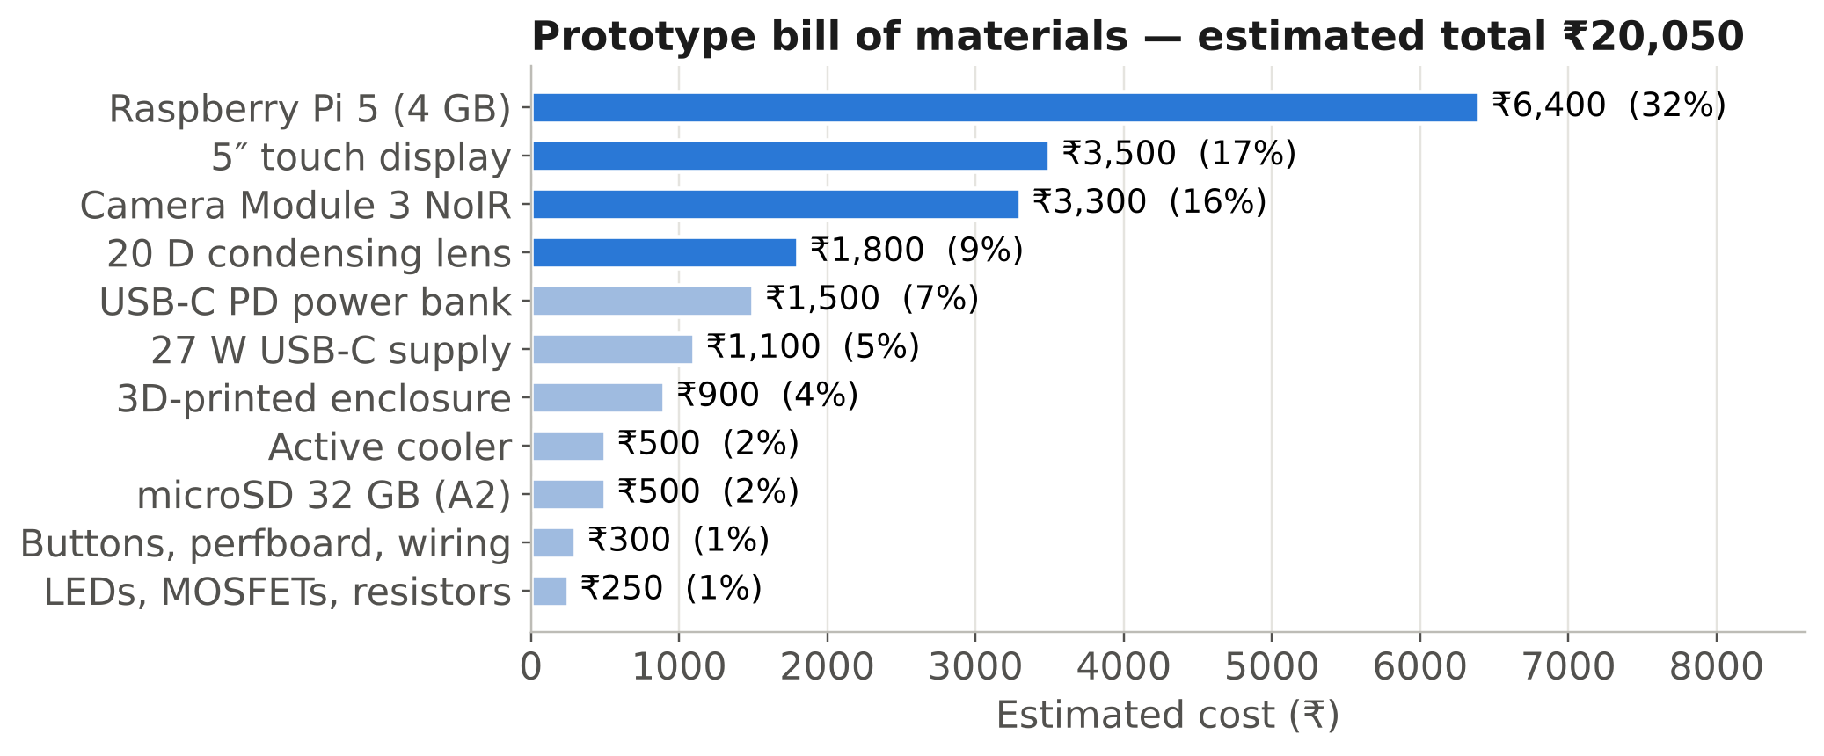
Figure 6.2: Breakdown of the estimated prototype cost.
The four largest items — the Raspberry Pi, display, camera and lens — account for 75 % of the cost (Figure 6.2). Table 6.3 is the design estimate; prototype v1 substituted a USB webcam, an Arduino Nano, steel guide rails, an acrylic enclosure and a mains adapter (Table 4.3), and its actual cost was ₹ [enter actual prototype cost]. At a production volume of a few hundred units, using a compute module, an OEM IMX708 camera, a moulded acrylic condensing lens and an injection-moulded housing, the unit cost is estimated at about ₹12,000. No training cost was incurred because free Colab resources were used.
Cost per screening. Amortising the prototype cost over three years at 20 screenings per day and 250 working days per year (15,000 screenings) gives about ₹1.3 per screening for equipment, plus negligible electricity. Commercial table-top fundus cameras cost several lakh rupees, and cloud AI services typically charge per image; the proposed device removes both barriers, the remaining cost being the health worker’s time. No external funding was received in Project-I.

6.7 Summary of Compliance
Table 6.4: Summary of societal considerations
Consideration | Key issue for this project | Design response | Section
Environment | Energy use, e-waste, battery disposal | ≈ 0.35 Wh per screening; modular, repairable design; RoHS parts; PLA enclosure | 6.1
Safety | Retinal light exposure; missed referable DR | IR alignment, short flash, measured exposure; quality gates; sensitivity-first referral | 6.2
Ethics | Consent, privacy, regulation, honest reporting | Ethics approval before data collection; anonymisation; research-only labelling; marked pending results | 6.3
Security | Health data on a portable device | No network services; encrypted storage; model hash check | 6.4
Inclusion | Literacy, language, cost, colour vision | Icon + text results; Odia/Hindi/English; ≈ ₹20,000 unit | 6.5
Cost | Affordability for primary care | ₹20,050 prototype; ≈ ₹12,000 at volume; ≈ ₹1.3 per screening | 6.6
Standards | Medical-device and light-safety norms | ISO 15004-2, IEC 62471, ISO 10940, IEC 62304, ISO 14971 applied | 3.6

Chapter 7: Conclusion and Future Scope

7.1 Conclusions
This project set out to make diabetic retinopathy screening possible where it is currently least available: at primary health centres and screening camps without a fundus camera, a grader or a reliable internet connection. In Project-I the team designed the complete device, built and verified its software, and assembled a first hardware prototype.
The optical design applies indirect ophthalmoscopy with a 20 D condensing lens; a sampling calculation showed that a Raspberry Pi Camera Module 3 about 160 mm behind the lens captures the fundus at about 1,400 pixels across — roughly 9 µm of retina per pixel — enough to resolve the lesions that define referable disease. Infrared alignment and a short white flash keep the pupil dilated without drugs, and the LED drivers, power budget and enclosure were designed and dimensioned.
On the software side, a self-contained Colab notebook downloads APTOS 2019, pre-processes it, trains an EfficientNet-B0 grader with a regression head and tuned thresholds, evaluates it on a held-out test set, explains it with Grad-CAM and exports a Raspberry Pi bundle. The exported FP32 ONNX model matches PyTorch to within 2 × 10⁻⁶, and the bundle runs stand-alone with three Python packages. On the APTOS test set the model reached a quadratic weighted kappa of 0.877 and referable-DR sensitivity and specificity of 93.7 % and 90.8 % (AUC 0.973), meeting all accuracy targets. Two results qualify this: post-training INT8 quantisation degraded QWK to 0.570 and was rejected, and Grad-CAM maps did not localise lesions, pointing to possible shortcut learning from acquisition artefacts that must be investigated before the model is trusted on new images.
The most important lesson came from the first capture trial: a sharp photograph of the wrong part of the eye would still receive a DR grade from any model. The resulting quality and fundus gates, which ask for a retake instead of grading an unusable image, are as essential to the device’s safety as the model’s accuracy.
Table 7.1: Achievement of objectives
No. | Objective | Status at the end of Project-I
O1 | DR grading model on the ICDR scale | Achieved: test QWK 0.877 (≥ 0.85); referable sensitivity 93.7 % / specificity 90.8 % (≥ 85 % / ≥ 80 %)
O2 | Offline deployment on Raspberry Pi 5 | Largely achieved: FP32 ONNX bundle (16.0 MB) verified; INT8 rejected (QWK 0.570); on-Pi timing pending (T10)
O3 | Low-cost optical head | Prototype v1 built (acrylic enclosure, rail-mounted camera carriage, Pi 5, display); NoIR camera, IR alignment and characterisation in Project-II
O4 | Validation on own captures | Planned for Project-II, after ethics approval
O5 | Safety and honest uncertainty | Quality and fundus gates implemented and verified on the capture trial; light-exposure measurement in Project-II

7.2 Limitations
- Grad-CAM activations concentrate at the image corners rather than on lesions, so part of the model’s performance may come from dataset-specific acquisition cues.
- Post-training INT8 quantisation is not usable for this model as trained.
- Classification performance has been measured only on APTOS 2019, which comes from clinical cameras; performance on the team’s own captures is unknown until measured.
- APTOS labels come from a single grading per image and the test set is small (29 severe NPDR images), so per-grade results are uncertain.
- The device does not grade diabetic macular oedema separately or detect other eye diseases.
- Raspberry Pi latency, battery runtime and retinal light exposure are design estimates until measured in Project-II.
- The fundus-image gate is a simple colour rule tuned on very few real examples.

7.3 Work to be carried out in 8^th^ Semester
- Prototype v2 optical head — replace the USB webcam with the Camera Module 3 NoIR to enable IR alignment, tune the working distances and LED placement, and measure field of view and resolving power against ISO 10940 targets with a test chart.
- Measure light exposure at the eye plane with an optical power meter and confirm ISO 15004-2 Group 1 compliance before imaging volunteers.
- Benchmark on the Raspberry Pi 5 — latency of FP32 and INT8 models, end-to-end time, thermal behaviour and battery runtime (T10, T12); choose the deployed precision.
- Build the touch-screen application implementing the state machine of Figure 3.9, with Odia/Hindi/English messages and encrypted local records.
- Obtain ethics approval and collect own-device images from consenting adults with diabetes in collaboration with an eye-care provider, with ophthalmologist grading as the reference.
- Remove shortcut cues and recover INT8 — mask everything outside the fundus more aggressively, add random erasing of the border region, re-check Grad-CAM, and use quantisation-aware training (or keep sensitive layers such as squeeze-and-excitation in FP32) to obtain an accurate INT8 model.
- Adapt the model to the new domain by fine-tuning on own-device images (with a separate held-out set), and replace the colour gate with a small learned gradable/ungradable classifier.
- Validate the complete device against ophthalmologist grading (O4: QWK ≥ 0.75 on at least 100 eyes; referable sensitivity and specificity with confidence intervals), and test externally on Messidor-2 and IDRiD.
- Disseminate the results as a conference or journal paper and release the code and design files.

References

[1] International Diabetes Federation, IDF Diabetes Atlas, 10th ed. Brussels, Belgium: IDF, 2021.
[2] R. M. Anjana et al., “Metabolic non-communicable disease health report of India: the ICMR-INDIAB national cross-sectional study (ICMR-INDIAB-17),” Lancet Diabetes Endocrinol., vol. 11, no. 7, pp. 474–489, Jul. 2023.
[3] D. S. W. Ting et al., “Artificial intelligence and deep learning in ophthalmology,” Br. J. Ophthalmol., vol. 103, no. 2, pp. 167–175, Feb. 2019.
[4] Z. L. Teo et al., “Global prevalence of diabetic retinopathy and projection of burden through 2045: systematic review and meta-analysis,” Ophthalmology, vol. 128, no. 11, pp. 1580–1591, Nov. 2021.
[5] R. Raman et al., “Prevalence of diabetic retinopathy in India stratified by known and undiagnosed diabetes, urban–rural locations, and socioeconomic indices: results from the SMART India population-based cross-sectional screening study,” Lancet Glob. Health, vol. 10, no. 12, pp. e1764–e1773, Dec. 2022.
[6] World Health Organization, World Report on Vision. Geneva, Switzerland: WHO, 2019.
[7] C. P. Wilkinson et al., “Proposed international clinical diabetic retinopathy and diabetic macular edema disease severity scales,” Ophthalmology, vol. 110, no. 9, pp. 1677–1682, Sep. 2003.
[8] E. Beede et al., “A human-centered evaluation of a deep learning system deployed in clinics for the detection of diabetic retinopathy,” in Proc. CHI Conf. Human Factors Comput. Syst., Honolulu, HI, USA, 2020, pp. 1–12.
[9] V. Gulshan et al., “Development and validation of a deep learning algorithm for detection of diabetic retinopathy in retinal fundus photographs,” JAMA, vol. 316, no. 22, pp. 2402–2410, Dec. 2016.
[10] D. S. W. Ting et al., “Development and validation of a deep learning system for diabetic retinopathy and related eye diseases using retinal images from multiethnic populations with diabetes,” JAMA, vol. 318, no. 22, pp. 2211–2223, Dec. 2017.
[11] M. D. Abràmoff, P. T. Lavin, M. Birch, N. Shah, and J. C. Folk, “Pivotal trial of an autonomous AI-based diagnostic system for detection of diabetic retinopathy in primary care offices,” npj Digit. Med., vol. 1, Art. no. 39, Aug. 2018.
[12] U.S. Food and Drug Administration, “De Novo classification request for IDx-DR (DEN180001),” Silver Spring, MD, USA, Apr. 2018.
[13] B. Y. Shen and S. Mukai, “A portable, inexpensive, nonmydriatic fundus camera based on the Raspberry Pi computer,” J. Ophthalmol., vol. 2017, Art. no. 4526243, Mar. 2017.
[14] L. J. Haddock, D. Y. Kim, and S. Mukai, “Simple, inexpensive technique for high-quality smartphone fundus photography in human and animal eyes,” J. Ophthalmol., vol. 2013, Art. no. 518479, 2013.
[15] J. Krause et al., “Grader variability and the importance of reference standards for evaluating machine learning models for diabetic retinopathy,” Ophthalmology, vol. 125, no. 8, pp. 1264–1272, Aug. 2018.
[16] S. Natarajan, A. Jain, R. Krishnan, A. Rogye, and S. Sivaprasad, “Diagnostic accuracy of community-based diabetic retinopathy screening with an offline artificial intelligence system on a smartphone,” JAMA Ophthalmol., vol. 137, no. 10, pp. 1182–1188, Oct. 2019.
[17] R. Rajalakshmi, R. Subashini, R. M. Anjana, and V. Mohan, “Automated diabetic retinopathy detection in smartphone-based fundus photography using artificial intelligence,” Eye, vol. 32, no. 6, pp. 1138–1144, Jun. 2018.
[18] Early Treatment Diabetic Retinopathy Study Research Group, “Grading diabetic retinopathy from stereoscopic color fundus photographs—an extension of the modified Airlie House classification: ETDRS report number 10,” Ophthalmology, vol. 98, no. 5, pp. 786–806, May 1991.
[19] T. Walter, J.-C. Klein, P. Massin, and A. Erginay, “A contribution of image processing to the diagnosis of diabetic retinopathy—detection of exudates in color fundus images of the human retina,” IEEE Trans. Med. Imaging, vol. 21, no. 10, pp. 1236–1243, Oct. 2002.
[20] M. Niemeijer, B. van Ginneken, J. Staal, M. S. A. Suttorp-Schulten, and M. D. Abràmoff, “Automatic detection of red lesions in digital color fundus photographs,” IEEE Trans. Med. Imaging, vol. 24, no. 5, pp. 584–592, May 2005.
[21] J. Staal, M. D. Abràmoff, M. Niemeijer, M. A. Viergever, and B. van Ginneken, “Ridge-based vessel segmentation in color images of the retina,” IEEE Trans. Med. Imaging, vol. 23, no. 4, pp. 501–509, Apr. 2004.
[22] B. Graham, “Kaggle diabetic retinopathy detection competition report,” Univ. of Warwick, Coventry, U.K., Tech. Rep., 2015.
[23] V. Gulshan et al., “Performance of a deep-learning algorithm vs manual grading for detecting diabetic retinopathy in India,” JAMA Ophthalmol., vol. 137, no. 9, pp. 987–993, Sep. 2019.
[24] P. Ruamviboonsuk et al., “Real-time diabetic retinopathy screening by deep learning in a multisite national screening programme: a prospective interventional cohort study,” Lancet Digit. Health, vol. 4, no. 4, pp. e235–e244, Apr. 2022.
[25] L. Dai et al., “A deep learning system for detecting diabetic retinopathy across the disease spectrum,” Nat. Commun., vol. 12, Art. no. 3242, May 2021.
[26] E. Ipp et al., “Pivotal evaluation of an artificial intelligence system for autonomous detection of referrable and vision-threatening diabetic retinopathy,” JAMA Netw. Open, vol. 4, no. 11, Art. no. e2134254, Nov. 2021.
[27] M. Sandler, A. Howard, M. Zhu, A. Zhmoginov, and L.-C. Chen, “MobileNetV2: inverted residuals and linear bottlenecks,” in Proc. IEEE/CVF Conf. Comput. Vis. Pattern Recognit. (CVPR), 2018, pp. 4510–4520.
[28] A. Howard et al., “Searching for MobileNetV3,” in Proc. IEEE/CVF Int. Conf. Comput. Vis. (ICCV), 2019, pp. 1314–1324.
[29] J. Hu, L. Shen, and G. Sun, “Squeeze-and-excitation networks,” in Proc. IEEE/CVF Conf. Comput. Vis. Pattern Recognit. (CVPR), 2018, pp. 7132–7141.
[30] M. Tan and Q. V. Le, “EfficientNet: rethinking model scaling for convolutional neural networks,” in Proc. 36th Int. Conf. Mach. Learn. (ICML), Long Beach, CA, USA, 2019, pp. 6105–6114.
[31] K. He, X. Zhang, S. Ren, and J. Sun, “Deep residual learning for image recognition,” in Proc. IEEE Conf. Comput. Vis. Pattern Recognit. (CVPR), 2016, pp. 770–778.
[32] B. Jacob et al., “Quantization and training of neural networks for efficient integer-arithmetic-only inference,” in Proc. IEEE/CVF Conf. Comput. Vis. Pattern Recognit. (CVPR), 2018, pp. 2704–2713.
[33] A. Bastawrous et al., “Clinical validation of a smartphone-based adapter for optic disc imaging in Kenya,” JAMA Ophthalmol., vol. 134, no. 2, pp. 151–158, Feb. 2016.
[34] J. Cuadros and G. Bresnick, “EyePACS: an adaptable telemedicine system for diabetic retinopathy screening,” J. Diabetes Sci. Technol., vol. 3, no. 3, pp. 509–516, May 2009.
[35] Asia Pacific Tele-Ophthalmology Society, “APTOS 2019 Blindness Detection,” Kaggle competition dataset, 2019. [Online]. Available: https://www.kaggle.com/c/aptos2019-blindness-detection
[36] P. Porwal et al., “Indian Diabetic Retinopathy Image Dataset (IDRiD): a database for diabetic retinopathy screening research,” Data, vol. 3, no. 3, Art. no. 25, Jul. 2018.
[37] E. Decencière et al., “Feedback on a publicly distributed image database: the Messidor database,” Image Anal. Stereol., vol. 33, no. 3, pp. 231–234, 2014.
[38] T. Li, Y. Gao, K. Wang, S. Guo, H. Liu, and H. Kang, “Diagnostic assessment of deep learning algorithms for diabetic retinopathy screening,” Inf. Sci., vol. 501, pp. 511–522, Oct. 2019.
[39] Raspberry Pi Ltd., “Raspberry Pi Camera Module 3 product brief,” Cambridge, U.K., 2023. [Online]. Available: https://datasheets.raspberrypi.com
[40] J. Cohen, “Weighted kappa: nominal scale agreement with provision for scaled disagreement or partial credit,” Psychol. Bull., vol. 70, no. 4, pp. 213–220, 1968.
[41] R. R. Selvaraju, M. Cogswell, A. Das, R. Vedantam, D. Parikh, and D. Batra, “Grad-CAM: visual explanations from deep networks via gradient-based localization,” in Proc. IEEE Int. Conf. Comput. Vis. (ICCV), 2017, pp. 618–626.
[42] Ophthalmic Instruments — Fundamental Requirements and Test Methods — Part 2: Light Hazard Protection, ISO 15004-2:2007, International Organization for Standardization, 2007.
[43] Photobiological Safety of Lamps and Lamp Systems, IEC 62471:2006, International Electrotechnical Commission, 2006.
[44] Ophthalmic Instruments — Fundus Cameras, ISO 10940:2009, International Organization for Standardization, 2009.
[45] Medical Device Software — Software Life Cycle Processes, IEC 62304:2006+AMD1:2015, International Electrotechnical Commission, 2015.
[46] Medical Devices — Application of Risk Management to Medical Devices, ISO 14971:2019, International Organization for Standardization, 2019.
[47] Medical Electrical Equipment — Part 1: General Requirements for Basic Safety and Essential Performance, IEC 60601-1:2005+AMD1:2012, International Electrotechnical Commission, 2012.
[48] Ministry of Health and Family Welfare, Government of India, “Medical Devices Rules, 2017,” G.S.R. 78(E), The Gazette of India, Jan. 2017.
[49] Government of India, “The Digital Personal Data Protection Act, 2023 (No. 22 of 2023),” The Gazette of India, Aug. 2023.
[50] A. Paszke et al., “PyTorch: an imperative style, high-performance deep learning library,” in Advances in Neural Information Processing Systems 32 (NeurIPS), 2019, pp. 8024–8035.
[51] R. Wightman, “PyTorch image models (timm),” GitHub repository, 2019. [Online]. Available: https://github.com/huggingface/pytorch-image-models
[52] ONNX Runtime developers, “ONNX Runtime: cross-platform, high-performance ML inferencing,” Microsoft, 2021. [Online]. Available: https://onnxruntime.ai
[53] Raspberry Pi Ltd., “Raspberry Pi 5 product brief,” Cambridge, U.K., 2023. [Online]. Available: https://datasheets.raspberrypi.com
[54] I. Loshchilov and F. Hutter, “Decoupled weight decay regularization,” in Proc. Int. Conf. Learn. Represent. (ICLR), New Orleans, LA, USA, 2019.
[55] L. N. Smith and N. Topin, “Super-convergence: very fast training of neural networks using large learning rates,” in Proc. SPIE 11006, Artificial Intelligence and Machine Learning for Multi-Domain Operations Applications, 2019, Art. no. 1100612.

Appendix A: Project Management and Teamwork

Team Structure and Individual Contributions
Roles below are a draft based on the work described in this report — each member should confirm or edit their own row before submission.
Table A.1: Roles and contributions of team members
Member (Roll No.) | Role | Main technical contributions | Report chapters written
Omm Sanjog Barik (2330382) | Team lead; hardware & integration | Optical-head and LED-driver design, power budget, enclosure concept, Colab training pipeline, Pi bundle integration, capture trials | 1, 3, 4
Laganjeet Jena (2330378) | Data & model | Dataset study and selection, pre-processing and augmentation, training runs and evaluation, Grad-CAM analysis | 4.2, 5
Piyush Raj (2330383) | Edge deployment | ONNX export and INT8 quantisation, backbone benchmarking, Raspberry Pi software and application design | 3.5.4, 5.1
Riddhi Khanna (2330393) | Research, standards & quality | Literature review, standards and regulatory analysis, risk register, ethics and consent documentation, test plan | 2, 6, 7

Supervision and Review Record
Table A.2: Summary of review meetings with Supervisor
Date | Review / meeting | Feedback received | Action taken
[ ] | Topic finalisation | [ ] | [ ]
[ ] | Literature and dataset review | [ ] | [ ]
[ ] | Design review (optics, model) | [ ] | [ ]
[ ] | Mid-semester review | [ ] | [ ]
[ ] | Pre-submission review of report | [ ] | [ ]

Lifelong Learning
The project required knowledge well beyond the B.Tech curriculum, which the team acquired as follows:
- Ophthalmology and DR grading — the ICDR and ETDRS scales, fundus anatomy and lesion appearance, learnt from the primary clinical papers [7], [18] and public grading tutorials, and applied in defining outputs and interpreting Grad-CAM maps.
- Ophthalmic optics — indirect ophthalmoscopy, condensing-lens magnification and field of view, learnt from the low-cost fundus-camera literature [13], [14] and applied in the sampling calculation of Section 3.5.2.
- Transfer learning and ordinal regression — EfficientNet, regression-with-thresholds and QWK optimisation, learnt from the original papers, Kaggle APTOS solutions and online courses (NPTEL Deep Learning), and applied in the training notebook.
- Edge deployment — ONNX export, static INT8 quantisation and ONNX Runtime on ARM, learnt from framework documentation [52] and applied in the Pi bundle.
- Medical-device regulation and standards — ISO 15004-2, ISO 14971, IEC 62304, the Medical Devices Rules 2017 and the DPDP Act 2023, studied to frame the safety and ethics design.
- Technical communication — producing figures, flowcharts and diagrams programmatically (Matplotlib, Graphviz) so that they can be regenerated when the design changes.

Appendix B: Gantt Chart

The schedule covers Project-I (7th semester, July–November 2026) and Project-II (8th semester, January–April 2027). Bars are coloured by status at the date of this report: completed, in progress and planned. The end-semester examination and winter break (December) is kept free of project milestones.
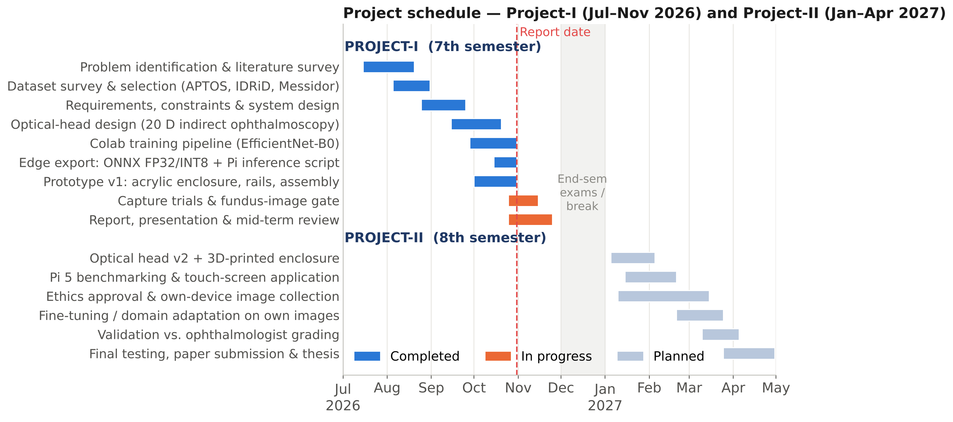
Figure B.1: Project schedule — Project-I and Project-II, month by month.

Appendix C: Datasheets and Design Calculations

Key datasheet parameters
Table C.1: Raspberry Pi 5 — parameters relevant to the design [53]
Parameter | Value
SoC | Broadcom BCM2712, 4 × Arm Cortex-A76 @ 2.4 GHz (ARMv8.2-A, incl. dot-product instructions)
Memory | 4 GB LPDDR4X-4267 (2 / 8 GB variants available)
Camera / display | 2 × 4-lane MIPI CSI/DSI transceivers (22-pin FPC)
I/O controller | RP1 — GPIO with hardware PWM, UART, SPI, I²C
Power input | USB-C, 5.1 V / 5 A with USB PD
Logic level | 3.3 V GPIO
Operating system | Raspberry Pi OS (Bookworm, 64-bit)

Table C.2: Raspberry Pi Camera Module 3 NoIR — parameters relevant to the design [39]
Parameter | Value
Sensor | Sony IMX708, 11.9 MP, 4,608 × 2,592 pixels, 1.4 µm pixel
Lens | f = 4.74 mm, f/1.8, motorised autofocus (minimum ≈ 10 cm)
Field of view (standard) | 66° horizontal, 41° vertical
Infrared | No IR-cut filter (NoIR) — sensitive to 850 nm
Interface | MIPI CSI-2, 2 lanes

Table C.3: Components of the LED driver
Component | Key parameters used in the design
AO3400 N-MOSFET | V_{DS} 30 V; I_{D} 5.7 A; V_{GS(th)} 0.65–1.45 V; R_{DS(on)} ≈ 50 mΩ @ V_{GS} = 2.5 V; SOT-23
850 nm IR LED (5 mm) | V_{f} ≈ 1.5 V @ 50 mA; narrow viewing angle (≈ 20–30°)
Warm-white LED (5 mm) | V_{f} ≈ 3.0 V @ 20 mA; ≈ 3,000 K
Resistors | 68 Ω and 100 Ω, 0.25 W, ±5 % (current limit); 220 Ω gate; 100 kΩ pull-down; 10 kΩ button pull-up
20 D condensing lens | f = 50 mm; double-aspheric; ≈ 50 mm clear aperture; static field ≈ 45°

Summary of design calculations
Table C.4: Summary of design calculations
Quantity | Expression | Result
Condensing-lens focal length | f = 1 / P = 1 / 20 D | 50 mm
Aerial-image magnification | m ≈ P_{eye} / P_{lens} = 60 / 20 | 3×
Retinal patch (≈ 45° field) | 45° × 0.29 mm/° | ≈ 13 mm
Aerial-image size | 3 × 13 mm | ≈ 39 mm
Required angular size for 1,400 px | 66° × 1,400 / 4,608 | ≈ 20°
Camera-to-aerial-image distance | (39 / 2) / tan 10° | ≈ 111 mm
Sensor sampling of retina | 13 mm / 1,400 px | ≈ 9.3 µm/px
Model-input sampling (384 px) | 13 mm / 384 px | ≈ 34 µm/px
IR LED resistor | (5.0 − 1.5) V / 50 mA | 70 Ω → 68 Ω
IR resistor dissipation | (51.5 mA)² × 68 Ω | 0.18 W
White LED resistor | (5.0 − 3.0) V / 20 mA | 100 Ω
MOSFET conduction loss | (0.206 A)² × 0.05 Ω | ≈ 2 mW
Gate charging current | 3.3 V / 220 Ω | 15 mA
Peak power | Sum of Table 3.7 | ≈ 9.8 W
Battery runtime | 31 Wh usable / 7 W | ≈ 4.4 h
Energy per screening | 7 W × 3 min | ≈ 0.35 Wh

Appendix D: Code, Design Files and Data

Table D.1: Repository information
Repository link | https://github.com/Omm-Sanjog/[repository-name]
Contents | DR_Fundus_Training.ipynb (training notebook); dr_pi_bundle/ (Raspberry Pi package); cad/ (enclosure files); figures/ (scripts that regenerate every figure in this report); docs/ (report, test records)
How to run — training | Open the notebook in Google Colab → Runtime → Change runtime type → T4 GPU (or CPU if no GPU is available) → Runtime → Run all. The notebook downloads APTOS 2019 automatically and finishes by downloading dr_pi_bundle.zip.
How to run — Raspberry Pi | unzip dr_pi_bundle.zip -d ~/dr && cd ~/dr; python3 -m venv venv && source venv/bin/activate; pip install -r requirements_pi.txt; python3 pi_inference.py eye.jpg or python3 pi_inference.py --camera
Data | APTOS 2019 via Hugging Face mirrors sngsfydy/aptos (full resolution) and bumbledeep/aptos (224 px); not redistributed in the repository
Licence | MIT for team code and design files (planned)

Key code excerpts
Fundus pre-processing (shared by training and the Pi).
def preprocess_fundus(img_rgb, size=384, ben_graham=True):
"""RGB uint8 image in -> RGB uint8 (size x size) out."""
img = pad_to_square(crop_fundus(img_rgb))
img = cv2.resize(img, (size, size), interpolation=cv2.INTER_AREA)
if ben_graham: # local contrast normalisation
blur = cv2.GaussianBlur(img, (0, 0), sigmaX=size / 30)
img = cv2.addWeighted(img, 4, blur, -4, 128)
mask = np.zeros((size, size), np.uint8)
cv2.circle(mask, (size // 2, size // 2), int(size * 0.47), 1, -1)
img = img * mask[:, :, None] + 128 * (1 - mask[:, :, None])
return img.astype(np.uint8)

Threshold optimisation on the validation set.
def optimize_thresholds(pred, y, init=[0.5, 1.5, 2.5, 3.5], rounds=3):
thr = list(init); best = qwk(y, to_grade(pred, thr))
for _ in range(rounds):
for i in range(4):
lo = thr[i - 1] + 0.02 if i > 0 else 0.0
hi = thr[i + 1] - 0.02 if i < 3 else 4.5
for c in np.arange(lo, hi, 0.02):
trial = thr.copy(); trial[i] = float(c)
s = qwk(y, to_grade(pred, trial))
if s > best:
best, thr = s, trial
return thr, best

On-device prediction with quality checks (`pi_inference.py`).
def predict(self, img_rgb):
cfg = self.cfg
problems = check_quality(quality_metrics(img_rgb), cfg)
x = preprocess_fundus(img_rgb, cfg["img_size"]).astype(np.float32) / 255.0
x = x.transpose(2, 0, 1)[None]
score = float(self.sess.run(None, {self.input_name: x})[0].reshape(-1)[0])
grade = int(np.digitize(score, cfg["thresholds"]))
return {"grade": grade, "grade_name": cfg["grades"][grade],
"score": round(score, 3), "referable": grade >= 2,
"image_ok": not problems, "quality_issues": problems}

Fundus-image gate.
def looks_like_fundus(rgb):
img = cv2.resize(rgb, (256, 256)).astype(np.float32)
lit = img.mean(axis=2) >= 20 # ignore black background
if lit.mean() < 0.05:
return False, 0.0
rg = float(np.median(img[..., 0][lit] / (img[..., 1][lit] + 1)))
return rg >= 1.6, rg

Appendix E: Individual Contribution Reports

One page per student. The contribution paragraphs follow the draft roles in Table A.1 — each student must review and personalise their own page before signing.
AI-BASED PORTABLE FUNDUS CAMERA AND ANALYSING UNIT FOR DIABETIC RETINOPATHY SCREENING
Omm Sanjog Barik — 2330382
Abstract (common to the group, ≤ 80 words): A low-cost, portable fundus camera and analysing unit was designed for offline diabetic retinopathy screening. A 20 D lens and Raspberry Pi NoIR camera capture the retina under infrared alignment and a short white flash; a Raspberry Pi 5 rejects ungradable or non-retinal images and grades the rest with an EfficientNet-B0 model trained on APTOS 2019 and exported to ONNX (16.0 MB); test QWK 0.877, referable sensitivity 93.7 %, specificity 90.8 %. The unit costs about ₹20,000 and targets primary health centres.
Individual contribution and findings: As team lead I defined the system architecture and requirements, designed the indirect-ophthalmoscopy optical layout and the sampling calculation that fixed the 160 mm lens-to-camera distance, dimensioned the IR and white LED drivers and the power budget, and produced the enclosure concept. I built the self-contained Colab training and export notebook and the Raspberry Pi inference bundle, and carried out the first capture trial, whose failure led directly to the fundus-image gate. The main technical lesson was that the reliability of an AI device is limited by the quality of its input as much as by the model.
Contribution to the report: Chapters 1, 3 and 4; Appendices B–D.
Contribution to the presentation and demonstration: System overview, hardware design and live demonstration of the Pi bundle.
Signature of Supervisor | Signature of Student

AI-BASED PORTABLE FUNDUS CAMERA AND ANALYSING UNIT FOR DIABETIC RETINOPATHY SCREENING
Laganjeet Jena — 2330378
Abstract (common to the group, ≤ 80 words): A low-cost, portable fundus camera and analysing unit was designed for offline diabetic retinopathy screening. A 20 D lens and Raspberry Pi NoIR camera capture the retina under infrared alignment and a short white flash; a Raspberry Pi 5 rejects ungradable or non-retinal images and grades the rest with an EfficientNet-B0 model trained on APTOS 2019 and exported to ONNX (16.0 MB); test QWK 0.877, referable sensitivity 93.7 %, specificity 90.8 %. The unit costs about ₹20,000 and targets primary health centres.
Individual contribution and findings: I studied the public DR datasets and selected APTOS 2019 for its Indian origin, analysed its class imbalance and designed the stratified split. I worked on the pre-processing and augmentation pipeline, ran the training experiments on Colab, tuned the grade thresholds and analysed the test results and Grad-CAM maps. I found that the colour and blur augmentations and the regression formulation matter most for the minority grades, and that single-grader labels limit the agreement achievable between adjacent grades.
Contribution to the report: Sections 4.2 and 5.1.4; Chapter 5 error analysis.
Contribution to the presentation and demonstration: Dataset, training and results.
Signature of Supervisor | Signature of Student

AI-BASED PORTABLE FUNDUS CAMERA AND ANALYSING UNIT FOR DIABETIC RETINOPATHY SCREENING
Piyush Raj — 2330383
Abstract (common to the group, ≤ 80 words): A low-cost, portable fundus camera and analysing unit was designed for offline diabetic retinopathy screening. A 20 D lens and Raspberry Pi NoIR camera capture the retina under infrared alignment and a short white flash; a Raspberry Pi 5 rejects ungradable or non-retinal images and grades the rest with an EfficientNet-B0 model trained on APTOS 2019 and exported to ONNX (16.0 MB); test QWK 0.877, referable sensitivity 93.7 %, specificity 90.8 %. The unit costs about ₹20,000 and targets primary health centres.
Individual contribution and findings: I worked on deploying the model to the edge: ONNX export with built-in normalisation, the parity check, static INT8 quantisation and the benchmarking of five candidate backbones. I designed the software architecture and state machine of the on-device application. The key finding was that post-training INT8 quantisation, although 70 % smaller, lowered test QWK from 0.877 to 0.570 and was slower than FP32 on an x86 processor, so the accuracy-gated export rule correctly deployed the FP32 model.
Contribution to the report: Sections 3.4, 3.5.4, 4.1.2–4.1.3 and 5.1.1–5.1.2.
Contribution to the presentation and demonstration: Edge deployment and benchmarking.
Signature of Supervisor | Signature of Student

AI-BASED PORTABLE FUNDUS CAMERA AND ANALYSING UNIT FOR DIABETIC RETINOPATHY SCREENING
Riddhi Khanna — 2330393
Abstract (common to the group, ≤ 80 words): A low-cost, portable fundus camera and analysing unit was designed for offline diabetic retinopathy screening. A 20 D lens and Raspberry Pi NoIR camera capture the retina under infrared alignment and a short white flash; a Raspberry Pi 5 rejects ungradable or non-retinal images and grades the rest with an EfficientNet-B0 model trained on APTOS 2019 and exported to ONNX (16.0 MB); test QWK 0.877, referable sensitivity 93.7 %, specificity 90.8 %. The unit costs about ₹20,000 and targets primary health centres.
Individual contribution and findings: I carried out the literature review of automated DR screening, edge AI and low-cost fundus imaging and identified the research gap. I studied the applicable standards and regulations (ISO 15004-2, ISO 14971, IEC 62304, Medical Devices Rules 2017, DPDP Act 2023), prepared the risk register and the ethics and consent plan, and wrote the test plan. I found that field studies identify image quality and connectivity — not model accuracy — as the main barriers to AI screening, which shaped the offline, gated design.
Contribution to the report: Chapters 2, 6 and 7.
Contribution to the presentation and demonstration: Literature, standards, ethics and future work.
Signature of Supervisor | Signature of Student

Appendix G: Publications, Patents and Certificates

No publication, patent application or certificate has resulted from this project at the time of submission of the Project-I report.
Planned outcomes for Project-II:
- A conference or journal paper reporting the device design and its validation against ophthalmologist grading on images captured with the team’s own optical head.
- A patent-landscape search before public release of the hardware design (Section 2.2), to decide whether any element — for example the integrated quality-gated capture-and-grade workflow — merits a patent application.
- Public release of the code, notebook and enclosure design files under an open licence.

