 |  | IEC 61010-1
Clause | Requirement — Test |  | Result — Remark | Verdict

6 | TABLE: Protection against electric shock - Block diagram of system Form A.5 |  |  |  |  |  |  |  |  |  | P
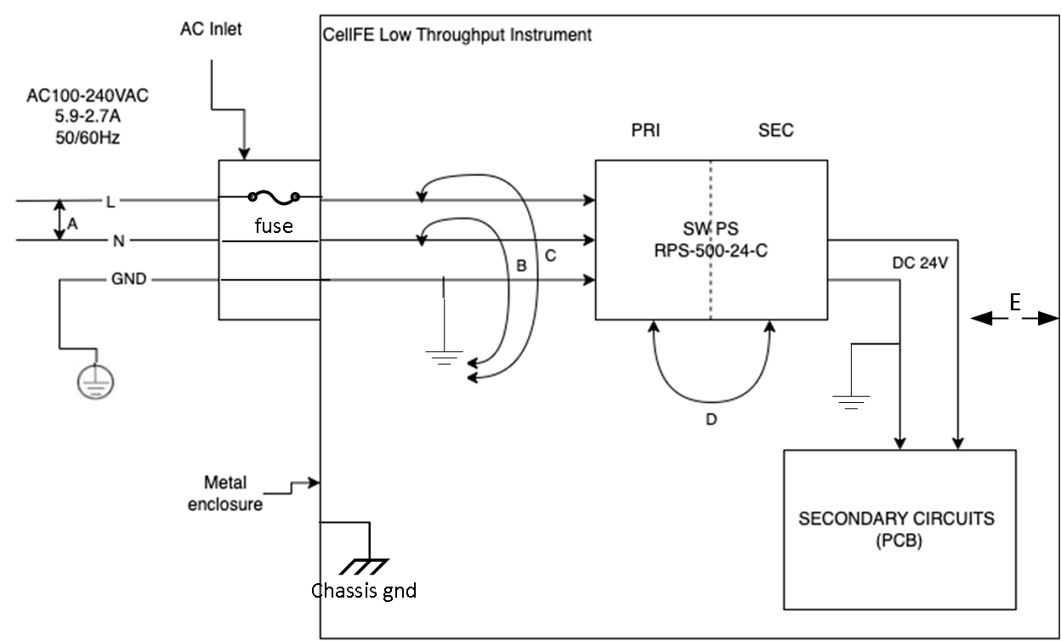
Pollution degree :2 |  |  |  |  | Overvoltage category: Ⅱ
Location or | Insulation type | Maximum working | CREEPAGE Distance (NOTE 3) |  |  |  |  | CLEARANCE (NOTE 3) | Test voltage | Comments
description | (NOTE 1) | voltage  (NOTE 2) | PWB mm | CTI |  | Other mm | CTI | mm | (NOTE 2) V
A | BI | 240Vrms | 1.5 | ≧100 |  | 3.0 | >100 | 1.5 |  | Line to Neutral before fuse
B and C | BI | 240Vrms | 1.5 | ≧100 |  | 3.0 | >100 | 1.5 |  | Line neutral to GND
D | RI or DI | 240Vrms+24V dc | 3.0 | ≧100 |  | 6.0 | >100 | 3.0 |  | Part of power supply
E | BI | 24Vdc | 0.04 | ≧100 |  | 1.25 | ≧100 | 0.5 |  | Secondary to chassis
NOTE 1 – Type of insulation: NOTE 2 - Types of voltage NOTE 3 - INSTALLATION CATEGORIES
BI = BASIC INSULATION Peak impulse test voltage (pulse) (OVERVOLTAGE CATEGORIES)
DI = DOUBLE INSULATION r.m.s. or POLLUTION DEGREES which differ from
PI = PROTECTIVE IMPEDANCE d.c. these should be shown under "Comments".
RI = Reinforced INSULATION peak SI = Supplementary INSULATION

