|  |  |
| --- | --- |
| **Service** | **Status** |
| Google Webmaster Tools | Submitted with xml sitemap ✓ |
| Bing Webmaster Tools | Submitted with xml sitemap ✓ |
| Meta tags | Inserted Properly ✓ |
| Keywords Density in Meta Tags | Good and Safe ✓ |
| Site Country | US ✓ |
| Analytics Setup | Already Done ✓ |
| H1 tags for titles and Header | Done, SEO Friendly Urls ✓ |
| SEO Friendly and optimized permalinks | Done ✓ |
| XML sitemap submission to Bing | Done ✓ |
| XML sitemap submission to Google | Done ✓ |
| Analytics Code | Already Inserted Properly ✓ |
| Malware / Virus Scan | Done ✓ |
| Scan Results: | No Malware / Virus is Detected ✓ |
| Google Webmasters html tag inserted | Successfully Updated ✓ |
| Bing Webmasters html tag inserted | Successfully Updated ✓ |
| Google Index Rate | Very Good and Fast ✓ |
| Sitemap Priority | Daily ✓ |
| Bing Index Rate | Good ✓ |
| Image alt tags | Done ✓ |
| All page Optimization | Not Available in Shopify ✓ |
| Total Plugins and Extentions | Not Available in Shopify ✓ |
| Site Platform | Shopify.com ✓ |
| XML Sitemap Generated by: | Shopify Web Builder ✓ |
| Broken Links Found | **1** |
| Broken Links Fixed | **1**/**1** |

The following screenshot of your Google Webmaster tools, showing that site is running fine and active for search.

I have submitted your site to Google Search via Google Webmaster tools, and I also submitted your xml Sitemap to Google Webmaster Tools, So google bots will crawl and index all of your pages for Search Engines Result Pages (SERP’s).

And when someone will search for you relevant keywords then Google will show your site in the search pages.

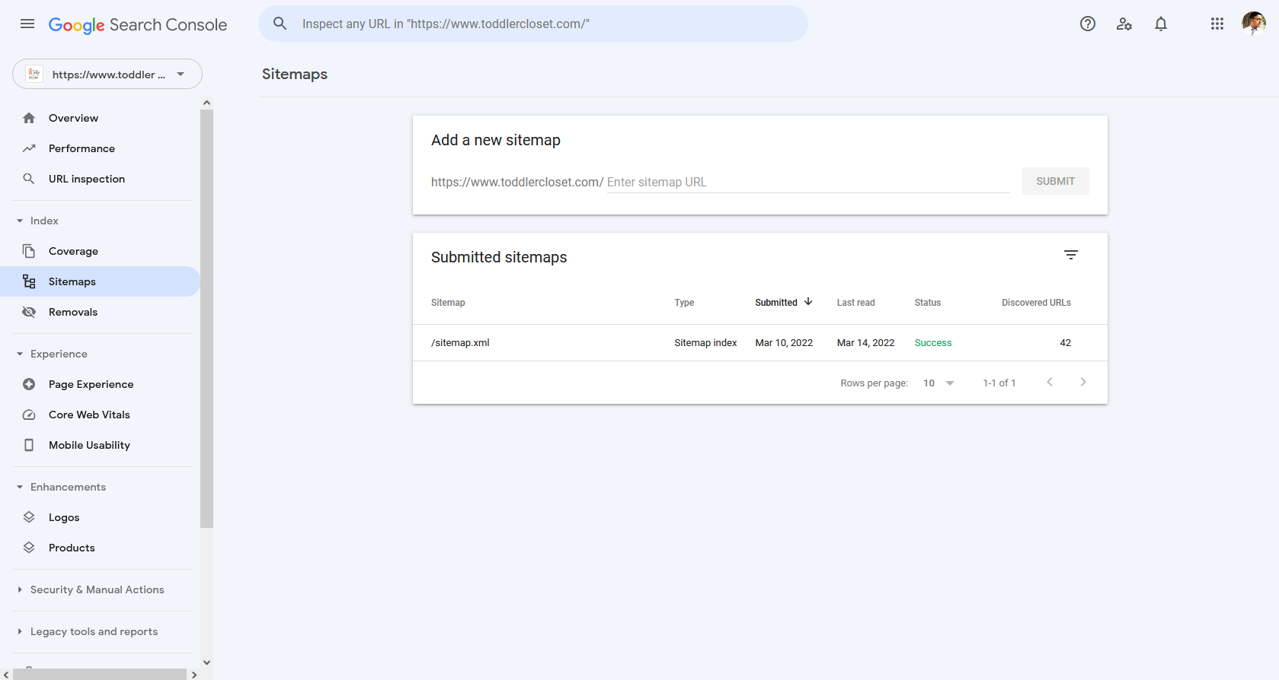

The Following screenshot is taken from your Bing Webmaster tools.I submitted your website to Bing Search with the help of Bing Webmaster tools along with your xml sitemap.Same like as google, bing’s bots will search, crawl and index your site for their Search Pages.

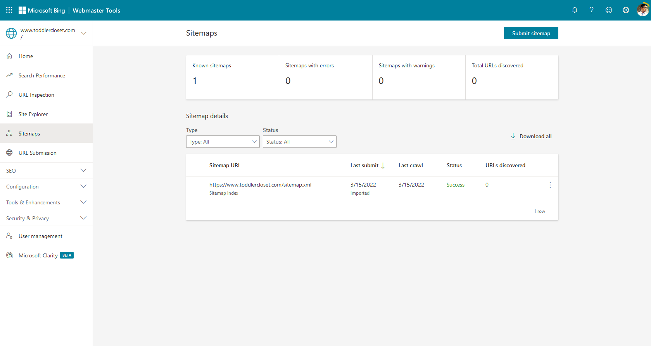

* **Google Analytics:**

Already Done!

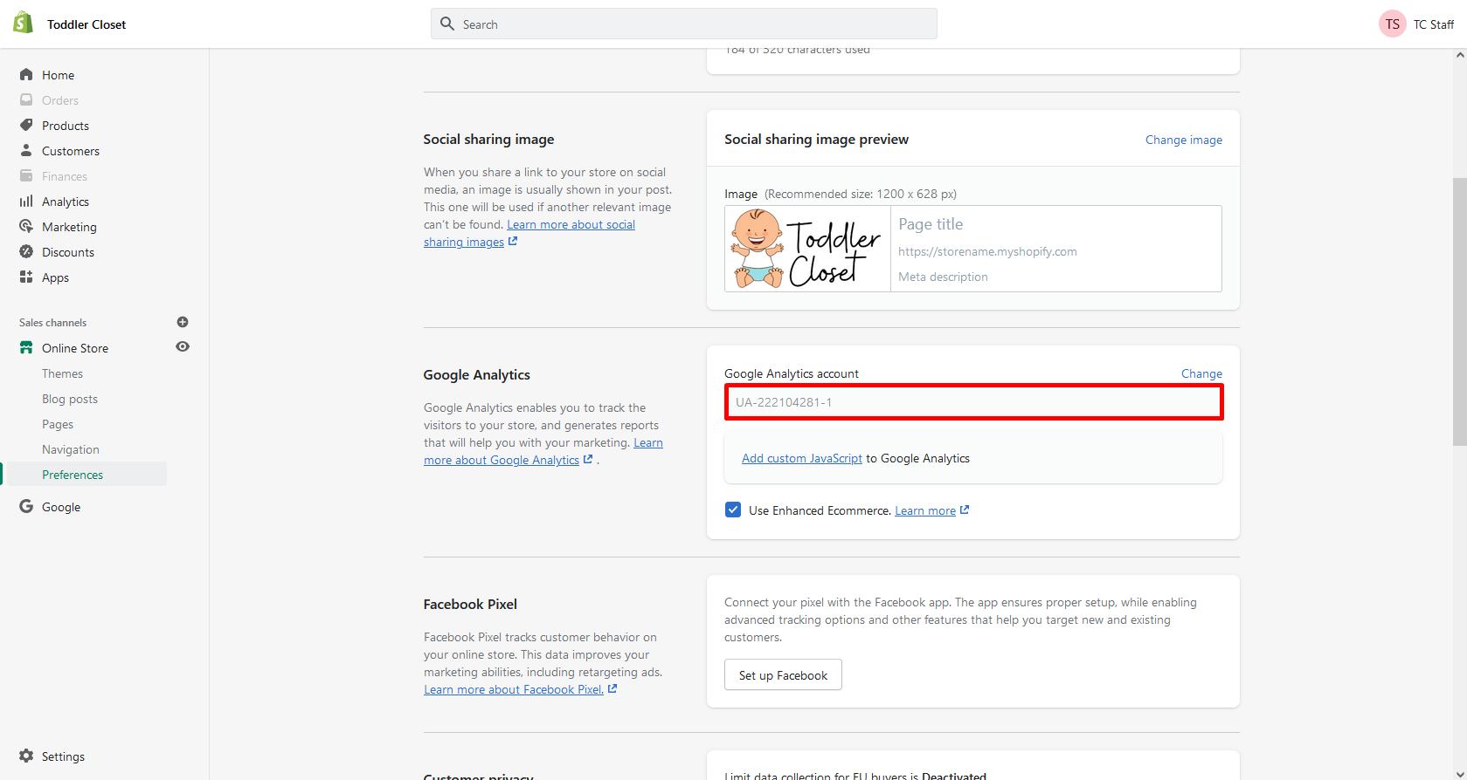

* I did a deep Keywords Research to find Most Searched and best keywords with low Competition and higher monthly searches.
* List of Researched Keywords and Finalized Keywords are attached.
* It is highly recommended to use these finalized keywords in your meta titles, descriptions, Headings, sub-headings and in the content.
* I submitted your website to Google and Bing Search Engines, with the help of Webmaster tools.
* I also verified your website in Google and Bing Webmaster tools by Meta Tags method.
* I created and submitted your sitemap with the help of Google XML sitemaps.
* I checked your website’s title, it is not very good, you should change it to make it SEO-Friendly as well as User-Friendly, for example:

|  |  |
| --- | --- |
| **Old Title** | **New Title** |
| **Toddler Closet - The Store for your Toddler** | **Toddler Closet - Buy Baby Essentials, Beds, Toys & Training Products** |

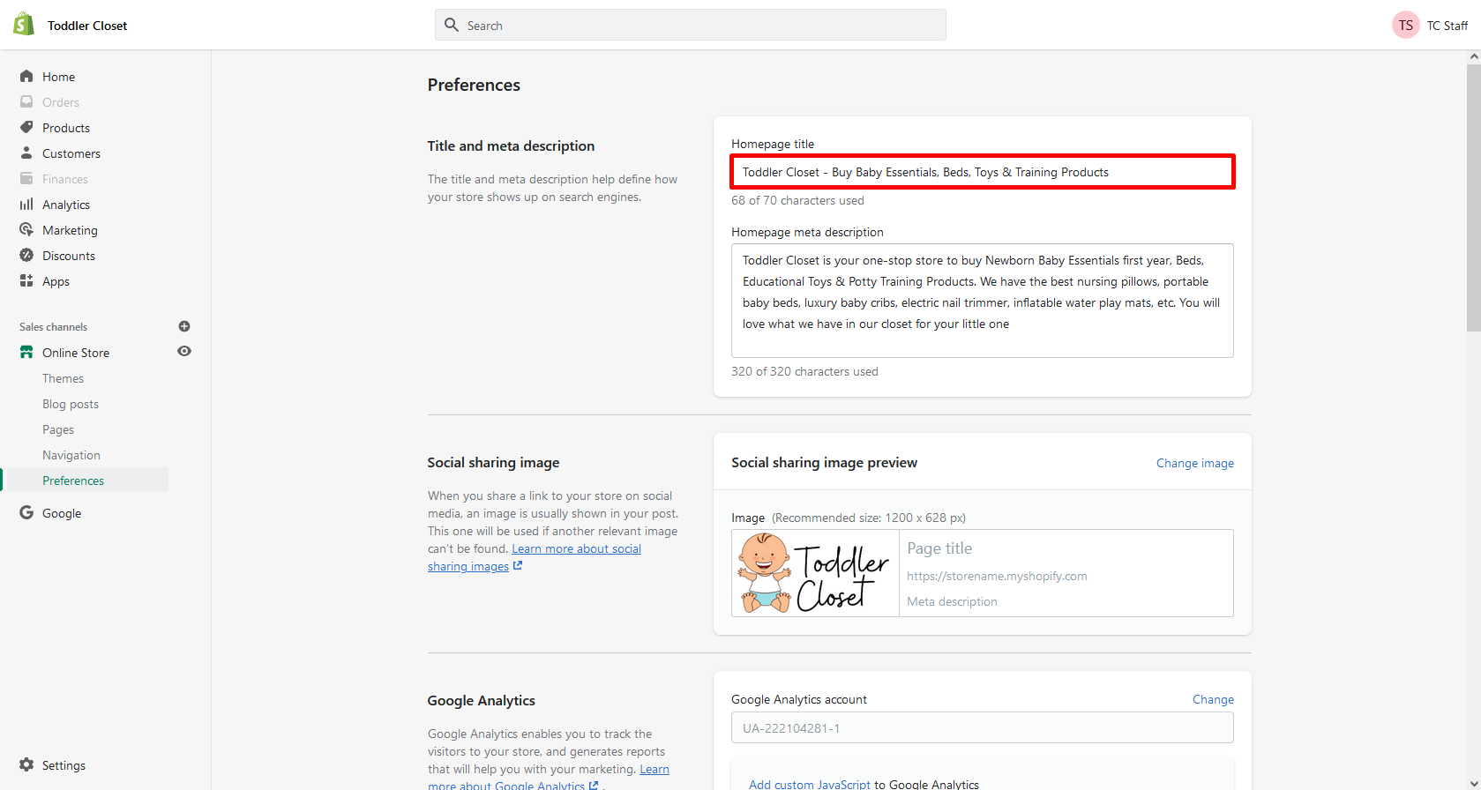

* The above title is just an **example of a SEO-Friendly title**, you can change it with your own expertise, keeping in mind that you should use some finalized keywords in it.
* I also checked description for your store’s homepage, It was quite good for users but not for the **Search Engines** so I’ve made some changes in it. You can also update it with some of the Finalized Keywords, Relevant Keywords and info about your store/products to make it more SEO-Friendly as well as User-Friendly:

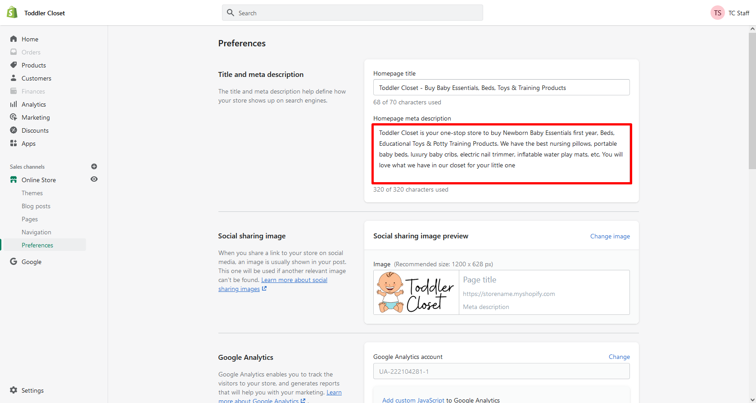

* You should be adding Keywords to make it SEO-Friendly and Some info and summary about your store and products to make it User-Friendly as well.
* (**Tip**) Shopify auto generates the meta description for your products, however you can edit that description/summary with your own keywords and info, to make it more SEO-Friendly as well as User-Friendly for more SEO Advantage and Exposure in Search Engine Result Pages SERP’s:

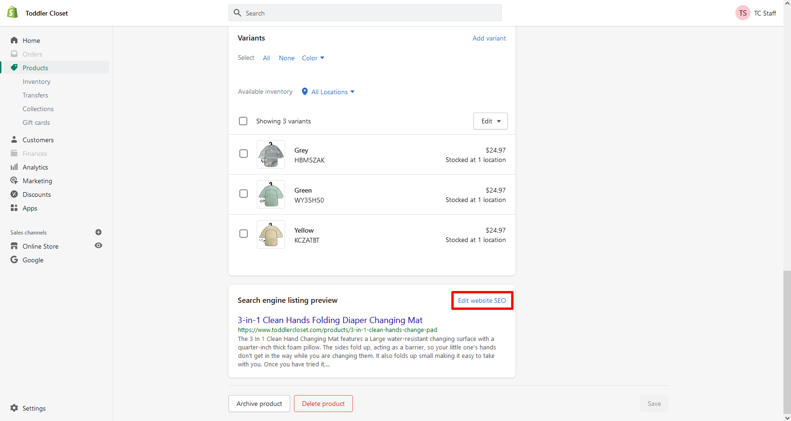

* It is recommended to have maximum 160 characters in meta description.
* To change the descripton and other settings you should follow **5 things**:

1. **Change the title of product page, by adding your main product target keywords in it, adding keyword in the start will be very helpful.**
2. **Change the description with suitable relevant keywords and limit should be 160 characters. Neither Less Nor More.**
3. **Change the URL for more SEO Exposure, For Example, If your title is: “Buy iphone 6 with 32GB Memory and 2 GB RAM” then your URL structure will be something like this:** [**www.sitename.com/products/buy-iphone-6-32gb-memory-2gb-ram-online**](http://www.sitename.com/buy-iphone-6-32gb-memory-2gb-ram-online) **or even more simpler and better like this: www.sitename.com/products/buy-iphone-6-32gb-2gb**
4. **URL should have main target keywords and should not have stopping words like the, is, an, a, etc.**
5. **URL can also have extra keywords, which are not present in title, like I use keyword “Online” in the above URL as example.**

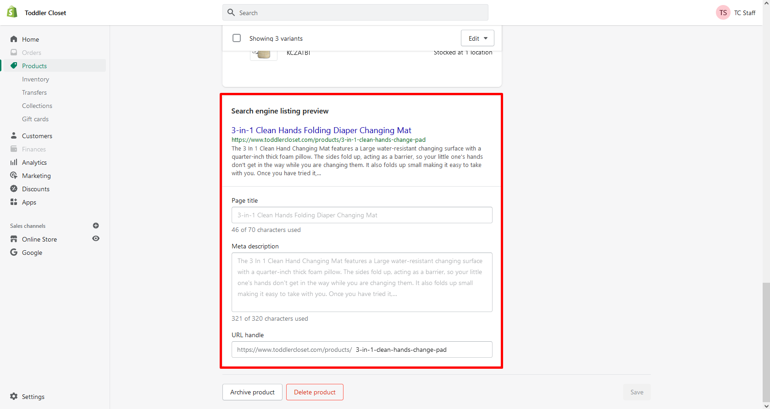

* It is also recommended to include your main and targeted keywords in the meta description, the best position is the start of the description.
* I have added image alt tags to all of your products images with the help of a free app, these tags will help your images to appear in Google Image Search when similar/relevant keywords will be searched:

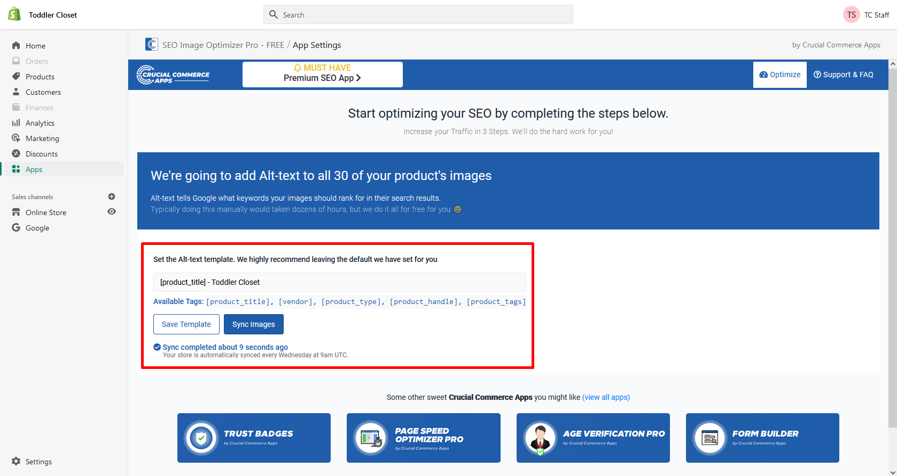

* I also checked your pages, pages also generate the meta description from the content. But adding your own customized and optimized meta description can help you to rank better, here is an example of customized Page Title and Meta Description you have for “About Us” page. Make sure it has maximum 160 characters and some finalized keywords if you write custom meta description.(**Make sure that your page’s meta description should have page name in it and start of description would be a fruitful position**), see the example:

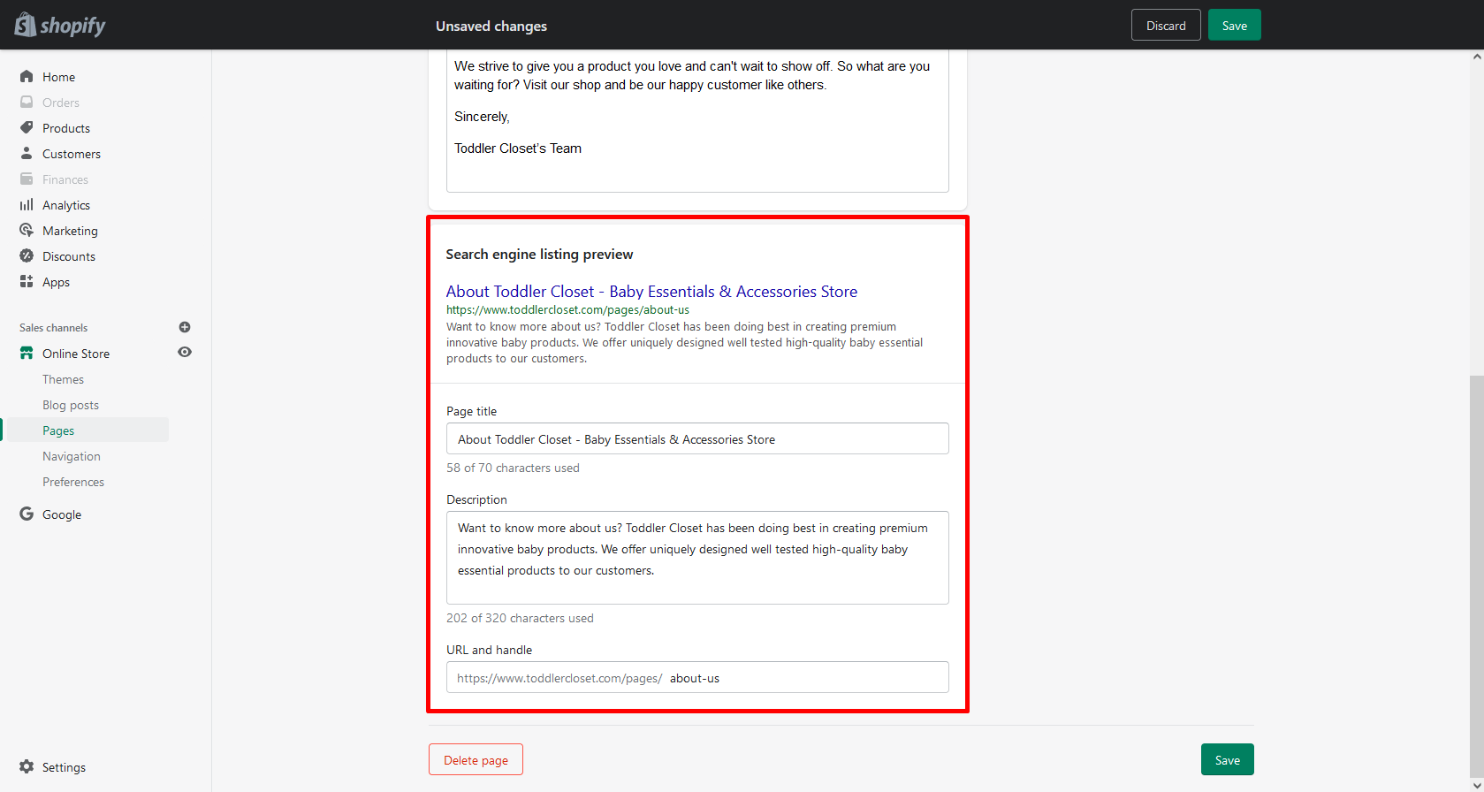

**Pages Optimization:**

* **I optimized other important pages as well, the details are:**

**Contact Us:**

I changed and customized it’s SEO Title and Meta Description with proper keywords to make them SEO-Friendly as well as User-Friendly and maintained the Keywords Density:

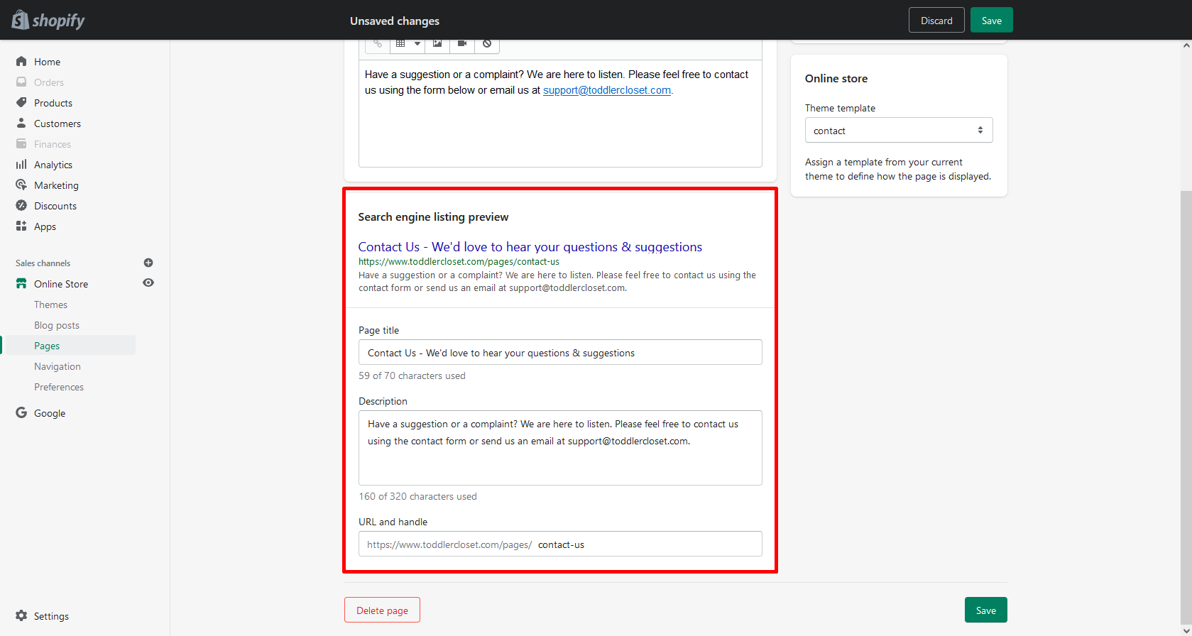

**Collections Optimization:**

**I have also optimized the important collections & a few products to make them SEO Friendly and User Friendly by adding proper SEO Meta Tags (Meta Titles, Descriptions & URL’s) for them, the details are:**

**Baby Toys:**

**I changed and customized it’s SEO Title and Meta Description with proper keywords to make them SEO-Friendly as well as User-Friendly and maintained the Keywords Density:**

|  |  |
| --- | --- |
| **Old Title** | **New Title** |
| **Baby Toys** | **Best Baby Toys - Beach Tent, Water Play Mat, Neck Float Ring Tube** |

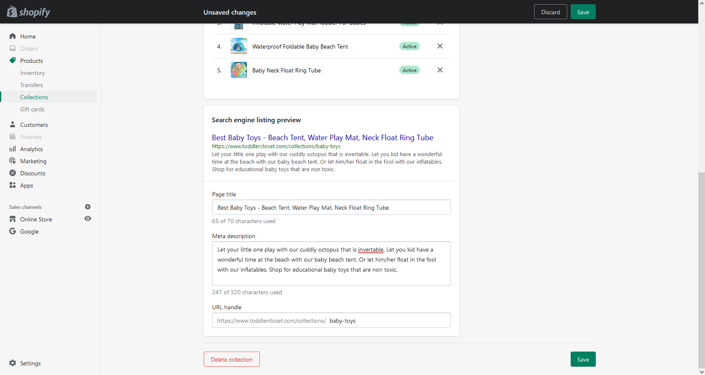

**Baby Training:**

**I changed and customized it’s SEO Title and Meta Description with proper keywords to make them SEO-Friendly as well as User-Friendly and maintained the Keywords Density:**

|  |  |
| --- | --- |
| **Old Title** | **New Title** |
| **Baby Training** | **Baby Training Products - Potty Seats & Urinal Trainers** |

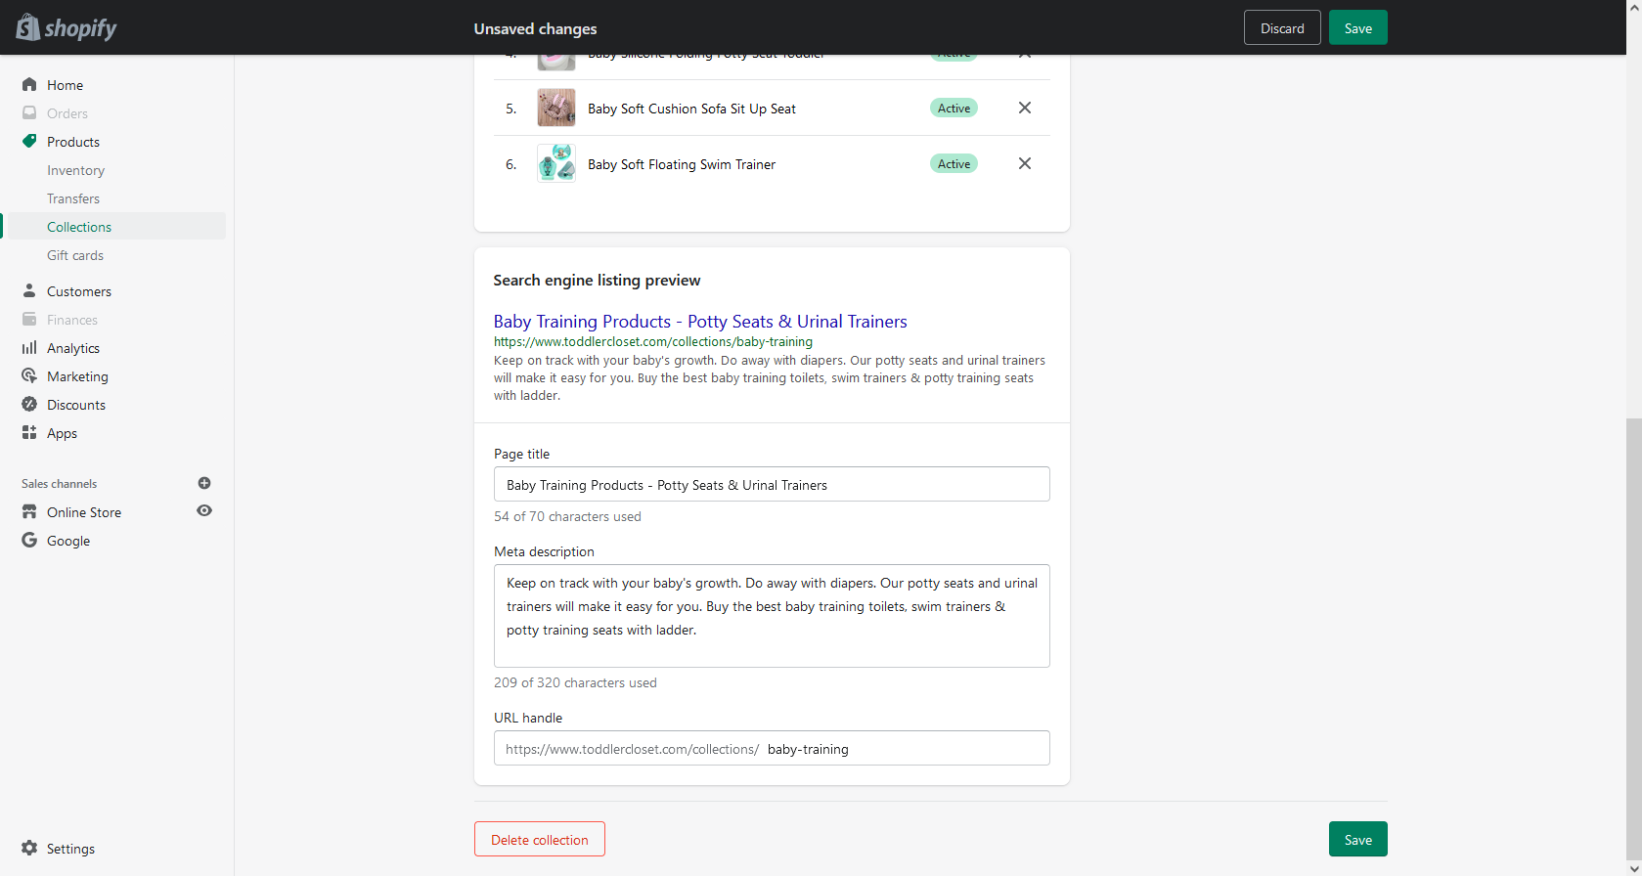

**Baby Essentials:**

**I changed and customized it’s SEO Title and Meta Description with proper keywords to make them SEO-Friendly as well as User-Friendly and maintained the Keywords Density:**

|  |  |
| --- | --- |
| **Old Title** | **New Title** |
| **Baby Essentials** | **Buy Baby Essentials: Nail Trimmers, Nasal Aspirators, Carriers & more** |

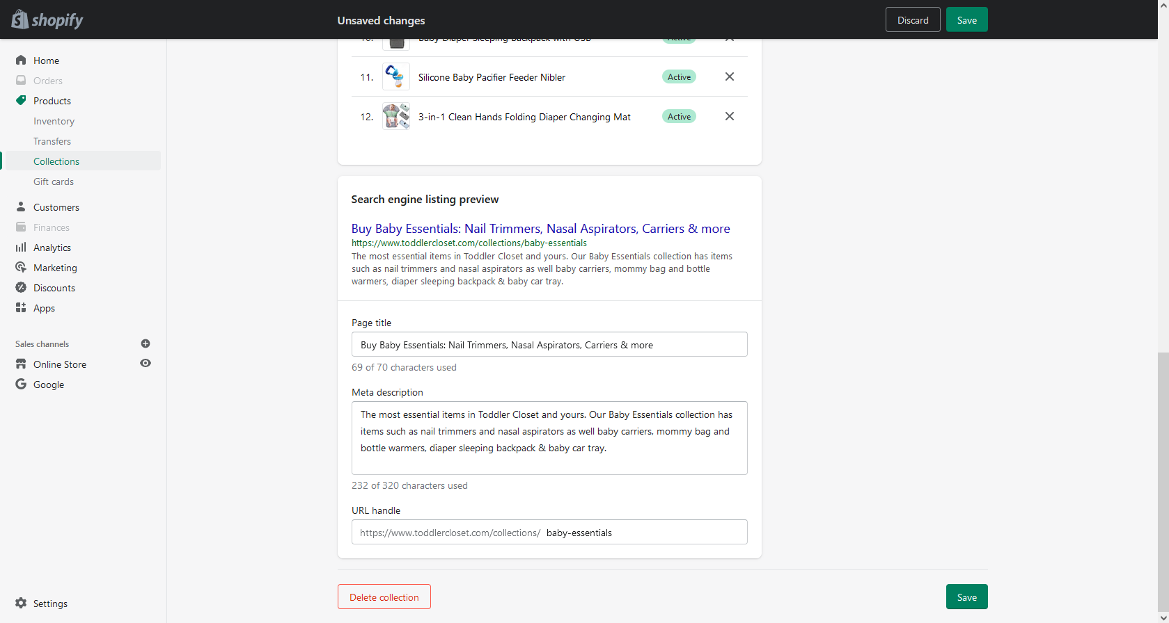

**Baby Beds:**

**I changed and customized it’s SEO Title and Meta Description with proper keywords to make them SEO-Friendly as well as User-Friendly and maintained the Keywords Density:**

|  |  |
| --- | --- |
| **Old Title** | **New Title** |
| **Baby Beds** | **Comfy Baby Beds - Head Protection & Nursing Pillows, Cribs & Beds** |

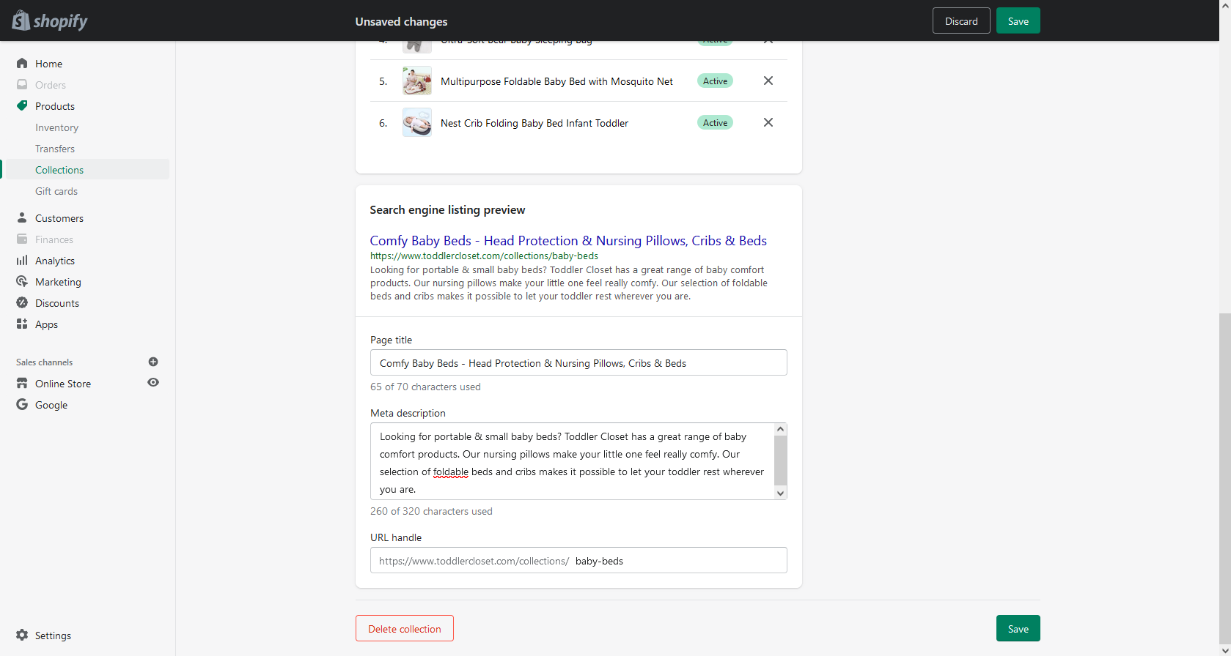

**Baby Silicone Folding Potty Seat Toddler:**

**I changed and customized it’s SEO Title and Meta Description with proper keywords to make them SEO-Friendly as well as User-Friendly and maintained the Keywords Density:**

|  |  |
| --- | --- |
| **Old Title** | **New Title** |
| **Baby Silicone Folding Potty Seat** | **Baby Silicone Folding Potty Seat - (Green/Blue/PInk)** |

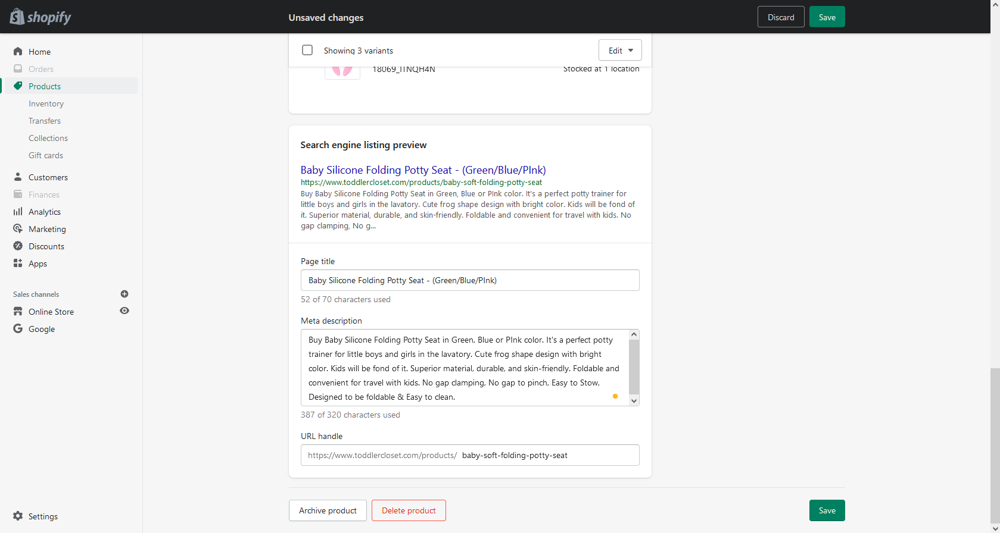

**Adjustable Baby Breastfeeding Nursing Pillow:**

**I changed and customized it’s SEO Title and Meta Description with proper keywords to make them SEO-Friendly as well as User-Friendly and maintained the Keywords Density:**

|  |  |
| --- | --- |
| **Old Title** | **New Title** |
| **Adjustable Baby Breastfeeding Nursing Pillow** | **Adjustable Baby Breastfeeding Nursing Pillow - Soft & Comfy** |

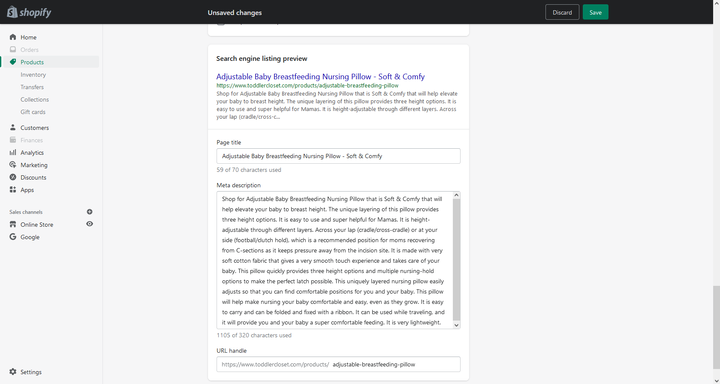

**Nest Crib Folding Baby Bed Infant Toddler:**

**I changed and customized it’s SEO Title and Meta Description with proper keywords to make them SEO-Friendly as well as User-Friendly and maintained the Keywords Density:**

|  |  |
| --- | --- |
| **Old Title** | **New Title** |
| **Nest Crib Folding Baby Bed Infant Toddler** | **Nest Crib Folding Baby Bed (Grey/Brown) - Portable & Comfy** |

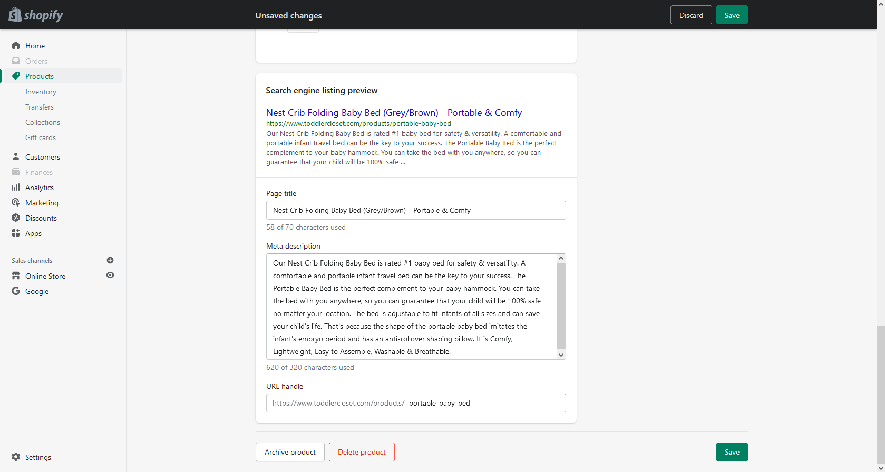

**Painless Electric Baby Nail Trimmer:**

**I changed and customized it’s SEO Title and Meta Description with proper keywords to make them SEO-Friendly as well as User-Friendly and maintained the Keywords Density:**

|  |  |
| --- | --- |
| **Old Title** | **New Title** |
| **Painless Electric Baby Nail Trimmer** | **Electric Baby Nail Trimmer (Blue/Pink) - Painless, Safer & Faster** |

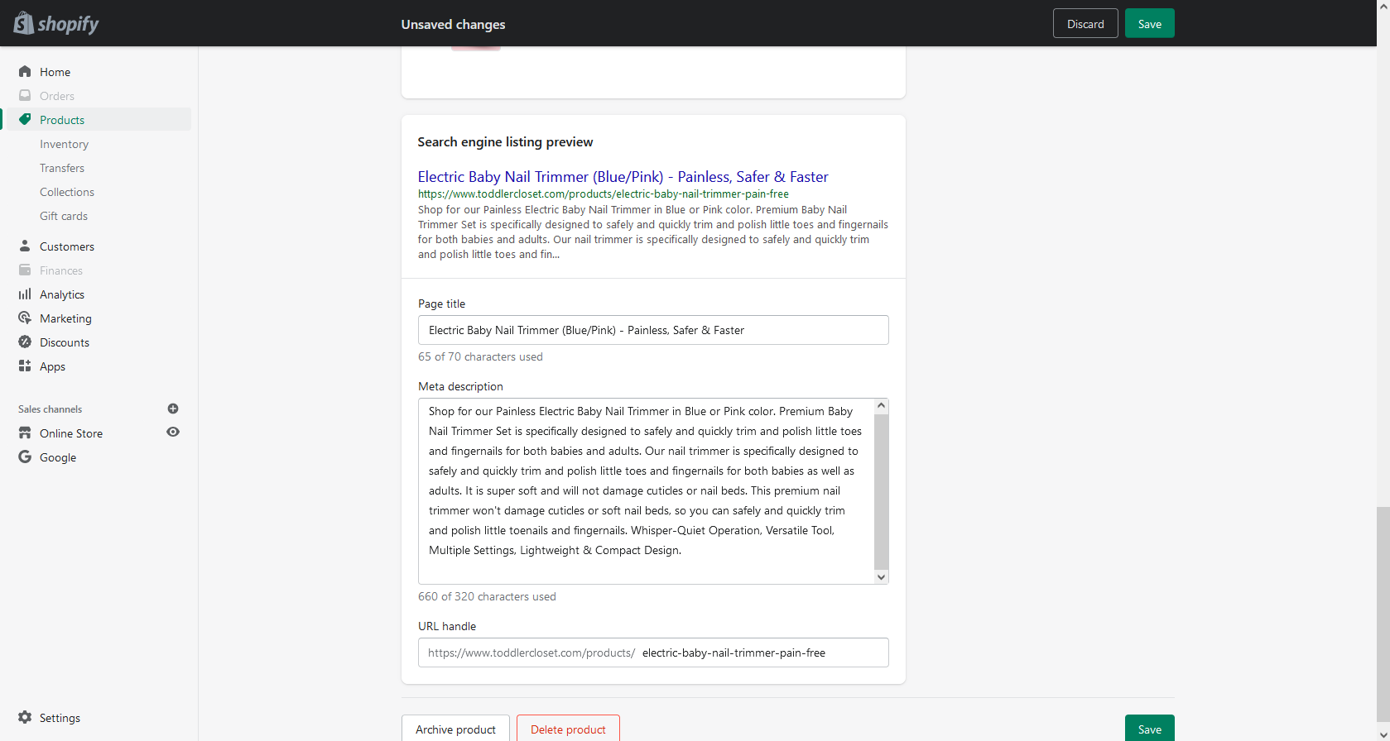

**Broken Links Status:**

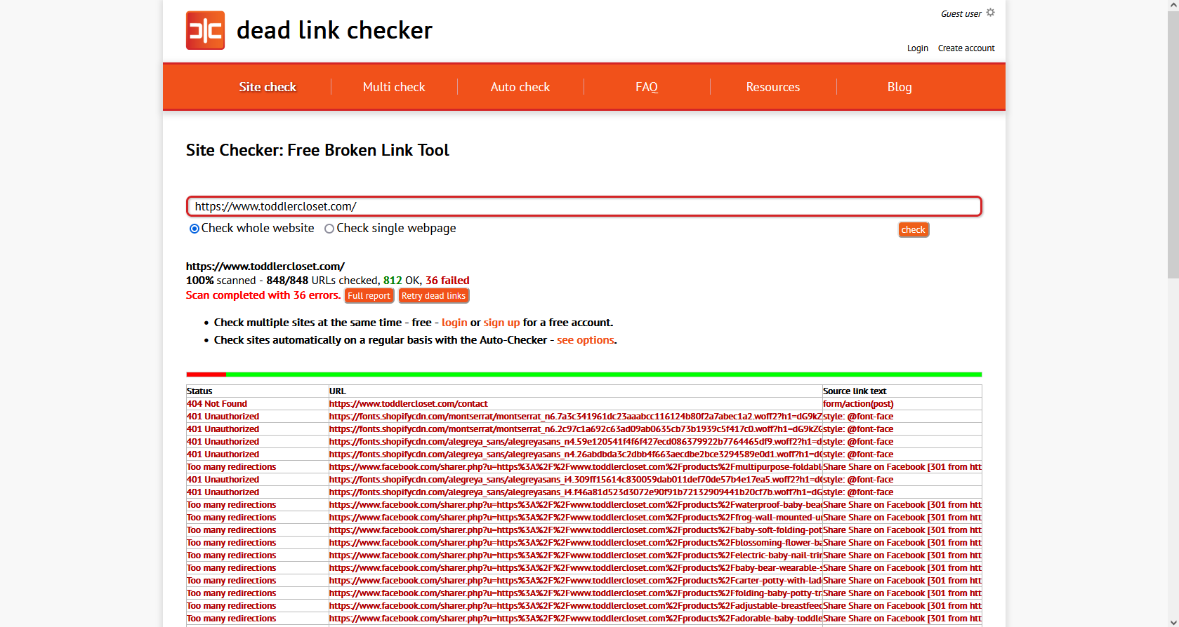

**After analyzing your website for broken links/dead links properly, I came to see only 1 broken/dead links, which has been fixed and redirected/pointed to its appropriate destinations:**

|  |  |
| --- | --- |
| **Broken/Dead Links** | **Fixed (Redirected to)** |
| <https://www.toddlercloset.com/contact> | <https://www.toddlercloset.com/pages/contact-us> |

**You can find the redirects on this page:**

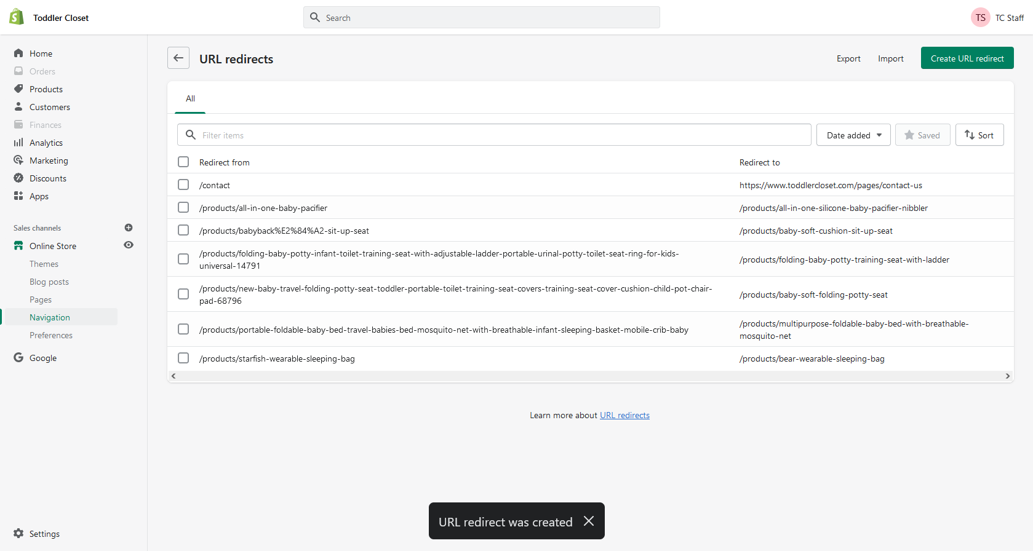

**Further Use of Keywords:**

Finalized Keywords are those keywords which I chosed from the list you provided and from some relevant keywords, on the basis of highest monthly searches.

You should use them in your:

* Titles
* Descriptions
* Content and Headings

**Help Zone**

Note that I am here to:

1. Check your site’s SEO anytime.
2. Help and guide you regarding SEO.
3. Fix and Solve your SEO issues.
4. Guide you for future strategies to enhance your SEO.
5. Do SEO updates and Maintenance.

**Feel free to ask for more work, I am here to help.**

**Don’t forget to contact me for more latest and affordable offers. Yeah I can give you discount, because you will be my repeated buyer/client.**

**Thanks for ordering my services,**

**Regards: www.fiverr.com/being_marketer**