**SE02**

**VEHICLE DETECTION SYSTEM**

B.S. (CS)/(SE) Final year project proposal

|  |  |  |  |  |
| --- | --- | --- | --- | --- |
| Sr.no | Name | Roll no | ST/CT No | Sec |
| 1 | ADNAN SAMAD | 19B-011-SE | ST-19010 | A |
| 2 | M.OMER.SIDDIQUI | 19B-004-SE | ST-19078 | A |
| 3 | ALISHA HAMEED | 19B-017-SE | ST-19018 | A |
| 4 | HAFIZ TAHA SHARIF | 19B-035-SE | ST-19041 | A |

Batch 2019

Date:

Department of Computer Science  
 UIT University

**Usman Institute of Technology**

**Department Of Computer Science**

**FINAL PROJECT APPROVAL FORM**

The Head of Department, Date:

Computer Science Department, Batch: _________

UIT University,

Karachi.

Subject: **Bachelor of Science in Computer Science/Software Engineering Final Year Project**

Respect Sir,

We, the below listed students of final Year BS _______ class, desire to undertake work on the following project.

We request you to kindly grant approval for undertaking the work on the above-cited project. I abide by all terms and conditions mentioned below.

1. I have selected this project on my own.
2. I have no objection working under the supervision of male/female supervisor, or if my project work is evaluated by male/female externals.
3. I am sure I can complete this project till _______________.
4. I am eager to work under the supervision of advisor assigned to this project.
5. I understand that FYP committee can modify the scope of the project as and when required.
6. I know that if do not appear in regular project progress presentations/milestones my project will be disqualified.
7. I know that if I do not appear in mid project presentation, whenever it is scheduled, I will not be eligible for final project viva
8. I fully understand that “***cheating***”**\*** may lead to cancelation of my project.
9. I understand that the decision of the FYP evaluation committee, for all issues, would be final, and no objections will be accepted.
10. I have no objection presenting my project to external or internal examiner assigned by the Head of the Department.
11. Project and Product deliverables at the time of submission of final year project every group is responsible to submit complete running system along with printed reports, source code, hardware (if any) etc to the project coordinator.
12. It would be the responsibility of Project coordinator to keep record of all projects in a system (in running form) as it would help to continue next project in continuation, depends upon the scope and application of project.
13. Proper dressing and way of presentation should be in English during proposal defend session, milestones and final presentations.
14. Marking of milestones and final presentation should be based on individual evaluation of each faculty members and marks would be granted during session.
15. When we go for proposal defends session a list of all previous projects with their brief introduction must be available during session for our reference. (Introduction, Scope of project, tools and technology and batch must be available).
16. I understand that it is my responsibility to update my advisor and FYP committee members with the status of my project and submit reports on time.

* Copying code from any resources
* Using off the shelf components without prior permission
* Outsourcing your project
* Hire a resource for the completing the FYP code or any part of the project.

Yours sincerely,

S.No. Roll No. Name Email Cell NO. Signature

1. 19B-011-SE ADNAN SAMAD [asamad@students.uit.edu](mailto:asamad@students.uit.edu) 0333-2423183

2. 19B-004-SE M.OMER SIDDIQUI [mosiddiqui@students.uit.edu](mailto:mosiddiqui@students.uit.edu) 0317-2271605

3. 19B-017-SE ALISHA HAMEED [ahameed@students.uit.edu](mailto:ahameed@students.uit.edu) 0312-2190077

4. 19B-035-SE HAFIZ TAHA SHARIF [hsharif@students.uit.edu](mailto:asamad@students.uit.edu) 0321-2591390

**TABLE OF CONTENTS**

Project executive summary 1

Project overview 1

Project objectives 1

Project scope 2

In scope: 2

Out of scope: 2

Deliverables produced 2

Project estimated effort/cost/duration 3

Estimated effort hours: 3

Estimated duration: 3

Project assumptions 4

Project risks 4

Project approach 5

Tools and technologies 5

Outstanding Issues 5

Expected Final product 5

Similar products available 5

List down similar products available online with URL.Project approvals: 5

Project approvals: 6

# Project executive summary

We wrote a initial proposal where we cover general aspect of our project. In this detail proposal we cover our detailed of our project.

# Project overview

*To secure the vehicles in a way that RFIDs will be install in number plates of vehicles so that if the car is being stolen, RFIDs will be detected through Google Map by giving the path & the location of vehicle with the help of installed RFIDs. It will also help the government by providing all the information of the vehicles so that government will easily find the unregistered & unpaid tax vehicles.*

# Project objectives

## *The Vehicle Detection System will meet the following objectives:*

## *•Objective of this project is to secure the vehicles in a way that if it is stolen, it will be detected through scanner installed on different location with the help of RFID tags and map it on Google Map with the last scanned location.*

## *•The Objective of this project is to provide the relevant information to the owners of vehicles so that they could know the location of their vehicles so it will be secure.*

## *•The last objective of this project is to provide all the information of the vehicles to excise department so that no-one could be able to run the vehicle without registering & without paying tax of the vehicle.*

# Project scope

The RFID scanner can scan the number and match the information of the owner and match this to the excise database. Moreover, the location of the vehicle will be sent to the control center, which will be helpful to identify the actual location in the city.

The scope of this project includes and excludes the following items.

## In scope:

To identify the loss of vehicles through its last mile status.

Track, Locate, Map. Computing power is required.

RFID number.

Newly registered vehicle through our website.

Mysql,Oracle.

Newly registered vehicles with RFID

## Out of scope:

For various points from where the car passes and reaches another point without mapping its last status.

Expense of long range scanner.

Cars which are not registered.

Vehicles without RFID e.g.Old cars

## 

## Deliverables produced

Project Deliverable 1: Non-working proto-type of the FYP.

Kindly prepare a video presentation and explain your work.

Actor use case diagram

Activity Diagram(workflow)

System diagram

Operational Diagram (for hardware-based Projects)

Project Deliverable 2: Class Diagram

Front-end (GUI/Web/ Mobile)

Sequence Diagram

Object Diagram and Entity Relation Diagram

If data driven application the exceptional report should be delivered

Else Algorithm Analysis.

Product Deliverable 1: Working Project in executable form with component, deployment and operational diagrams.

## Project estimated effort/cost/duration

This project is free of cost or for educational purposes. The duration of this project is 8 months.

**GANTT chart/ Increments/ sprints:**

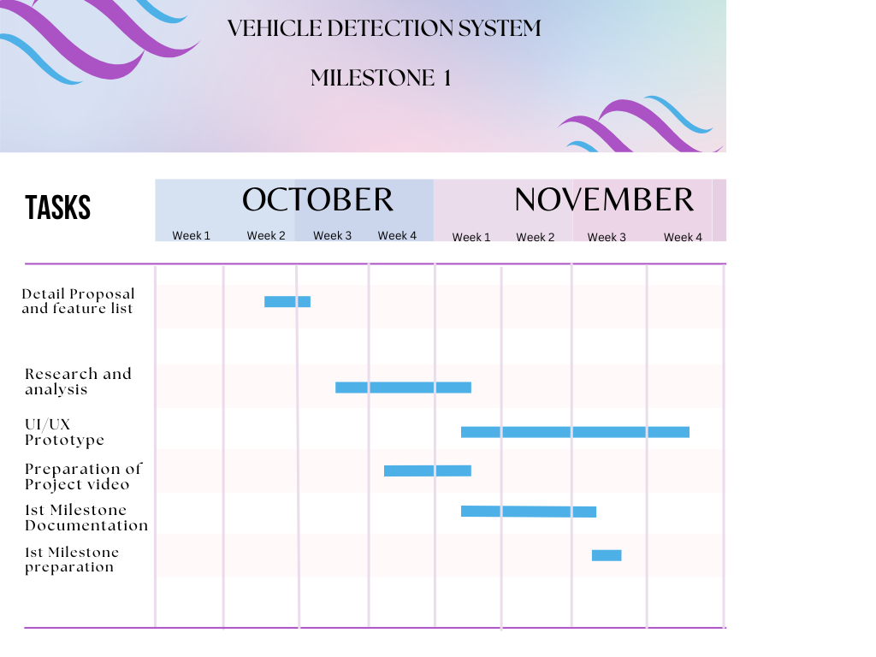

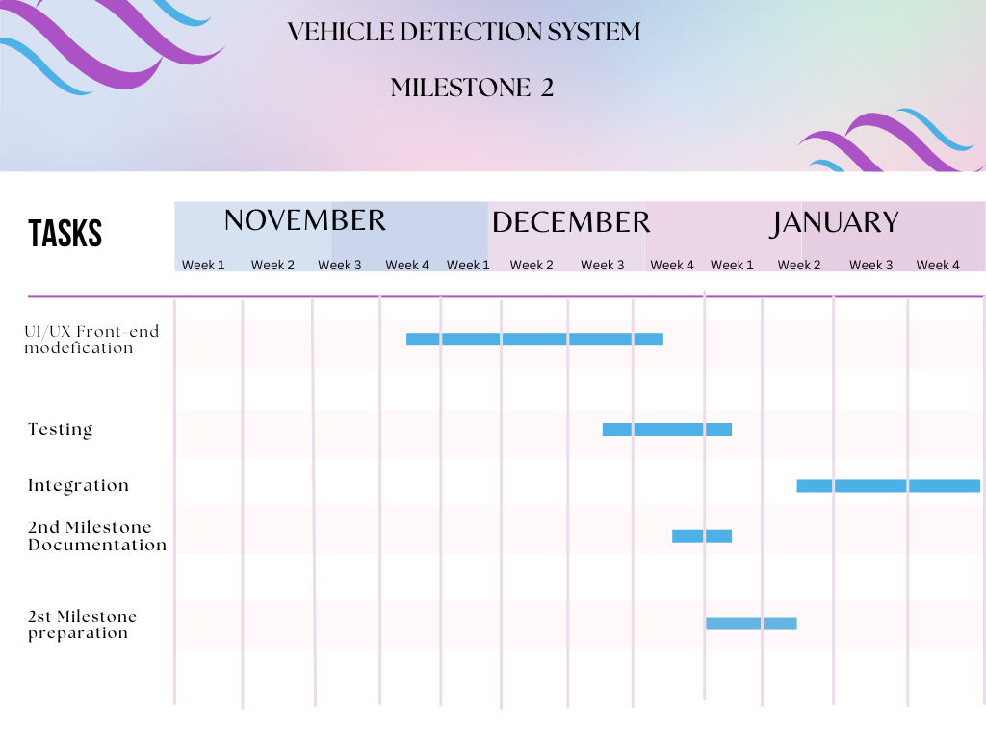

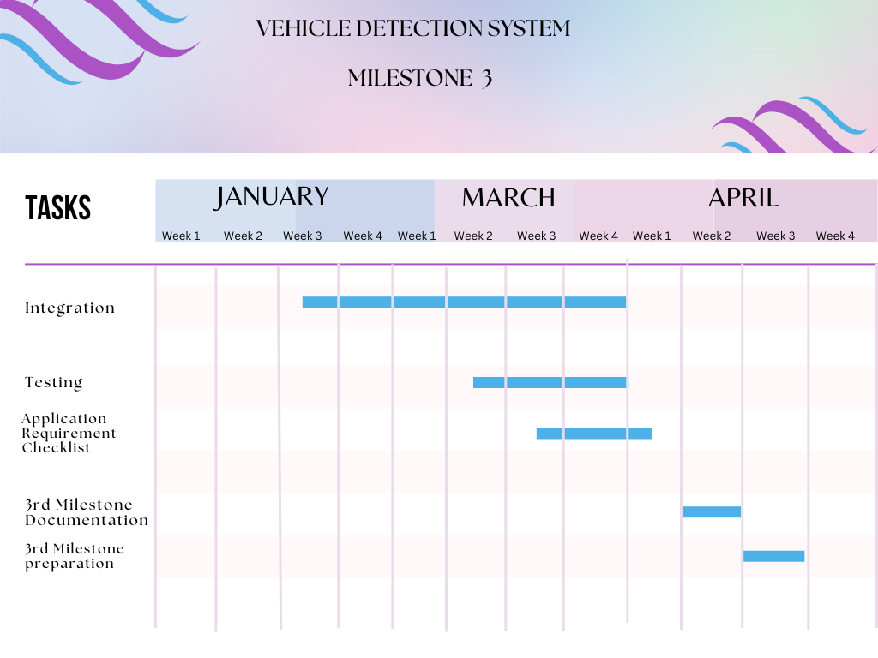

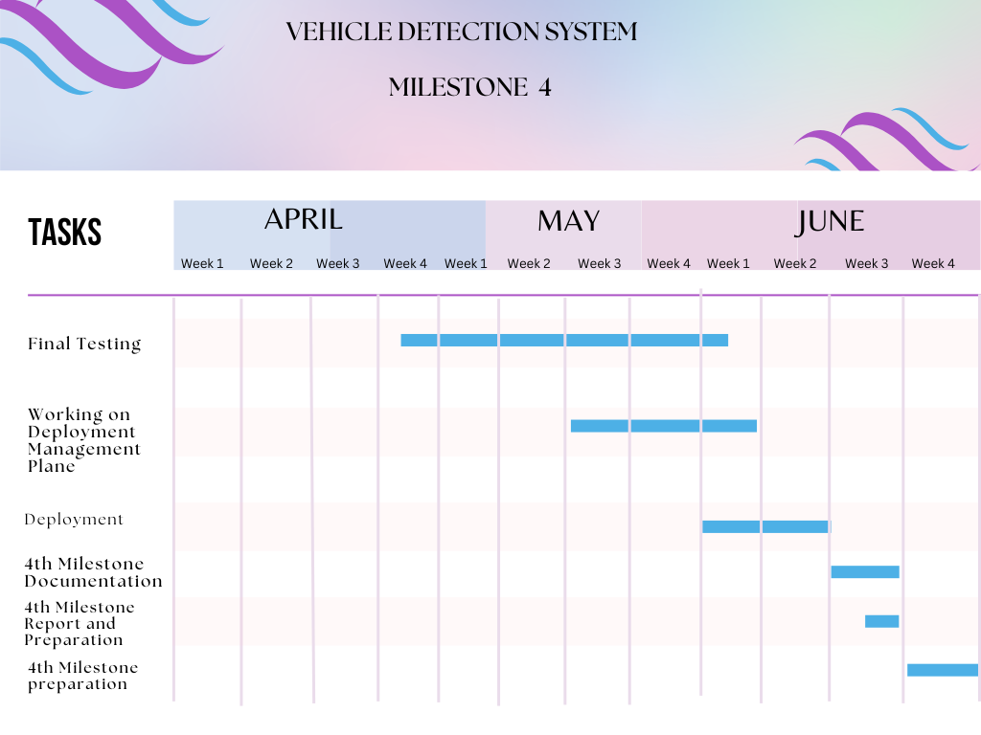

## Estimated effort hours:

|  |  |
| --- | --- |
| **Members** | **Estimated hrs per Week** |
| Adnan Samad | 5 hrs |
| M Omer Siddiqui | 5 hrs |
| Alisha hameed | 5 hrs |
| Hafiz Taha Sharif | 5 hrs |
|  |  |
| Discussion/Meeting with Supervisor | 2 hrs |

## Estimated duration:

|  |  |  |
| --- | --- | --- |
| **Milestone** | **Date completed** | **Deliverable(s) completed** |
| Project planning | 14/10/22 | 1. Project definition 2. Workplan |
| Milestone 1 | 20/11/22 | 1. Deliverable 1 2. Deliverable 2 |
| Milestone 2 | 30/12/22 | 1. Deliverable 3 |
| Milestone 3 | 10/02/23 | 1. Deliverable 4 |
| Milestone 4 | 10/04/23 | 1. Deliverable 5 |
| Project conclusion | 10/08/23 |  |

# Project assumptions

The owner of the cars can secure his car by locating his car 24/7

The owner critical information like credential can be stole and compromised

Installation of the project can be difficult and can bear expenses.

might be beneficial for government.

# Project risks

|  |  |  |
| --- | --- | --- |
| **Risk Area** | **Level (H/M/L)** | **Risk Plan** |
| 1. Scanner might be stolen. | M | GPS/SIM might be install in the scanner. |
| 2. Number plate might be replace. | H | RFID can be place inside the vehicle |
| 3. may try to skip scanner areas | H | May install the scanner on entry and exit areas |

# Project approach

We will follow the proper agile process like daily stand up meetings and keep tracking project status.

## Tools and technologies

This section is used to describe hardware, software, and libraries that will be used to successfully develop and implement the project, usually hardware is supported with its specifications, software with its versions, and libraries with its expected functions.

*Hardware: Scanner,Rfid,client-server*

*Software(s) : VS Code(latest version),Figma for designing.*

*Libraries : Django-framework*

# *Algorithms*

*Graph-generating algorithm*

# Expected Final product

*Our final product will be the tracking vehicle map which can search car through RFID scanning and can generate path of the vehicle with the last updated location from the checkpoint from where it passes. We require RFID scanner,RFID number plate and a server from which we extract our location and match the car information initiated with a RFID generated number.*

# Similar products available

# *This section is used to describe about the available products in market which are similar to your Project according to (Functional Activities), (GUI), (Reporting),etc*

# *Clearly mention the url with date in list order. Also mentioned the SIMILARITY FACTOR of your Project with the available online Project.*

|  |  |  |  |
| --- | --- | --- | --- |
| ID | Url | Similarity Factor | Date |
| 1 | https://www.corerfid.com/rfid-applications/rfid-in-distribution/rfid-vehicle-tracking/ | 80% |  |
| 2 | https://ramprfid.com/technology/ | 85% |  |

# Project approvals:

Name:  
Project Supervisor Signature

Member, FYP Committee, UIT Signature