StickyNotes will automatically start up everytime you log in
StickyNotes starts up with one empty Note
Expands / Collapses the options bar show below

1 | 2 | 3 | 4 | 5 | 6 | 7 | 8

1 | Create a new Note using current Note as template. | Alt-N
2 | Press to Expand or Collapse additional Toolbar actions | Alt-E
3 | Select Note Text Font Properties | Alt-F
4 | Select and Customize Note Background Color Properties | Alt-B
5 | Toggle Reminder and Todo Properties | Alt-R
6 | Toggle Settings and Security Properties | Alt-R
7 | Toggle Pin Note above all Windows | Alt-P
8 | Remove Note Permanently | Alt-D

brings up the font dialog to change Font type & size
Brings up Color dialog to select Note Background Color

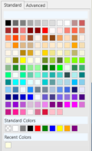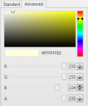
You can customize the Color inluding making the Note semi-transparent by reducing the A (Alpha) component

