CUSTOM MANY2ONE FIELDS

Plm client can map CAD property with Odoo even if Odoo field is a many2one field.
Starting from Odoo model (for example plm.finishing).

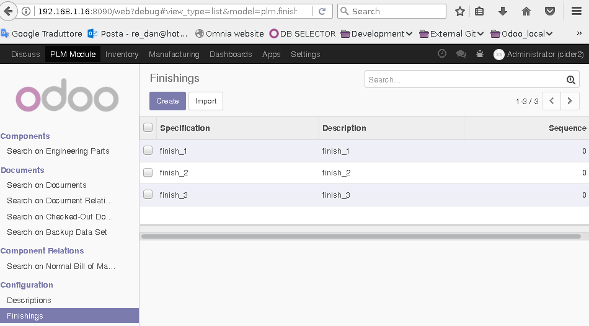

We have three records in this model.
In the component form I have my many2one field (“Surface Finishing”) linked to this table.
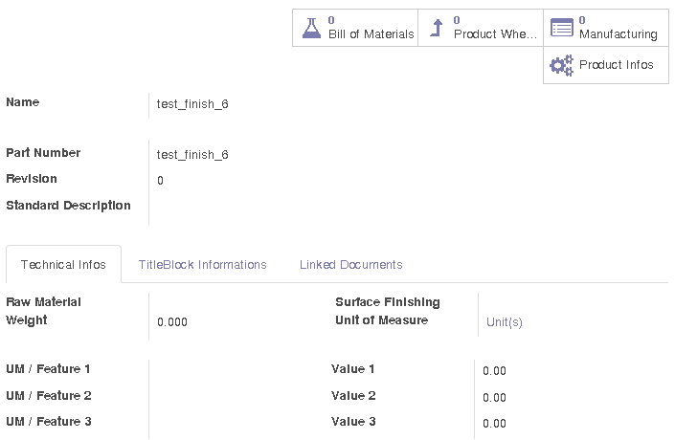
In my CAD properties I have my surface finishing property called “Surface Finishing 2” and it's value is “finish_2”.
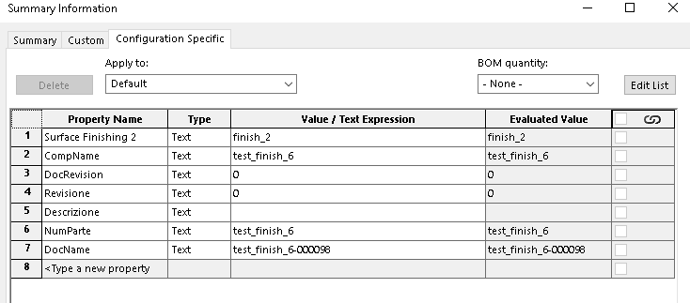
I want to save this component linking this surface finishing with Odoo related field.
To have these this procedure working you have to give OmniaSolutions the name of the CAD property (Surface Finishing 2) and the name of the related many2one field in Odoo (tmp_surface).
Our procedure will search the value of the CAD property (finish_2) in the table of related model (plm.finishing) by name, if the object is found is saved in Odoo form.

