Workorder Machine Controller

To start work with workorder machine you have to digit the following path in the browser:

http://127.0.0.1:8069/web/workorder_machine

- 127.0.0.1 has to be replaced with the Odoo server IP Address
- 8069 has to be replaced with Odoo server port

The following view will be displayed
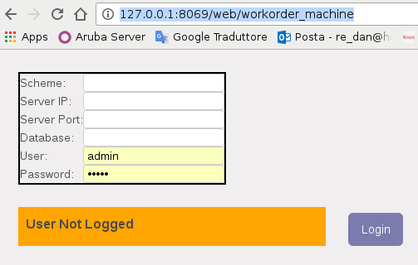
You have to setup correctly these informations to Login in the correct database and with the correct user, for example

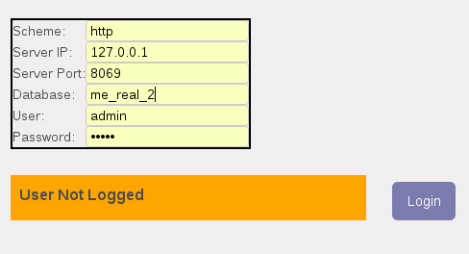

Now you have to click the Login button, if everything is ok this form will be shown

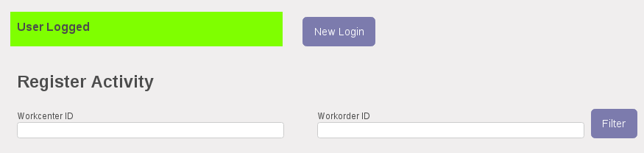
In the Register Activity section you have the possibility to filter by Workcenter and Workorder ID.
The only one required information is the Workcenter ID, so I setup it and click the Filter button

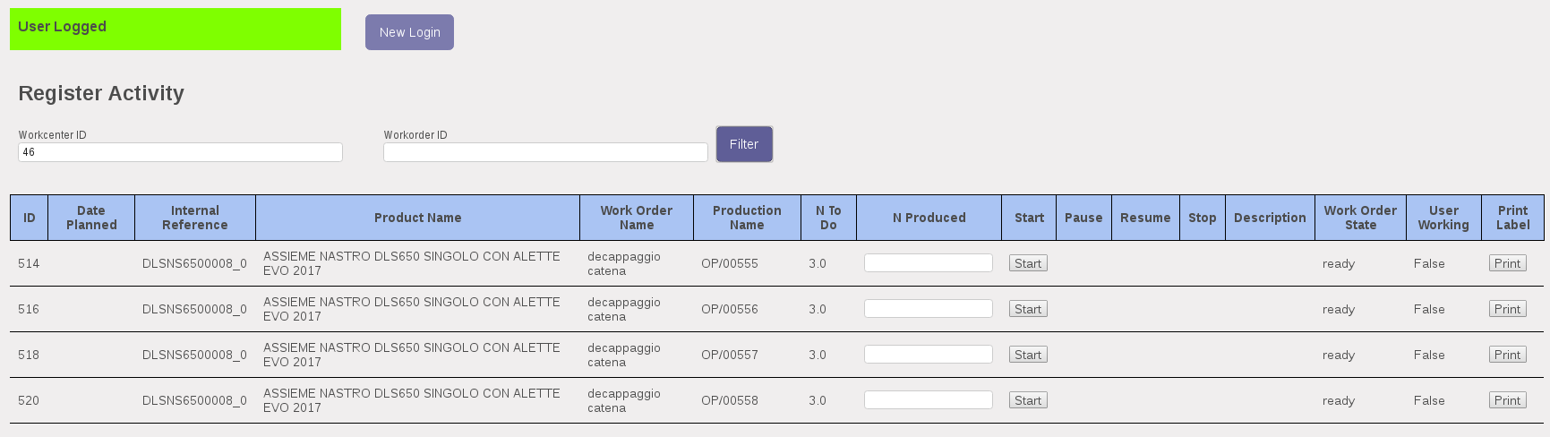
Now I have a list of lines that are showing me all opened Workorder operations to do for this Workcenter.

Once you have found your operation to do you have to click Start button to begin the working procedure. Here the result

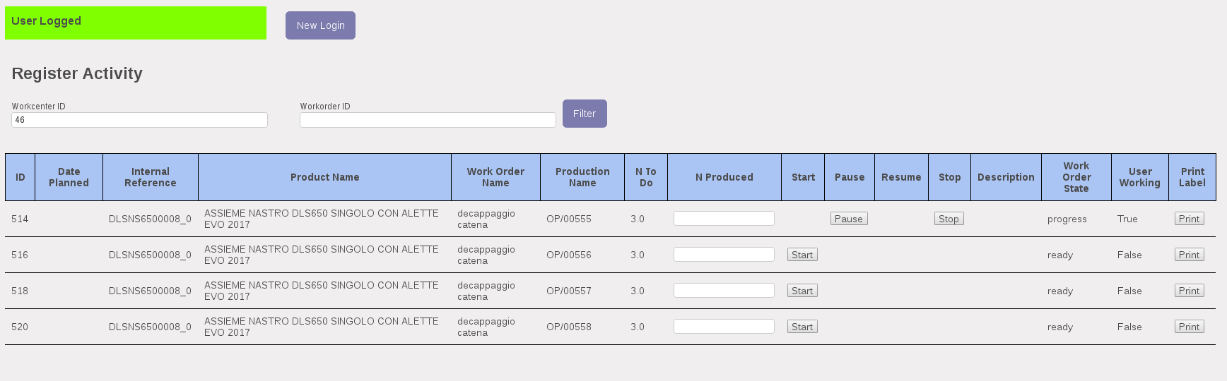
Now you have two choices, Pause or Stop.
For example we want to pause the work, we click the Pause button and the result is

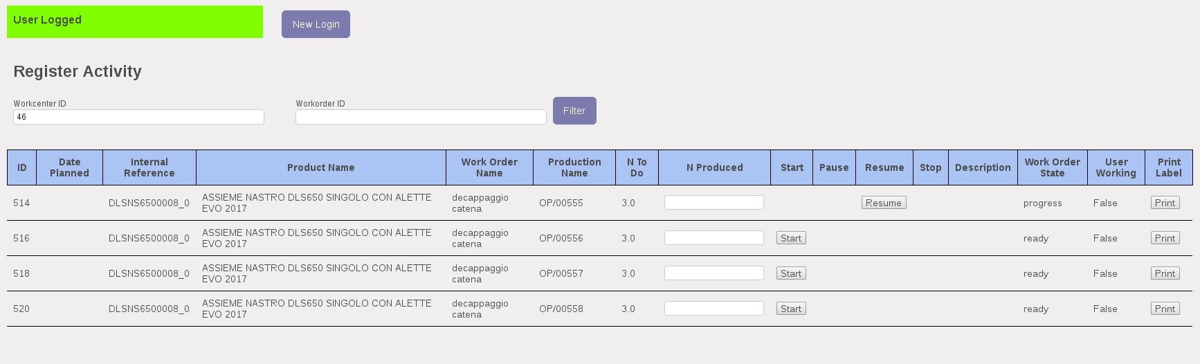
Now I have the possibility to resume the work, so I click the Resume button and I came back in the previous case.
Finally I need to finish and close my workorder, so I set the number of pieces produced in N Produced column, the number has to be equal to N To Do column quantity.
Once I setup the correct quantity I can click the Stop button to register the production and close the workorder.

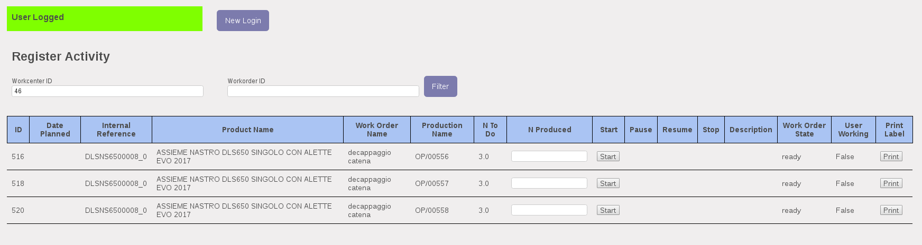
As I can see after the Stop button click the Workorder is closed and not shown in the todo list.

At the end of each line you have the Print button to print the product label related to the product to produce. If you click it the PDF label is generated.

