IMPORT PRODUCTION COST DOCUMENTATION
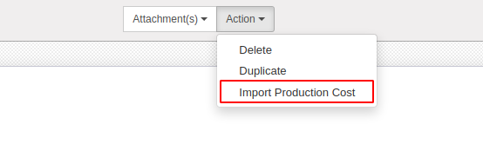
To calculate the total cost of a certain product production just go into ‘Chart of Analytic Accounts’ and from the Action drop down menu click on ‘Import Production Cost’.

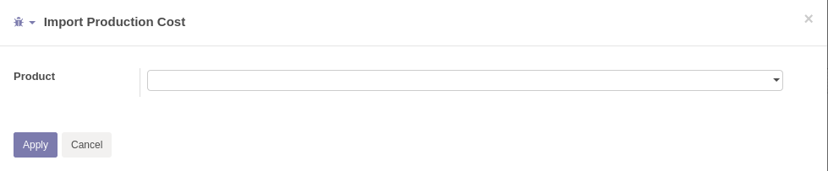

A wizard will open and by adding a product it will calculate all costs of all levels.



From the ‘Cost/Revenue’ button it is possible to see all production costs of that Analytic Account.

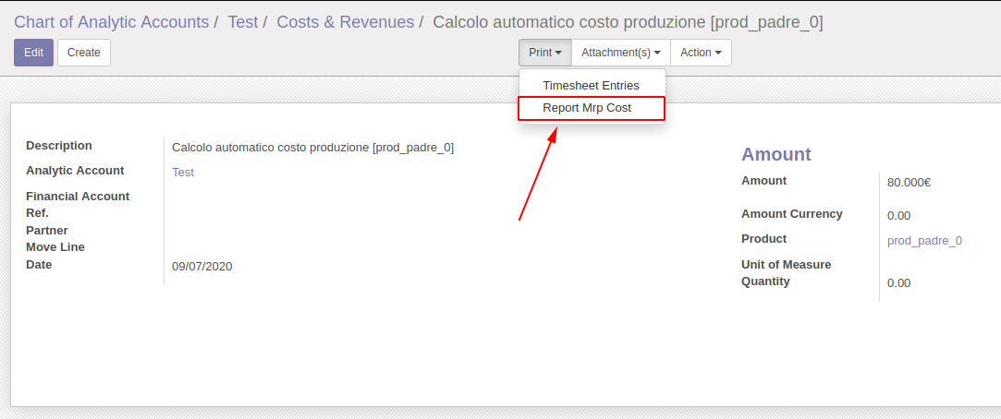
Once the total cost of a product production is calculated, it is possible to print a detailed report of all the prices on all levels.

