How to Add a Contact

ADD A CONTACT -- All Contacts MUST be added into SFDC first – ALWAYS!
Contacts added from Accounts ONLY. Must be on the Account page first.

Go to the Account to which you will add the contact….
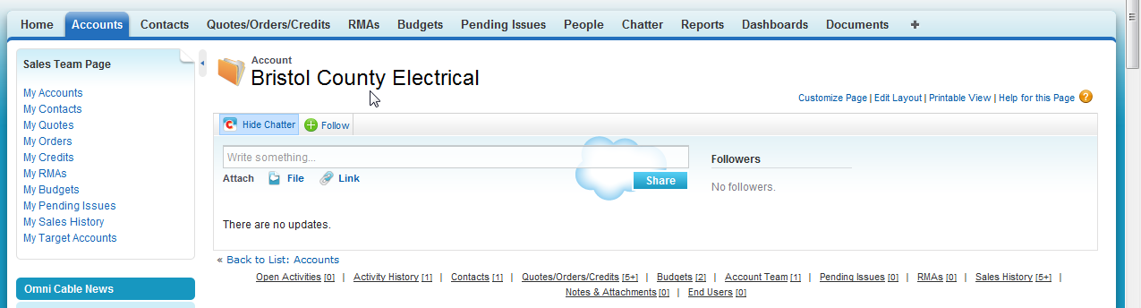

Click New Contact
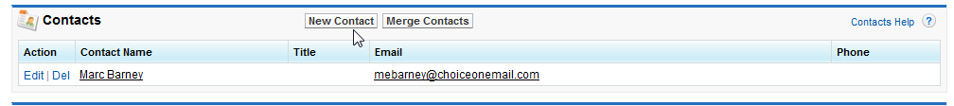

Enter the information…. Mandatory fields – First Name / Last Name / Email
All other information, fill in as much as possible. Information will be sent to OPUS within 10 minutes (on the 5’s).
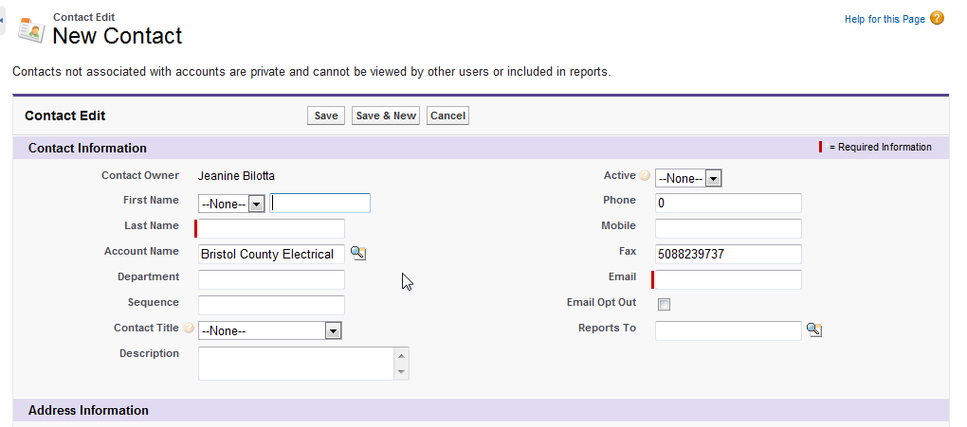

Click SAVE – Don’t forget to click SAVE!
