How to Add an Email to Salesforce

If there’s an email in Outlook that you would like to have a record of in Salesforce….

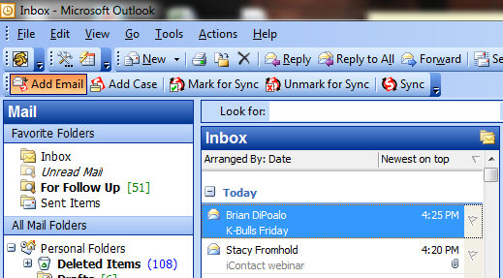

Click on the email you want added to Salesforce, then click “Add Email.” A new window will open. Your contact’s email address will show in the Search box. Click Go! and double click on the contact’s info that appears. Their name will now appear under “Your Name selection.”
Click “Add to Salesforce.”

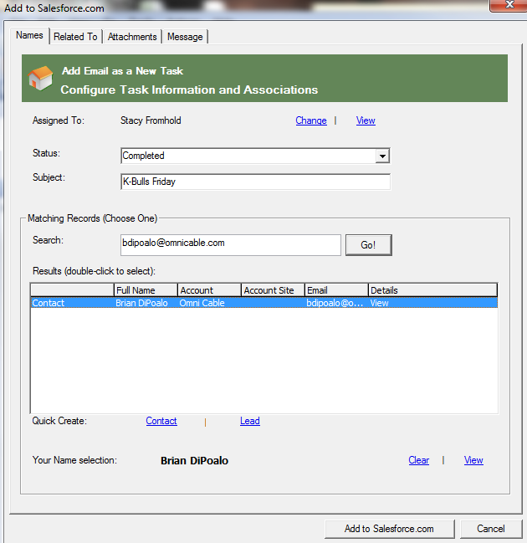

You can also relate the email to an Account or Quote/Order/Credit number. Click the “Related To” tab, type the Account Name or Quote/Order/Credit number into the search box and click Go! Then click on your selection and click “Add to Salesforce.com”

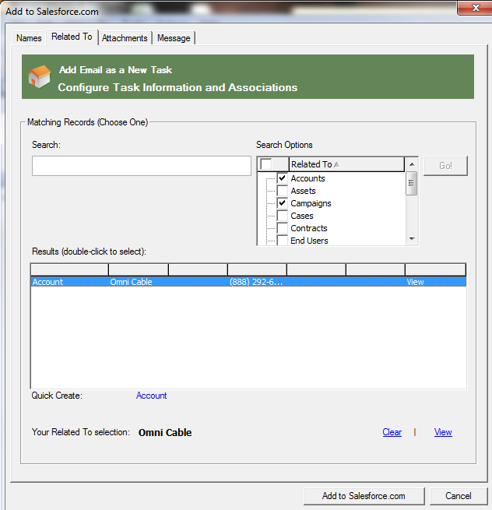
Search for an Account or a Quote/Order/Credit number to relate the email to

