How to Complete a Task

Click on the X to the left of the Task….

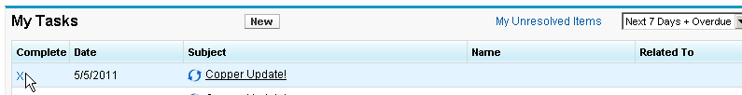

The Status of the Task automatically changes to Complete, all you need to do is enter your notes, and hit SAVE.

