How to Create/Assign a Task

You can create/ assign a task from any of the following, depending upon related to:
- Account Detail Page
- Contact Detail Page
- Quote / Order Detail Page
- Home Page Task List

Under Activity History on detail page – Click New Task
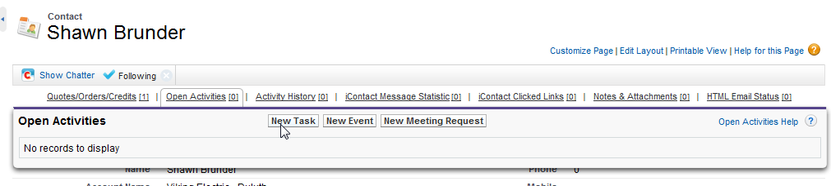

Defaults to Assigned to You(User) – can change as needed

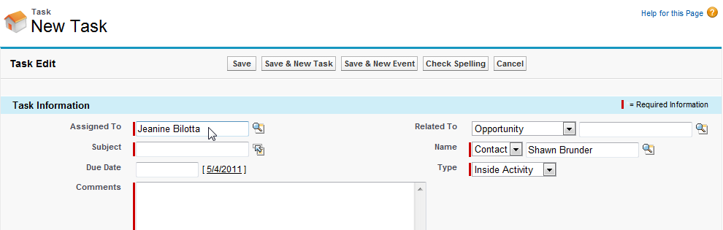

OR
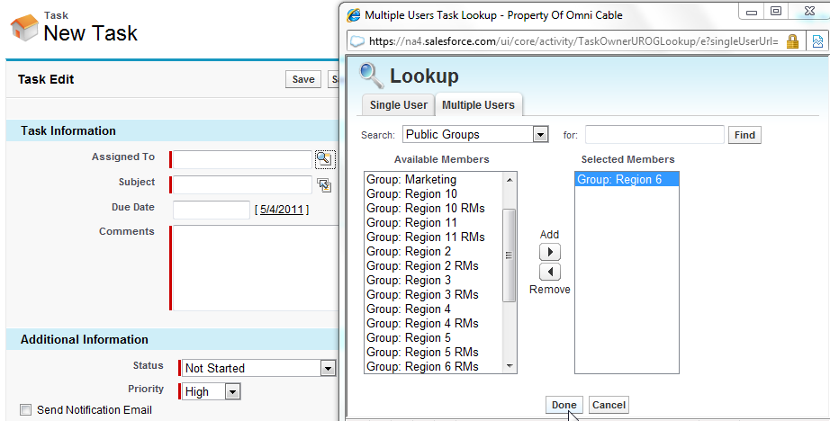

Enter Due Date / Description / Reminder Time / Etc…..Click SAVE!

