How to Create/Assign an Event

You can create an event from any of the following (depending upon related to):
- Account Detail Page
- Contact Detail Page
- Quote / Order Page
- Home Page Calendar

Under Activity History – Click New Event
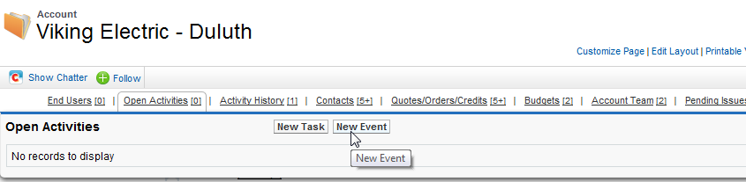

Defaults to Assigned to You(User) – can change as needed
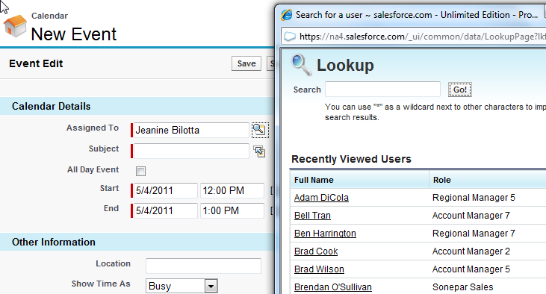

Enter Due Date / Description / Reminder Time / Etc…..
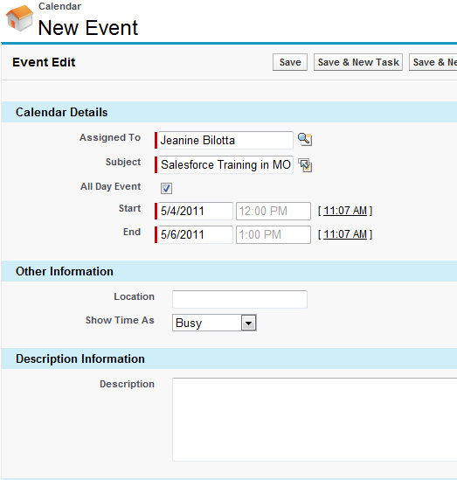

Invite Attendees as needed (at the bottom of the page)

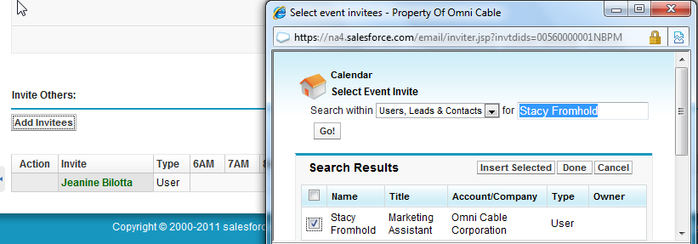

Click SAVE!

