How to Email a Vendor Spec Sheet

Click on the Documents Tab

Type your part number into the Documents Search Bar and click “Find Document.” (Put the part number in “quotations” to narrow down the results)
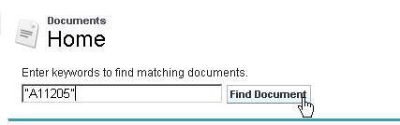

Below are the results -- Southwire and General Cable specs for that part number.

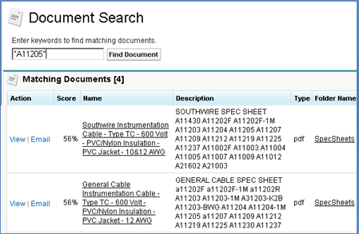

Click “View” to see the spec pdf or click “Email” to email the spec to a customer.

If you choose “Email,” fill out the “To” info. Use the “Look up” button (magnifying glass) to find your contact and click on their name.
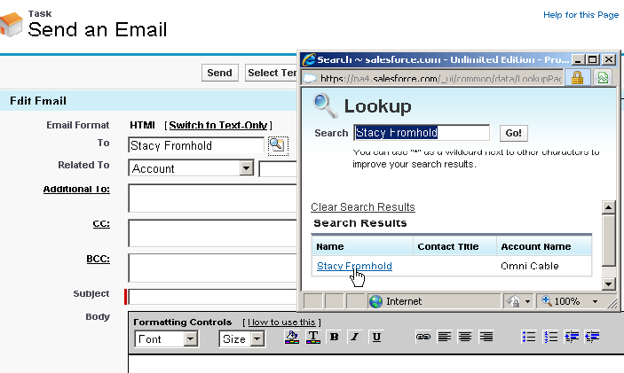

You can write your own message or click “Select Template.”
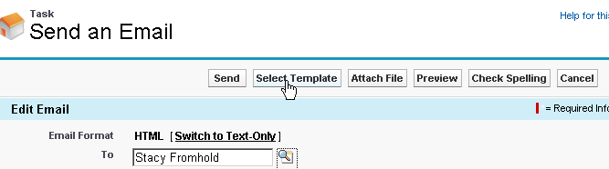

Select the “Spec Sheet Request” Template from the Sales templates folder. 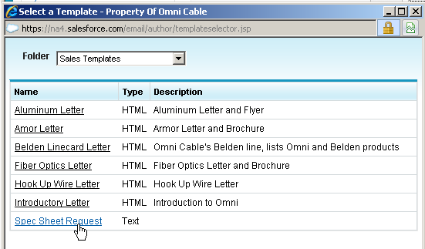

The subject is changed to ‘Spec Sheet from Omni Cable’ and there’s now a short message. If you previously clicked on your contact’s name in the “Look up” box, the contact’s first name will auto-fill.

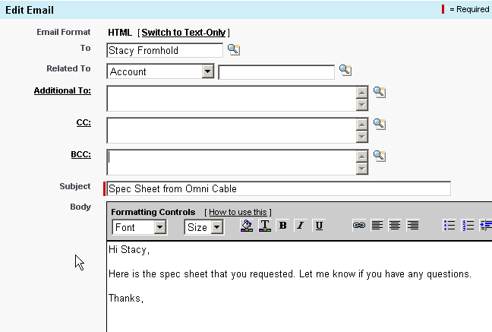
You can edit or change the message if needed. Your spec sheet is attached and your signature will be added at the bottom of the email if you’ve set up your email signature in Salesforce. To set up your signature, click on YOUR NAME at the top right in Salesforce | My Settings | Email | My Email Settings.

Click SEND. A record of your email will now be in the account and contact’s Activity History.

