How to Follow Up on a Quote

Access Quote # from a variety of methods….
  - My Quotes
  - Account Detail page
  - Contact detail page
  - Search for Quote #

Once you are in the quote….
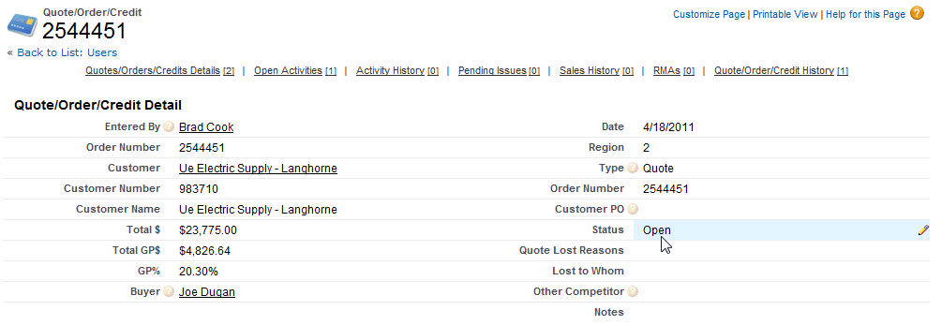

Double Click the Status and Update accordingly.....
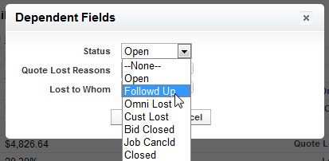

Enter useful notes – be detailed but concise … Click SAVE!
