How to Log a Call

You can log a call from any account or contact’s detail page. The Log a Call button is under “Activity History.”

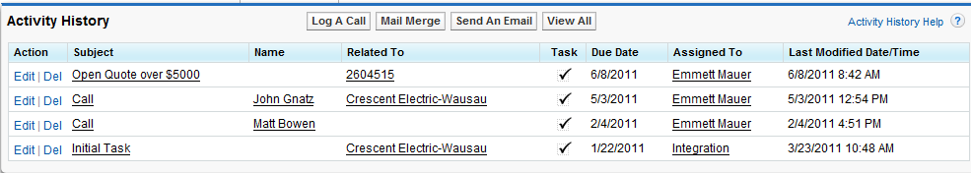

When you click Log a Call, the following screen appears…

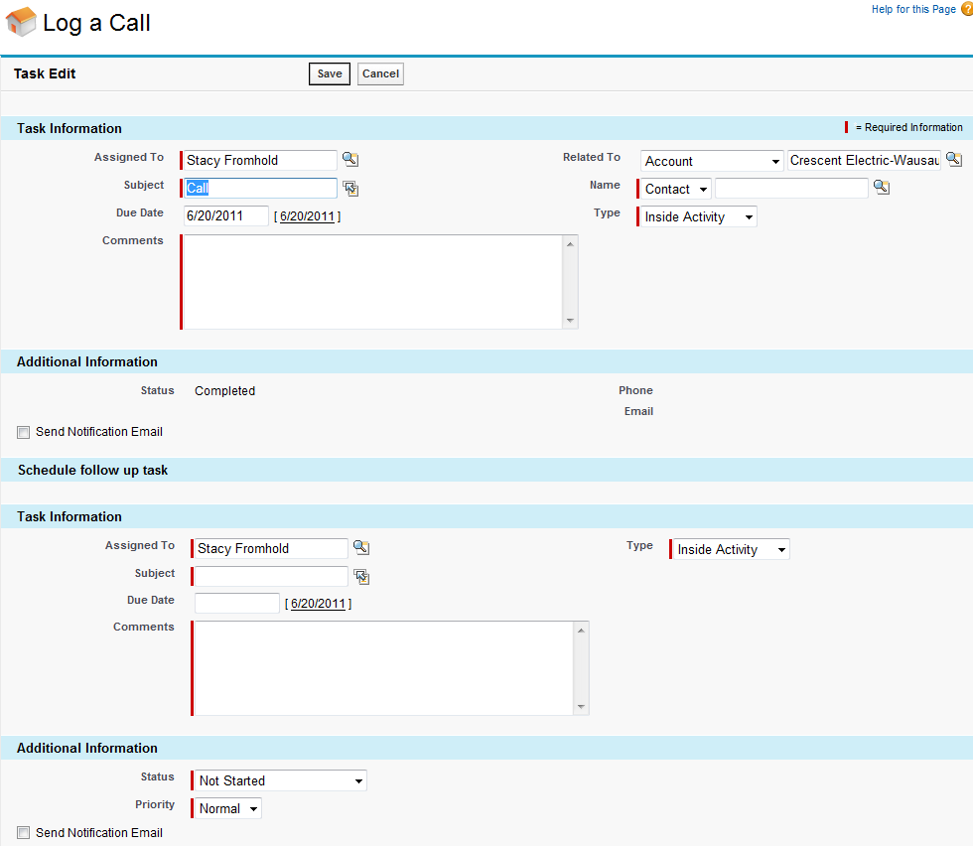

Here you fill out details about the call and you can also create a Follow Up task if needed. Don’t forget to click SAVE! The call is now logged under the contact and account’s Activity History.

