How to Send and Add Emails from Outlook to Salesforce
If you are composing an email in Outlook and want to have a record of it in Salesforce… Instead of clicking “Send,” click “Send and Add.” It has now been added to Salesforce and you should receive a confirmation email saying so.

If Salesforce wasn’t able to link the email to an existing contact’s email address, it will show up in your tasks as “Unresolved Item.” From there, you can edit it and relate it to a specific account or contact, or if it was a mistake you can delete it.

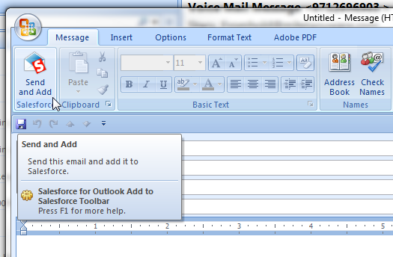

If there’s an existing email in Outlook that you would like to have a record of in Salesforce, just click on the email you want added to Salesforce, then click “Add Email.”
You should receive a confirmation email letting you know that the email has been added.

