Updating/Deactivating/Moving Contacts

UPDATING – CLEAN DATA IS GOOD DATA!
Update as much information as possible about your contacts, especially Contact Title.

DEACTIVATING
Deactivate contacts that no longer work with the company.
Go to the contact’s page, double click “Active” and change the “A” to a “D”)

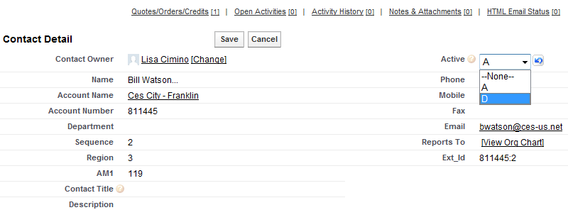

CONTACTS SWITCHING BRANCHES
If a contact branches (as opposed to leaving the company entirely), don’t deactivate them and try to create a new contact. Email Stacy Fromhold the contact’s name and what branch they should be moved to and she will switch them in the system. You will get stopped by the Dupe Catcher if you try to enter a duplicate contact.

CONTACTS CHANGING COMPANIES
If a contact leaves a company and goes to work for a different company (i.e. Contact moves from Gexpro to Wesco), deactivate their former contact page and create a new one with the new company.

