Salesforce Training Checklist
Getting started:

- Set up email signature – Name (top right) | Setup | Email | My Email Settings
- Download Chatter Desktop (may need to download Adobe Air first)

Review the basics:
- Home Page
- Accounts
- Contacts
- Quotes/Orders/Credits
- Reports & Dashboards
- Documents tab - Omni literature, spec sheets
- Chatter – how it works, how we use it

Review how to:
- Add a Contact
- Update or Deactivate Contacts
- Log a Call
- Create/Assign Tasks
- Create/Assign Events
- Update a Quote
- Complete a Task
- Find/Email a spec sheet
- Add an Outlook Email to Salesforce

Watch Videos on the intranet http://www.omnicable.com/employee/Omni%20University.html
- How to use the Calendar
- Customers Stats/Products Purchased/Sales Call Stats
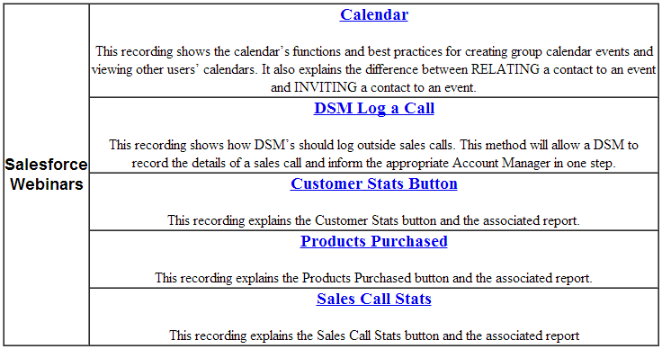
DSMs only

