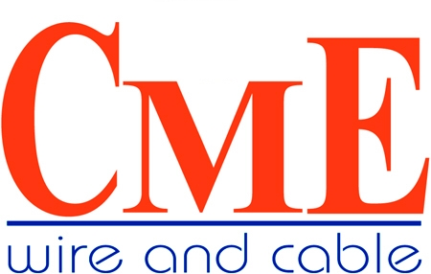
September 14, 2009

Reference: “Buy American”

- CME Wire and Cable is a U.S. corporation, headquartered in Suwanee, Georgia with distribution centers located in Atlanta, San Antonio Texas and Santa Fe Springs, California and is part of the Xignux Group of companies. Xignux is a global multi-billion dollar Corporation that is made up of four divisions and is headquartered in Monterrey, Mexico. CME Wire and Cable offers a broad line of both bare and insulated copper and aluminum, low and high voltage products designed to service the industrial, utility, commercial and transportation marketplaces.

- All of CME’s cables are manufactured by Viakable, Conductores Monterrey that exhibits the latest state of the art manufacturing technology in the world. Also, Xignux Yazaki, our joint venture company, is one of the largest suppliers to for automotive wire harnesses and instrumentation. Conductores Monterrey produces a major portion of the wire harnesses for the US automotive industry.

- CME’s major businesses and projects are with US electrical utilities for transmission and distribution lines, power generation, petrochemicals, oil rigs, commercial shipboard, and commercial infrastructures such as universities, airports and other industrial manufacturing plants. Also, we have shipped product to the Norfolk Navy Shipyards in Norfolk, VA., as well as other government facilities.

- The majority of our product components are US produced. Our insulating compounds are primarily from Dow Chemical. An example would be UL listed MV 105C cables, UD Primary cables including aluminum power conductors The copper rod is purchased on a normal basis from Cobre Mexico (42%), Grupo Mexico (34%0 and USA (24%). The EPR insulation is a DuPont polymer.

- Our interpretation of Buy American under the current NAFTA guidelines is to totally encompass North America; that being, Canada, US and Mexico.

In conclusion, more than 50% of CME’s product cost consists of materials purchased in the USA.

Should you require any additional information, please do not hesitate to call.

Robert Cavorsi
Director
Power Cable Division

495 Horizon Drive, NE – Suite 100 – Suwanee, GA. 30024
Phone; 770-623-0001 – Fax: 770-546-5729

