Salesforce 101 – 10.21.11
Cool New App – Dragon SFDC

Have you heard of Dragon Dictation? You talk into your phone and it records your words in text.

- With the Dragon SFDC app, you can record yourself and then have the option to post the text into an email, a text message, Log a Call, or Chatter.

3 Easy Steps!

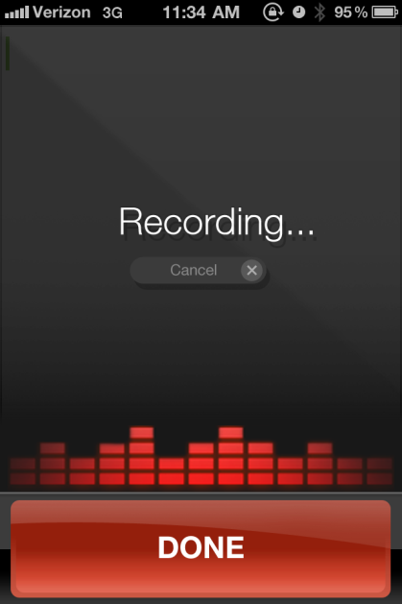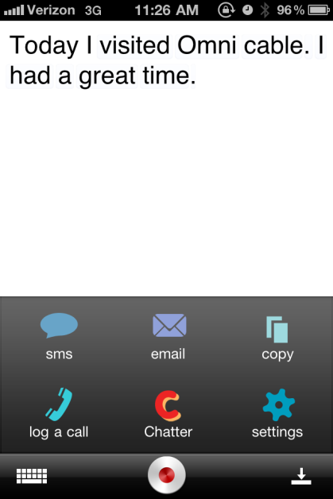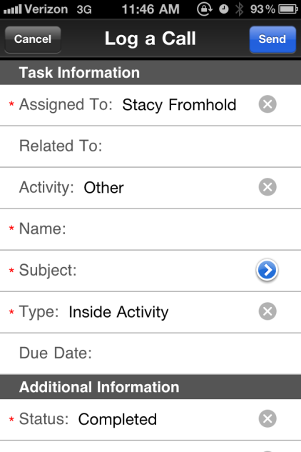

- Record your message 2. Fix any mistakes and select sharing option 3. Fill in Related info

This is a great app for logging sales calls on your iPhone when you are on the road. Just record any notes you have about the sales call or lunch n learn, then log a call and relate it to the account and contact you visited.

Thanks to Bill Blank for discovering this cool app!

