Salesforce 101 – 10.21.11
Vendors in Salesforce

- Vendors are now in Salesforce under the Accounts tab. Use the VENDORS view in the accounts tab to see all vendors.

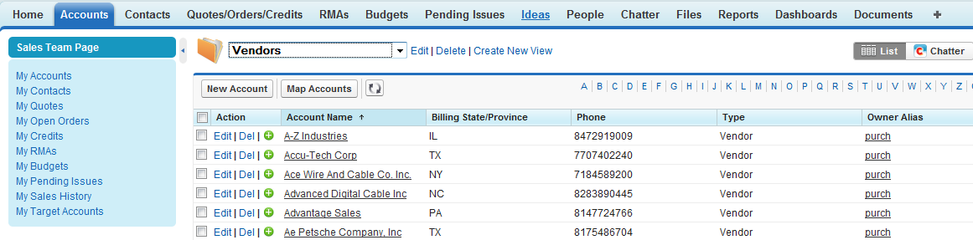

- There is a related list on Vendor detail pages called VENDOR OFFERINGS that shows the Vendor Product Families, Ranking, and Product Descriptions for items that the vendor sells.

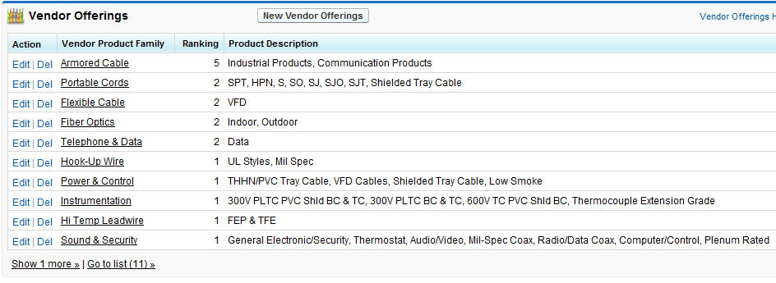

- Like other accounts, Vendor detail pages have related lists for Contacts, Open Activities, Activity History, and Notes & Attachments.

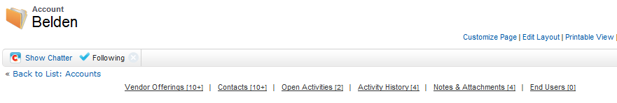

- If you want to add a new Vendor contact, you must contact someone in Purchasing with the contact’s information and they will enter it into Salesforce.

