Salesforce 101 – 10.7.11
Sales Call Stats Button

- At the top of every account detail page, there is a new button called Sales Call Stats. When you click on this button it brings you to the report “Sales Calls Stats.”

- This is a great report to bring with you when you visit accounts.

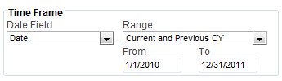

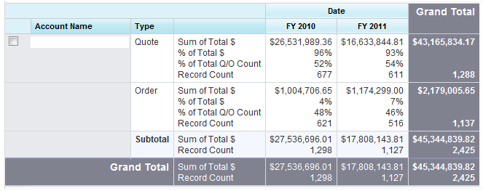
* If you want to change the time frame, just change the Range and click “Run Report.”

93% of QUOTED DOLLARS have stayed quotes and NOT been converted to orders ($16.6M out of $17.8M)
7% of QUOTED DOLLARS have become orders ($1.1M out of $18.8M total)

54% of QUOTES have stayed quotes and NOT been converted to orders (611 out of 1,127 total)
46% of QUOTES have become orders (516 out of 1,127 total)

