Salesforce 101 – SFDC Webinars on the Intranet

I’ve recorded 5 Salesforce Webinars on the following topics: Calendar Functions, DSM Log a Call, Customer Stats Button, Products Purchased Button, & Sales Call Stats Button. You can find links to the recorded webinars on the University tab on the Intranet.

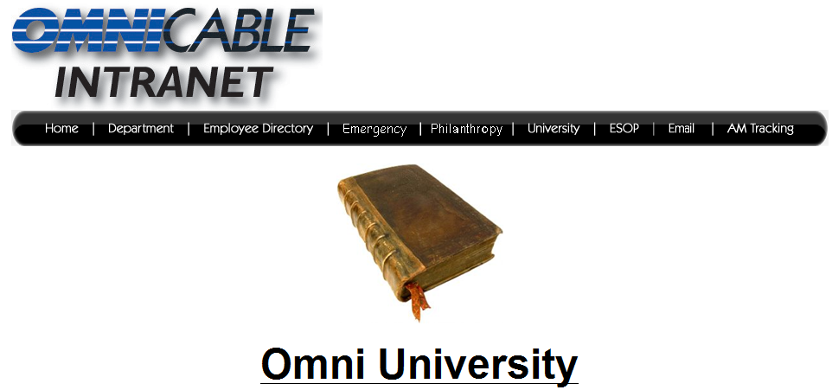

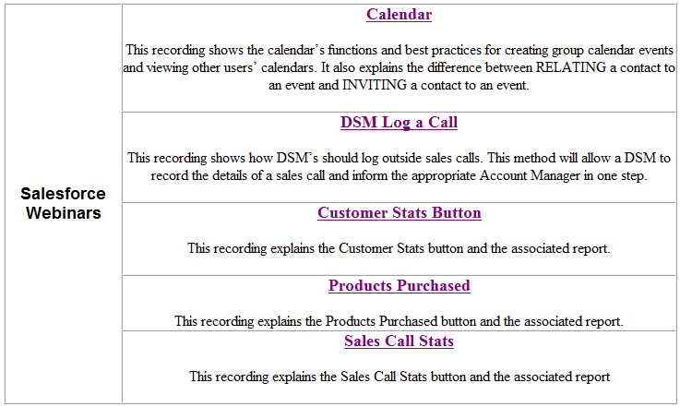

The webinars are only 3-6 minutes long, so check them out and feel free to give me any feedback or questions you may have.

