Account Manager Home Page Dashboard

GP% Invoiced Orders Under $1,000

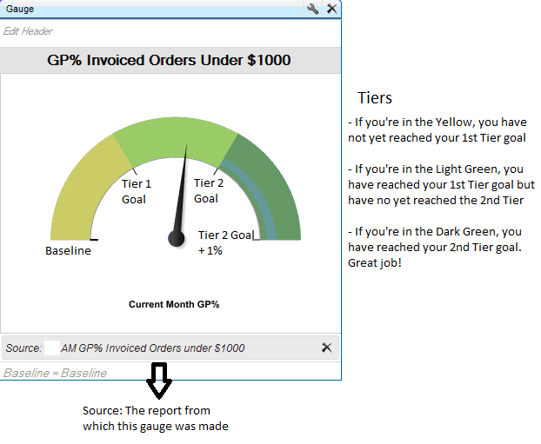

To view the report from which this dashboard was created, just click anywhere on the dashboard. The report lists the current month GP% for each of your accounts. At the bottom of the report, the grand total shows the Current Month GP% for all of your accounts.

