Salesforce 101 – 6.17.11
Chatter Usage

There are Chatter windows at the top of your home page, on account detail pages, on contact detail pages, and in the Chatter tab. Some people have also downloaded Chatter Desktop and Chatter mobile.

- Use your Home Page Chatter to send messages or ask questions. For example, you might ask if anyone knows where you can find a certain cable.
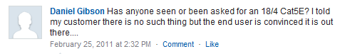

- To Chatter directly to a user you are following, type "@" and then type the user’s name and your message.


- Each region also has its own Chatter group for messages specific to the branch. These posts will show on the Chatter updates of the group’s members.

- When you follow a user/account/contact/group, you receive updates on any new Chatter that is posted by or about them.

- You can use Chatter to write notes about an account or contact. Only other users who are following that account or contact will receive updates.

To follow an account, click “Follow” on the account detail page.
To follow a specific contact at an account, just click “Follow” on the contact detail page.

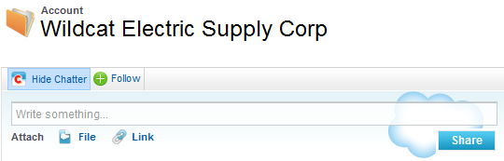
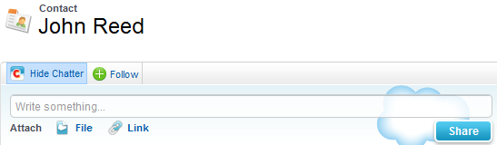

OR

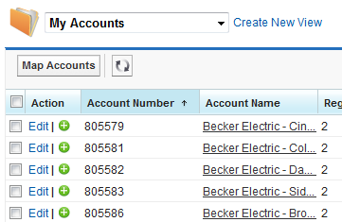

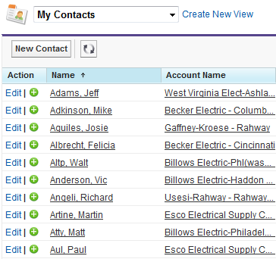

- Please keep in mind that anything you say in Chatter is public information and that the information you post should be Salesforce- or work-related and appropriate.

Here’s what you need to do…
- Follow your accounts and contacts
- Follow everyone at Omni (see below)

