Salesforce 101 – 6.24.11
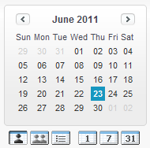

Multi User View

Group Calendar

- You can find your group calendar by clicking on the
“Multi User View” icon on the SFDC home page

- Under View, select your region’s calendar. You will now see the calendars for everyone at your branch.

- You can view daily, weekly, and monthly calendars by clicking on these buttons

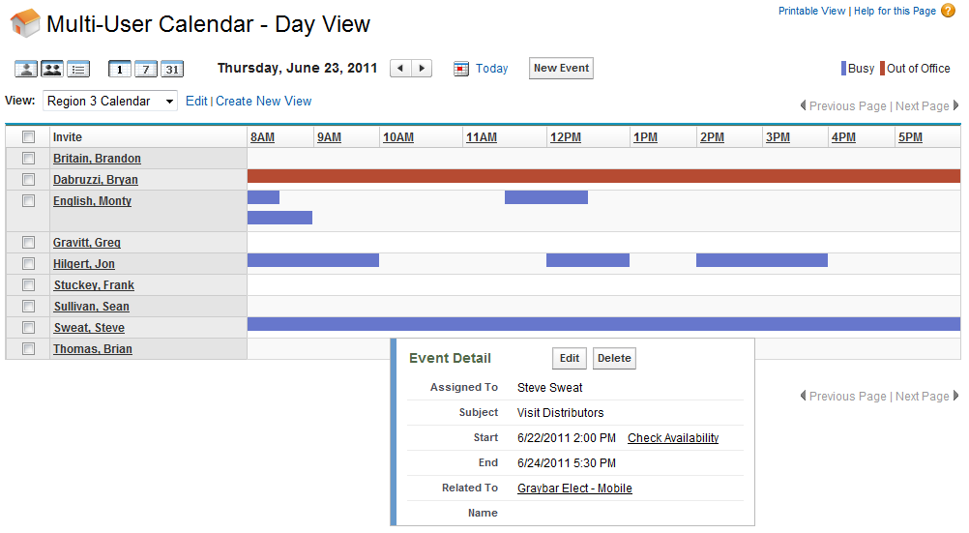
Hover over any purple or red bar to see the details of the event

* Purple indicates “Busy”
* Red indicates “Out of Office”
* All customer visits should be entered in your Salesforce calendar

- PTO should be entered into your Salesforce calendar. Just create an event, select “PTO” as the subject, and indicate that you will be out of office during that time.

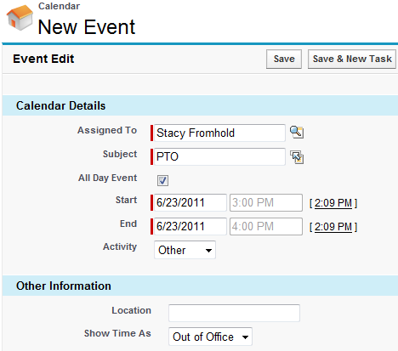
Note: PTO still needs to be entered in the Paychex system.

- You can view your personal calendar events on the Salesforce mobile app

