Salesforce 101

TARGET ACCOUNTS SALES TO BUDGET DASHBOARD

This dashboard gives a quarterly view of your Target Account’s sales to budgets, broken down by months. The blue bar represents Invoiced Monthly Sales and the green bar represents Monthly Budgets.

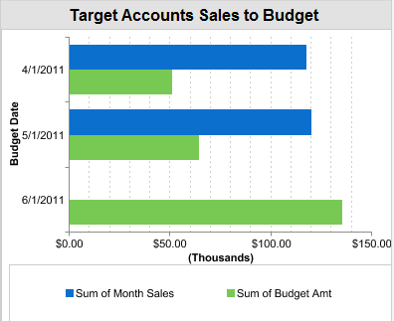

When you click on the dashboard, it takes you to the report. The report shows your target accounts and the monthly budgets and sales for each.

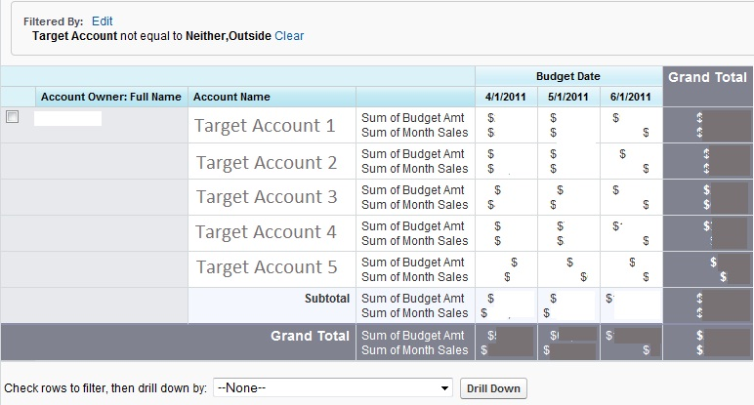

If you wanted to see this report in a different time frame (for example, current year), just go to the top right of the report and change the range from “Current CQ” (Calendar Quarter) to “Current CY” (Calendar Year). You must click RUN REPORT to see the data change.

