Salesforce 101 – 7.1.11
Salesforce/Outlook Integration

- Allows you to add emails from Outlook to Salesforce
- There are 2 primary functions in the Salesforce/Outlook Integration:

1. How to Add an Email to Salesforce

If there’s an email in Outlook that you would like to have a record of in Salesforce….

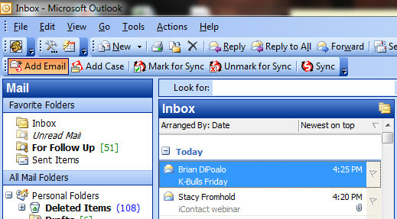

Click on the email you want added to Salesforce, then click “Add Email.” A new window will open. Your contact’s email address will show in the Search box. Click Go! and double click on the contact’s info that appears. Their name will now appear under “Your Name selection.” Click “Add to Salesforce.”

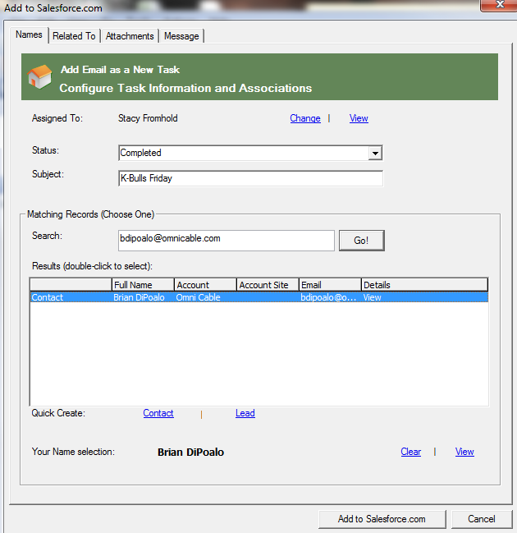

You can also relate the email to an Account or Quote/Order/Credit number. Click the “Related To” tab, type the Account Name or Quote/Order/Credit number into the search box and click Go! Then click on your selection and click “Add to Salesforce.com”

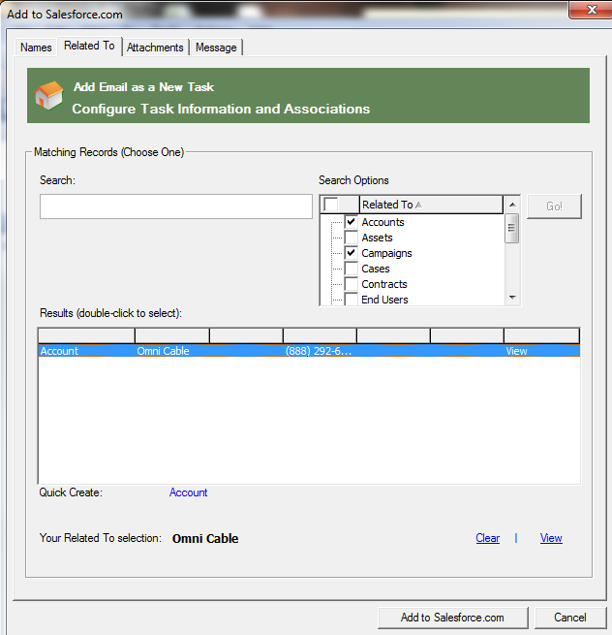
Search for an Account or a Quote/Order/Credit number to relate the email to

2. How to Send and Add an Email from Outlook to Salesforce
If you are composing an email in Outlook and want to have a record of it in Salesforce, instead of clicking “Send,” click “Send and Add.”

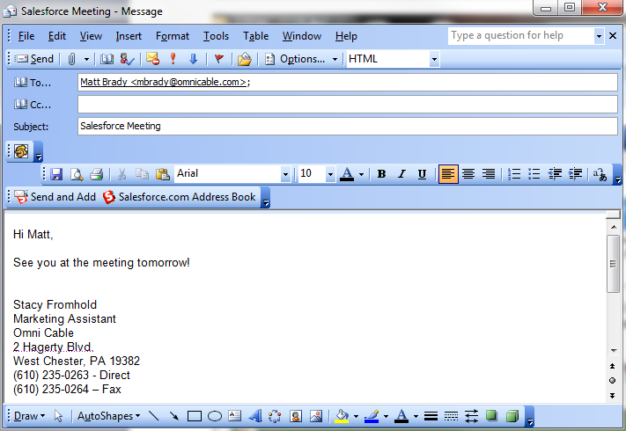

A new window will open. Your contact’s email address will show in the Search box. Click Go! and double click on the contact’s info that appears. Their name will now appear under “Your Name selection.” Click “Add to Salesforce.”
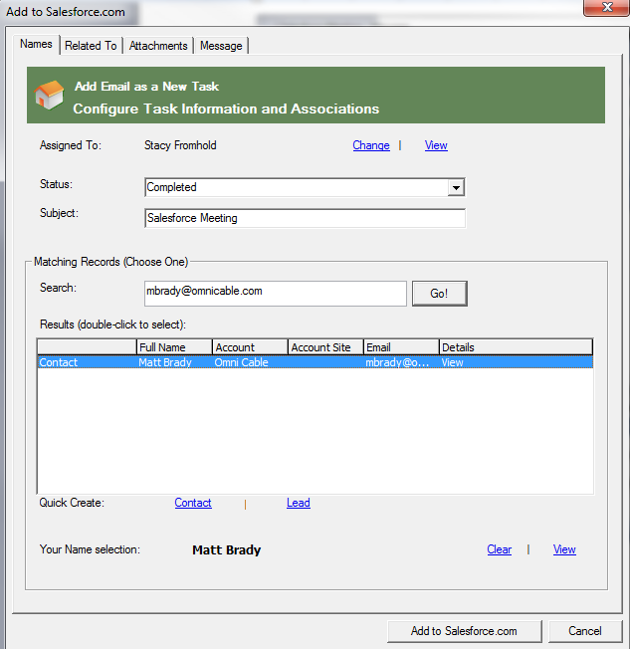

You can also relate the email to an Account or Quote/Order/Credit number. Click the “Related To” tab, type the Account Name or Quote/Order/Credit number into the search box and click Go! Then click on your selection and click “Add to Salesforce.com”

The Outlook/Salesforce Integration is a really cool feature because instead of searching through your entire mailbox, you can file email under the contact’s page for easy retrieval.

