Salesforce 101 – 7.29.11
Changing the Due Date for Quote follow-up Tasks

Situation: you quoted a customer yesterday and now there’s a task on your home page to follow up on that quote. However, the quote is for a job or bid a few weeks/months down the road so you don’t want to follow up right away. Here’s how you change the due date for the follow-up reminder:

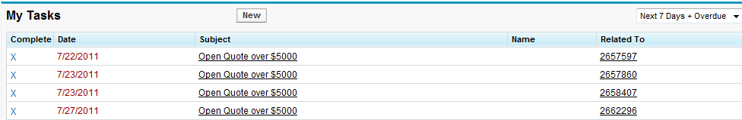

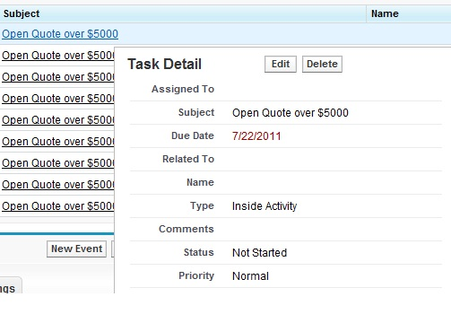
- Hover over the task subject and click “Edit.”

- Then change the due date to the next time you want to be reminded to follow up on that quote.

- The task will not show on your home page tasks until the new due date comes around

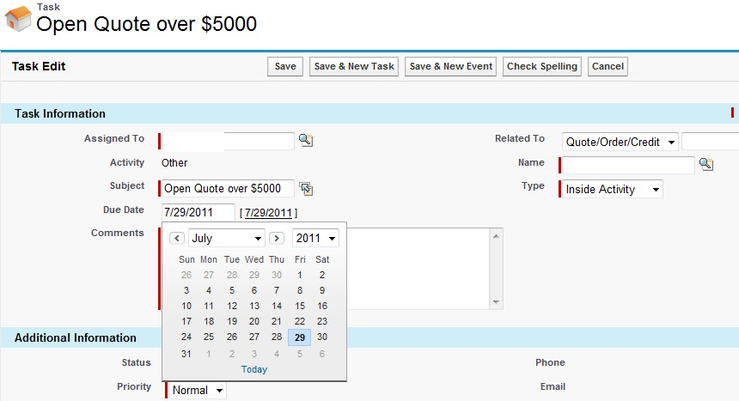

** It’s a good idea to set your home page tasks view to “Next 7 Days + Overdue.” That way you will see follow-up reminders that you haven’t addressed yet as well as any tasks for the upcoming week.

