Salesforce 101 – 8.12.11
Products Purchased Button

- At the top of every account detail page, there is a button called Products Purchased. When you click on this button it brings you to the report “Products Purchased JD.”

- This report shows the number of quotes and orders broken down by the product class for the current and previous calendar year (specifically for that account).

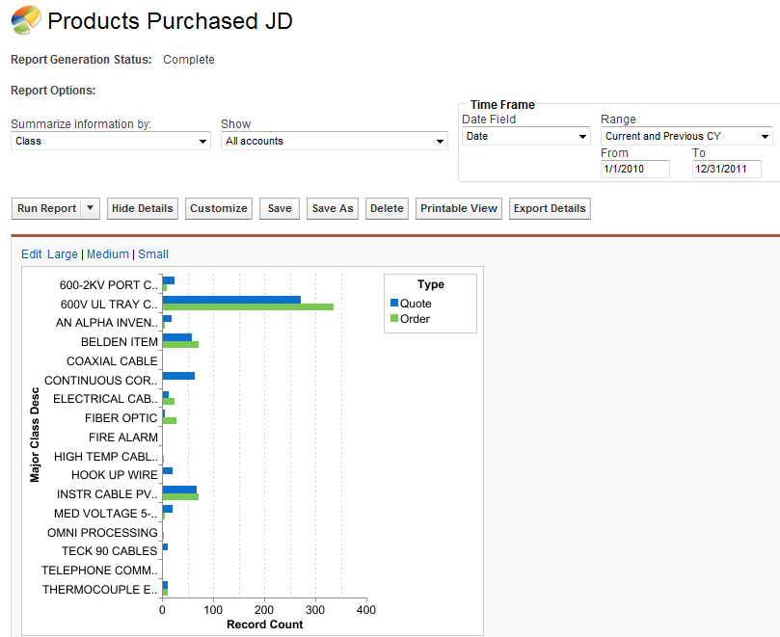
* If you want to change the time frame (for example, to just see data for the current year), just change the Range and click “Run Report.”

More detailed information about the individual quotes and orders is in the report below the chart
