Salesforce 101 – 8.5.11
ABC’s of Activities

- Activities are TASKS + EVENTS

- Tasks are to-do items including reminders, emails, and logged calls. You can assign tasks to yourself or others, and you have to mark tasks as complete to remove them from your home page tasks. Open tasks (ex. “Follow up with Jim”) are shown in the “Open Activities” section on account and contact pages. Completed tasks (ex. Emails and logged calls) are shown in the “Activity History” section on account and contact pages.

  - Reminder: To complete a task, click on the X to the left of the date and then click save in the window that appears. You should complete tasks (not delete them) so that you have a history of that task in Salesforce.
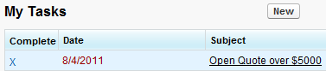

- Events include conference calls, trips, meetings, location visits -- anything with a set time. You can invite other users and contacts to events. You don’t “complete” events; they simply disappear from your home screen calendar once the date has passed. Activities become part of a contact or account’s Activity History once they have happened.

  - Examples: PTO, location visit, sales meeting, golf outing

