Salesforce 101 – 9.16.11
OMNI Chatter

Chatter is now going to be the primary forum for company discussion, messages, and questions. Pete Comber, Greg Donato, and Chris Bertolami will be using Chatter to gather and distribute sales and purchasing info. So make sure you’re in the loop!
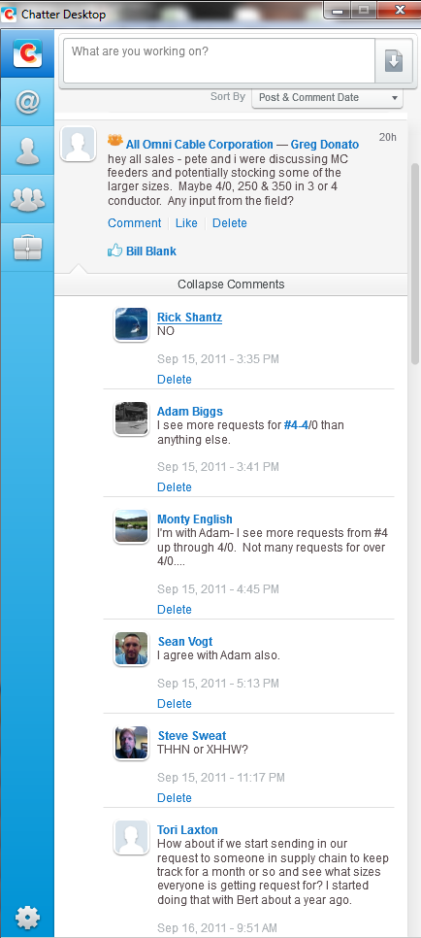
- Download Chatter Desktop
- Once you download Chatter desktop, you can “set it and forget it.” Chatter Desktop will automatically start on your desktop when you turn your computer on.
- You can keep the window minimized. Like Outlook, new chatter updates pop up in a small window in the bottom right corner of your screen.
- Everyone is already a member of the “All Omni Cable Corporation” group, so if you have something to put out to everyone on Salesforce, post your comments in that group.
- Many regions have been using their branches’ chatter groups for information specific to their branch.

Have you downloaded Chatter Desktop yet? If not, go to the Chatter tab on SFDC and click “Get Chatter Desktop.” Click “open” then follow the instructions and accept all the settings from there.

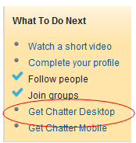

Keep in mind that what you say in Chatter can be seen by others, so make sure your messages are appropriate.

** If you have any questions or need help getting started up with Chatter Desktop, just give me a call.

