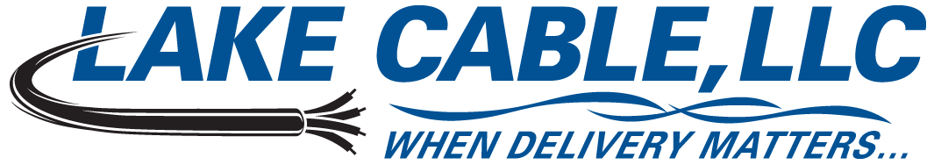
529 Thomas Drive, Bensenville, IL 60106 USA – Ph: 847-238-3000 Toll Free: 888-518-8086 Fax: 630-860-5944

14 AWG 1 Pair Shielded 600V Instrumentation Tray Cable Specification – Quad Rated

Lake Cable Part #: V142S-QR

Description: 14 AWG, 1 pair shielded 600V instrumentation tray cable constructed with stranded bare copper, polyvinylchloride and nylon insulation, an aluminum/mylar shield with a stranded tinned copper drain wire and an overall polyvinylchloride jacket. Individual conductors are manufactured in accordance with UL Standard 83, Type THHN/THWN/VW-1. Cable is manufactured in the USA in accordance with UL Standard 1277 and NEC listed Type TC, suitable for use in Class I Division II hazardous locations and approved for installation in cable trays per Article 336 and for use as fire protective signaling cable per Article 760 of the National Electric Code. Cable may be installed in open air, in ducts or conduits, in trays or troughs and is approved for direct burial and outdoor applications. Jacket is sunlight & oil I resistant and cable is (UL) TC approved for 600V, 90°C Dry/Wet, quad rated TC, PLTC, NPLF and FPL and meets or exceeds the requirements of UL 1581 and 1202 (FT-4) 70,000 BTU/HR and ICEA T-29-520 210,000 BTU/HR flame tests.

1. Conductor
1.1 AWG Size & Stranding: 14 AWG, Class B 7 Strands
1.2 Material: Annealed Bare Copper
2. Insulation
2.1 Material: Polyvinylchloride & Nylon per UL Standard 83, Type THHN/THWN/VW-1
2.2 Wall Thickness: 0.015” PVC & 0.005” Nylon - The minimum at any point shall not be less than 90%
of the specified wall thickness
3. Color Code
3.1 Code: Method 1, Table E-2
4. Assembly
4.1 Lay Length: 3.00” LHL, Nominal - 4.00 TPF
4.2 Fillers: N/A
4.3 Binder: N/A
4.4 Shield: Aluminum/Mylar Tape - 100% coverage
4.5 Drain Wire: 16 AWG, 7 Strand Tinned Copper
5. Jacket
5.1 Material: Polyvinylchloride per UL Standard 1277
5.2 Wall Thickness: 0.045” - The minimum at any point shall not be less than 80% of the specified
wall thickness
5.3 Diameter: 0.313”
5.4 Color: Black
5.5 Weight: 68 lbs./Mft.
5.6 Ripcord: Yes
6. Markings
6.1 Type: Cable shall be permanently identified via surface inkjet print
6.2 Legend: LAKE CABLE E208309 14AWG 1PR SHIELDED (UL) TC 600V PLTC NPLF FPL PVC/NYLON
90’C DRY/WET PVC JACKET SUN RES DIR BUR OIL RES I FT4 “ROHS”
6.3 Sequential Footage Markers: Yes
7. Standards
7.1 UL listed as Type TC per UL Standard 1277 and Quad Rated TC, PLTC, NPLF & FPL
7.2 UL approved for Sunlight Resistant, Oil Resistant I & Direct Burial applications
7.3 Individual conductors pass UL VW-1 flame test, rated THHN/THWN/VW-1
7.4 Cable meets UL 1581 & 1202 (FT-4) 70,000 BTU/HR & ICEA T-29-520 210,000 BTU/HR requirements
7.5 Meets ICEA S-95-658, where applicable
7.6 All materials used in the manufacture of this cable are RoHS compliant
ALL SPECIFIED PARAMETERS ARE NOMINAL AND SUBJECT TO VERIFICATION

