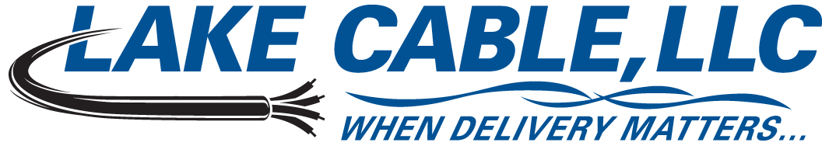
529 Thomas Drive, Bensenville, IL 60106 USA – Ph: 847-238-3000 Toll Free: 888-518-8086 Fax: 630-860-5944

18 AWG 2 Conductor Shielded 600V Instrumentation Tray Cable Specification – Quad Rated

Lake Cable Part #: V182S-QR

Description: 18 AWG, 2 conductor shielded 600V instrumentation tray cable constructed with stranded bare copper, polyvinylchloride and nylon insulation, an aluminum/mylar shield with a stranded tinned copper drain wire and an overall polyvinylchloride jacket. Cable is manufactured in the USA in accordance with UL Standard 1277 and NEC listed Type TC, suitable for use in Class I Division II hazardous locations and approved for installation in cable trays per Article 336 and for use as fire protective signaling cable per Article 760 of the National Electric Code. Cable may be installed in open air, in ducts or conduits, in trays or troughs and is approved for direct burial and outdoor applications. Jacket is sunlight and oil I resistant and cable is (UL) TC approved for 600V, 90°C Dry/Wet, quad rated TC, PLTC, NPLF and FPL and meets or exceeds the requirements of UL 1581 and 1202 (FT-4) 70,000 BTU/HR and ICEA T-29-520 210,000 BTU/HR flame tests.

1. Conductor
1.1 AWG Size & Stranding: 18 AWG, Class B 7 Strands
1.2 Material: Annealed Bare Copper
2. Insulation
2.1 Material: Polyvinylchloride & Nylon
2.2 Wall Thickness: 0.015” PVC & 0.005” Nylon - The minimum at any point shall not be less than 90%
of the specified wall thickness
3. Color Code
3.1 Code: Black, Red
4. Assembly
4.1 Lay Length: Per UL Standard 1277
4.2 Fillers: N/A
4.3 Binder: N/A
4.4 Shield: Aluminum/Mylar Tape - 100% coverage
4.5 Drain Wire: 20 AWG, 7 Strand Tinned Copper
5. Jacket
5.1 Material: Polyvinylchloride per UL Standard 1277
5.2 Wall Thickness: 0.045” - The minimum at any point shall not be less than 80% of the specified
wall thickness
5.3 Diameter: 0.268”
5.4 Color: Black
5.5 Weight: 41 lbs./Mft.
5.6 Ripcord: Yes
6. Markings
6.1 Type: Cable shall be permanently identified via surface inkjet print
6.2 Legend: LAKE CABLE E208309 18AWG 2C SHIELDED (UL) TC 600V PLTC NPLF FPL PVC/NYLON
90’C DRY/WET PVC JACKET SUN RES DIR BUR OIL RES I FT4 “ROHS”
6.3 Sequential Footage Markers: Yes
7. Electrical Characteristics
7.1 Impedance: 47 Ω
7.2 Capacitance: 48.91 pF/ft.
7.3 DC Resistance: 6.9 Ω/Mft. @ 20°
8. Standards
8.1 UL listed as Type TC per UL Standard 1277 and Quad Rated TC, PLTC, NPLF & FPL
8.2 UL approved for Direct Burial, Sunlight and Oil I Resistant applications
8.3 Cable meets UL 1581 & 1202 (FT-4) 70,000 BTU/HR & ICEA T-29-520 210,000 BTU/HR requirements
8.4 Meets ICEA S-73-532, where applicable
8.5 All materials used in the manufacture of this cable are RoHS compliant

ALL SPECIFIED PARAMETERS ARE NOMINAL AND SUBJECT TO VERIFICATION

